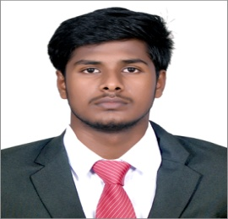

**MANIKANDAN**

No.150,Kamban st.,

Major Saravanan nagar,

karuvadikuppam,

Puducherry-08.



[manikumarann20@gmail.com](mailto:shri.babuji@shriresume.com)

 8248188396

# CAREER OBJECTIVE



To secure a challenging position in a reputable organization to expand my leanings, knowledge, and skills.

|  |  |  |
| --- | --- | --- |
| **EDUCATION** |  | |
|  | B.TECH [Information Technology] | Year of Graduation, 2020 |
|  | Manakula Vinayagar Institute of Technology,  Puducherry. | CGPA 8.76 |
|  | **HSC**  (State Board) | Graduated, 2016 |
|  | V O C government higher secondary school,  Puducherry. | Percentage-79.33% |
|  | **SSLC**  **(**State Board **)**  P. Kamaraj Govt boys high school,  Puducherry. | Graduated, 2014  Percentage-92.2% |

# SOFTWARE PROFICIENCY



**AREA OF INTEREST**

* Programming Languages : Basics of C, C++, JAVA, Python
* Development Tool : Net Beans
* Web Designing : HTML,CSS

* Data Structure
* Object Oriented Programming

# PROJECTS

|  |  |
| --- | --- |
| **Title** | **Description** |
| Main Project |  |
|  |
| Mini  Project | **ONLINE TOLLGATE AUTOMATION** |
|  |

**ACHIEVEMENTS**

**WORKSHOP/SYMPOSIUM/IN-PLANT TRAINING/PROJECT CONTENT**

**PERSONAL DETAILS**

Father's Name : Mr.V.Kumaran Marital Status : Single

D.O.B : Augest 20,1999 Nationality : Indian

Gender : Male

MANIKANDAN K