ggplot

KRM

2024-10-05

## R Markdown

This is an R Markdown document. Markdown is a simple formatting syntax for authoring HTML, PDF, and MS Word documents. For more details on using R Markdown see <http://rmarkdown.rstudio.com>.

When you click the **Knit** button a document will be generated that includes both content as well as the output of any embedded R code chunks within the document. You can embed an R code chunk like this:

summary(cars)

## speed dist   
## Min. : 4.0 Min. : 2.00   
## 1st Qu.:12.0 1st Qu.: 26.00   
## Median :15.0 Median : 36.00   
## Mean :15.4 Mean : 42.98   
## 3rd Qu.:19.0 3rd Qu.: 56.00   
## Max. :25.0 Max. :120.00

## Including Plots

You can also embed plots, for example:



Note that the echo = FALSE parameter was added to the code chunk to prevent printing of the R code that generated the plot.

library(tidyverse)

## Warning: package 'ggplot2' was built under R version 4.4.1

## ── Attaching core tidyverse packages ──────────────────────── tidyverse 2.0.0 ──  
## ✔ dplyr 1.1.4 ✔ readr 2.1.5  
## ✔ forcats 1.0.0 ✔ stringr 1.5.1  
## ✔ ggplot2 3.5.1 ✔ tibble 3.2.1  
## ✔ lubridate 1.9.3 ✔ tidyr 1.3.1  
## ✔ purrr 1.0.2   
## ── Conflicts ────────────────────────────────────────── tidyverse_conflicts() ──  
## ✖ dplyr::filter() masks stats::filter()  
## ✖ dplyr::lag() masks stats::lag()  
## ℹ Use the conflicted package (<http://conflicted.r-lib.org/>) to force all conflicts to become errors

data("fruit")  
summary(fruit)

## Length Class Mode   
## 80 character character

dim(fruit)

## NULL

library(dplyr)  
library(ggplot2)  
data("diamonds")  
View(diamonds)

library(ggsci)

## Warning: package 'ggsci' was built under R version 4.4.1

library(ggpubr)

## Warning: package 'ggpubr' was built under R version 4.4.1

library(ggExtra)

## Warning: package 'ggExtra' was built under R version 4.4.1

library(aplot)

## Warning: package 'aplot' was built under R version 4.4.1

ggplot()+geom_point(data=diamonds,mapping=aes(x=carat,y=cut,color=price),alpha=0.5,size=3)

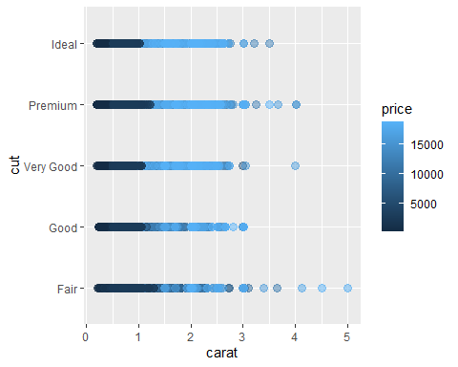

data(iris)  
View(iris)  
colnames(iris)

## [1] "Sepal.Length" "Sepal.Width" "Petal.Length" "Petal.Width" "Species"

gpi <- ggplot(iris,aes(Sepal.Length,Sepal.Width,color=Species))+  
geom_point()  
  
gpi

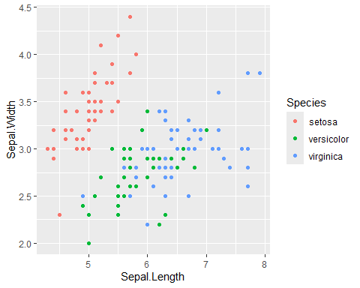

# legend position == bottom / top / c(x,y) placement of legend the sidebar  
  
gpi1 <- ggplot(iris,aes(Sepal.Length,Sepal.Width,color=Species))+  
geom_point()+ theme_classic()+theme(legend.position = c(0.7,0.25))

## Warning: A numeric `legend.position` argument in `theme()` was deprecated in ggplot2  
## 3.5.0.  
## ℹ Please use the `legend.position.inside` argument of `theme()` instead.  
## This warning is displayed once every 8 hours.  
## Call `lifecycle::last_lifecycle_warnings()` to see where this warning was  
## generated.

gpi1

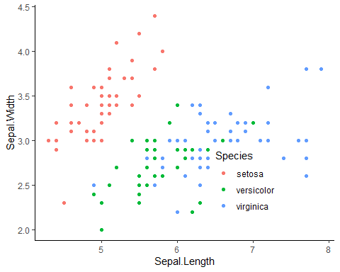

gpi <- ggplot(iris,aes(Sepal.Length,Sepal.Width,color=Species))+  
geom_point()+ theme_classic()+theme(legend.position = "top")  
  
ggMarginal(gpi,groupFill = TRUE)

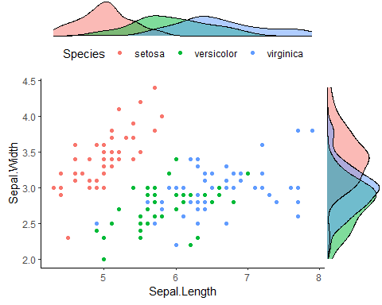

gpi <- ggplot(iris,aes(Sepal.Length,Sepal.Width,color=Species))+  
geom_point()+ theme_classic()+theme(legend.position = c(0.7,0.25))  
  
ggMarginal(gpi,groupFill = TRUE, type="boxplot")

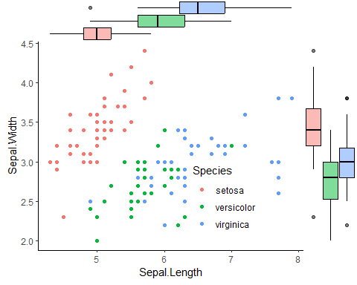

gpi <- ggplot(iris,aes(Sepal.Length,Sepal.Width,color=Species))+  
geom_point()+ theme_classic()+theme(legend.position = c(0.7,0.25))  
  
ggMarginal(gpi,groupFill = TRUE, type="boxplot", margin="y")

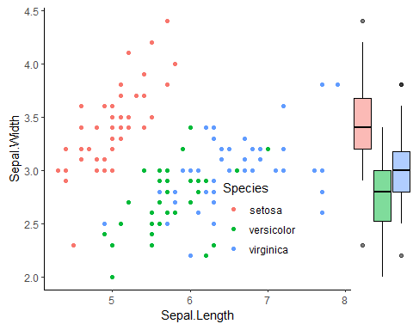

gpi <- ggplot(iris,aes(Sepal.Length,Sepal.Width,color=Species))+  
geom_point()+ theme_classic()+theme(legend.position = c(0.7,0.25))  
  
ggMarginal(gpi,groupFill = TRUE, type="boxplot", margin="x")

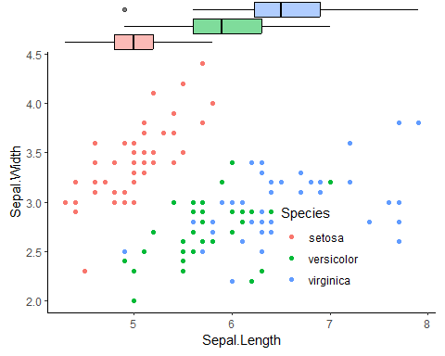

# we can change the type == histogram, column chart, density plot

# geom smooth adding the separator line

gpi <- ggplot(iris,aes(Sepal.Length,Sepal.Width,color=Species))+  
geom_point()+ theme_classic()+theme(legend.position = "top")+geom_smooth()  
  
ggMarginal(gpi,groupFill = TRUE)

## `geom_smooth()` using method = 'loess' and formula = 'y ~ x'  
## `geom_smooth()` using method = 'loess' and formula = 'y ~ x'

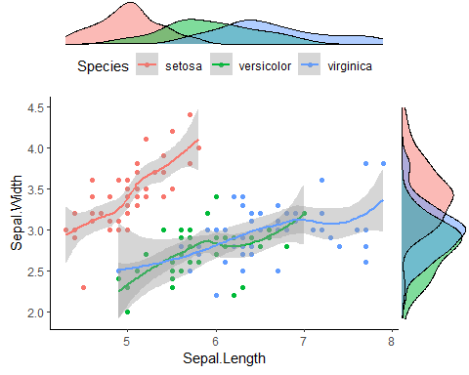

gpia<-ggplot(iris,aes(Sepal.Width,fill=Species))+geom_density()+  
 theme_void()+theme(legend.position="none")  
  
gpia

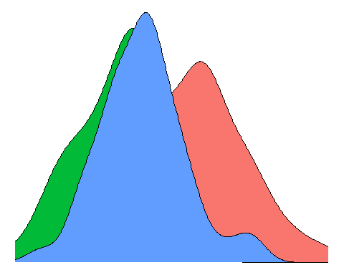

## alpha value added in density the color theme change  
gpia<-ggplot(iris,aes(Sepal.Width,fill=Species))+geom_density(alpha=0.3)+  
 theme_void()+theme(legend.position="none")  
  
gpia

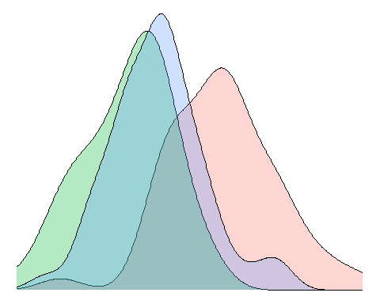

gpiab1<-ggplot(iris,aes(1,Sepal.Width,fill=Species))+geom_boxplot(alpha=0.3)+  
 theme_void()+theme(legend.position="none")  
  
gpiab1

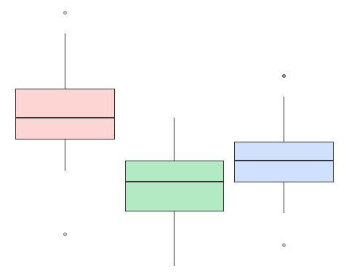

ap<-gpi1 %>% insert_top(gpia,height = 0.3) %>% insert_right(gpia,width = 0.3)  
  
ap

## Warning: Removed 149 rows containing non-finite outside the scale range  
## (`stat_density()`).

## Warning: Groups with fewer than two data points have been dropped.

## Warning in max(ids, na.rm = TRUE): no non-missing arguments to max; returning  
## -Inf  
## Warning in max(ids, na.rm = TRUE): no non-missing arguments to max; returning  
## -Inf  
## Warning in max(ids, na.rm = TRUE): no non-missing arguments to max; returning  
## -Inf  
## Warning in max(ids, na.rm = TRUE): no non-missing arguments to max; returning  
## -Inf

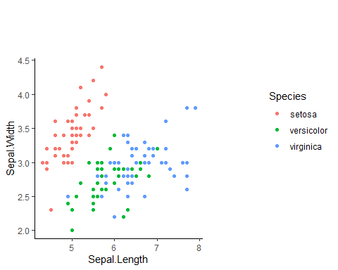

counts<-table(iris$Species)  
counts

##   
## setosa versicolor virginica   
## 50 50 50

barplot(counts)

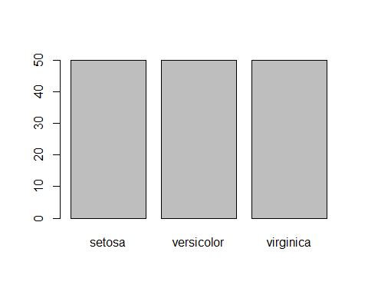

pie(counts)

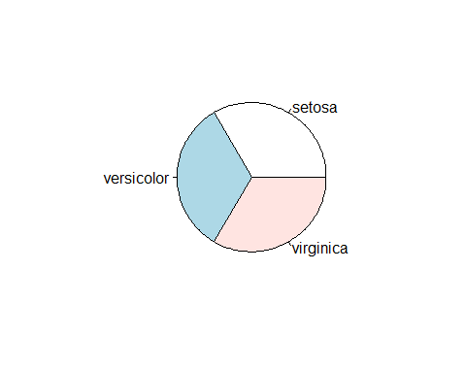

plot(iris$Sepal.Length,iris$Petal.Width)

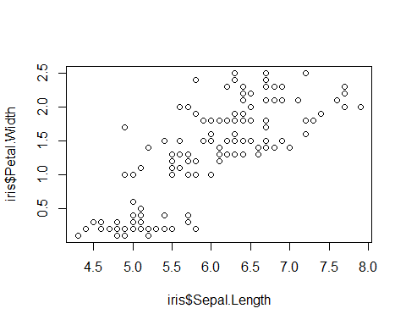

iris

## Sepal.Length Sepal.Width Petal.Length Petal.Width Species  
## 1 5.1 3.5 1.4 0.2 setosa  
## 2 4.9 3.0 1.4 0.2 setosa  
## 3 4.7 3.2 1.3 0.2 setosa  
## 4 4.6 3.1 1.5 0.2 setosa  
## 5 5.0 3.6 1.4 0.2 setosa  
## 6 5.4 3.9 1.7 0.4 setosa  
## 7 4.6 3.4 1.4 0.3 setosa  
## 8 5.0 3.4 1.5 0.2 setosa  
## 9 4.4 2.9 1.4 0.2 setosa  
## 10 4.9 3.1 1.5 0.1 setosa  
## 11 5.4 3.7 1.5 0.2 setosa  
## 12 4.8 3.4 1.6 0.2 setosa  
## 13 4.8 3.0 1.4 0.1 setosa  
## 14 4.3 3.0 1.1 0.1 setosa  
## 15 5.8 4.0 1.2 0.2 setosa  
## 16 5.7 4.4 1.5 0.4 setosa  
## 17 5.4 3.9 1.3 0.4 setosa  
## 18 5.1 3.5 1.4 0.3 setosa  
## 19 5.7 3.8 1.7 0.3 setosa  
## 20 5.1 3.8 1.5 0.3 setosa  
## 21 5.4 3.4 1.7 0.2 setosa  
## 22 5.1 3.7 1.5 0.4 setosa  
## 23 4.6 3.6 1.0 0.2 setosa  
## 24 5.1 3.3 1.7 0.5 setosa  
## 25 4.8 3.4 1.9 0.2 setosa  
## 26 5.0 3.0 1.6 0.2 setosa  
## 27 5.0 3.4 1.6 0.4 setosa  
## 28 5.2 3.5 1.5 0.2 setosa  
## 29 5.2 3.4 1.4 0.2 setosa  
## 30 4.7 3.2 1.6 0.2 setosa  
## 31 4.8 3.1 1.6 0.2 setosa  
## 32 5.4 3.4 1.5 0.4 setosa  
## 33 5.2 4.1 1.5 0.1 setosa  
## 34 5.5 4.2 1.4 0.2 setosa  
## 35 4.9 3.1 1.5 0.2 setosa  
## 36 5.0 3.2 1.2 0.2 setosa  
## 37 5.5 3.5 1.3 0.2 setosa  
## 38 4.9 3.6 1.4 0.1 setosa  
## 39 4.4 3.0 1.3 0.2 setosa  
## 40 5.1 3.4 1.5 0.2 setosa  
## 41 5.0 3.5 1.3 0.3 setosa  
## 42 4.5 2.3 1.3 0.3 setosa  
## 43 4.4 3.2 1.3 0.2 setosa  
## 44 5.0 3.5 1.6 0.6 setosa  
## 45 5.1 3.8 1.9 0.4 setosa  
## 46 4.8 3.0 1.4 0.3 setosa  
## 47 5.1 3.8 1.6 0.2 setosa  
## 48 4.6 3.2 1.4 0.2 setosa  
## 49 5.3 3.7 1.5 0.2 setosa  
## 50 5.0 3.3 1.4 0.2 setosa  
## 51 7.0 3.2 4.7 1.4 versicolor  
## 52 6.4 3.2 4.5 1.5 versicolor  
## 53 6.9 3.1 4.9 1.5 versicolor  
## 54 5.5 2.3 4.0 1.3 versicolor  
## 55 6.5 2.8 4.6 1.5 versicolor  
## 56 5.7 2.8 4.5 1.3 versicolor  
## 57 6.3 3.3 4.7 1.6 versicolor  
## 58 4.9 2.4 3.3 1.0 versicolor  
## 59 6.6 2.9 4.6 1.3 versicolor  
## 60 5.2 2.7 3.9 1.4 versicolor  
## 61 5.0 2.0 3.5 1.0 versicolor  
## 62 5.9 3.0 4.2 1.5 versicolor  
## 63 6.0 2.2 4.0 1.0 versicolor  
## 64 6.1 2.9 4.7 1.4 versicolor  
## 65 5.6 2.9 3.6 1.3 versicolor  
## 66 6.7 3.1 4.4 1.4 versicolor  
## 67 5.6 3.0 4.5 1.5 versicolor  
## 68 5.8 2.7 4.1 1.0 versicolor  
## 69 6.2 2.2 4.5 1.5 versicolor  
## 70 5.6 2.5 3.9 1.1 versicolor  
## 71 5.9 3.2 4.8 1.8 versicolor  
## 72 6.1 2.8 4.0 1.3 versicolor  
## 73 6.3 2.5 4.9 1.5 versicolor  
## 74 6.1 2.8 4.7 1.2 versicolor  
## 75 6.4 2.9 4.3 1.3 versicolor  
## 76 6.6 3.0 4.4 1.4 versicolor  
## 77 6.8 2.8 4.8 1.4 versicolor  
## 78 6.7 3.0 5.0 1.7 versicolor  
## 79 6.0 2.9 4.5 1.5 versicolor  
## 80 5.7 2.6 3.5 1.0 versicolor  
## 81 5.5 2.4 3.8 1.1 versicolor  
## 82 5.5 2.4 3.7 1.0 versicolor  
## 83 5.8 2.7 3.9 1.2 versicolor  
## 84 6.0 2.7 5.1 1.6 versicolor  
## 85 5.4 3.0 4.5 1.5 versicolor  
## 86 6.0 3.4 4.5 1.6 versicolor  
## 87 6.7 3.1 4.7 1.5 versicolor  
## 88 6.3 2.3 4.4 1.3 versicolor  
## 89 5.6 3.0 4.1 1.3 versicolor  
## 90 5.5 2.5 4.0 1.3 versicolor  
## 91 5.5 2.6 4.4 1.2 versicolor  
## 92 6.1 3.0 4.6 1.4 versicolor  
## 93 5.8 2.6 4.0 1.2 versicolor  
## 94 5.0 2.3 3.3 1.0 versicolor  
## 95 5.6 2.7 4.2 1.3 versicolor  
## 96 5.7 3.0 4.2 1.2 versicolor  
## 97 5.7 2.9 4.2 1.3 versicolor  
## 98 6.2 2.9 4.3 1.3 versicolor  
## 99 5.1 2.5 3.0 1.1 versicolor  
## 100 5.7 2.8 4.1 1.3 versicolor  
## 101 6.3 3.3 6.0 2.5 virginica  
## 102 5.8 2.7 5.1 1.9 virginica  
## 103 7.1 3.0 5.9 2.1 virginica  
## 104 6.3 2.9 5.6 1.8 virginica  
## 105 6.5 3.0 5.8 2.2 virginica  
## 106 7.6 3.0 6.6 2.1 virginica  
## 107 4.9 2.5 4.5 1.7 virginica  
## 108 7.3 2.9 6.3 1.8 virginica  
## 109 6.7 2.5 5.8 1.8 virginica  
## 110 7.2 3.6 6.1 2.5 virginica  
## 111 6.5 3.2 5.1 2.0 virginica  
## 112 6.4 2.7 5.3 1.9 virginica  
## 113 6.8 3.0 5.5 2.1 virginica  
## 114 5.7 2.5 5.0 2.0 virginica  
## 115 5.8 2.8 5.1 2.4 virginica  
## 116 6.4 3.2 5.3 2.3 virginica  
## 117 6.5 3.0 5.5 1.8 virginica  
## 118 7.7 3.8 6.7 2.2 virginica  
## 119 7.7 2.6 6.9 2.3 virginica  
## 120 6.0 2.2 5.0 1.5 virginica  
## 121 6.9 3.2 5.7 2.3 virginica  
## 122 5.6 2.8 4.9 2.0 virginica  
## 123 7.7 2.8 6.7 2.0 virginica  
## 124 6.3 2.7 4.9 1.8 virginica  
## 125 6.7 3.3 5.7 2.1 virginica  
## 126 7.2 3.2 6.0 1.8 virginica  
## 127 6.2 2.8 4.8 1.8 virginica  
## 128 6.1 3.0 4.9 1.8 virginica  
## 129 6.4 2.8 5.6 2.1 virginica  
## 130 7.2 3.0 5.8 1.6 virginica  
## 131 7.4 2.8 6.1 1.9 virginica  
## 132 7.9 3.8 6.4 2.0 virginica  
## 133 6.4 2.8 5.6 2.2 virginica  
## 134 6.3 2.8 5.1 1.5 virginica  
## 135 6.1 2.6 5.6 1.4 virginica  
## 136 7.7 3.0 6.1 2.3 virginica  
## 137 6.3 3.4 5.6 2.4 virginica  
## 138 6.4 3.1 5.5 1.8 virginica  
## 139 6.0 3.0 4.8 1.8 virginica  
## 140 6.9 3.1 5.4 2.1 virginica  
## 141 6.7 3.1 5.6 2.4 virginica  
## 142 6.9 3.1 5.1 2.3 virginica  
## 143 5.8 2.7 5.1 1.9 virginica  
## 144 6.8 3.2 5.9 2.3 virginica  
## 145 6.7 3.3 5.7 2.5 virginica  
## 146 6.7 3.0 5.2 2.3 virginica  
## 147 6.3 2.5 5.0 1.9 virginica  
## 148 6.5 3.0 5.2 2.0 virginica  
## 149 6.2 3.4 5.4 2.3 virginica  
## 150 5.9 3.0 5.1 1.8 virginica