**Results:**

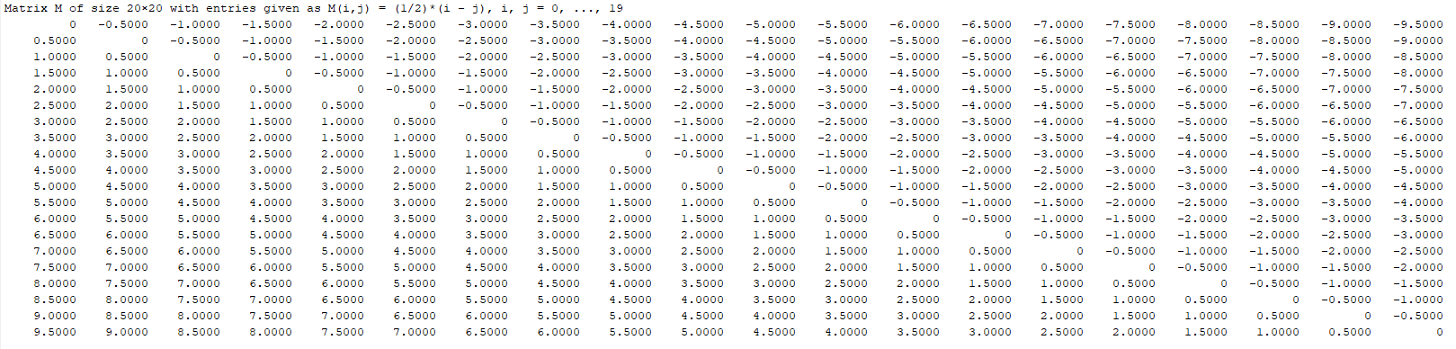**Matrix M of size 20 x 20.**

1. **Testing function Code 1:**

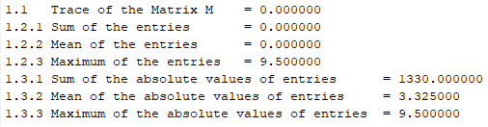

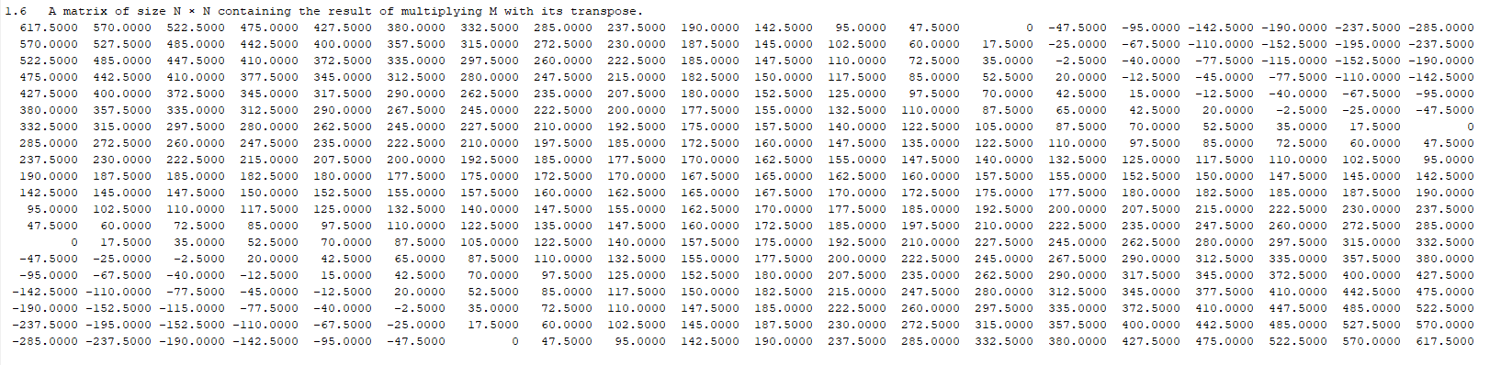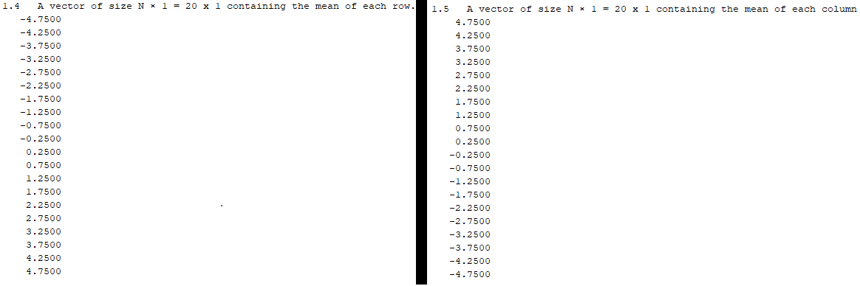**M * M transpose**

**Result Comparison:**



**Comparing Results of Calculation when solved without using built in functions & by using built in functions**

* 1. Calculation of Trace without using built-in function Matched exactly with calculation Trace by using built-in function
  2. Calculation of Sum, Mean & Maximum of all the entries without using built-in function Matched exactly with calculation Sum, Mean & Maximum of all the entries by using built-in function
  3. Calculation of Sum, Mean & Maximum of all the absolute values of entries without using built-in function Matched exactly with calculation Sum, Mean & Maximum of all the absolute values of entries by using built-in function
  4. Calculation of Row mean without using built-in function Matched exactly with calculation Row mean by using built-in function
  5. Calculation of Column mean without using built-in function Matched exactly with calculation Column mean by using built-in function
  6. Calculation of M * M transpose without using built-in function Matched exactly with calculation M * M transpose by using built-in function

1. **Testing Function code 2:**

N = 20, a = 0

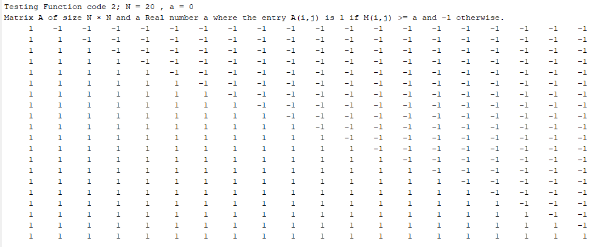

1. **Sorting real number array into ascending order form.**

vector with combination of all real number types = [3, 6, 4, 9, 1/2, 0, 0.9, -5]

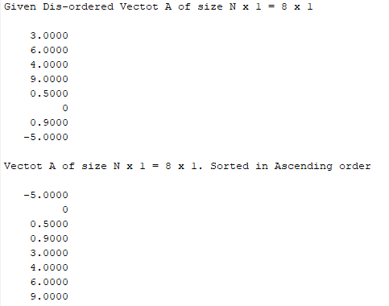

1. **Computing Prime numbers up to a given maximal number using the iterative algorithm called sieve of Eratosthenes.**

Maximal number = 100

* Sieve of Eratosthenes iterative algorithm to find Prime Numbers
* It took 74 iterations to calculate all the Prime Numbers less than equal to 100
* There are total of 25 Prime numbers less than 100, they are:
* 2 3 5 7 11 13 17 19 23 29 31 37 41 43 47 53 59 61 67 71 73 79 83 89 97