AI Assisted Coding

Assignment (5.4)

2403A51290(T.Manikanta)

Batch-12(CSE)

Description 1:

* Prompt GitHub Copilot to generate a Python script that collects user data (e.g., name, age, email). Then, ask Copilot to add comments on how to anonymize or protect this data.

Expected Output #1:

* A script with inline Copilot-suggested code and comments explaining how to safeguard or

anonymize user information (e.g., hashing emails, not storing data unencrypted)

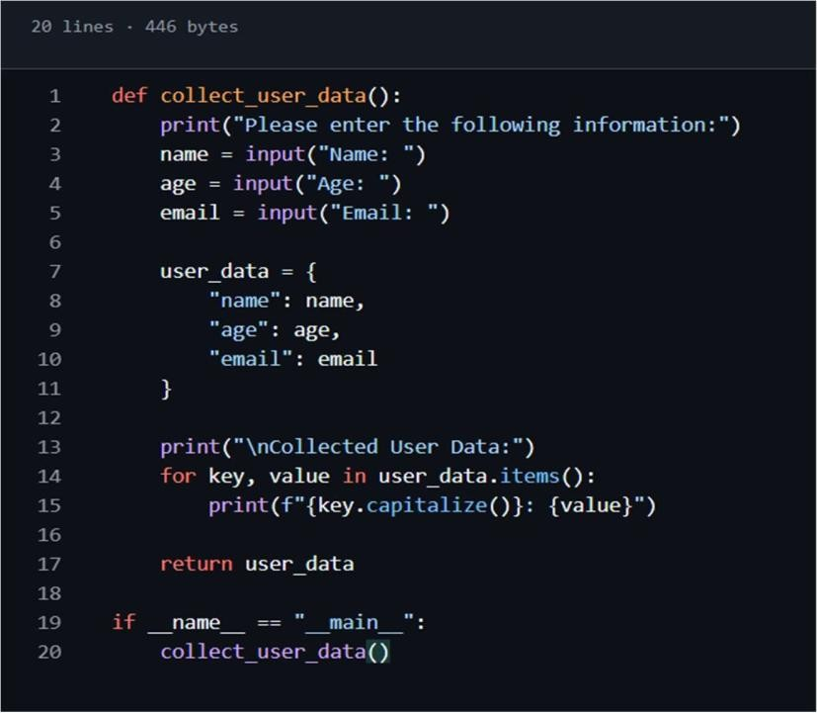

Copilot code with comments on how to nonymize or protect this data.:

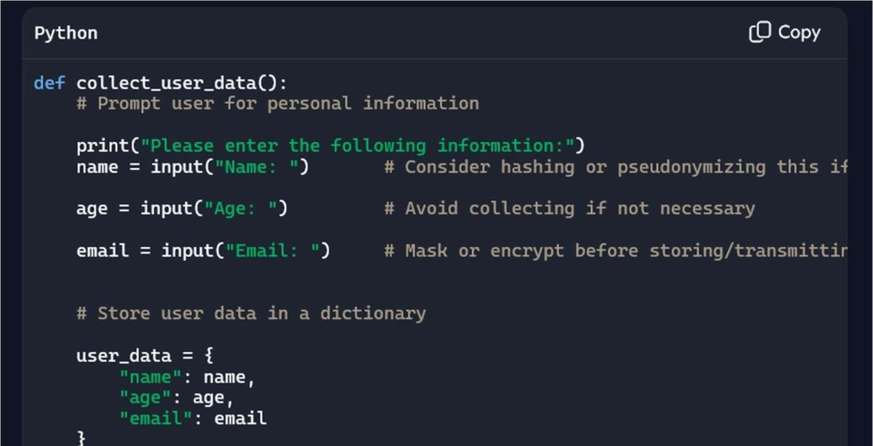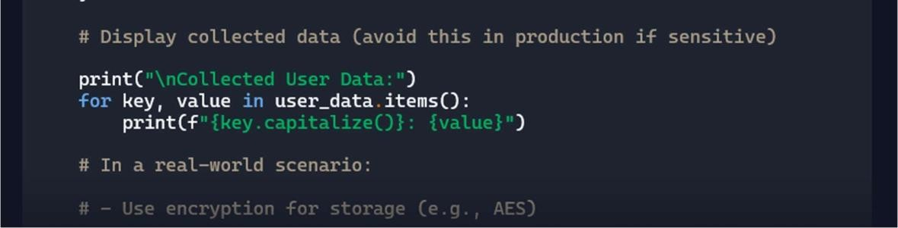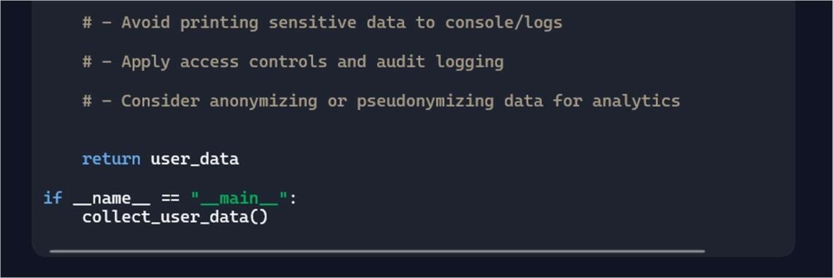

Task Description 0-2:

* Ask Copilot to generate a Python function for sentiment analysis. Then prompt Copilot to

identify and handle potential biases in the data––

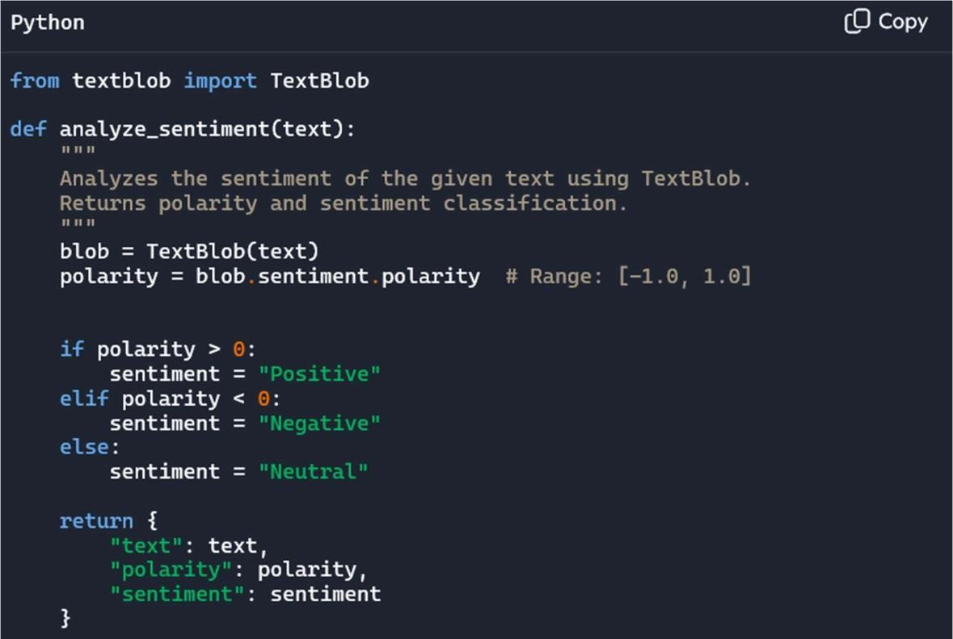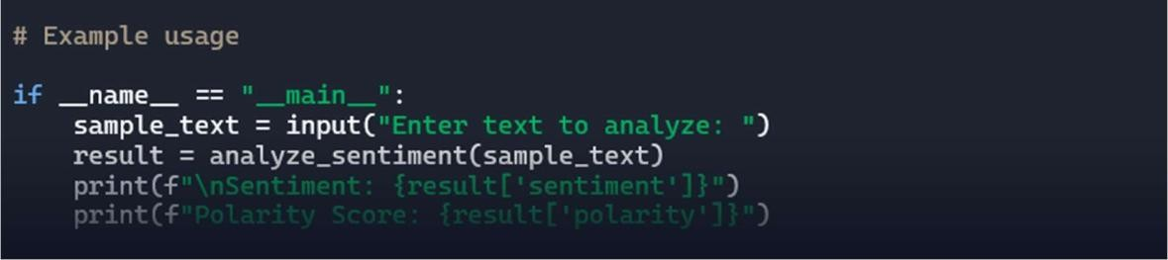

identify and handle potential biases in the data :

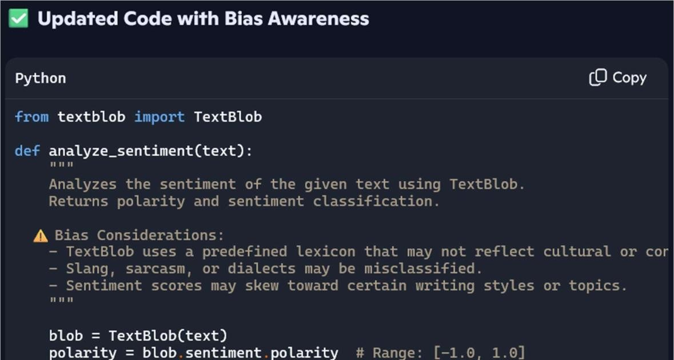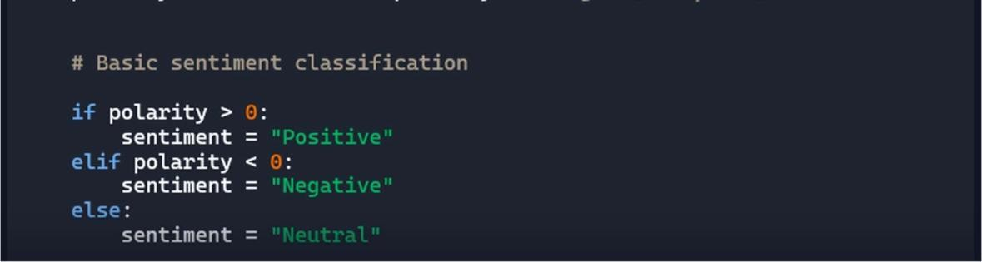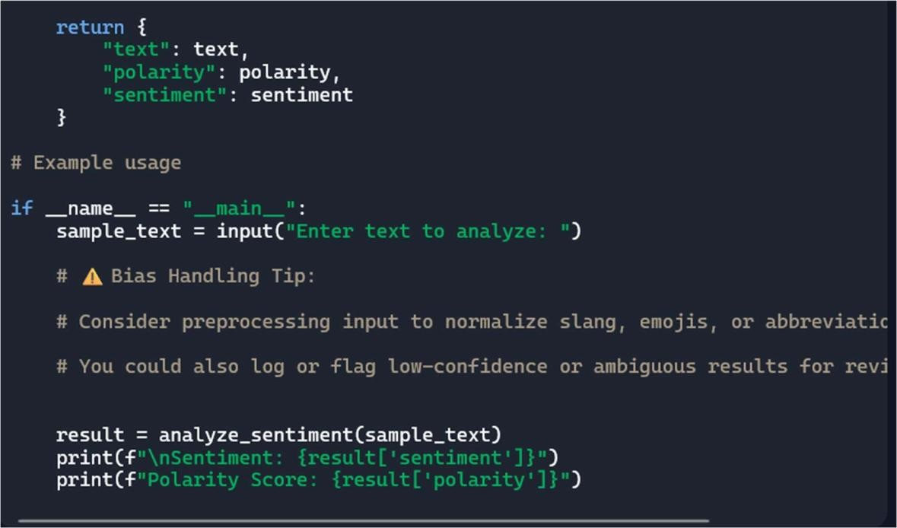

Task Description 3:

* Use Copilot to write a Python program that recommends products based on user history. Ask it to follow ethical guidelines like transparency and fairness.

Expected Output #3:

* Copilot suggestions that include explanations, fairness checks (e.g., avoiding favoritism), and user feedback options in the code

Copilot Code:

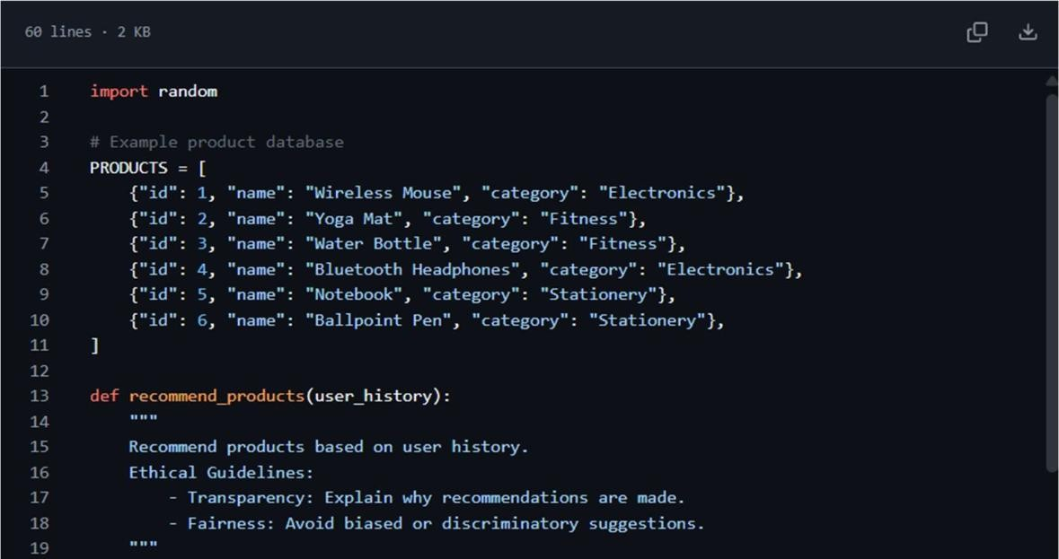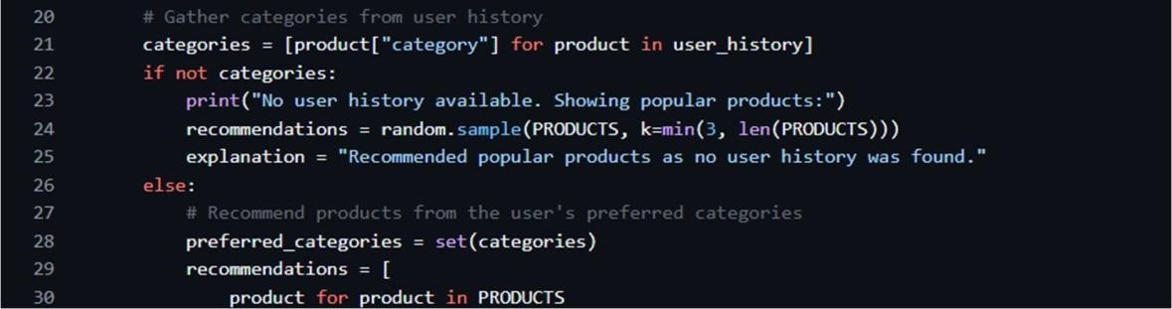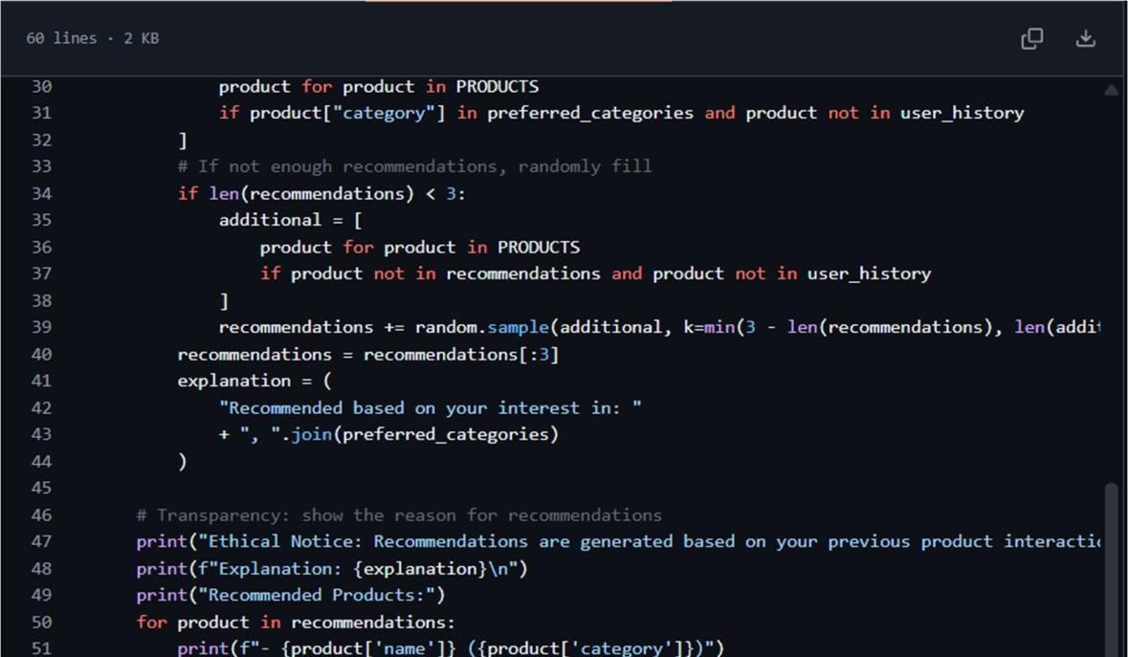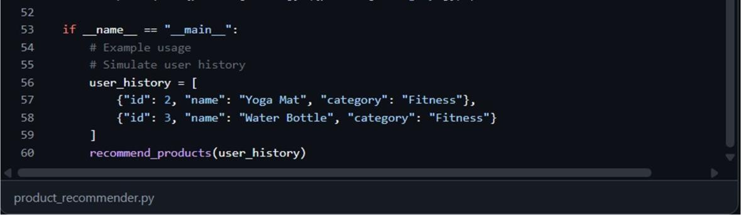

Task Description 4:

* Prompt Copilot to generate logging functionality in a Python web application.

Then, ask it to ensure the logs do not record sensitive information.

Expected Output #4:

* Logging code that avoids saving personal identifiers (e.g., passwords, emails), and includes comments about ethical logging practices Copilot Code:

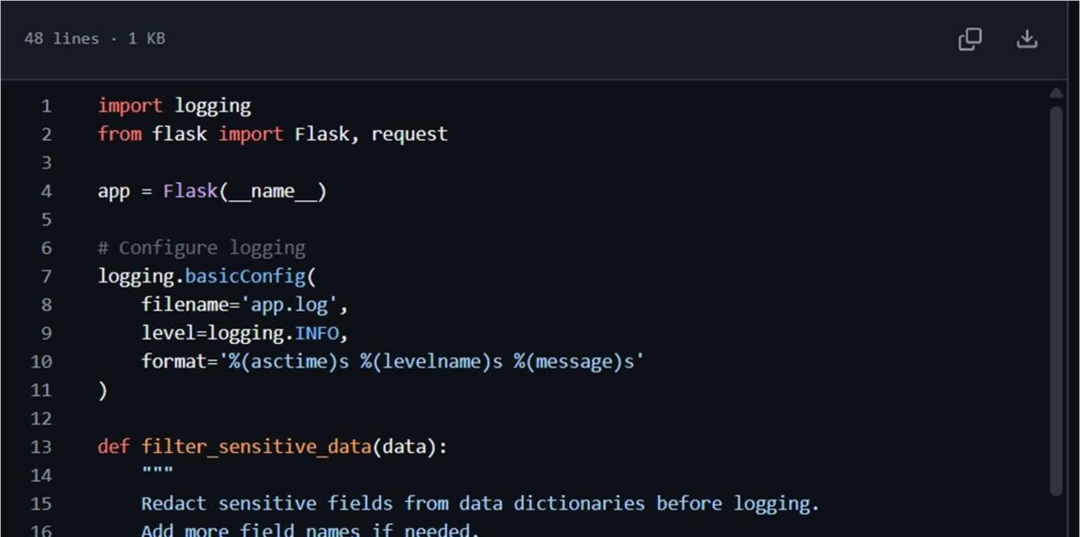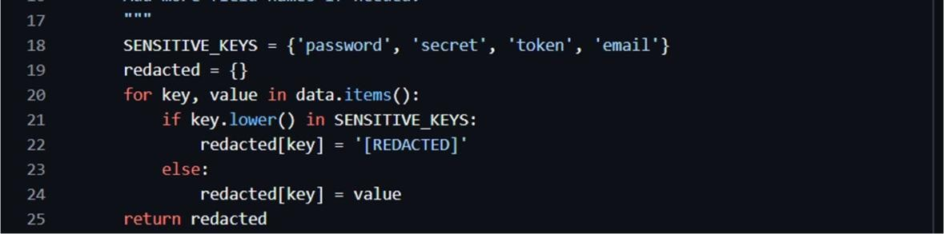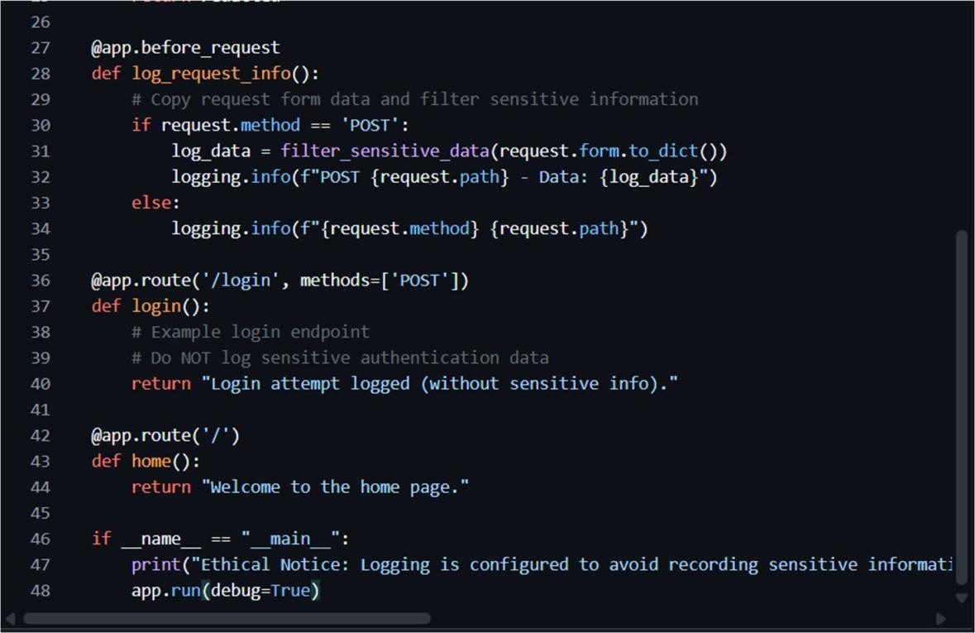

Task Description 5:

* Ask Copilot to generate a machine learning model. Then, prompt it to add documentation on how to use the model responsibly (e.g., explainability, accuracy limits).

Expected Output #5:

* Copilot-generated model code with a README or inline documentation suggesting responsible usage, limitations, and fairness considerations Copilot Code:

