**Experiment 1**

Valiveti Manikanta Bhuvanesh

19BCD7088

AIM: Visualizing data using R with different type of graphs and charts

**1.Pie Chart**

**Code:**

slices <-c(10, 12,4, 16, 8)

Ibls <-c("US", "UK", "Australia", "Germany", "France")

pie(slices, labels = Ibls, main="Pie Chart of Countries",col=rainbow(slices))

dev.off

**Output:**

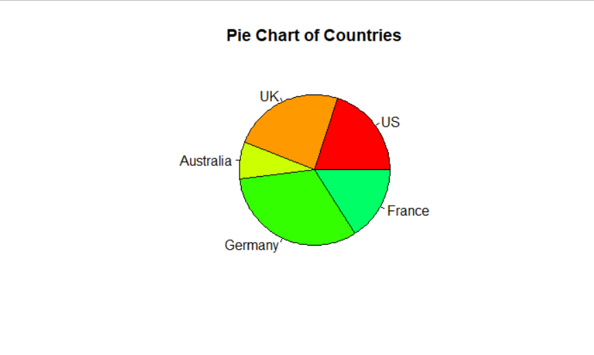

**Code:**

slices <-c(10, 12, 4, 16, 8)

Ibls <-c("US", "UK", "Australia", "Germany", "France")

pct <-round(slices/sum(slices)*100)

Ibls <- paste(Ibls, pct)

Ibls <- paste(Ibls, "%" ,sep="")

pie(slices, labels=Ibls, col=rainbow(length(Ibls)), main="Pie Chart of Countries")

**Output:**

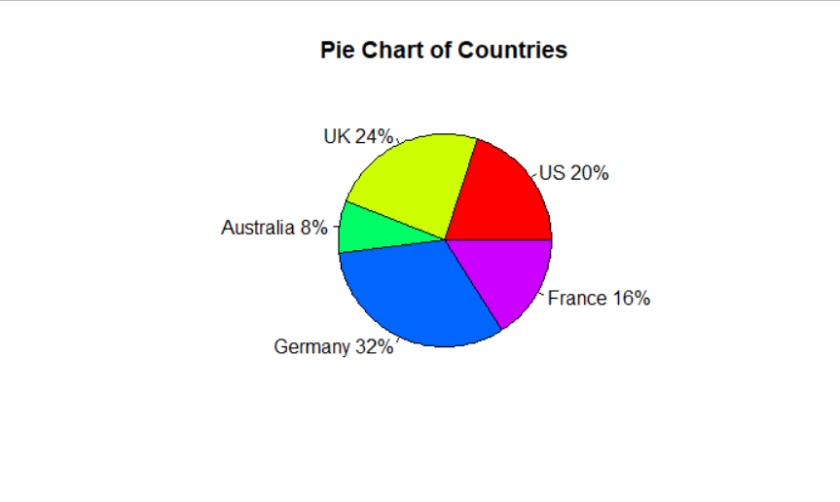

**Code:**

time <-c(3,4,5,1,2,8)

activity <-c("Moring activities", "Lab", "Classes", "Playing","Eating", "Sleeping")

pct <-round(time/sum(time)*100)

activity <- paste(activity, pct)

activity <- paste(activity, "%" ,sep="")

pie(time, labels=activity, col=rainbow(length(activity)), main="Pie Chart of Daily activities")

**Output:**

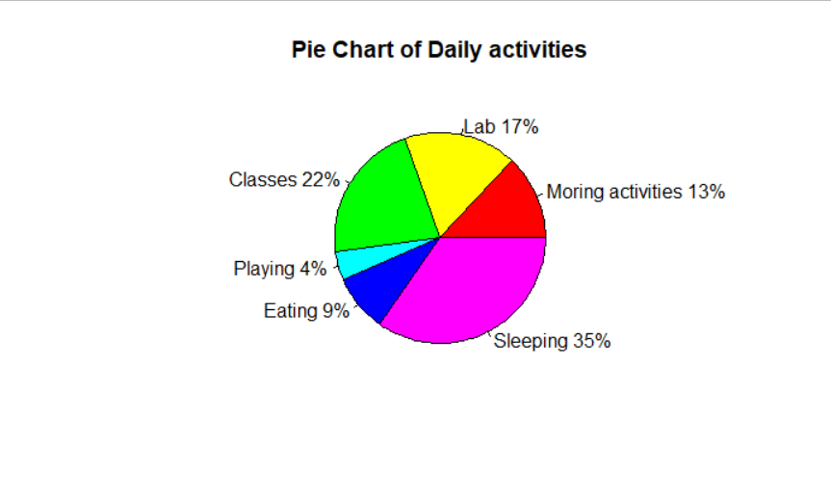

**2.Scatter Plot**

**Code:**

x <-mtcars$wt

y<-mtcars$mpg

plot(x, y, main = "Main title", xlab = "X axis title", ylab="Y axis title",pch=19, frame = FALSE)

abline(lm(y~x,data=mtcars), col="blue")

**Output:**

