19BCD7088

1. **Write a program to demonstrate the chess Board 8 X 8**

**Code:**

**int r,c;**

**int x=400;**

**int y=400;**

**int dx = 400/8;**

**void setup(){**

**size(400,400);**

**}**

**void draw(){**

**for(r=0;r<8;r++){**

**for(c=0;c<8;c++){**

**if((c+r) % 2 == 0){**

**fill(0);**

**}**

**else{**

**fill(255);**

**}**

**rect(r*dx,c*dx,dx,dx);**

**}**

**}**

**}**

**Output:**

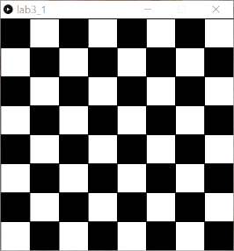

1. **Draw the circle. Set the attributes like style,type,width etc.**

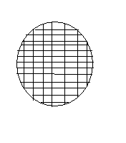

Code:

function setup() {

createCanvas(600,400);

}

function draw() {

var inv = createInput('');

inv.attribute('value','circle');

inv.position(60,80);

inv.style('width','70px');

fill(0);

circle(200,200,150,150);

}

Output:

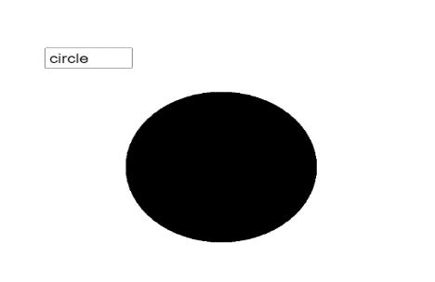

**Draw the ellipse. Set the attributes like fillcolour,fillstyle,linecolour,linewidth**

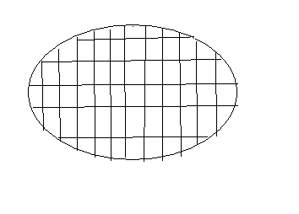

Code:

function setup() {

createCanvas(600,400);

}

function draw() {

var inv = createInput('');

inv.attribute('value','ellipse');

inv.position(50,60);

inv.style('width','70px');

fill('yellow');

stroke('black');

ellipse(200,200,300,150);

}

Output:

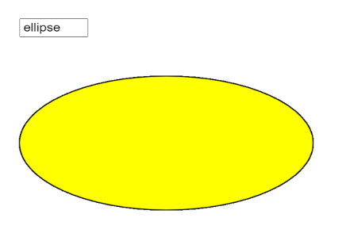

1. Write a program to demonstrate the different stages of moon.

Code:

void setup(){

size(800, 300);

background(0);

}

void draw(){

float k = 0;

for(int i = 50; i < 500; i=i+(500/5)){

pushMatrix();

fill(255);

translate(i, height/2);

rotate(-PI/2);

arc(0, 0, 50, 50, 0, PI*4);

fill(0);

k=k+5;

arc(k, k, 50, 50, 0, PI*4);

popMatrix();

}

fill(255);

translate(550, height/2);

rotate(-PI/2);

arc(0, 0, 50, 50, 0, PI*4);

}

Output:

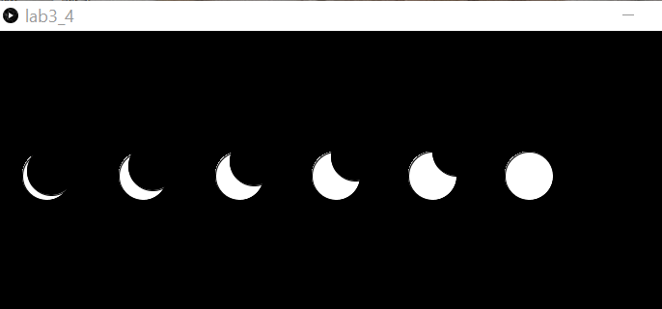

1. **Write a program to demonstrate the traffic light.**

**int p = 0;**

**void setup() {**

**size(400,400);**

**frameRate(1);**

**}**

**void draw() {**

**background(255);**

**fill(0);**

**rect(140, 70, 110, 250);**

**if(p==0){**

**fill(255,0,0);**

**ellipse(195, 120, 50, 50);**

**fill(128,128,128);**

**ellipse(195, 200, 50, 50);**

**fill(128,128,128);**

**ellipse(195, 280, 50, 50);**

**p++;**

**}**

**else if(p==1){**

**fill(128,128,128);**

**ellipse(195, 120, 50, 50);**

**fill(255,255,0);**

**ellipse(195, 200, 50, 50);**

**fill(128,128,128);**

**ellipse(195, 280, 50, 50);**

**p++;**

**}**

**else{**

**fill(128,128,128);**

**ellipse(195, 120, 50, 50);**

**fill(128,128,128);**

**ellipse(195, 200, 50, 50);**

**fill(0,255,0);**

**ellipse(195, 280, 50, 50);**

**p=0;**

**}**

**}**

**Output:**

