V.Manikanta Bhuvanesh

19BCD7088

Lab 1

1. **Basic commands.**

1+2

2*3

6/3

a=1

b=4

a+b

a-b

a*b

a/b

search()

a=readline("Enter a number")

ls()

getwd()

list.files()



# Create vector of numeric, complex, logical and character types of any length.

a=c(1,2,3,4,5,6)

a

b=c(1+3i,2+4i,5+8i,8+7i)

b

d=c("T","F","F","T","F","T","T")

d

o=c('a','b','c','d')

o

f=c(1,3,5,3+4i,"T",'a')

f

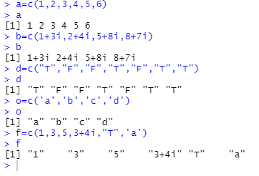

1. **Create vector a and b and both of them and store it in a.**

a=c(1,5,3,87,3,8)

b=c(4,8,6,5,9,3,9,4)

a=c(a,b)

a

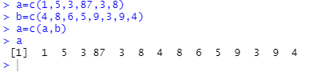

1. **Create a vector a that includes null values. Find mean, product and sum.**

a=c(1,4,6,7,2,NA,28,NA,NA,7)

mean(a, na.rm=TRUE)

sum(a, na.rm=TRUE)

prod(a, na.rm=TRUE)

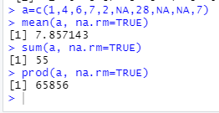

1. **Create a vector of size 10. Find highest and lowest value in the vector.**

g=c(23,1,3,54,56,86,23,45,67,87)

max(g)

min(g)

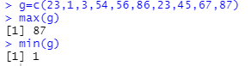

1. **Find second highest element in a vector.**

sort(g,TRUE)[2]



1. **Using Interest function on three vectors.**

a=c(500,465,700,478,892,446)

w=(0.8*5)/100

p=a*w

p

1. **Duplicated and unique elements in a vector.**

t=c(2,2,4,5,7,4,8,4)

unique(t)

t[duplicated(t)]

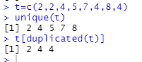

1. **Create vectors a, b, c. Convert these into 3*3 matrix.**

a=c(1,2,3)

b=c(4,5,6)

c=c(7,8,9)

p=cbind(a,b,c)

p

