**VIT-AP UNIVERSITY, ANDHRA PRADESH**

**CSE2047 – Data Analytics - Lab Sheet : 3**

**Academic year:** 2020-2021  **Branch/ Class:** B.Tech/M.Tech

**Semester:** Fall  **Date:**

**Faculty Name:** Prof. S.Gopikrishnan  **School:** SCOPE

**Student name:** Valiveti Manikanta Bhuvanesh **Reg. no.:** 19BCD7088

**LAB 3**

**Questions:**

1. **Find out mean of all columns of BMI dataset using for loop.**

df<-read.csv("bmi_data.csv")

df

sum =0

count=0

for (i in df$Age) {

sum = sum+i

count=count+1

}

sum/count

sum =0

count=0

for (i in na.omit(df$Height)) {

sum = sum+i

count=count+1

}

sum/count

sum =0

count=0

for (i in na.omit(df$Weight)) {

sum = sum+i

count=count+1

}

sum/count

sum =0

count=0

for (i in na.omit(df$BMI)) {

sum = sum+i

count=count+1

}

sum/count

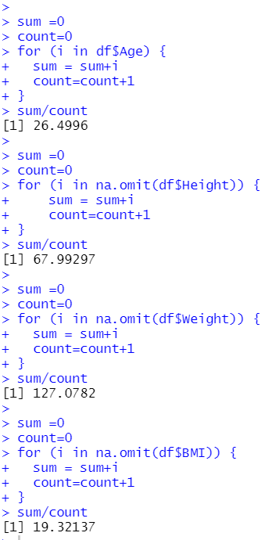

1. **Create two vectors - height and weight of 20 students and convert it to a matrix**

height = c(23,34,54,34,67,98,56,76,23,56,87,56,45,34,32,54,76,98,89,90)

weight = c(23,54,65,76,87,78,56,45,34,23,24,35,36,67,56,87,56,47,76,73)

m=cbind(height,weight)

m

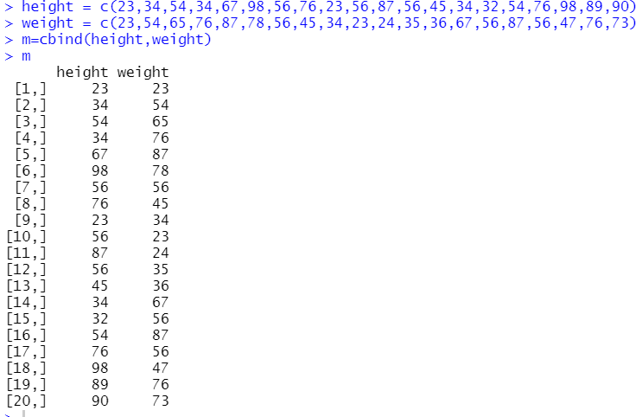

1. **Convert matrix into data frame and find the weight of 12th student**

df1= as.data.frame(m)

df1

df1$weight[12]

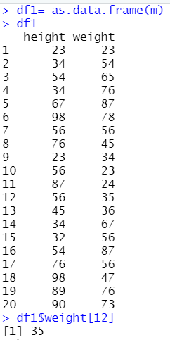

1. **Categorize high and low based on bmi factor using if condition**

v=c(1:dim(df)[1])

v

for (i in v) {

if(!is.na(df$BMI[i])){

if(df$BMI[i]>=19){

df$bmifactor[i]="High"

}

else if(df$BMI[i]< 19){

df$bmifactor[i]="Low"

}

else{

df$bmifactor[i]="NA"

}

}

}

print(df)

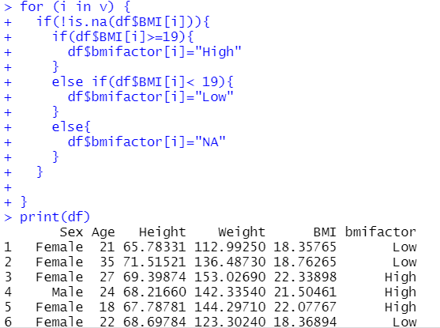

1. **Using switch case categorize into  
    Category  
    BMI range - weight/height  
    Severe Thinness < 16  
    Moderate Thinness 16 - 17  
    Mild Thinness 17 - 18.5  
    Normal 18.5 - 25  
    Overweight 25 - 30  
    Obese Class I 30 - 35  
    Obese Class II 35 - 40  
    Obese Class III > 40**

flag=0

for (i in v) {

n=df$BMI[i]

if(!is.na(n)){

if((n<16)){

flag=1

}

else if(n>=16 & n<17){

flag=2

}

else if(n>=17 & n<18.5){

flag=3

}

else if(n>=18.5 & n<25){

flag=4

}

else if(n>=25 & n<30){

flag=5

}

else if(n>=30 & n<35){

flag=6

}

else if(n>=35 & n<40){

flag=7

}

else{

flag=8

}

x<- switch (flag,

"Severe Thinness",

"Moderate Thinness",

"Mild Thinness",

"Normal",

"Overweight",

"Obese Class I",

"Obese Class II",

"Obese Class III"

)

}

df$bmifactor1[i]=x

}

print(df)

