**VIT-AP UNIVERSITY, ANDHRA PRADESH**

**CSE2047 – Data Analytics - Lab Sheet : 5**

**Academic year:** 2020-2021  **Branch/ Class:** B.Tech/M.Tech

**Semester:** Fall  **Date:**

**Faculty Name:** Prof. S.Gopikrishnan  **School:** SCOPE

**Student name:** Valiveti Manikanta bhuvanesh **Reg. no.: 19BCD7088**

**LAB 5**

Questions:

1. Use a nested for loop (a for loop inside a for loop) that produces the following matrix, pre-allocate the matrix with NA values.

0 1 2 3 4

1 0 1 2 3

2 1 0 1 2

3 2 1 0 1

4 3 2 1 0

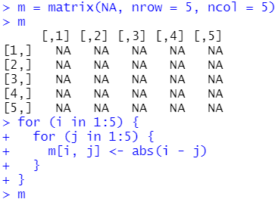

1. Using the following variable:

x=100

y=50

i=1

For this exercise, write a repeat () loop that incrementing i computes x=x-i and y=y+i until x<y.

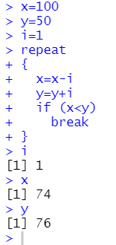

1. Find out the river length less than 400, if so, identify it as short river. count the number of short rivers. if the river length is > 800, then it is long. count the number of long rivers. (Use revier dataset)

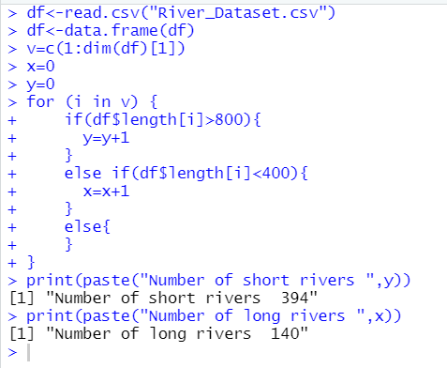

1. Using an if -else find out the long living animal based on lifespan. (Use animal dataset)
2. Count how many males are in underweight and overweight. you need to measure with ounce. 1 ounce=28.34 gm. (Use BMI Dataset)

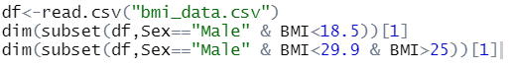

1. create a dummy dataset with numeric values. a) write a function for calculating the mean. b) Write a function to compute standard deviation.

