**VIT-AP UNIVERSITY, ANDHRA PRADESH**

**CSE2047 – Data Analytics - Lab Sheet : 7**

**Academic year:** 2020-2021  **Branch/ Class:** B.Tech/M.Tech

**Semester:** Fall  **Date:**

**Faculty Name:** Prof. S.Gopikrishnan  **School:** SCOPE

**Student name:** Valiveti Manikanta bhuvanesh **Reg. no.: 19BCD7088**

**LAB 7**

**Use Iris dataset to show visual exploratory data Analysis in R**

**Part-1 (Ref:** [**https://www.guru99.com/r-scatter-plot-ggplot2.html**](https://www.guru99.com/r-scatter-plot-ggplot2.html) **)**

1. **Draw Basic scatter plot between SepalLengthCm and SepalWidthCm.**

df<-iris

ggplot(df, aes(x = Sepal.Length, y = Sepal.Width)) + geom_point()

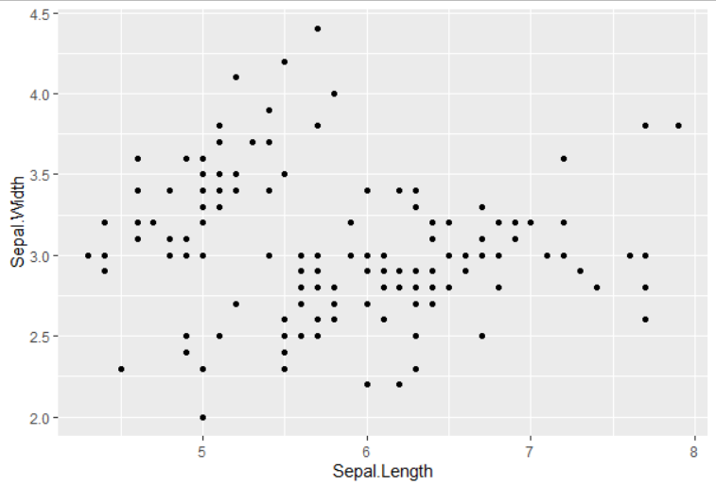

1. **Visualize Scatter plot with color between group SepalLengthCm and SepalWidthCm and group by Species.**

ggplot(df, aes(x = Sepal.Length, y = Sepal.Width)) + geom_point(aes(color = factor(Species)))

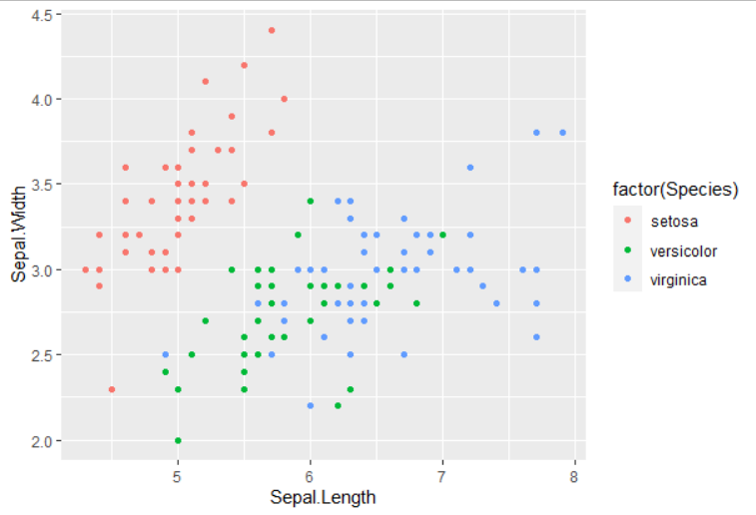

1. **Visualize Scatter plot with added fitted values between PetalLengthCm and PetalWidthCm and use Linear regression for fitted line.**

mygraph<-ggplot(df, aes(x = Petal.Length, y = Petal.Width)) + geom_point(aes(color = factor(Species))) + stat_smooth(method = "lm",col = "#0000FF",se = FALSE,size = 2)

mygraph

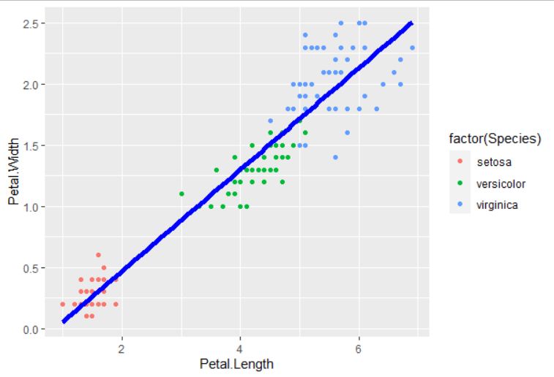

1. **Add the following information to the above drawn graph**
   1. **Add a title as “Iris visualization on Petal”**
   2. **Rename x-axis as “Petal Length in Cm” and y-axis as “Petal Width in Cm”**

mygraph + labs(title = "Iris visualization on Petal",x="Petal Length in Cm",y="Petal Width in Cm"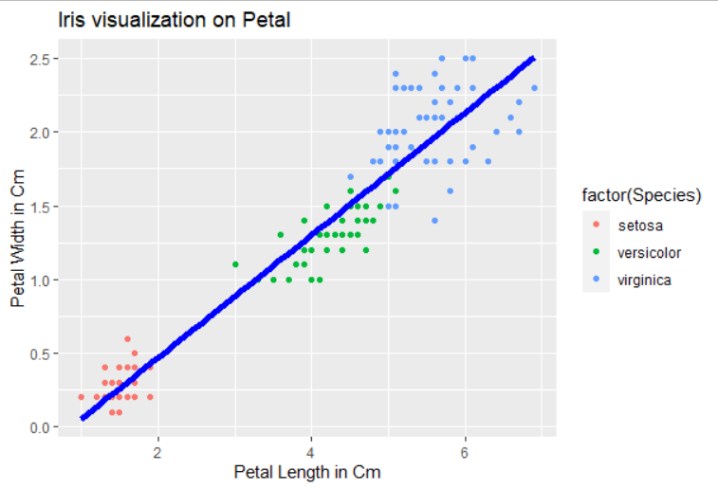

**Part-2 (Ref:** [**https://www.guru99.com/r-boxplot-tutorial.html**](https://www.guru99.com/r-boxplot-tutorial.html) **)**

1. **Visualize the Basic box plot on species wise weight data**

mybox<-ggplot(df, aes(x = Sepal.Length, y = Sepal.Width))

mybox + geom_boxplot()

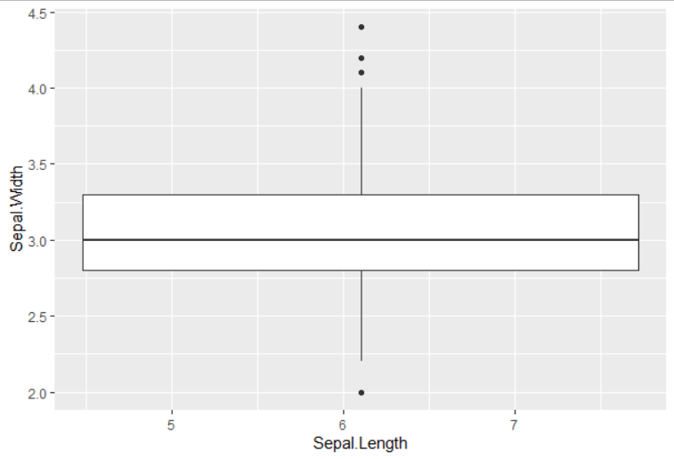

1. **Change side of the graph which you have plotted in question 1**

mybox + geom_boxplot()+ coord_flip()

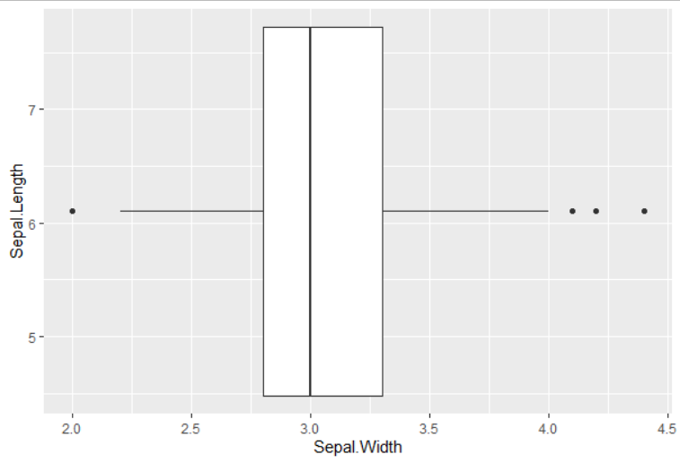

1. **Visualize the outliers of weight data in different colour**

mybox + geom_boxplot(outlier.colour = "red",outlier.shape = 4,outlier.size = 3) + theme_classic()

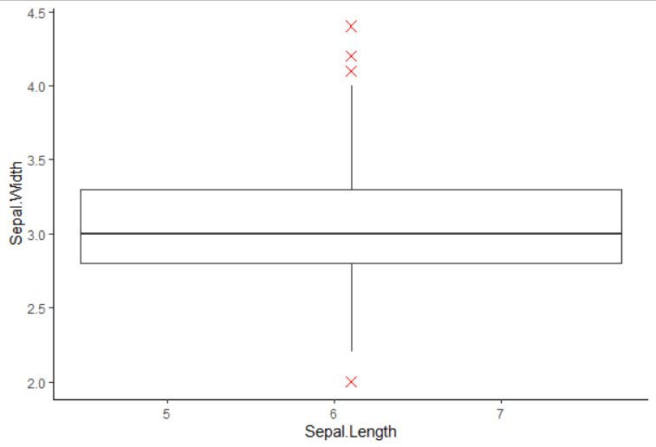

1. **Add the summary statistic on the box plot drawn in question 1.**

mybox + geom_boxplot() + stat_summary(fun.y = mean,geom = "point", size = 3,color = "red") + theme_classic()

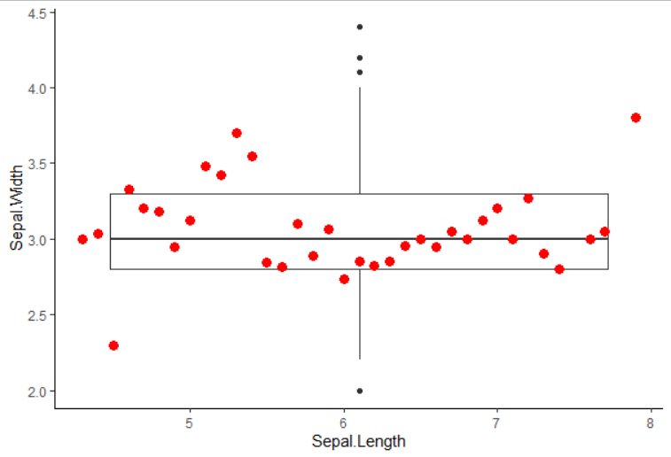

1. **Change the colour of the box based on season**

ggplot(df, aes(x = Sepal.Length, y = Sepal.Width,color=Species))+ geom_boxplot()

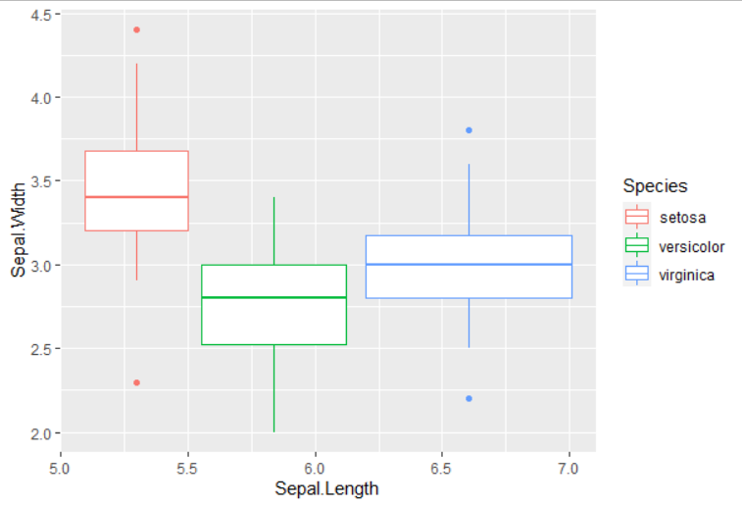

1. **Visualize the Box Plot with Jittered Dots**

mybox + geom_boxplot() + geom_jitter(shape = 15,color = "steelblue",position = position_jitter(width = 0.21)) +theme_classic()

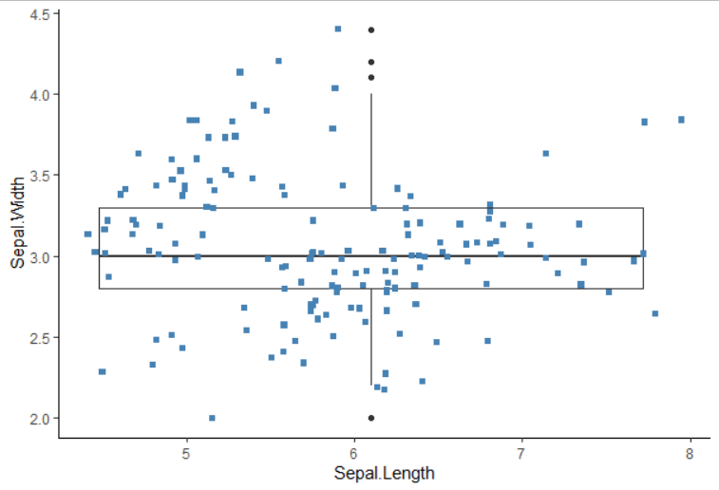

1. **Plot Notched Box Plot**

mybox + geom_boxplot(notch = TRUE) + theme_classic()

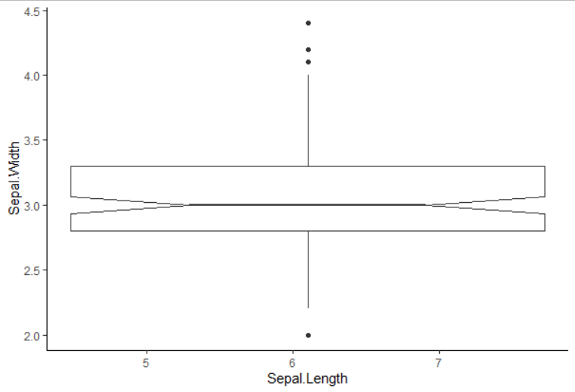

**Part-3 (Ref:** [**https://www.guru99.com/r-bar-chart-histogram.html**](https://www.guru99.com/r-bar-chart-histogram.html) **)**

1. **Show individual geom bar plot on factors of SepalLengthCm, SepalWidthCm, SepalLengthCm and SepalWidthCm**

mybar<-ggplot(df,aes(x=factor(Sepal.Length)))

mybar+geom_bar()

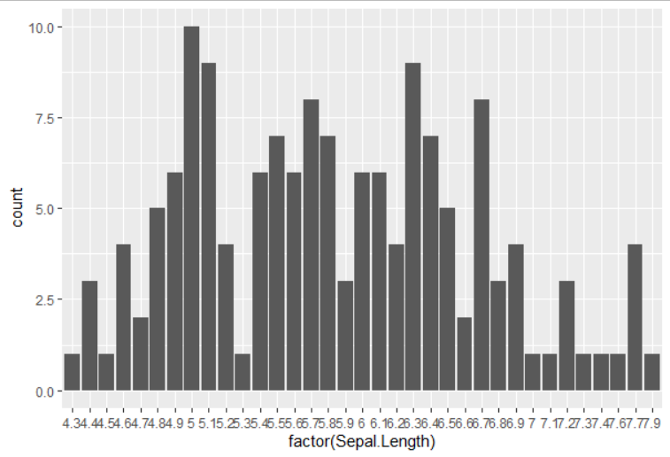

ggplot(df,aes(x=factor(Sepal.Width)))+geom_bar()

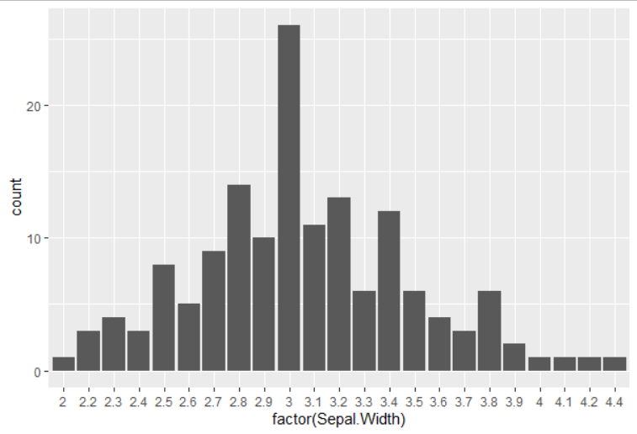

1. **Visualize the colour geom bar plot on factors of season data**

mybar + geom_bar(fill = "coral")+theme_classic()

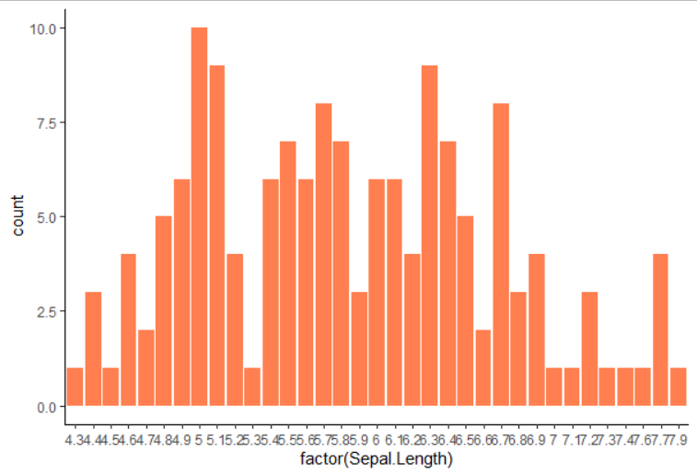

1. **Add species group in the bars which you have drawn in question 2.**

mutate(Species = factor(Species, labels = c("setosa", "versicolor","virginica")),Sepal.Width = factor(Sepal.Width))

ggplot(df, aes(x = Sepal.Width, fill = Species)) +geom_bar() +theme_classic()

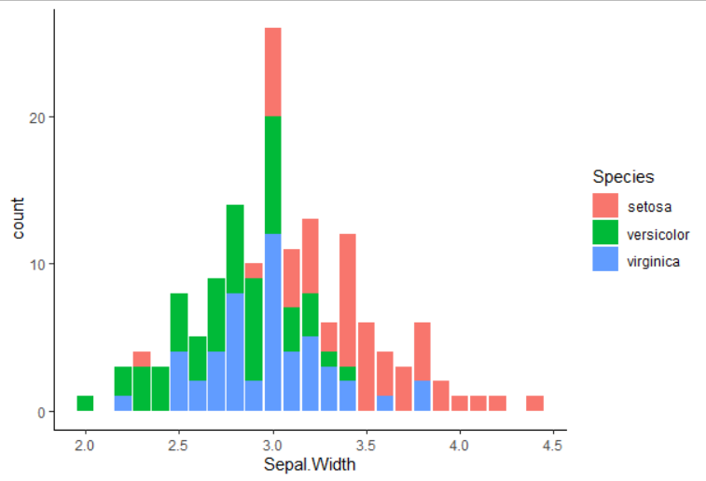

1. **Create a basic histogram with season and weight data**

mutate(Sepal.Length = factor(Sepal.Length))

group_by(Species)

ggplot(df, aes(x = Sepal.Length, y = Sepal.Width)) +geom_bar(stat = "identity")

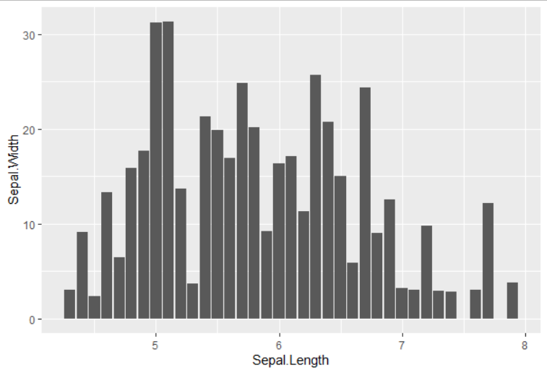

1. **Change the colour and add labels to the graph which you drawn in question 4**

ggplot(df, aes(x = Sepal.Length, y = Sepal.Width,fill=Species)) +geom_bar(stat = "identity")+geom_text(aes(label =Sepal.Width ))+theme_classic()

