Valiveti Manikanta Bhuvanesh

19BCD7088

L55+L56

1. Open Rstudio/Rconsole

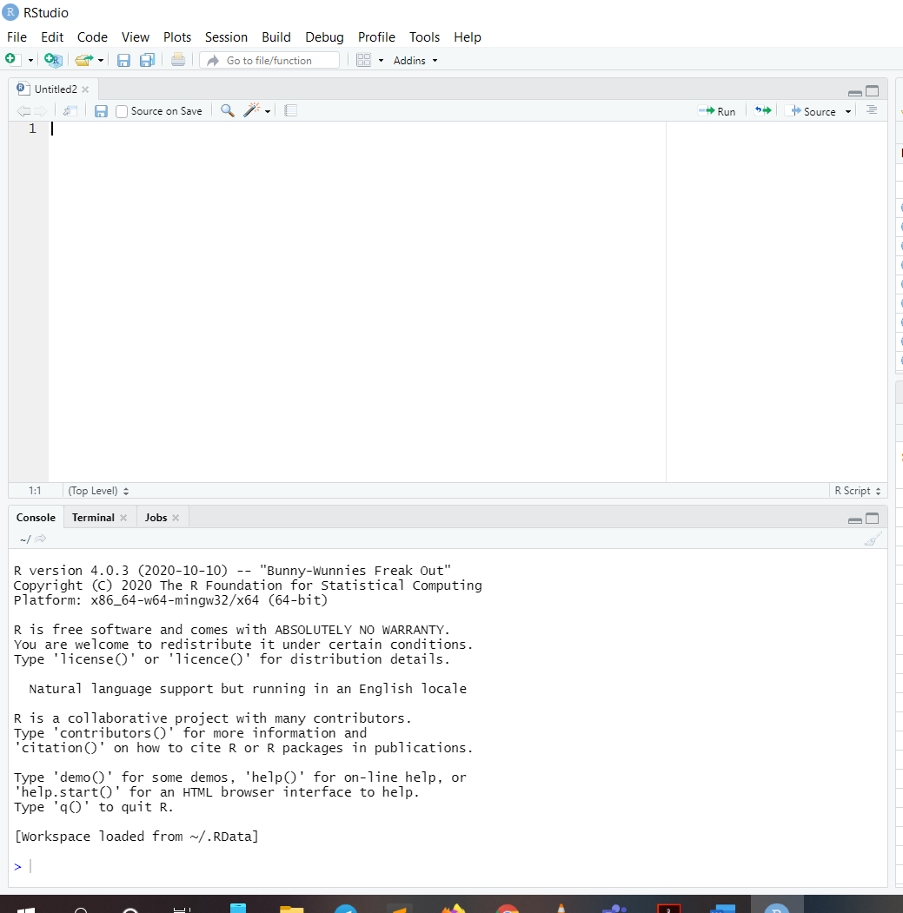

1. In console, Print the dataset mtcars

Mtcars

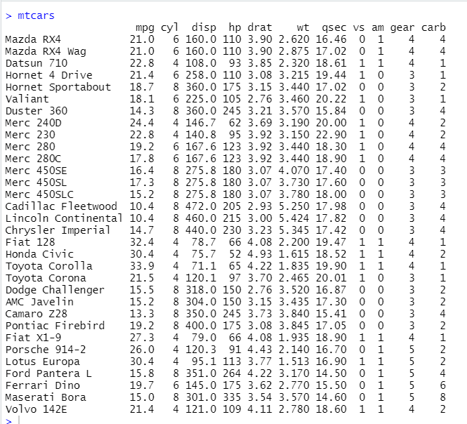

1. Print the strcture of the dataset

data(mtcars)

mtcars

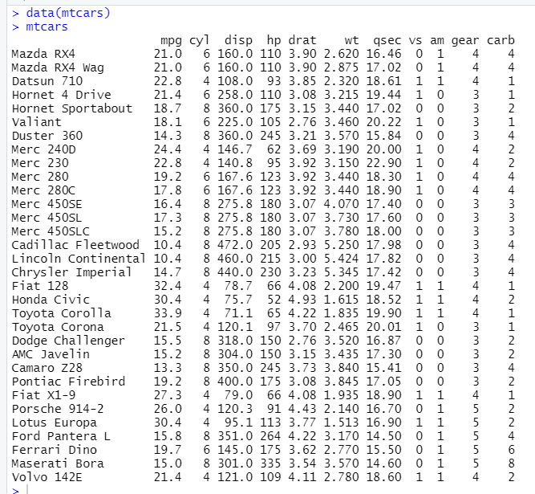

1. What is the datatype of the datset?

a<-mtcars

typeof(a)

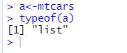

1. How many colmns and rows are there in the dataset??

nrow(mtcars)

ncol(mtcars)

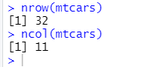

1. What information (structure summary) you will get from str() function?

str(mtcars)

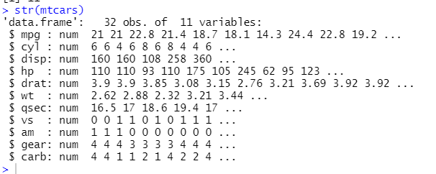

1. Print the row names

rownames(mtcars)

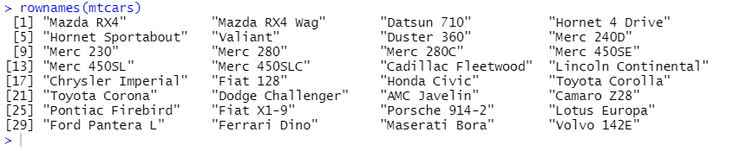

1. Print the column names

colnames(mtcars)



1. Print the number of columns in mtcars (Hint: Use function - ncol)

ncol(mtcars)



1. Print the number of rows (Hint: Use function - nrow)

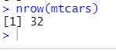

1. Print all the elements of 2nd row

mtcars[2,]

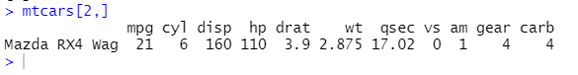

1. Print all the elements of 2nd, 5th and 13th row

mtcars[c(2,5,13),]

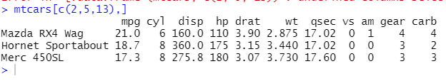

1. Print the elements of rows from 15 to 20

mtcars[15:20,]

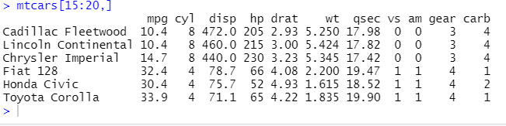

1. Print the elements of rows from 13 to 24, 28 and 30

mtcars[c(13:24,28,30),]

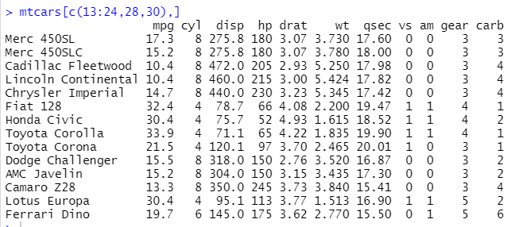

1. Print all odd indexed rows (rows 1,3,5,...) (Hint: Use function - seq)

mtcars[c(seq(1,32,2)),]

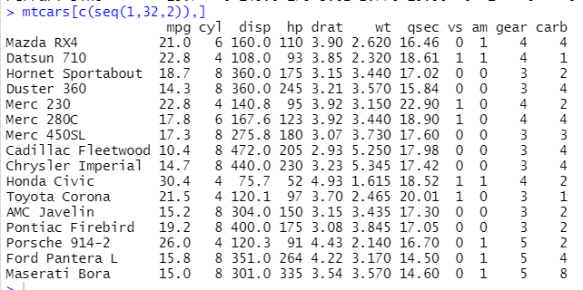

1. Print all even indexed rows (rows 2,4,6,...)

mtcars[c(seq(2,32,2)),]

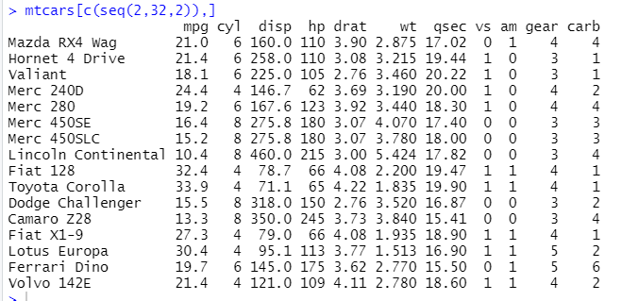

1. Print every 3rd row from 1st row (1,4,7,10..)

mtcars[c(seq(1,32,3)),]

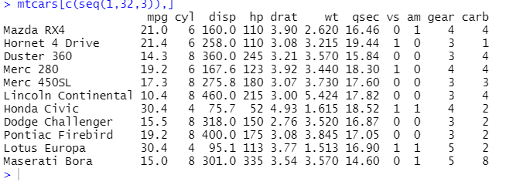

1. Print first row and last row (Hint: Use function - ncol)

mtcars[c(1,ncol(mtcars)),]

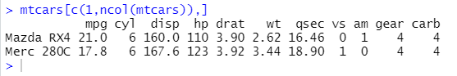

1. Print last 3 rows without using tail() function

tail(mtcars,3)

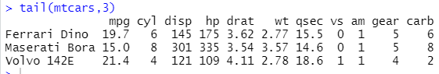

1. Print the elements of 3rd column

mtcars[,3]



1. Print the elements of column with name "wt"

mtcars[,"wt"]



1. Print the elements of columns "mpg" and "qsec"

mtcars[,c("mpg","qsec")]

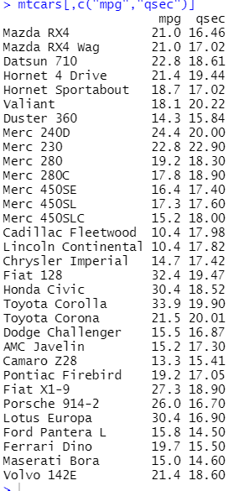

1. Print first three columns

mtcars[,c(1:3)]

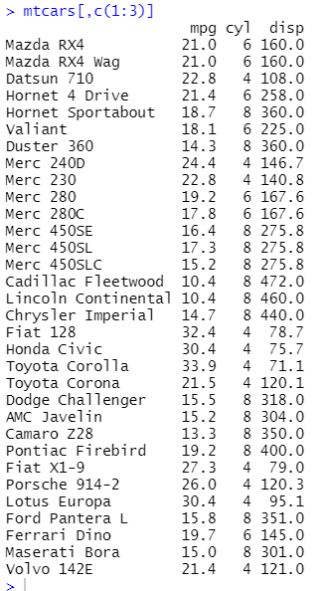

1. Print the elements of columns from 5 to 10

mtcars[,c(5:10)]

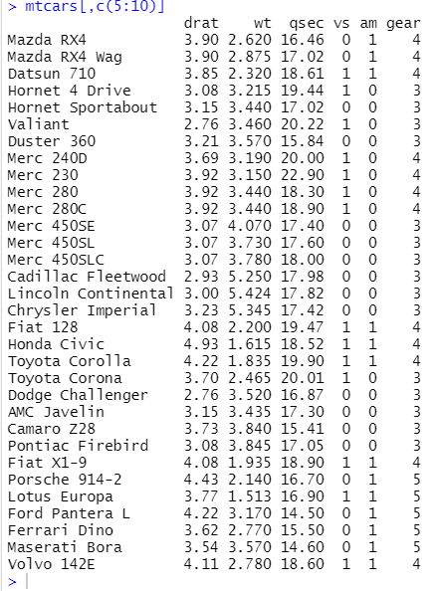

1. Print the elements of columns from 3 to 7, 9 and 11

mtcars[,c(3:7,9,11)]

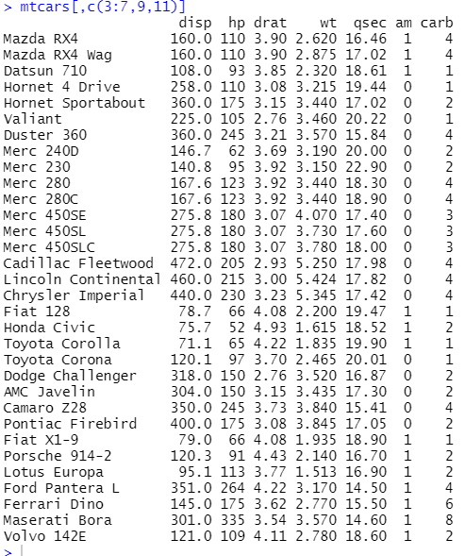

1. Print all odd indexed columns (1,3,5,...)

mtcars[,c(seq(1,11,2))]

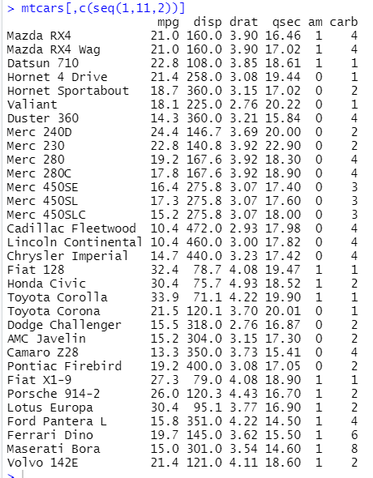

1. Print all even indexed columns (2,4,6,...)

mtcars[,c(seq(2,11,2))]

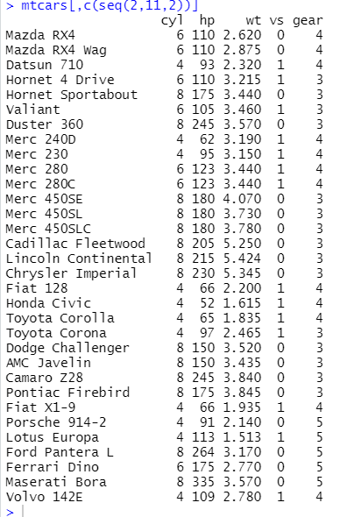

1. Print every 3rd column from 1st column (1,4,7,10..)

mtcars[,c(seq(1,11,3))]

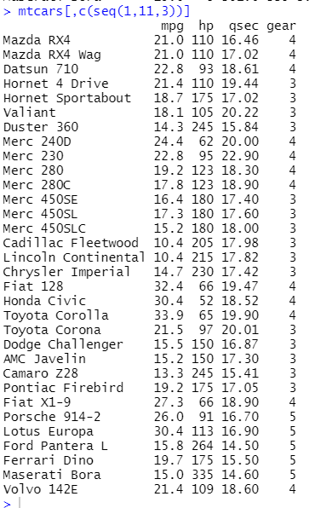

1. Print first column and last column

mtcars[,c(1,ncol(mtcars))]

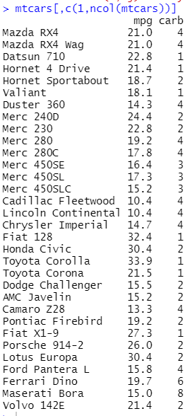

1. Print last 3 columns

mtcars[,c(9:ncol(mtcars))]

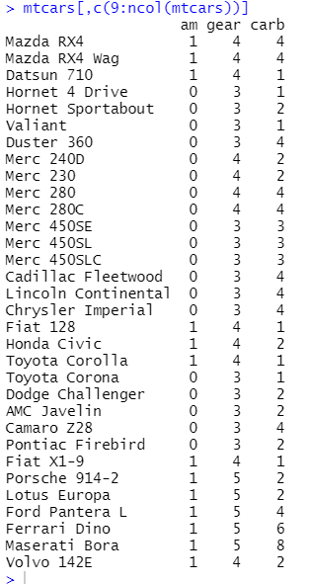

1. Print first Row and 2nd and third column

mtcars[c(1,2),3]



1. Print First, Second Row and Second and Third Column

mtcars[c(1,2),c(2,3)]

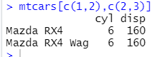

1. Print element at 2nd row, third column

mtcars[2,3]



1. Print all the rows having "mpg" value greater than 14

subset(mtcars,mpg>14)

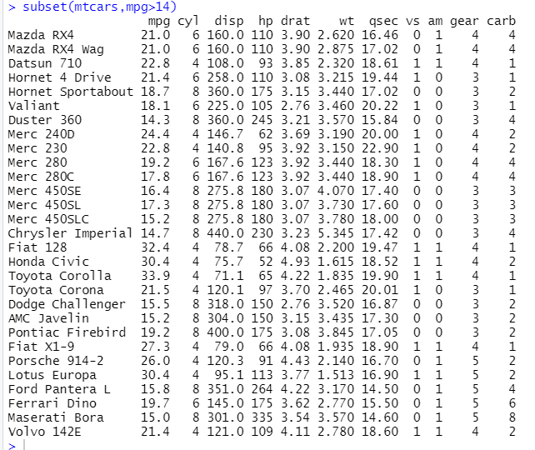

1. Print all the rows having "hp" value less than 100

subset(mtcars,hp<100)

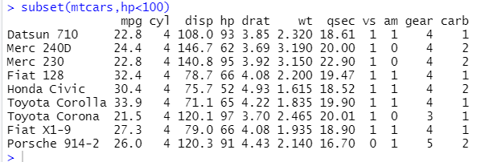

1. Print all the rows having "disp" value is between 100 and 200

subset(mtcars,disp>100&&disp<200)

