setwd("C:/Users/Bhuvanesh/Documents/R")

Valiveti Manikanta Bhuvanesh

19BCD7088

L55+L56

a=read.csv("heart_failure_clinical_records_dataset.csv")

a

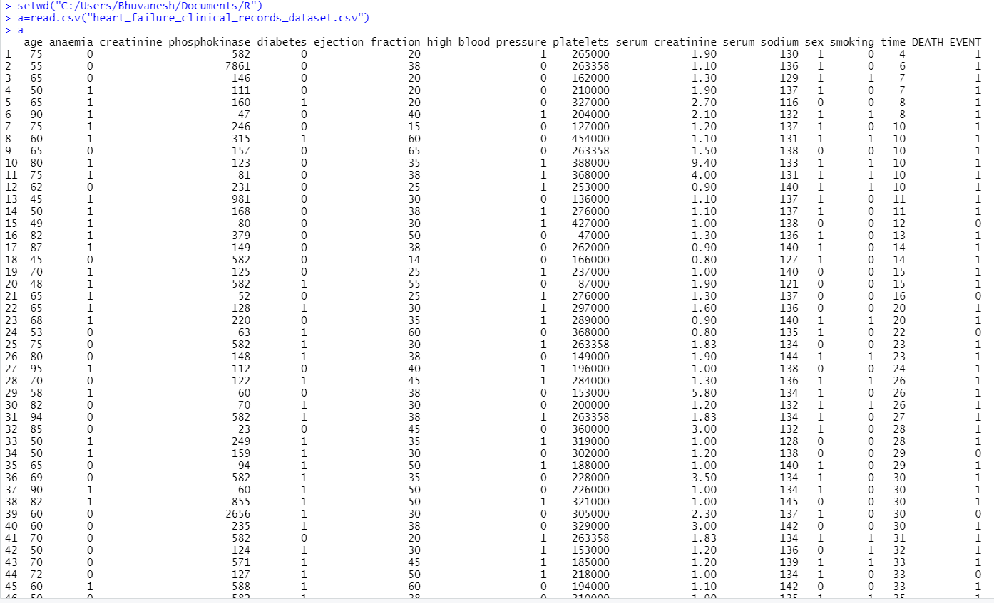

hist(a$age)

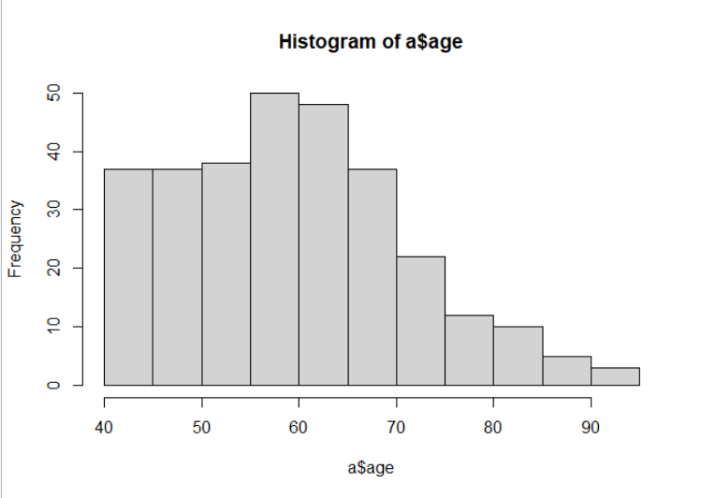

hist(a$anaemia)

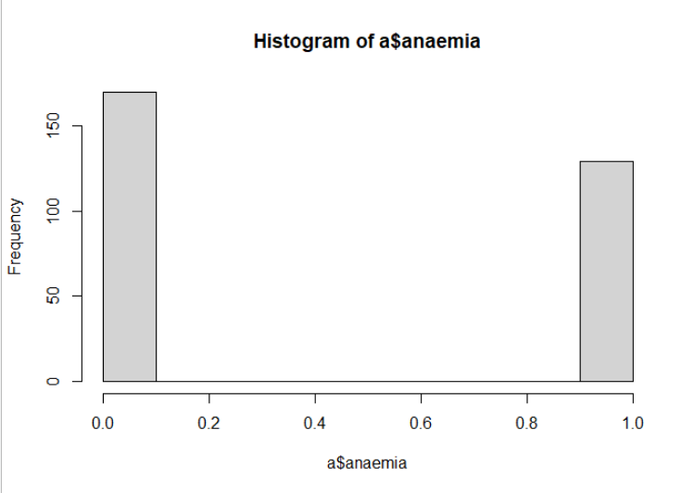

hist(a$creatinine_phosphokinase)

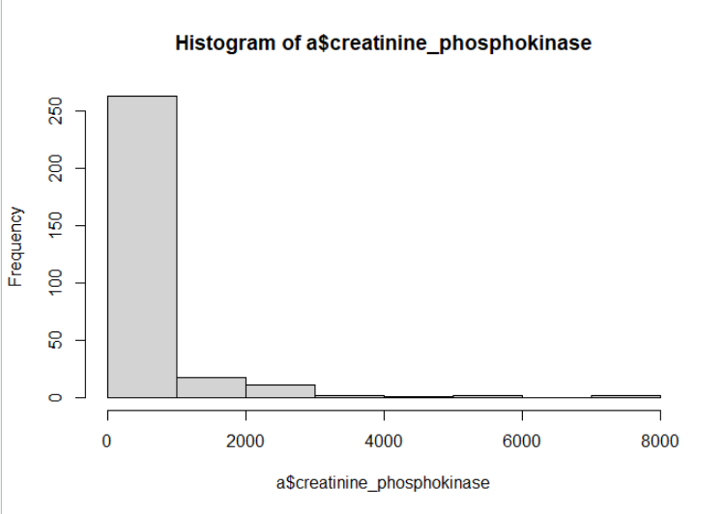

hist(a$diabetes)

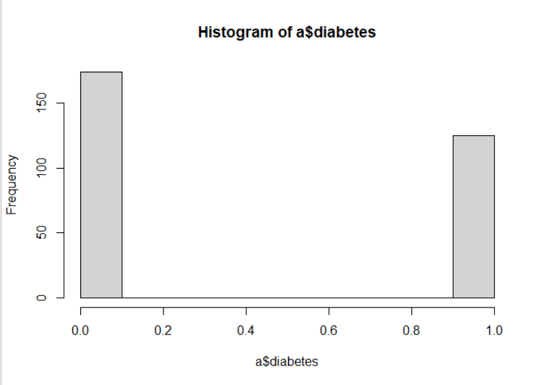

hist(a$ejection_fraction)

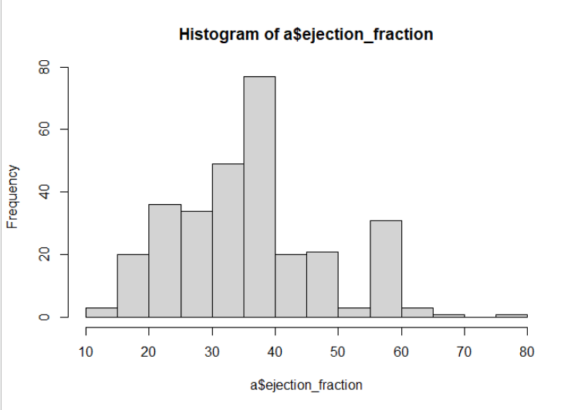

hist(a$high_blood_pressure)

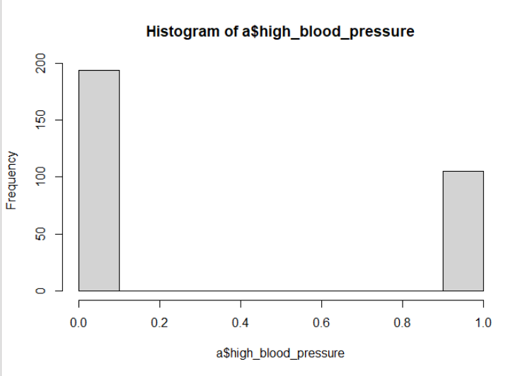

hist(a$platelets)

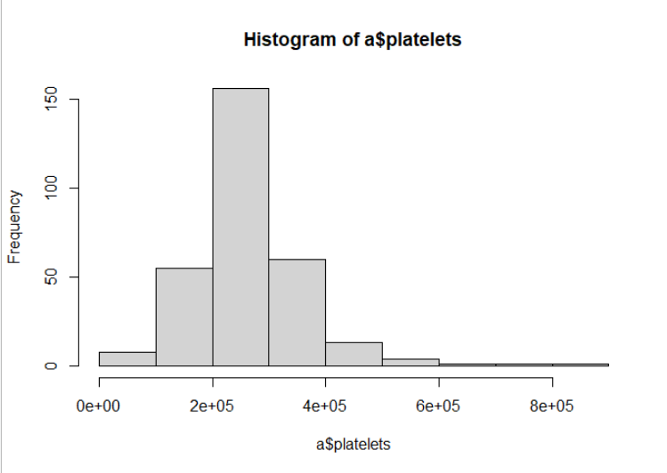

hist(a$serum_creatinine)

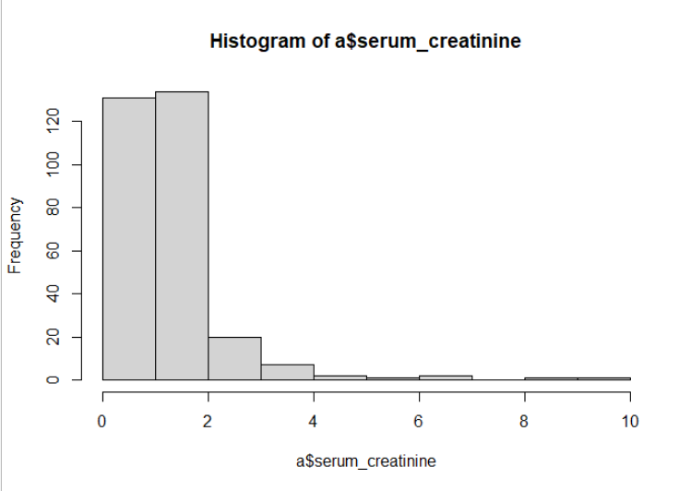

hist(a$serum_sodium)

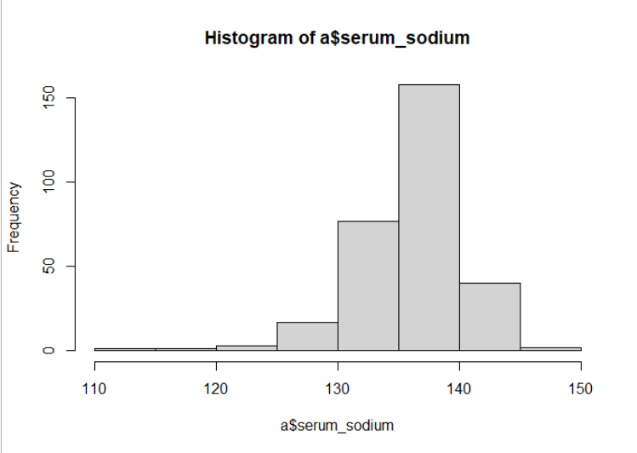

hist(a$sex)

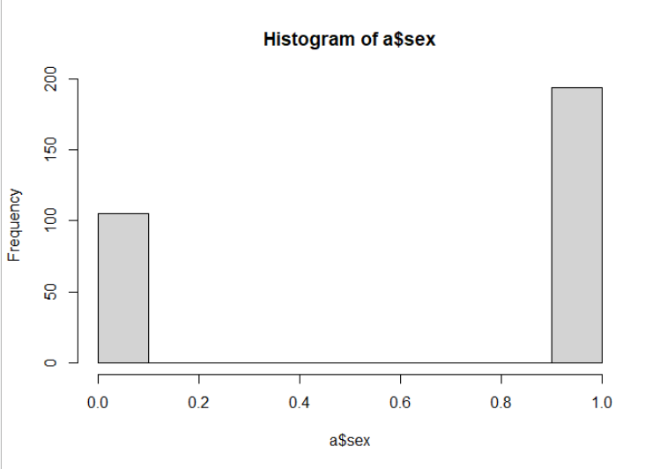

hist(a$smoking)

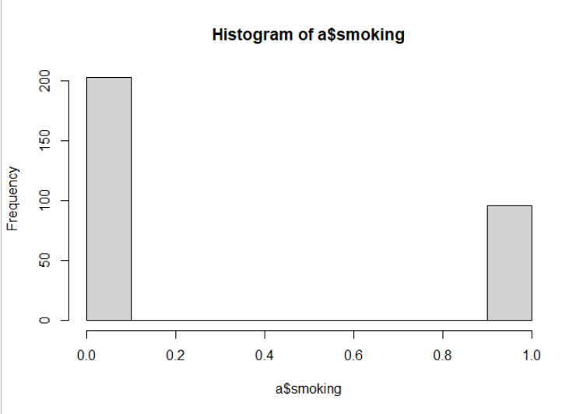

hist(a$time)

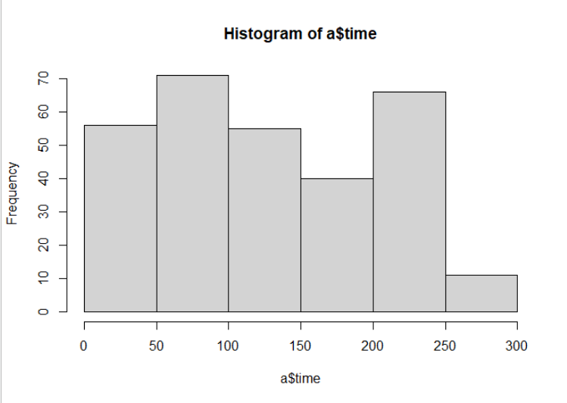

hist(a$DEATH_EVENT)

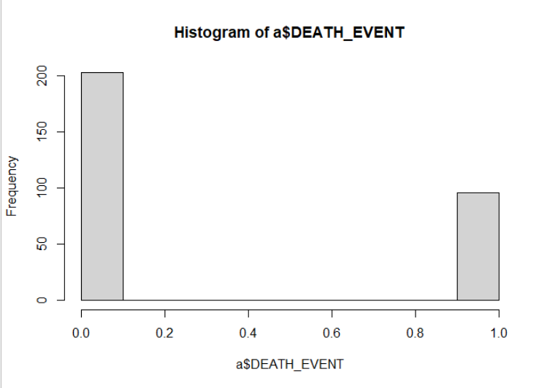

barplot(a$age)

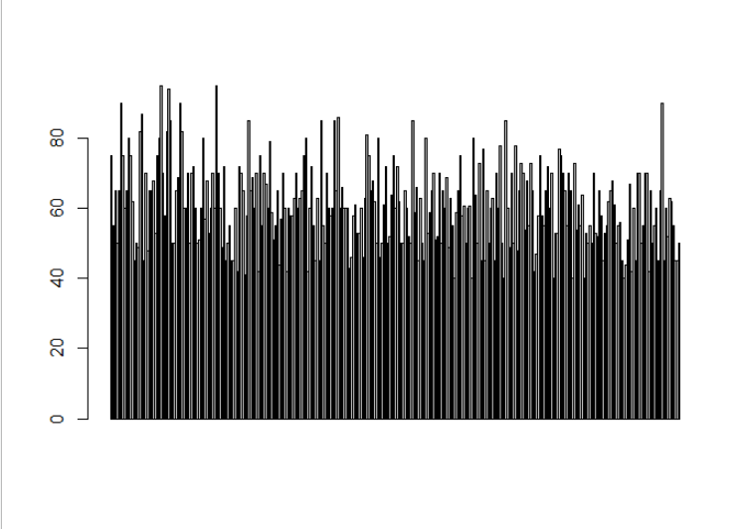

barplot(a$anaemia)

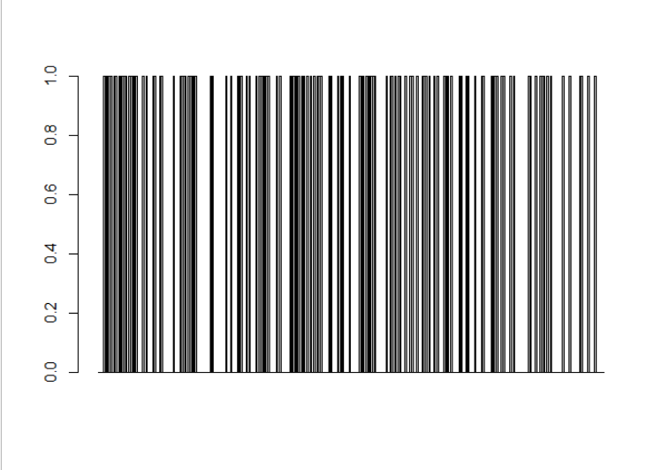

barplot(a$creatinine_phosphokinase)

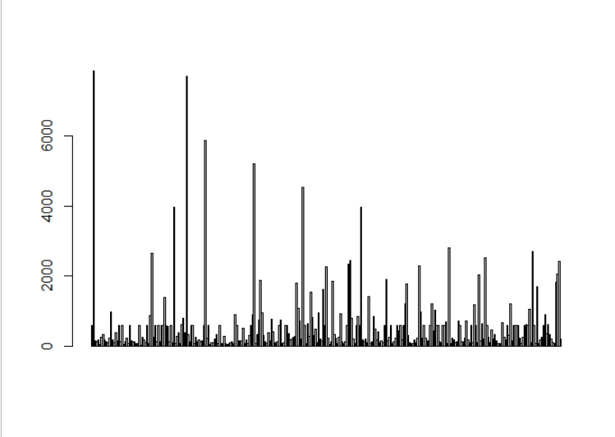

barplot(a$diabetes)

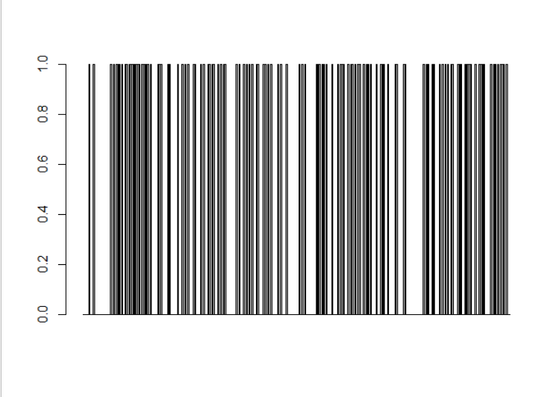

barplot(a$ejection_fraction)

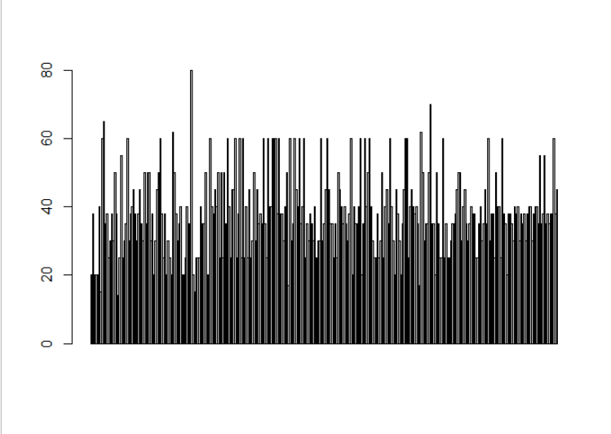

barplot(a$high_blood_pressure)

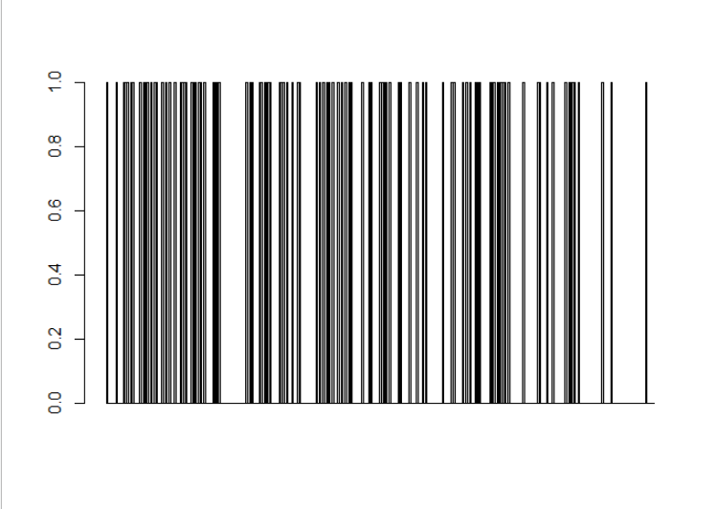

barplot(a$platelets)

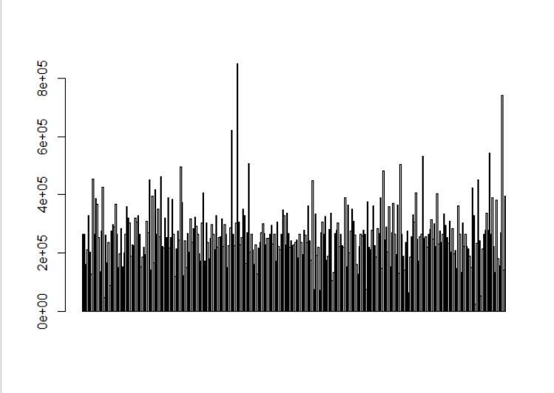

barplot(a$serum_creatinine)

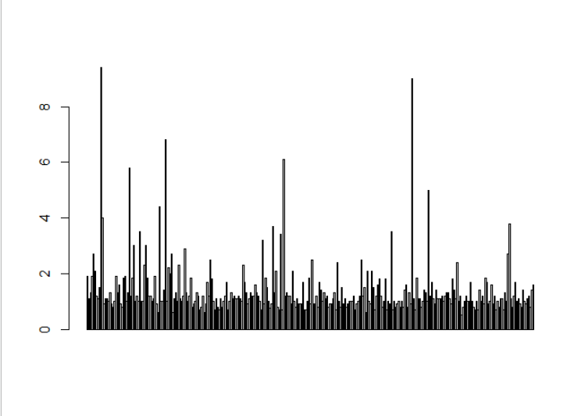

barplot(a$serum_sodium)

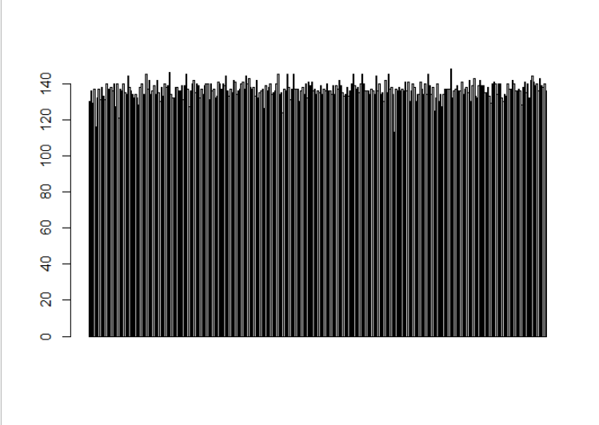

barplot(a$sex)

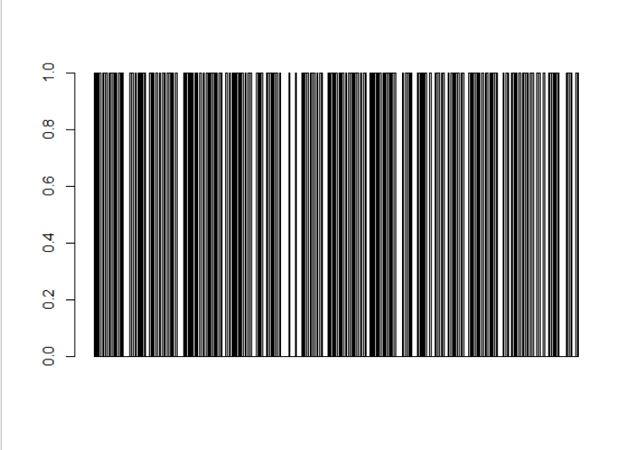

barplot(a$smoking)

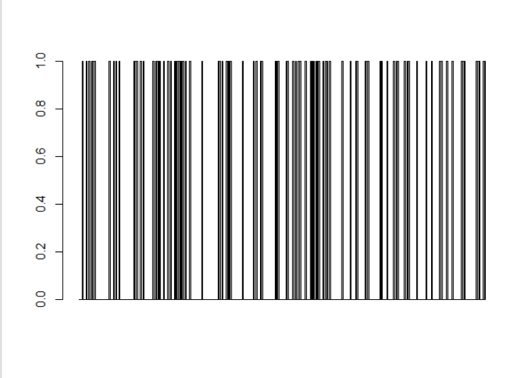

barplot(a$time)

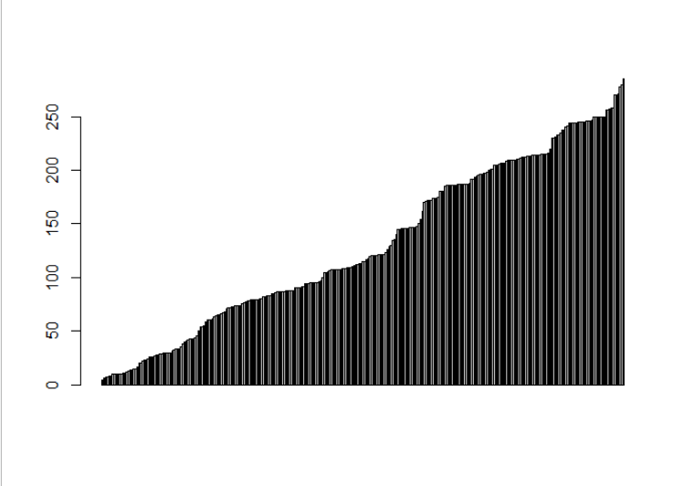

barplot(a$DEATH_EVENT)

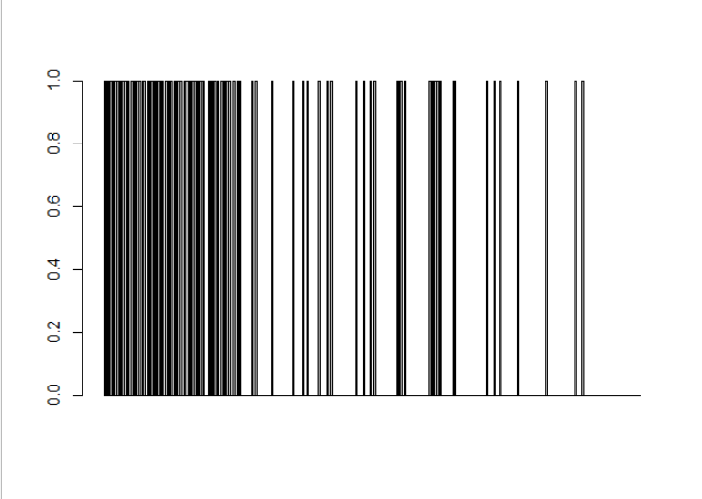

boxplot(a$age)

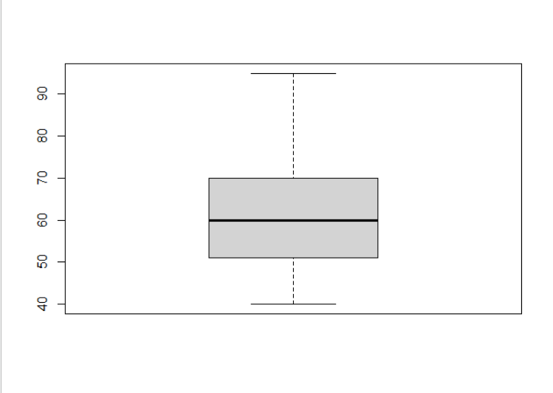

boxplot(a$anaemia)

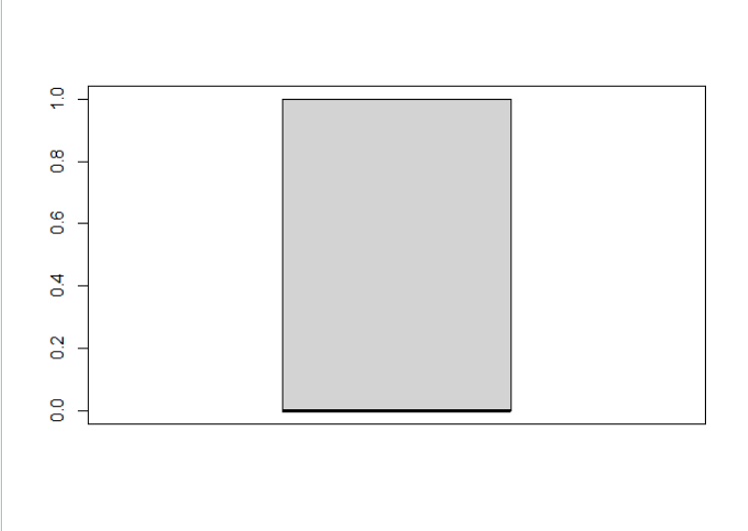

boxplot(a$creatinine_phosphokinase)

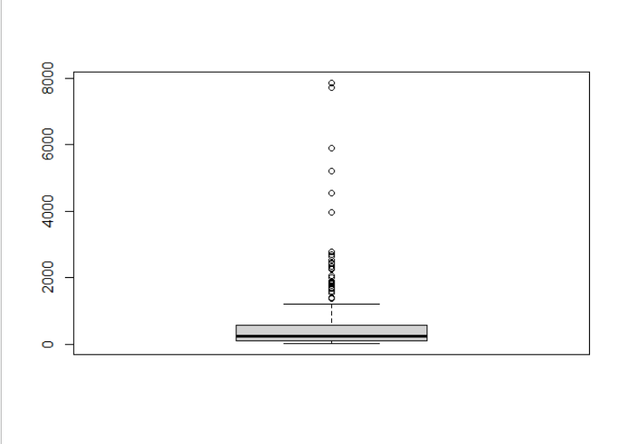

boxplot(a$diabetes)



boxplot(a$ejection_fraction)

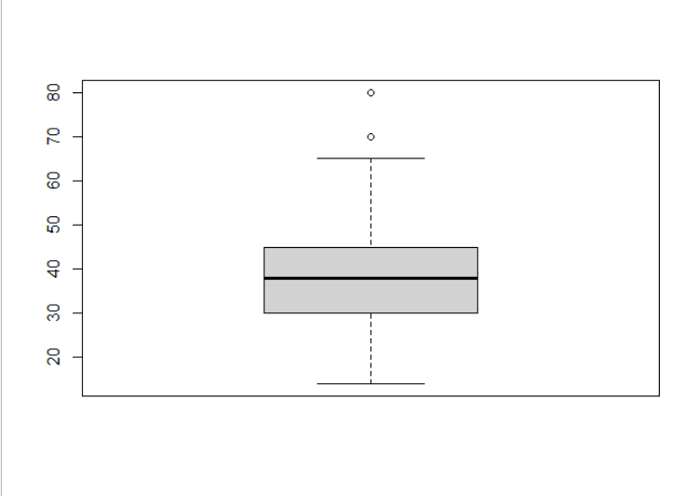

boxplot(a$high_blood_pressure)



boxplot(a$platelets)

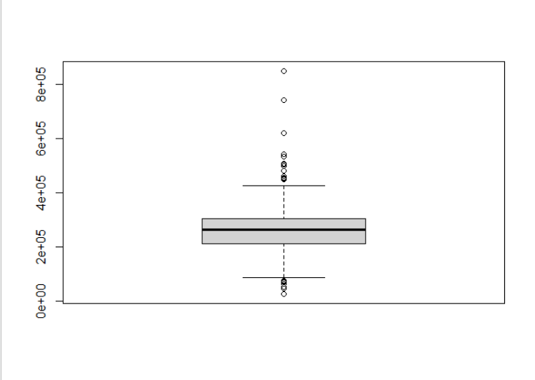

boxplot(a$serum_creatinine)

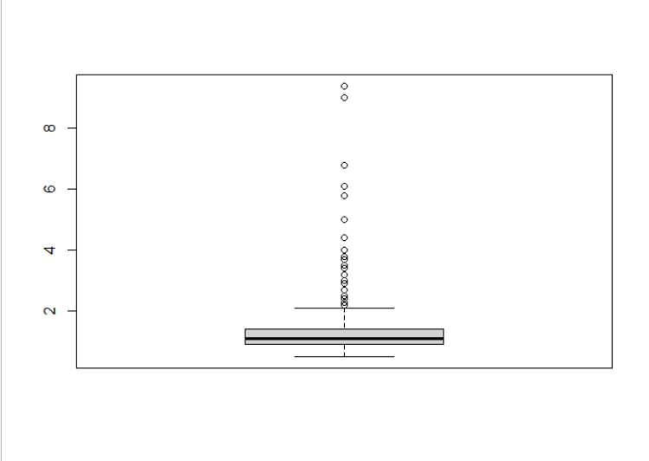

boxplot(a$serum_sodium)

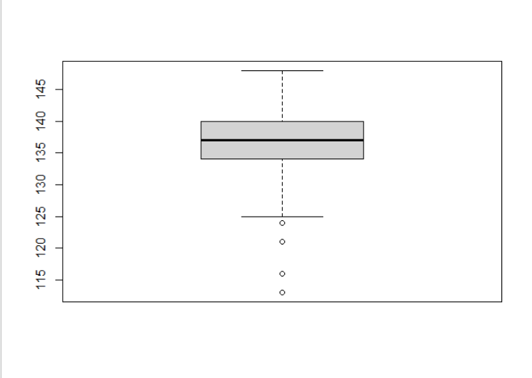

boxplot(a$sex)

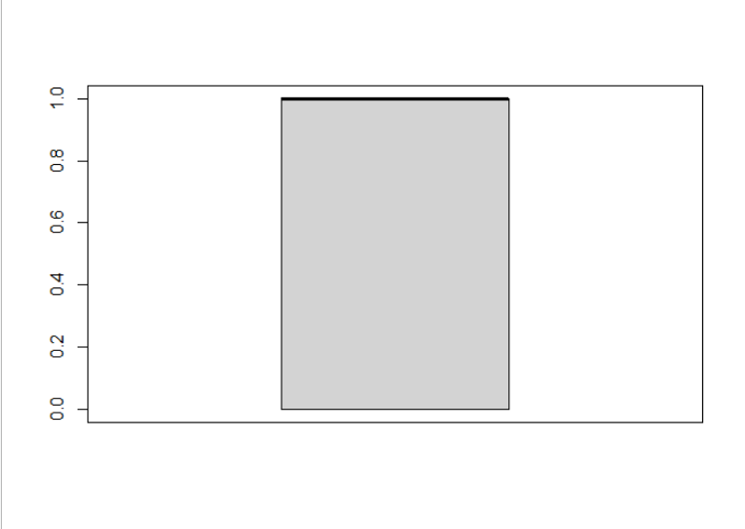

boxplot(a$smoking)



boxplot(a$time)

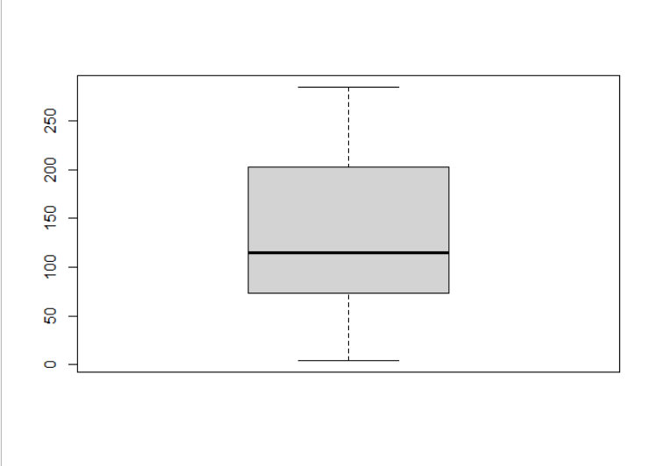

boxplot(a$DEATH_EVENT)



pie(a$age)

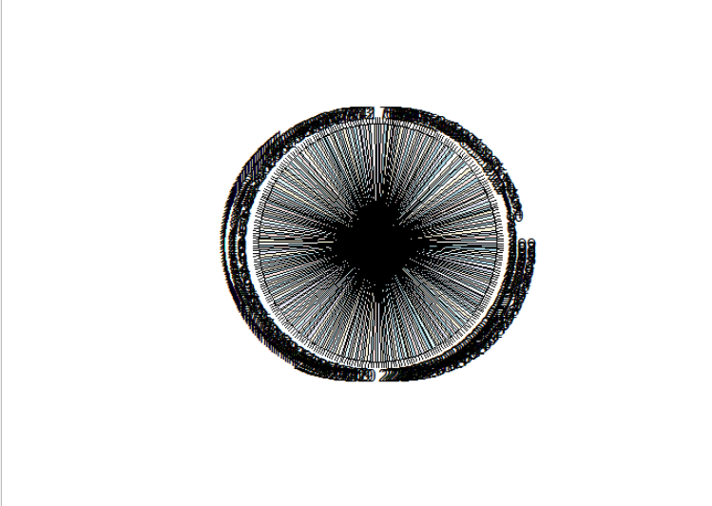

pie(a$anaemia)

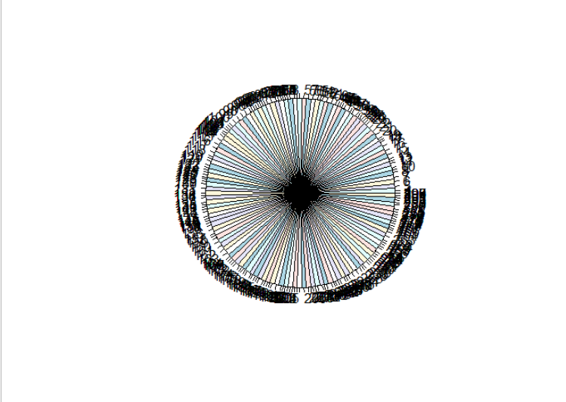

pie(a$creatinine_phosphokinase)

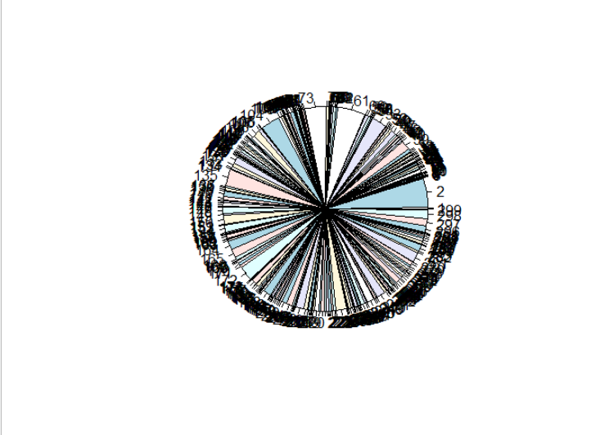

pie(a$diabetes)

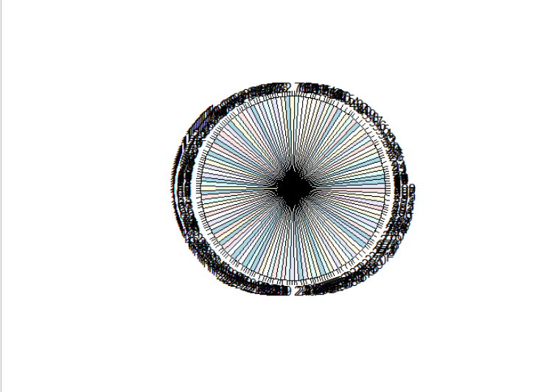

pie(a$ejection_fraction)

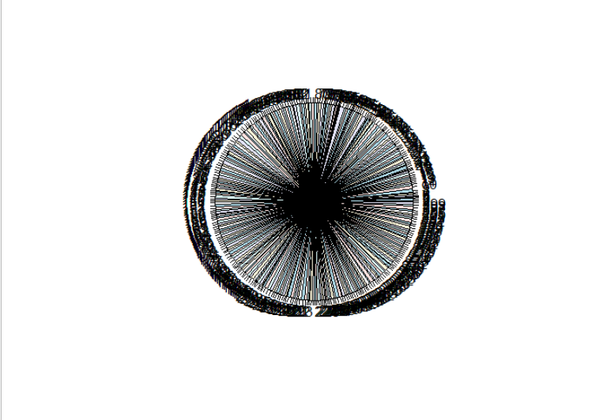

pie(a$high_blood_pressure)

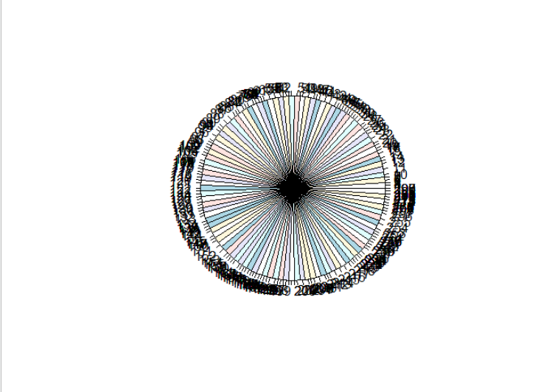

pie(a$platelets)

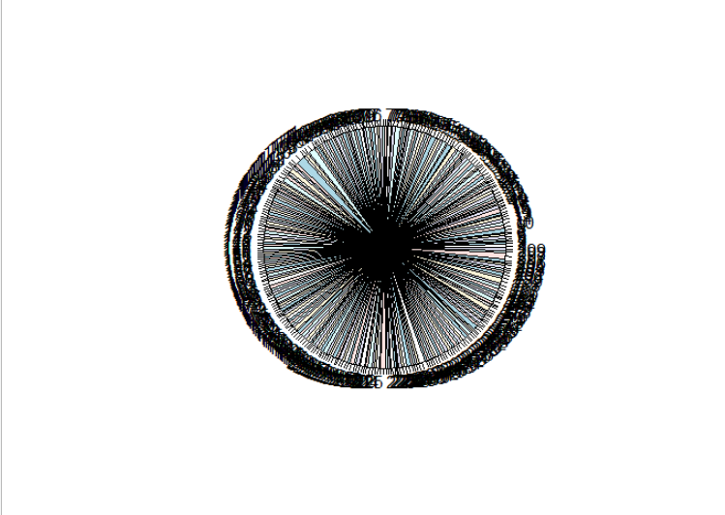

pie(a$serum_creatinine)

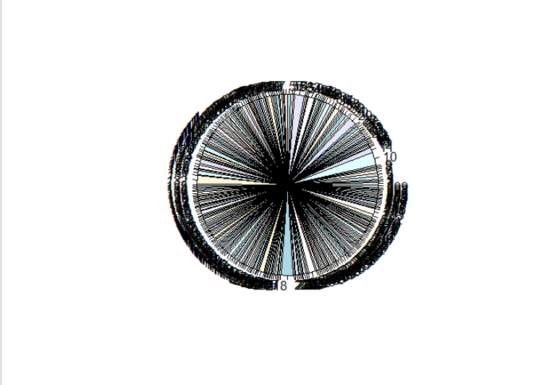

pie(a$serum_sodium)

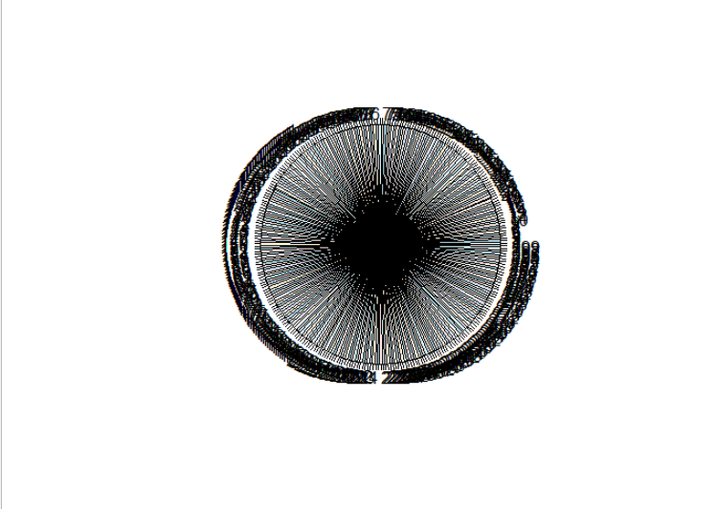

pie(a$sex)

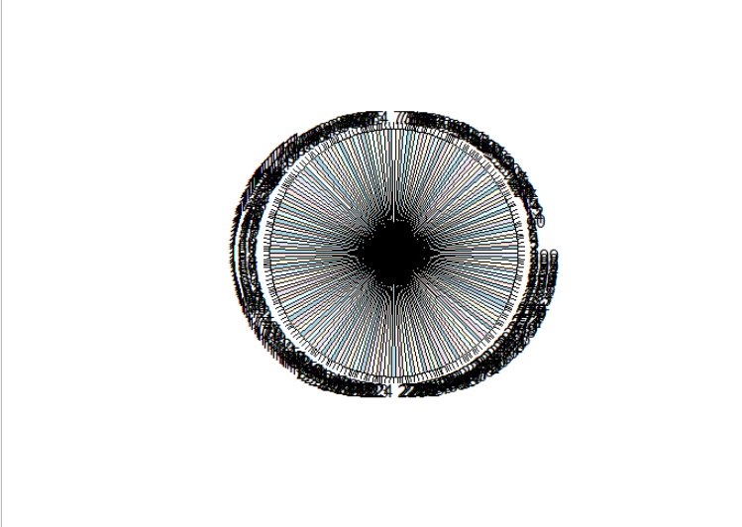

pie(a$smoking)

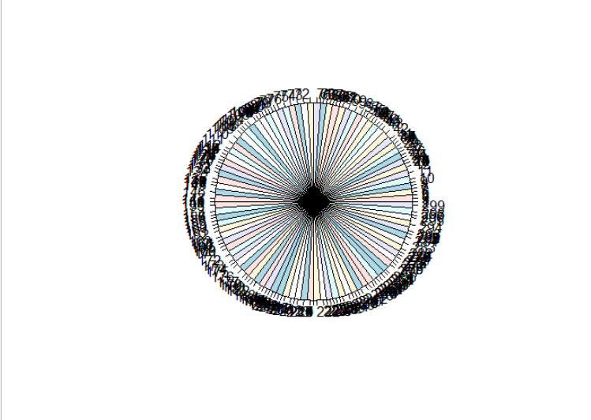

pie(a$time)

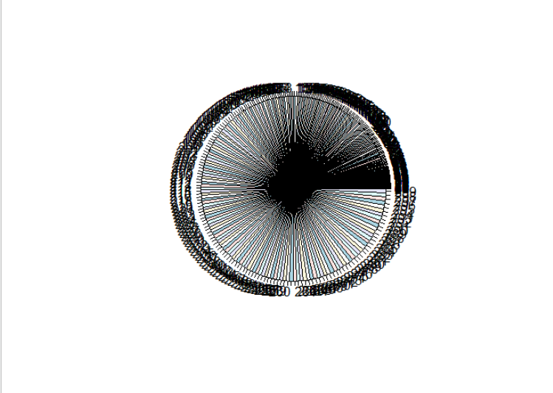

pie(a$DEATH_EVENT)

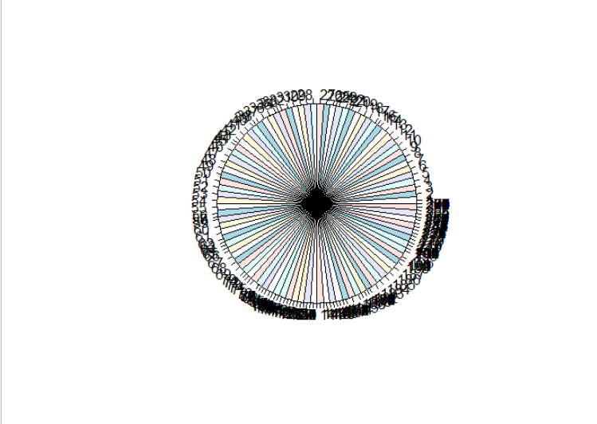

plot(a$age,type="o")

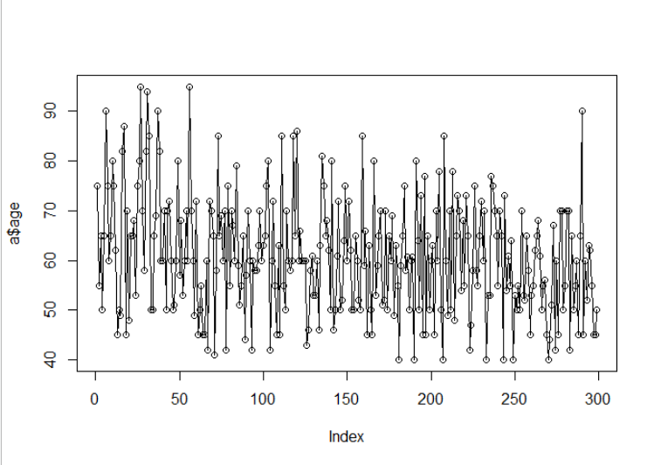

plot(a$anaemia,type="o")

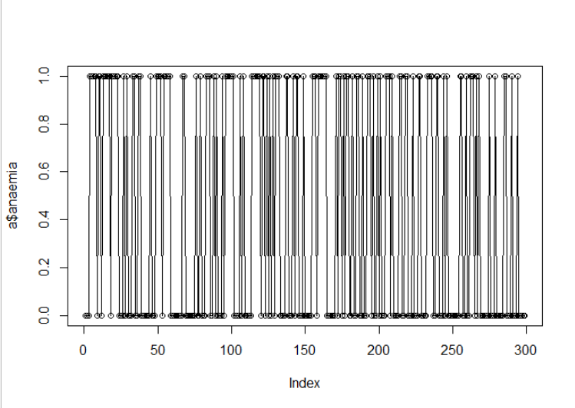

plot(a$creatinine_phosphokinase,type="o")

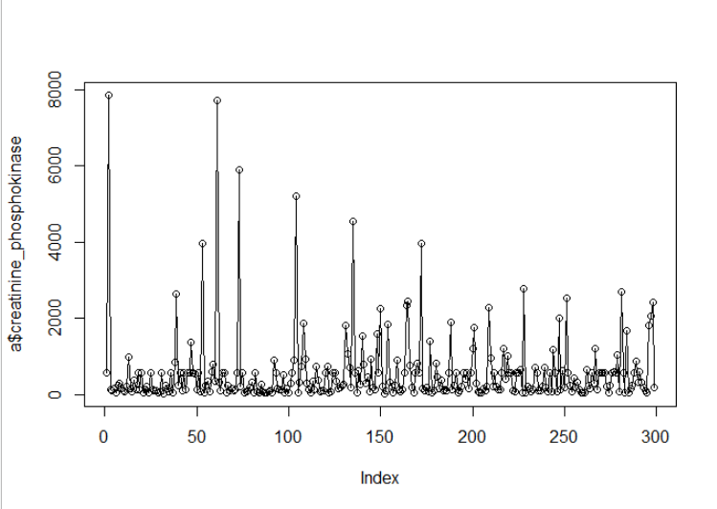

plot(a$diabetes,type="o")

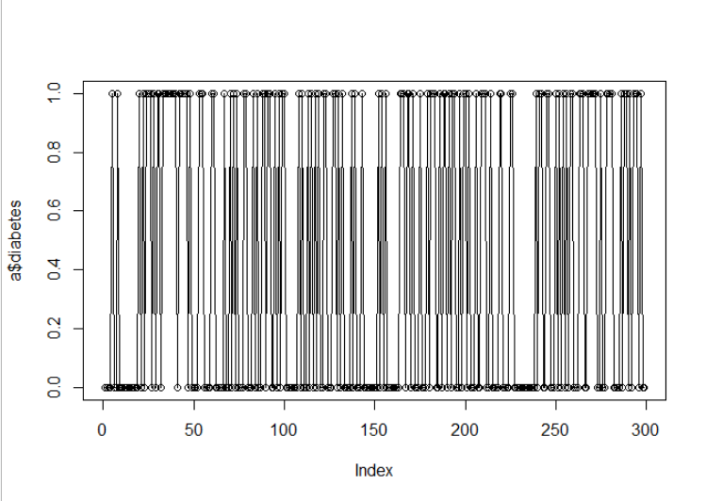

plot(a$ejection_fraction,type="o")

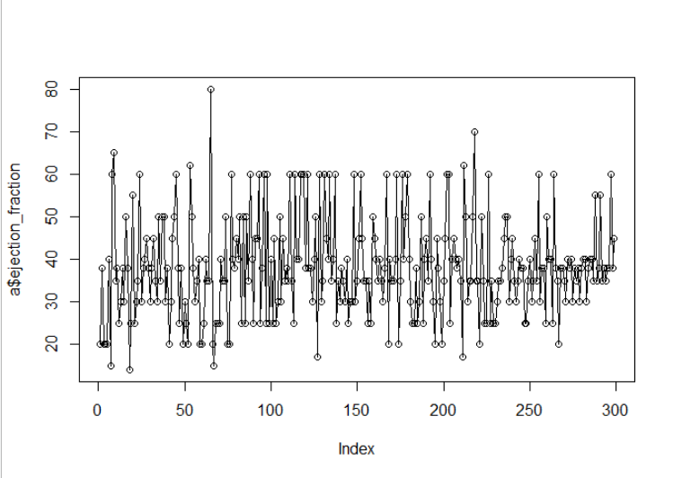

plot(a$high_blood_pressure,type="o")

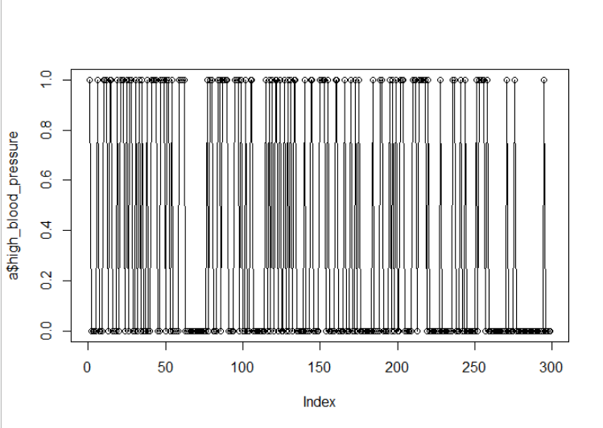

plot(a$platelets,type="o")

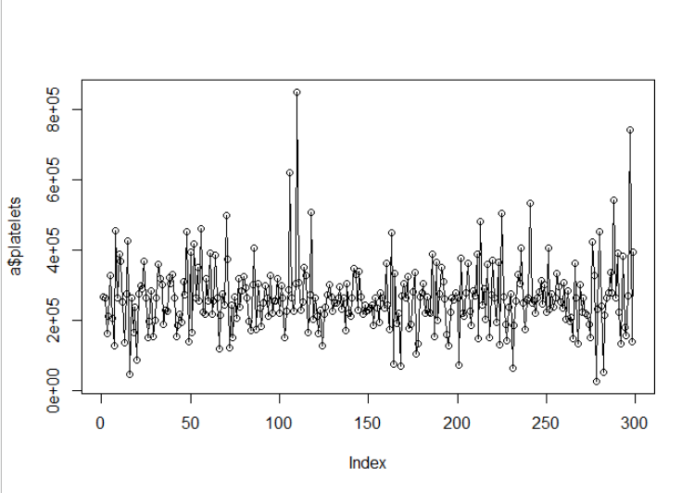

plot(a$serum_creatinine,type="o")

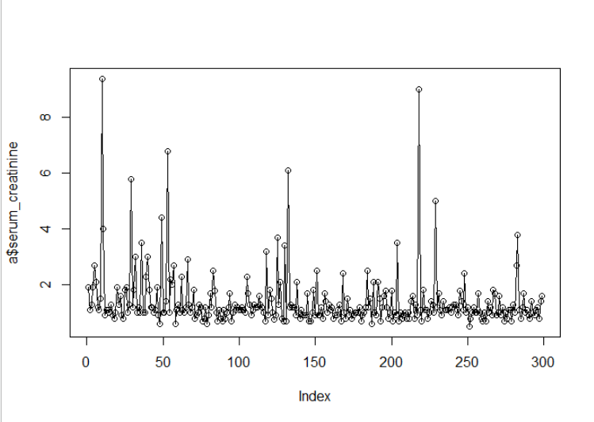

plot(a$serum_sodium,type="o")

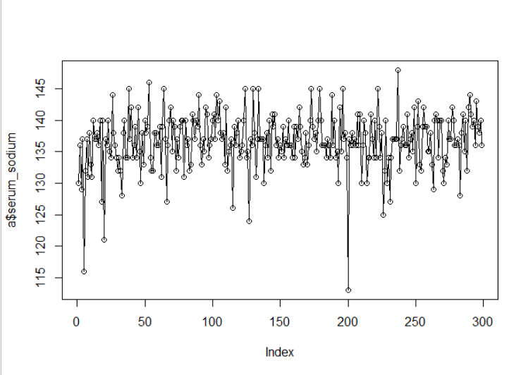

plot(a$sex,type="o")

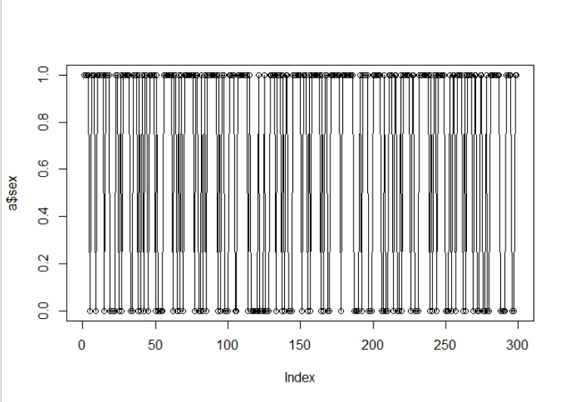

plot(a$smoking,type="o")

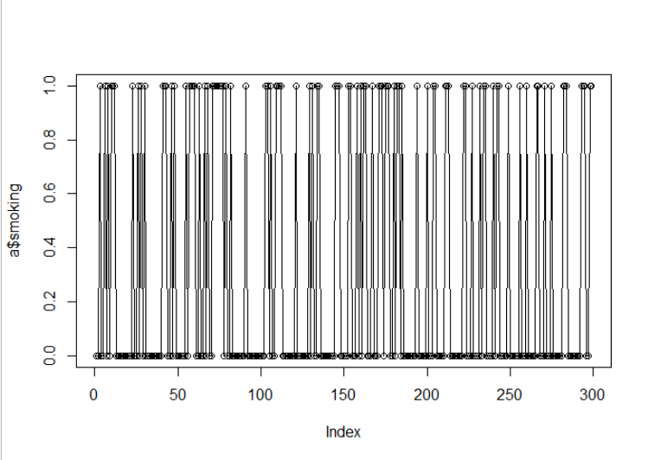

plot(a$time,type="o")

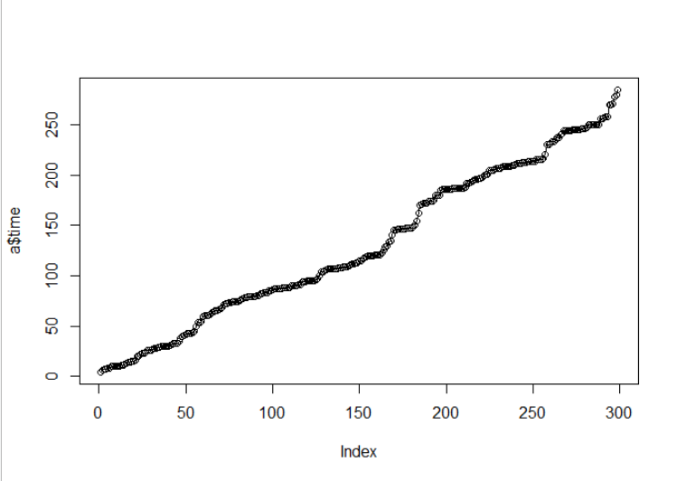

plot(a$DEATH_EVENT,type="o")

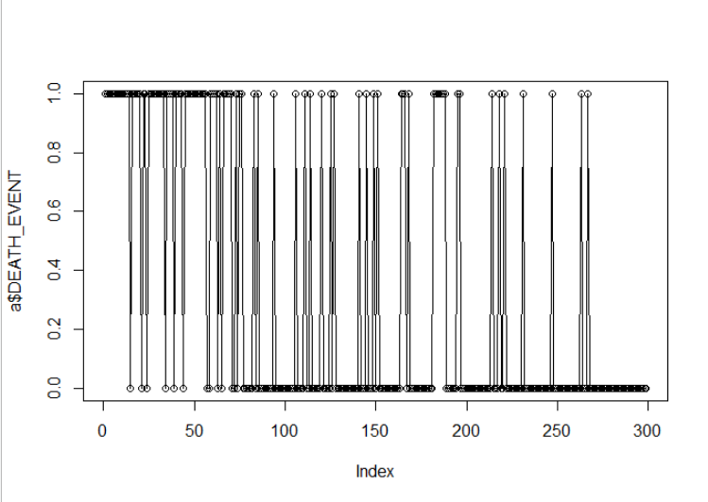

plot(a$age)

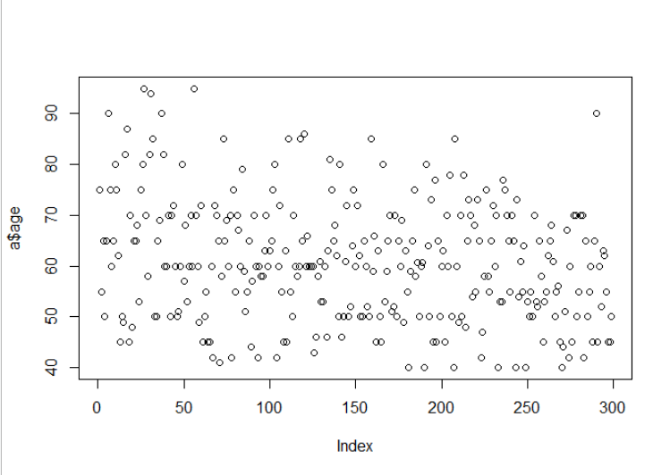

plot(a$anaemia)

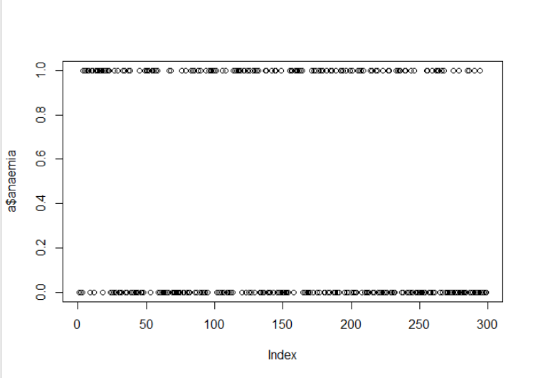

plot(a$creatinine_phosphokinase)

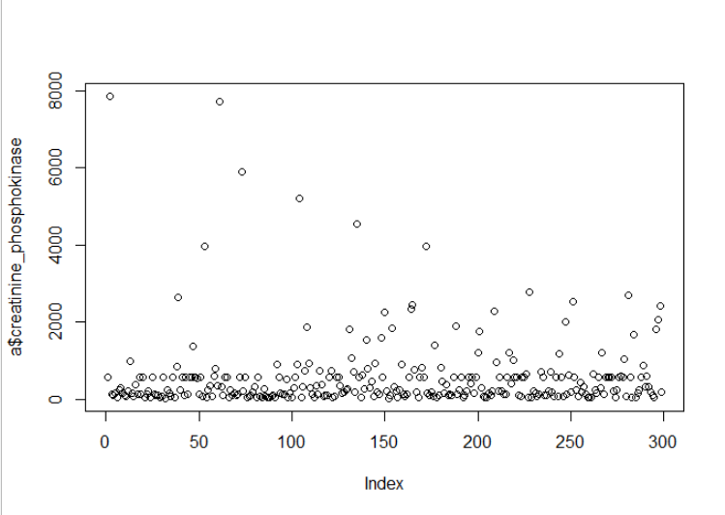

plot(a$diabetes)

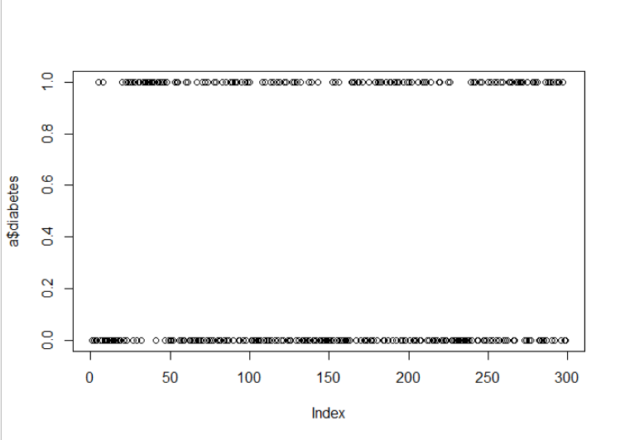

plot(a$ejection_fraction)

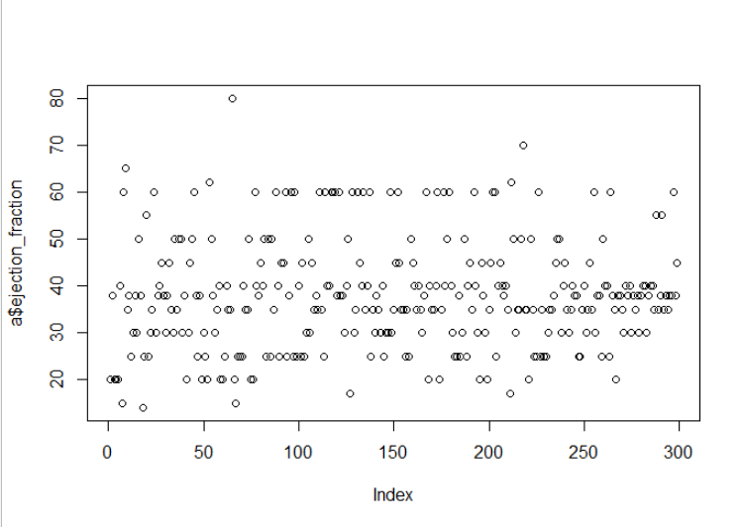

plot(a$high_blood_pressure)

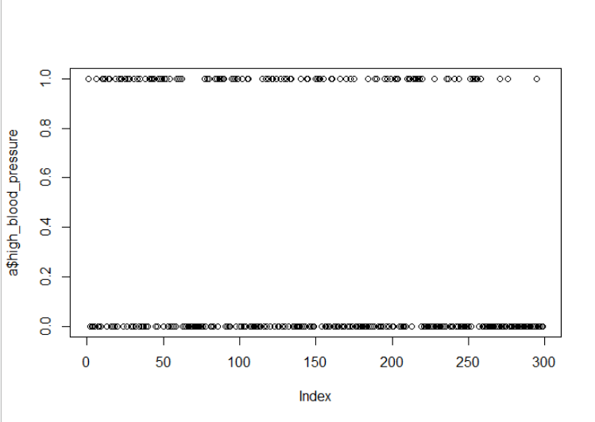

plot(a$platelets)

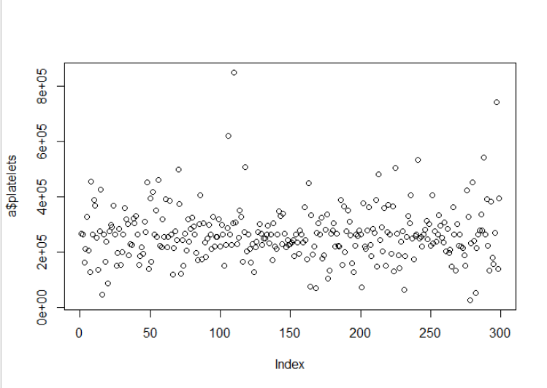

plot(a$serum_creatinine)

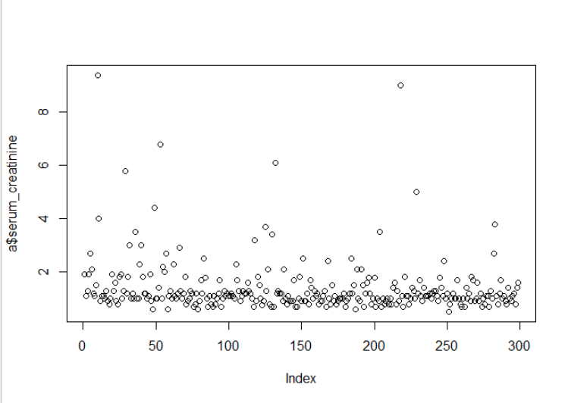

plot(a$serum_sodium)

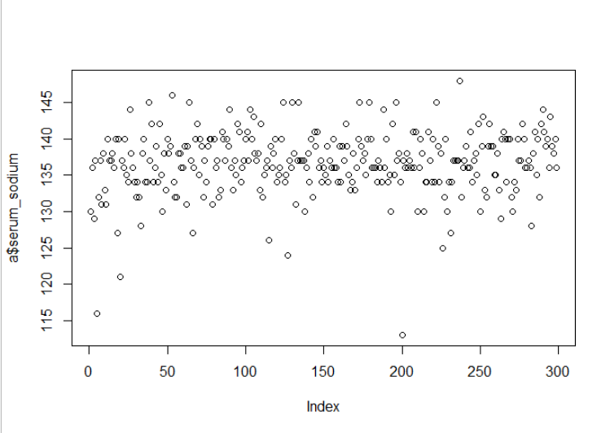

plot(a$sex)

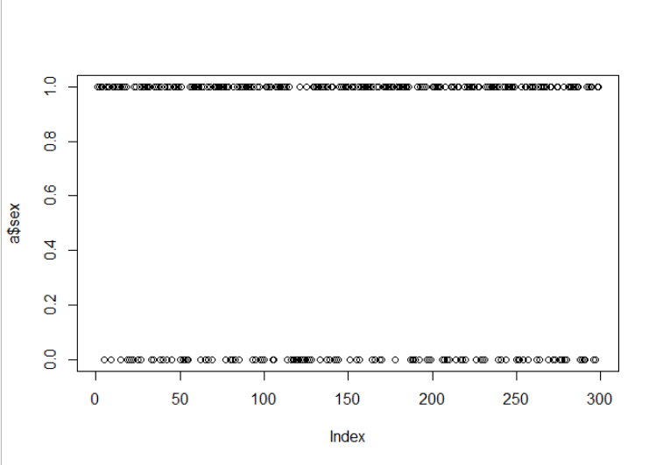

plot(a$smoking)

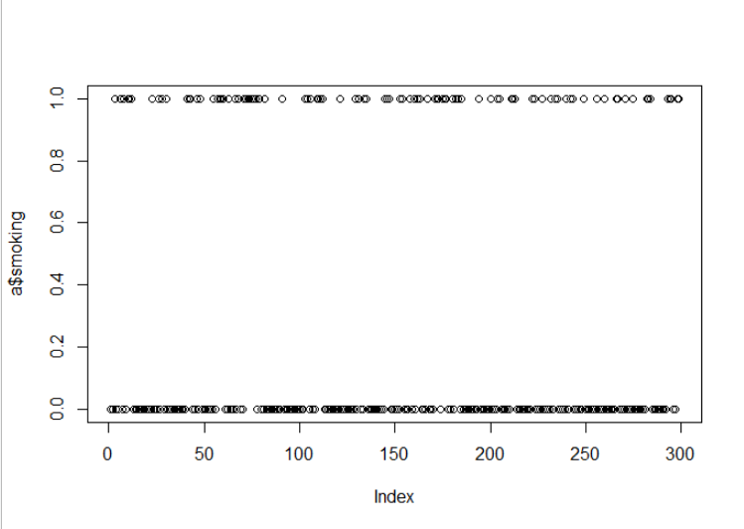

plot(a$time)

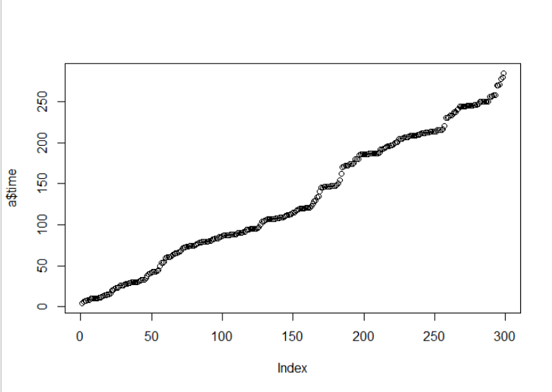

plot(a$DEATH_EVENT)

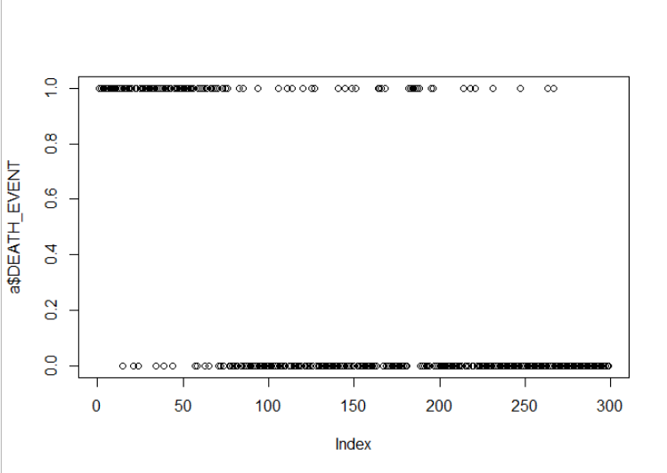

Write a Python program to find the minimum and maximum value in a given 1Darray

a=[5,86,2,4,69,45,23]

max(a)

min(a)

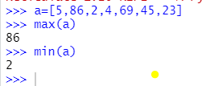

Write a NumPy program to get the minimum and maximum value of a given arraalong the second axis. Note: use arrange and shape functions

import numpy as np

a=np.arange(9).reshape((3,3))

a

np.amax(a,1)

np.amin(a,1)

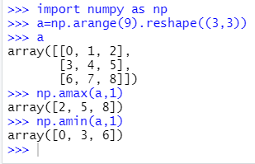

Write a NumPy program to compute the median of a given 1D-array

import numpy as np

arr = np.array([1, 2, 3, 4, 5])

arr

np.median(arr)

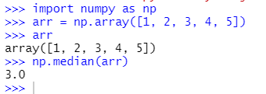

Write a NumPy program to compute the mean, standard deviation, and variance of a

given array.

import numpy as np

arr = np.array([1, 2, 3, 4, 5])

arr

np.mean(arr)

np.std(arr)

np.var(arr)

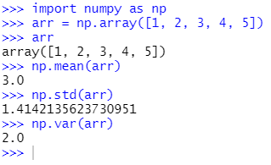

Write a NumPy program to compute the covariance matrix of two given arrays

import numpy as np

a=np.arange(1,10).reshape((3,3))

b=np.arange(10,19).reshape((3,3))

np.cov(a,b)

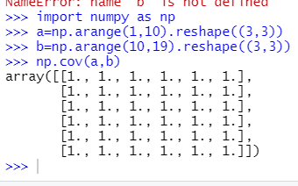

Write a Python program to count number of occurrences of each value in a given

Array

import numpy as np

a=np.array([2,4,4,5,8,6,6,7,7,7,9,6,4,2,3])

np.bincount(a)

