1. Write a NumPy program to convert a list of numeric value into a one-dimensional  
   NumPy array.

Valiveti Manikanta Bhuvanesh

19BCD7088

L55+L56

import numpy as np

a=[1,2,3,4,5,6]

b=np.array(a)

b

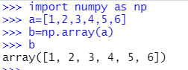

2. Write a NumPy program to create a 3x3 matrix with values ranging from 2 to 10.

c=np.arange(2,11)

c=c.reshape(3,3)

c

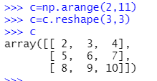  
3. Write a NumPy program to create an array with values ranging from 12 to 38.

d=np.arange(12,38)

d

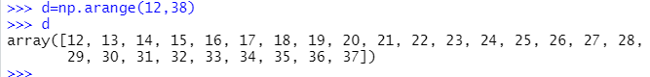

4. Write a NumPy program to reverse an array (first element becomes last) using  
indices.

a

np.flip(a)

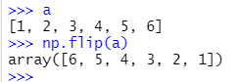  
5. Write a NumPy program to create a null vector of size 10 and update sixth value to  
11.

e=np.zeros(10)

e[6]=11

e

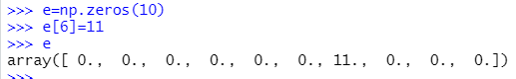  
6. Write a NumPy program to append values to the end of an array.

a

d

np.append(a,d)

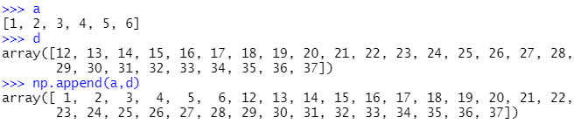

7. Write a NumPy program to get the unique elements of an array.

f=np.array([1,1,1,1,2,2,2,3,3,4,4,5,6,7,6,5,7,8,9,9,8])

f

np.unique(f)

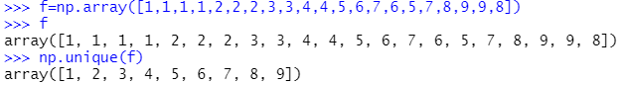  
8. Write a NumPy program to find the indices of the maximum and minimum values  
along the given axis of an array.

g=np.array([3,4,5,2,1])

np.argmax(g)

np.argmin(g)

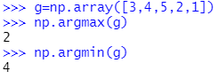  
9. Write a NumPy program to sort an along the first, last axis of an array

h=np.array([[2,5,1,3],[9,7,6,0],[5,4,2,7]])

h

np.sort(h,axis=0)

np.sort(h,axis=1)

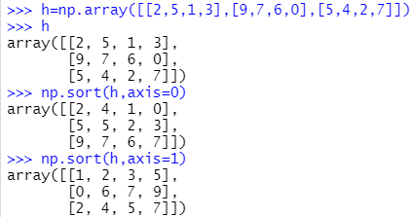

10.Write a Numpy program to create 8x8 matrix with random values and make into 2  
arrays of size 4x4 and print

i=np.random.randint(100,200,(8,8))

i

p = np.hsplit(np.vsplit(i, 2)[0], 2)

q = np.hsplit(np.vsplit(i, 2)[1], 2)

p[0]

p[1]

q[0]

q[1]

