Valiveti Manikanta Bhuvanesh

19BCD7088

L55+L56

Write a Pandas program to create 4x4 random numbers array and display the default index  
and set [a,b,c,c,d ] column as an Index in a given data frame?

import numpy as np

import pandas as pd

a=np.arange(1,17).reshape(4,4)

df=pd.DataFrame(a)

print(df)

x=df.index.values

print(x)

index = {'a', 'b', 'c', 'd'}

df=pd.DataFrame(a, index)

print(df)

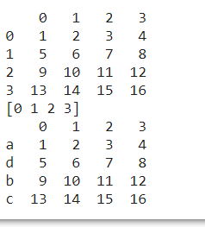

2. Write a Pandas program to create a data frame with size 10x5 and set a title or name of the  
index column

a=np.arange(1,51).reshape(10,5)

df=pd.DataFrame(a,columns=('1stcolumn','2ndcolumn','3rdcolumn','4thcolumn','5thcolumn'))

print(df)

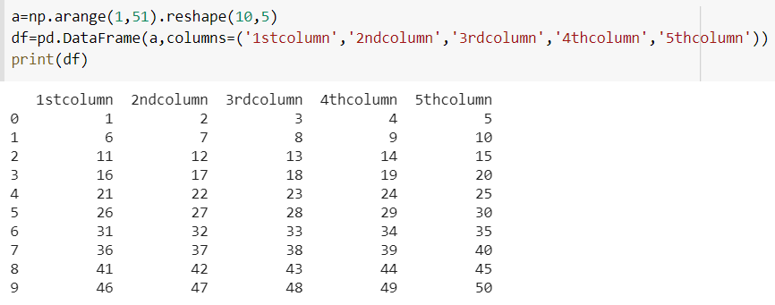  
Perform the following operations on the below data table.

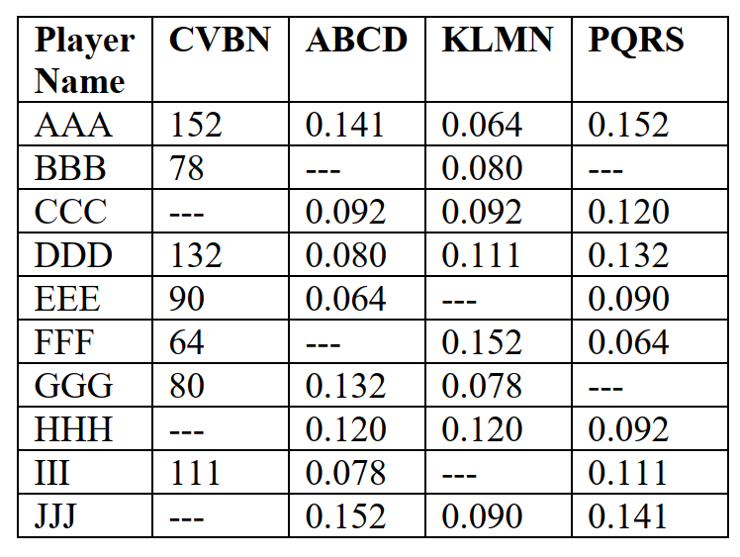

data={'Player Nmae':['AAA','BBB','CCC','DDD','EEE','FFF','GGG','HHH','III','JJJ'],'CVBN':[152,78,np.nan,132,90,64,80,np.nan,111,np.nan],'ABCD':[0.141,np.nan,0.092,0.080,0.064,np.nan,0.132,0.120,0.078,0.152],'KLMN':[0.064,0.080,0.092,0.111,np.nan,0.152,0.078,0.120,np.nan,0.090],'PQRS':[0.152,np.nan,0.120,0.132,0.090,0.064,np.nan,0.092,0.111,0.141]}

Create data frame and print

df=pd.DataFrame(data)

print(df)

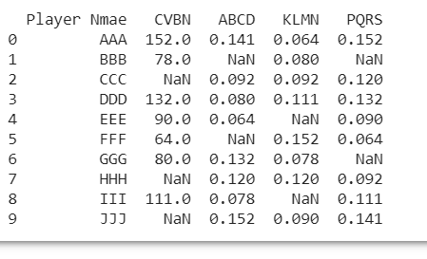

Print individual column as a series

 pd.Series(df['Player Name'])

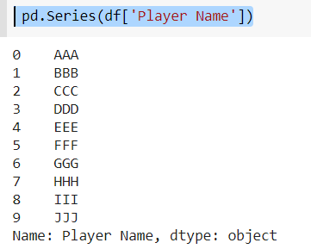

Replace the empty cells with mean on the column individually and print the same

df['CVBN']=df['CVBN'].fillna(np.mean(df['CVBN']))

df['ABCD']=df['ABCD'].fillna(np.mean(df['ABCD']))

df['KLMN']=df['KLMN'].fillna(np.mean(df['KLMN']))

df['PQRS']=df['PQRS'].fillna(np.mean(df['PQRS']))

print(df)

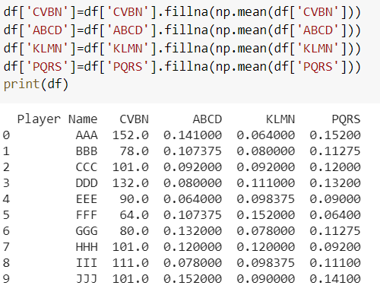

Print sum of the columns on the resultant obtained in 5

df.sum()

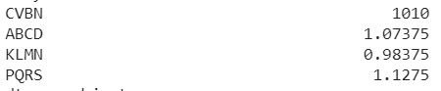

Print the indices of data frame

df.index.values

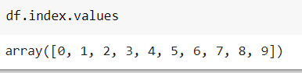

Assign explicit indices Row1, Row2,……Row10 and print.

index=['Row1','Row2','Row3','Row4','Row5','Row6','Row7','Row8','Row9','Row10',]

pd.DataFrame(data,index)

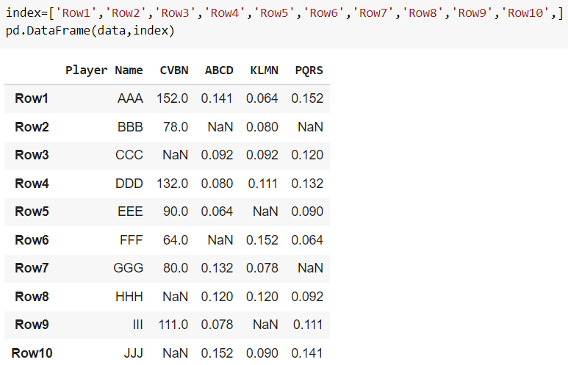

Print the last column and its sum, mean, median, and mode

print(df.iloc[:,-1].sum())

print(df.iloc[:,-1].mean())

print(df.iloc[:,-1].median())

print(df.iloc[:,-1].mode()[0])

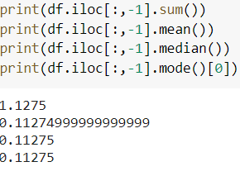

Print the 3 rd row and its sum, mean, median, and mode

print(df.loc[2,['CVBN','ABCD','KLMN','PQRS']].sum())

print(df.loc[2,['CVBN','ABCD','KLMN','PQRS']].mean())

print(df.loc[2,['CVBN','ABCD','KLMN','PQRS']].median())

print(df.loc[2,['CVBN','ABCD','KLMN','PQRS']].mode()[0])

