Valiveti Manikanta Bhuvanesh

19BCD7088

L55+L56

Age<-readline("Enter your age")

if (Age>=18){

print("eligible")

}else{

print("not eligible")

}

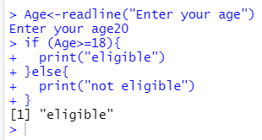

Age<-readline("Enter your age")

Weight<-readline("Enter your weight")

if (Age>=18 && Weight>50){

print("eligible to donate blood")

}else{

print("not eligible")

}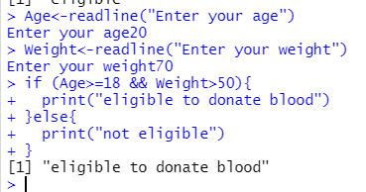

var1<-readline("Enter your 1st subject mark out of 100 marks")

v1=as.numeric(var1)

var2<-readline("Enter your 2nd subject mark out of 100 marks")

v2=as.numeric(var2)

var3<-readline("Enter your 3rd subject mark out of 100 marks")

v3=as.numeric(var3)

var4<-readline("Enter your 4th subject mark out of 100 marks")

v4=as.numeric(var4)

var5<-readline("Enter your 5th subject mark out of 1000 marks")

v5=as.numeric(var5)

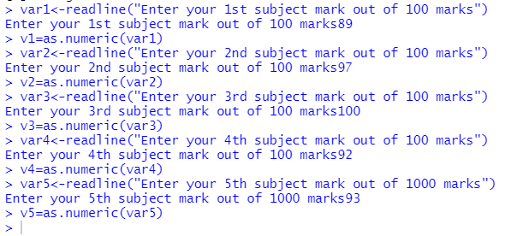

Sum<-sum(v1,v2,v3,v4,v5)

Avg<-Sum/5

Avg

if(Avg>=90){

"A"

}else if(Avg<90&&Avg>=80){

"B"

}else if(Avg<80&&Avg>=70){

"C"

}else if(Avg<70&&Avg>=60){

"D"

}else{

"Fail"

}

