Data <- data.frame(grade=c("A", "B", "A","B", "C", "A","C"), bar=1:7)

Valiveti Manikanta bhuvanesh

19BCD7088

L55+L56

m=Data["bar"]

m=m[1:7,1]

m

me=mean(m)

g=Data["grade"]

g=g[1:7,1]

g[me]

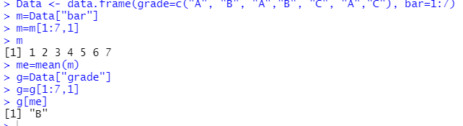

a=sample(-100:100,5)

a

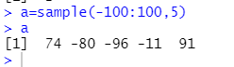

a=matrix(1:100,4,4,T)

b=matrix(1:100,4,4,T)

a

b

a+b

a-b

a\*b

a/b

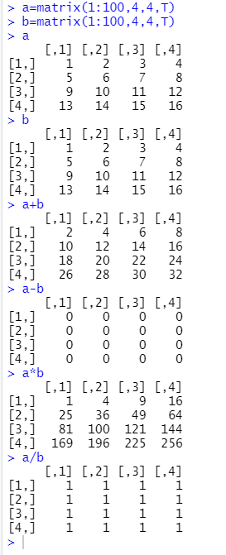

x=c(100:200)

for(val in x){

print(val)

if(val%%3==0){

print("The number is multiple of 3")

}

else if(val%%5==0){

print( "The number is multiple of 5")

}

else if(val%%3==0&val%%5==0){

print("multiple of both 3 and 5")

}

else {

print("Is not multiple")

}

}

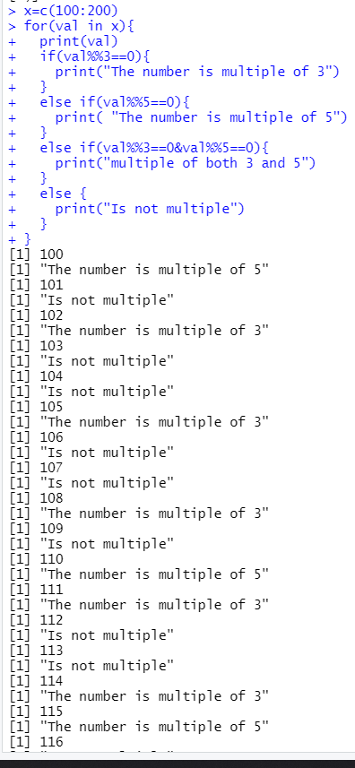

a=matrix(1:20,T,dim(x) <- c(5,4))

apply(a,1,max)

