**1)**a=readline(prompt = "1st integer")

Valiveti Manikanta bhuvanesh

19BCD7088

L55+L56

b=readline(prompt = "2nd integer")

if(a>b){

print(paste(a," is greater than ",b))

}else{

print(paste(b," is greater than ",a))

}

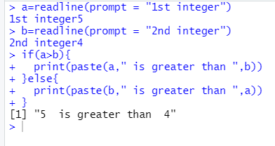

**2)**a=readline(prompt = "1st integer")

b=readline(prompt = "2nd integer")

c=readline(prompt = "3rd integer")

if(a>b&&a>c){

print(paste(a," is greatest"))

}else if(b>c){

print(paste(b," is greatest"))

}else{

print(paste(c," is greatest"))

}

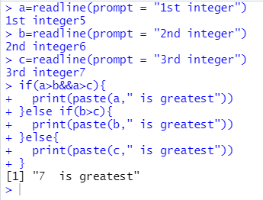

3**)**a=readline(prompt = "1st integer")

if(a>0){

print(paste(a," is positive"))

}else if(a<0){

print(paste(a," is negative"))

}else{

print(paste(a," is zero"))

}

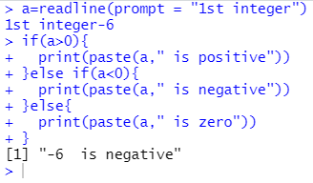

**4)**a=as.integer(readline(prompt = "1st integer"))

if(a%%5 == 0 && a%%11 == 0){

print(paste(a, " is divisible by both 5 and 11"))

}else{

print(paste(a," is divisible by both 5 and 11"))

}

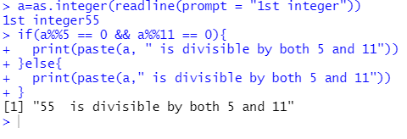

**5)**a=as.integer(readline(prompt = "1st integer"))

if(a%%2==0){

print(paste(a," is even number"))

}else{

print(paste(a," is odd number"))

}

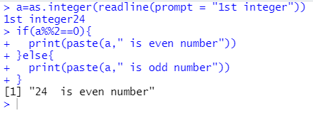

**6)**a=as.integer(readline(prompt = "1st integer"))

if(a%%4 == 0){

print(paste(a," is a leap year"))

}else{

print(paste(a," is not a leap year"))

}

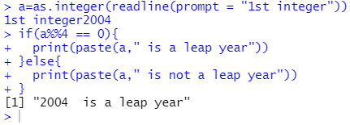

**7)**a=readline(prompt = "Give any character or number")

if((a>='A' &&a<='Z')||(a>='a' &&a<='z')){

print(paste(a," is a alphabet"))

}else{

print(paste(a," is not a alphabet"))

}

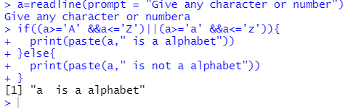

**8)**a=readline(prompt = "Give alphabet")

if((a>='A' &&a<='Z')||(a>='a' &&a<='z')){

if(a=='a'||a=='e'||a=='i'||a=='o'||a=='u'||a=='A'||a=='E'||a=='I'||a=='O'||a=='U'){

print(paste(a," is a vowel"))

}else{

print(paste(a," is a consonant"))

}

}else{

print(paste(a," is not a alphabet"))

}

