1. a<-c(1,2,3,4,5,6)

Valiveti Manikanta Bhuvanesh

19BCD7088

a

b<-c(1+2i,2+3i,3+4i,5+6i,6+7i,7+8i)

b

c<-c('a','b','c','d','e','f')

c

d<-c("True","False","False","False","True","True")

d

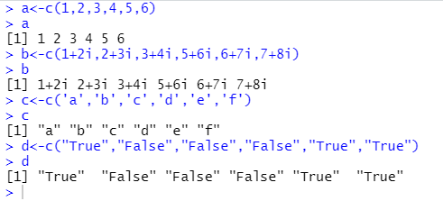

1. a<-c(1,2,3)

b<-c(6,7,8)

a+b

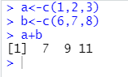

1. a<-c()

b<-c(9,8,7,6,5,4,1,2,3)

append(a,b)

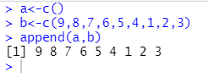

1. a<-c(1,2,3)

b<-c(6,7,8)

a\*b

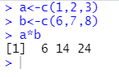

1. a<-c(1,2,3)

b<-c(6,7,8)

a/b

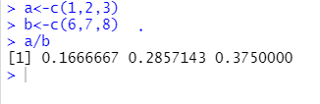

1. a<-c(3,6,9,2,5,8,1,4,7)

sum(a)

mean(a)

prod(a)

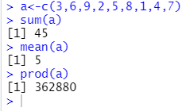

1. a<-c(3,6,5,NA,NaN)

sum(a,na.rm=TRUE,nan.rm=TRUE)

prod(a,na.rm=TRUE,nan.rm=TRUE)

mean(a,na.rm=TRUE,nan.rm=TRUE)

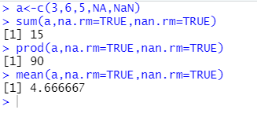

1. a<-c(3,6,9,2,5,8,1,4,7)

min(a)

max(a)

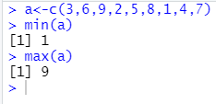

1. a<-c(3,6,9,2,5,8,1,4,7)

sort(a)

sort(a,decreasing = TRUE)

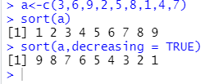

1. a<-c(3,6,9,2,5,8,1,4,7)

a+3

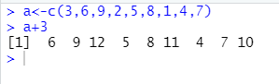

1. a<-c(1,2,3)

b<-c(6,7,8)

cbind(a,b)

rbind(a,b)

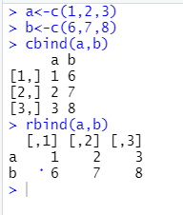

1. a<-c(1,2,3)

b<-c(6,3,8)

setdiff(a,b)

