Valiveti Manikanta Bhuvanesh

19BCD7088

1. a<-matrix(,5,5)

a

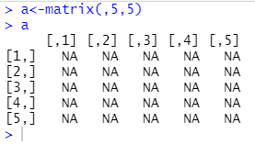

1. a<-matrix(c(1:50),10,5,TRUE)

a

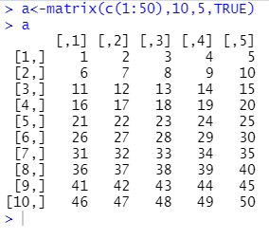

1. a<-matrix(c(1:60),10,6,TRUE)

a[2,3]

a[3,]

a[,4]

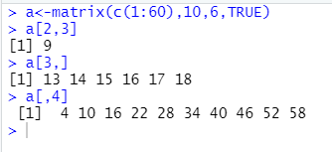

1. a<-matrix(c(1:12),4,3)

b<-matrix(c(12:23),4,3)

a

b

a+b

a-b

a\*b

a/b

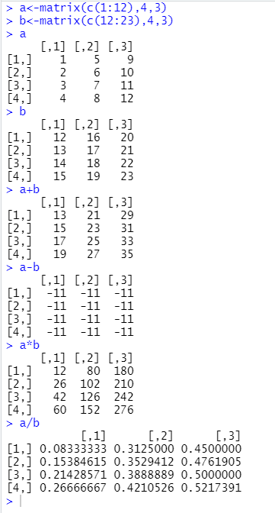

1. as.vector(a)

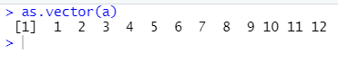

1. a[a[]>7]

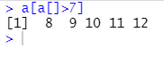

1. a<-matrix(c(1:16),4,4)

b<-matrix(c(12:23),3,4)

rbind(a,b)

dim(rbind(a,b))

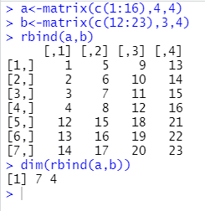

1. a<-matrix(c(1:50),10,5,TRUE)

a

as.vector(a)

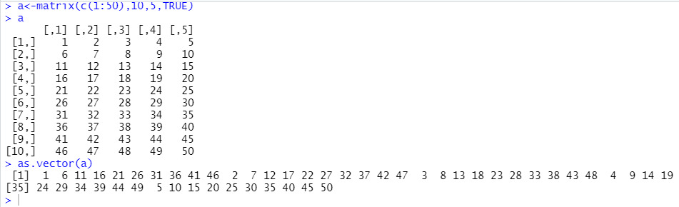

1. a<-matrix(c(1:9),3,3)

b<-matrix(c(10:18),3,3)

a

b

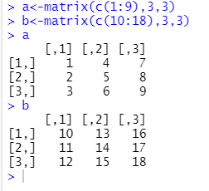

1. a<-c(1:24)

dim(a)=c(2,3,4)

a

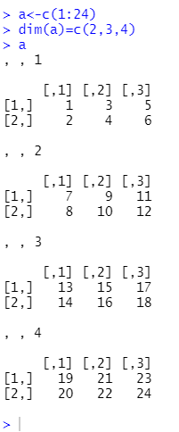

1. a<-matrix(c(1:9),3,3)

b<-matrix(c(10:18),3,3)

b[2,]

a[3,3]

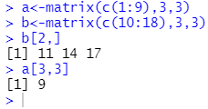

1. a<-matrix(c(1:9),3,3)

b<-matrix(c(10:18),3,3)

c<-matrix(c(19:27),3,3)

rbind(a[1,],b[1,],c[1,])

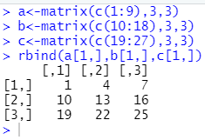

1. a<-seq(50,,2,15)

a<-matrix(a,5,3,TRUE)

a

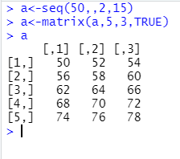

1. a<-c(1:24)

dim(a)=c(3,4,2)

a

