Reg_No<-c('19bcd7088','19bcd7110','19bcd7034','19bcd7054','19bce7203','19bce7102','19bme5023','19bcn7024','19bce7069','19bcn7452','19bce7894','20bcd8056','20bcd7203','20bcn7123','20bcd7124')

Valiveti Manikanta Bhuvanesh

19BCD7088

L55+L56

Name<-c('bhuvanesh','ramesh','manish','susank','suraj','ujwal','suresh','nagarjuna','vema','sushanth','manas','ifran','srikar','cyrus','nithin')

M1<-c(99,65,25,48,78,57,63,15,88,89,48,75,73,86,65)

M2<-c(75,84,96,75,63,45,65,85,41,35,75,85,94,99,42)

M3<-c(58,45,63,48,96,94,75,86,42,53,61,52,48,49,76)

M4<-c(65,48,59,75,86,91,92,93,42,53,61,52,43,84,75)

M5<-c(48,49,59,75,86,42,53,61,58,58,54,88,77,66,99)

Stu_Result<-data.frame(Reg_No,Name,M1,M2,M3,M4,M5)

Stu_Result

a<-c()

sum<-0

for(i in 1:15)

{

for(j in 3:7)

{

sum<-sum+Stu_Result[i,j]

}

a[i]<-sum/5

sum<-0

}

Stu_Result$Average<-a

Stu_Result

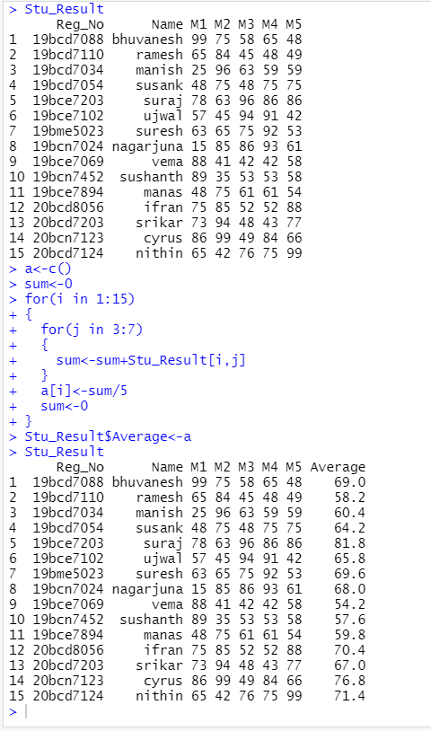

temp<-c()

for(i in 1:15)

{

if(Stu_Result[i,8]>=90){

temp[i]<-'S'

} else if(Stu_Result[i,8]>=81&&Stu_Result[i,8]<90){

temp[i]<-'A'

}else if(Stu_Result[i,8]>=71&&Stu_Result[i,8]<=80){

temp[i]<-'B'

} else if(Stu_Result[i,8]>=61&&Stu_Result[i,8]<=70){

temp[i]<-'C'

} else if(Stu_Result[i,8]>=51&&Stu_Result[i,8]<=60){

temp[i]<-'P'

} else{

temp[i]<-'F'

}}

Stu_Result$Grade<-temp

Updated_Stu_Result<-Stu_Result

Updated_Stu_Result

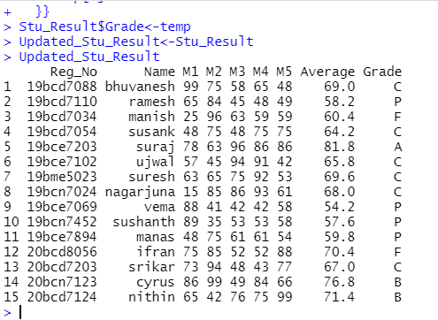

#c

New_Stu_Result<-data.frame(Updated_Stu_Result)

New_Stu_Result

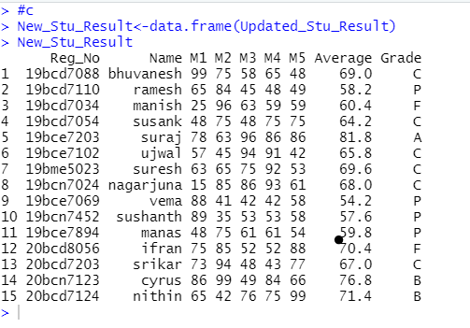

#Quetion2

Sepal.Length<-c(5.4,5.2,5.8,5.1,6.3,5.7,6.7,5.4,6.7,5.5)

Sepal.Width<-c(3.4,4.1,2.6,3.5,2.5,3.8,3.1,3.4,3.1,3.5)

Petal.Length<-c(1.5,1.5,4,1.4,4.9,1.7,5.6,1.7,4.4,1.3)

Petal.Width<-c(0.4,0.1,1.2,0.3,1.5,0.3,2.4,0.2,1.4,0.2)

Species<-c("setosa","setosa","versicolor","setosa","versicolor","setosa","virginica","setosa","versicolor","setosa")

data<-data.frame(Sepal.Length,Sepal.Width,Petal.Length,Petal.Width,Species)

data

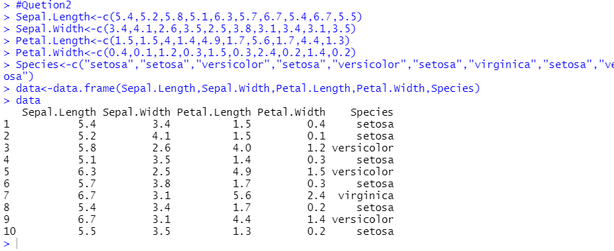

#a

mean(Sepal.Length)

median(Sepal.Length)

#b

mode(data$Species)

#c

sd(Petal.Width)

var(Petal.Width)

#d

a<-(1.5-min(Sepal.Width))/(max(Sepal.Width)-min(Sepal.Width))

a

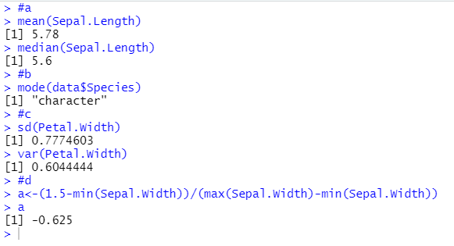

#e

m<-mean(Petal.Length)

n<-sd(Petal.Length)

znorm<-function(x){(x-m)/n}

data$znorm_Petal.Length<-znorm(data$Petal.Length)

data

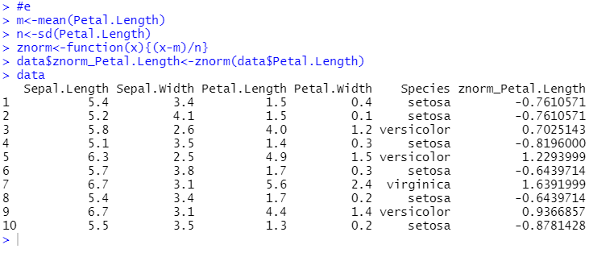

#Question3

n=as.integer(readline("Enter a number to find factorial: "))

fact=1

if(n<0){

print("Factorial does not exist.")

}else if(n==0){

print("Factorial is 1 ")

}else{

for(i in 1:n){

fact=fact*i

}

print(paste("Factorial is", fact))

}

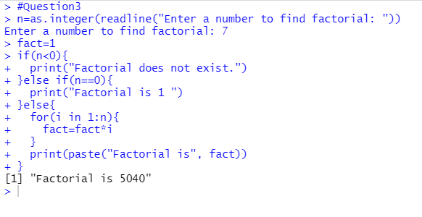

#Question4

n<-as.integer(readline(prompt="Input a number : "))

x<-1

a<-c()

for(i in 1:n)

{

t<-i

s<-0

while(t!=0) {

r<-as.integer(t%%10)

s<-s+(r^3)

t<-t/10

}if(s==i){

a[x]<-i

x<-x+1

}}

cat("The armstrong numbers b/w 1-",n," are:", a)

#Question5

EmployeeID<-c(1:20)

ManagerID<-c(0,1,2,3,3,3,3,4,4,4,3,4,4,3,3,1,2,2,2,2)

Title<-c("Chief Executive Officer","Vice President Engineering","Engineering Manager","Senior Tool Designer","Design Engineer","Design Engineer","Research and Development Manager","Research and Development Engineer","Research and Development Engineer","Research and Development Manager","Senior Tool Designer","Tool Designer","Tool Designer","Senior Design Engineer","Design Engineer","Marketing Manager","Marketing Assistant","Marketing Specialist","Marketing Assistant","Marketing Assistant")

BirthDate<-as.Date(c('1969-01-29','1971-08-01','1974-11-12','1974-12-23','1952-09-27','1959-03-11','1987-02-24','1986-06-05','1979-01-21','1984-11-30','1978-01-17','1959-07-29','1989-05-28','1979-06-16','1961-05-02','1975-03-19','1987-05-03','1978-03-06','1978-01-29','1975-03-17'))

MaritalStatus<-c("S","S","M","S","M","M","M","S","M","M","S","M","M","S","M","S","S","S","S","M")

Gender<-c("M","F","M","M","F","M","M","F","F","M","M","M","F","M","F","M","M","M","F","F")

data<-data.frame(EmployeeID,ManagerID,Title,BirthDate,MaritalStatus,Gender)

data

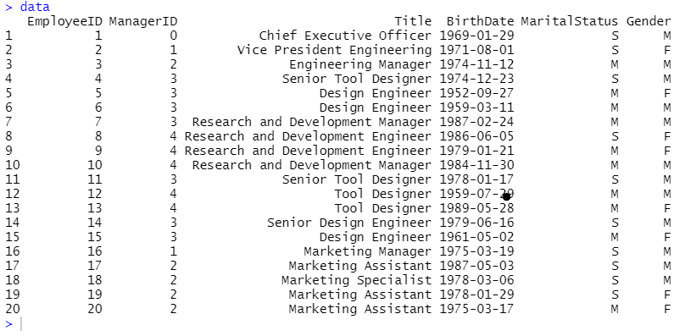

#1

data$Age<-as.numeric(difftime(Sys.Date(),BirthDate,units="weeks"))/52.25

data

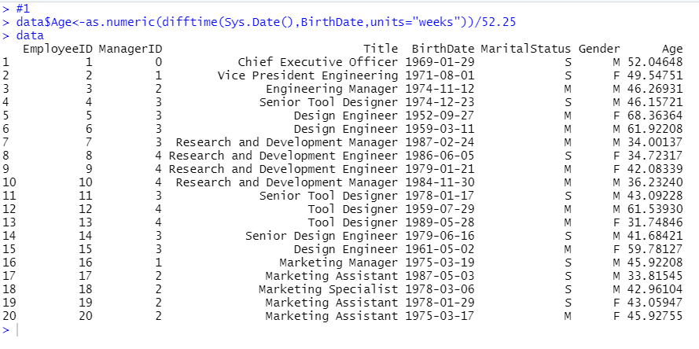

#2

mean(data$Age)

median(data$Age)

var(data$Age)

sd(data$Age)

#3

for(i in 1:20)

{if(data[i,6]=='F'){

print(data[i,])

}}

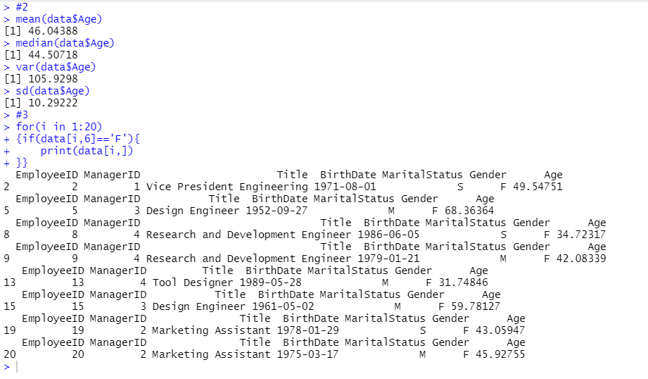

#4

for(i in 1:20)

{if(data[i,6]=='M'&&data[i,5]=='S'){

print(data[i,])

}}

#5

for(i in 1:20)

{if(data[i,3]=='Marketing Assistant'&&data[i,5]=='S'){

print(data[i,])

}}

