Valiveti Manikanta Bhuvanesh

19BCD7088

L55+L56

**1(a)**

MC<-mtcars

MC

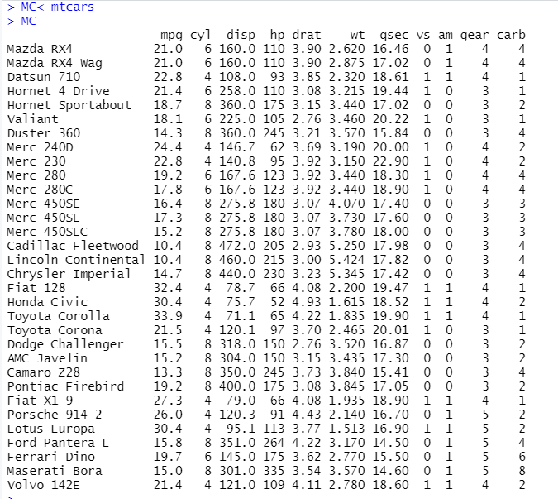

1(b)

MC[order(MC$mpg),]

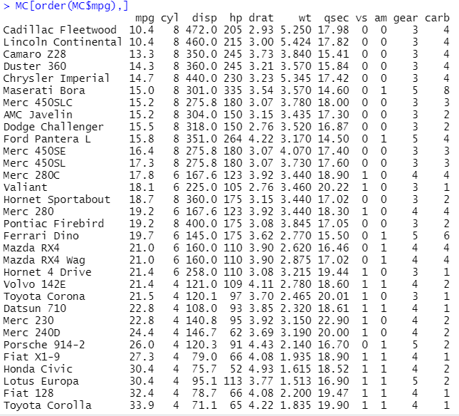

1(c)

MC[order(MC$cyl,decreasing="TRUE"),]

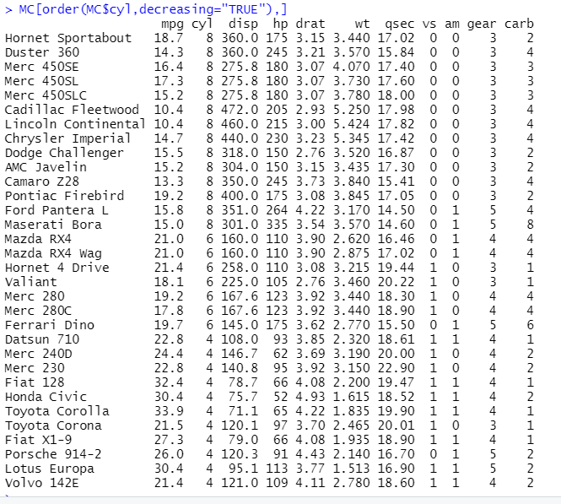

1(d)

MC[duplicated(MC$hp),]

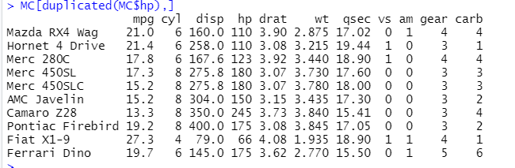

1(e)

MC[!duplicated(MC$gear,MC$carb),]

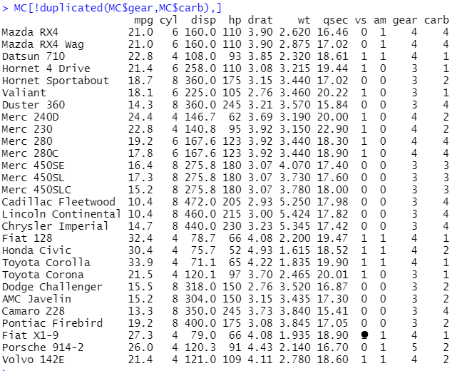

1(f)

m<-MC$mpg

mean(m)

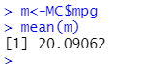

1(g)

mo <- c(MC$drat)

mode <- unique(mo)

mode[which.max(tabulate(match(mo, mode)))]

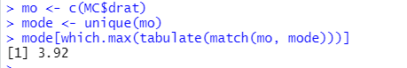

1(h)

price<-c(seq(10000000,320000000,10000000))

price

MC<-cbind(MC,price)

MC

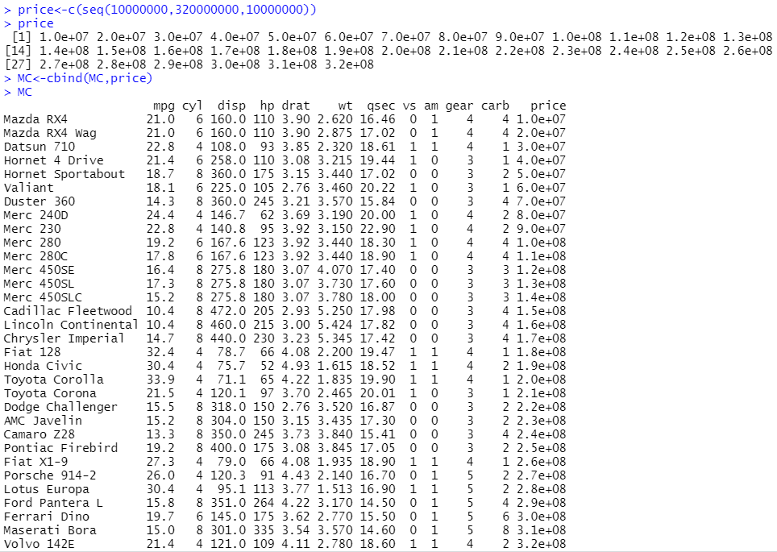

1(i)

MC[unique(MC$vs),]

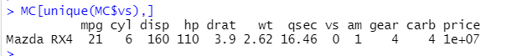

1(j)

MC[!duplicated(MC$am),]

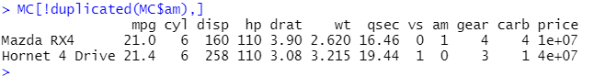

1(k)

var(MC$disp)

sd(MC$disp)

mean(MC$disp)

var(MC$qsec)

sd(MC$qsec)

mean(MC$qsec)

var(MC$wt)

sd(MC$wt)

mean(MC$wt)

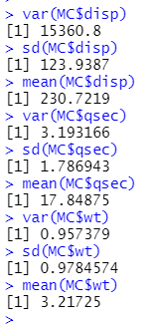

1(l)

MC[duplicated(MC$disp),]

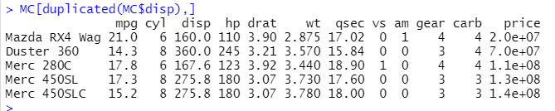

1(m)

unique(MC$disp)



1(n)

MC[!duplicated(MC$disp),]

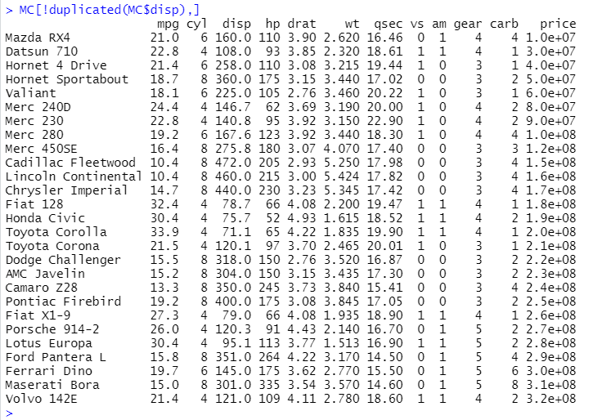

1(o)

unique(MC$cyl)

unique(MC$mpg)

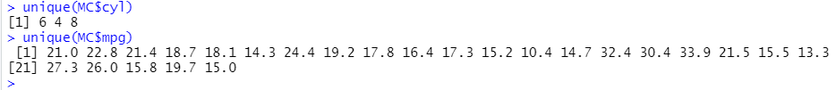

2(a)

mtcars2<-MC[c(1:5),]

mtcars2

merge(x=MC,y=mtcars2,by="mpg")

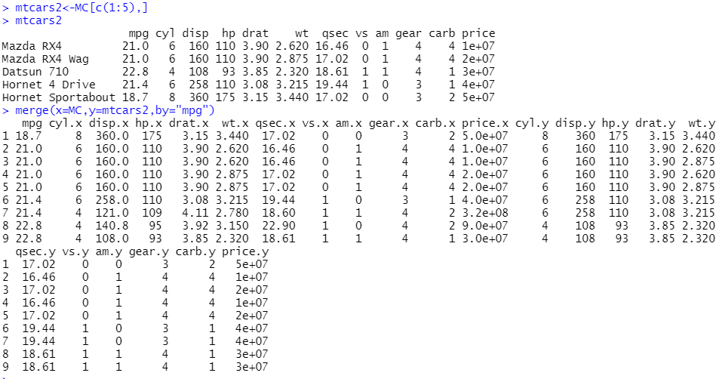

2(b)

merge(x=MC,y=mtcars2,all.x = TRUE)

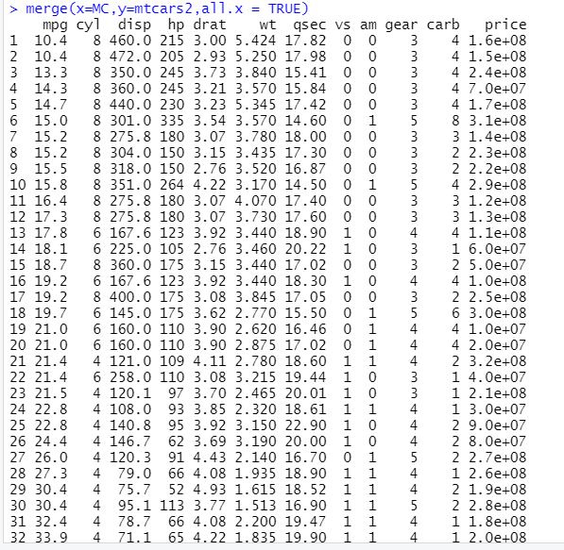

2(c)

merge(x=MC,y=mtcars2,all.y = TRUE)

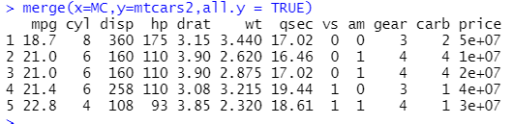

2(d)

merge(x=MC,y=mtcars2,all = TRUE)

