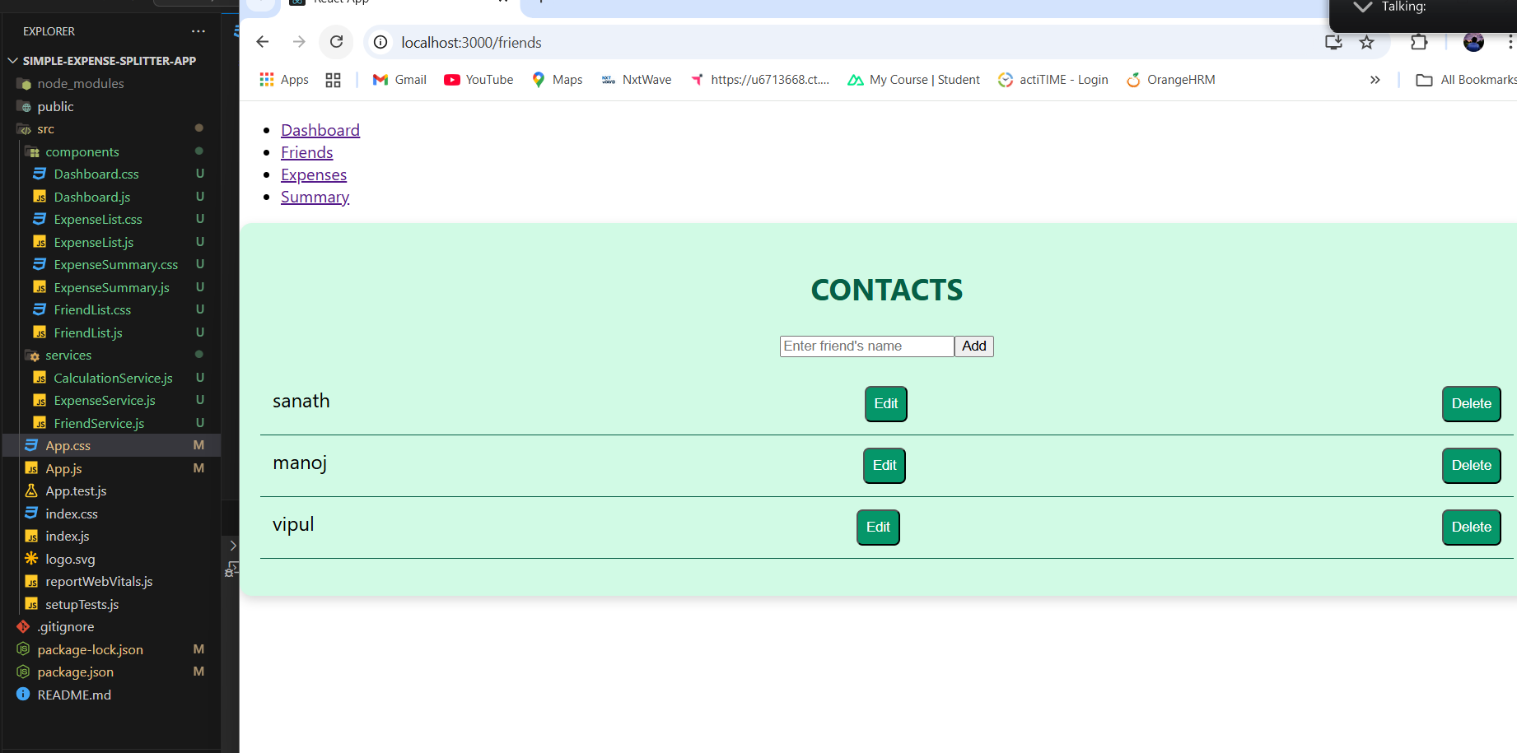

* We can add friends

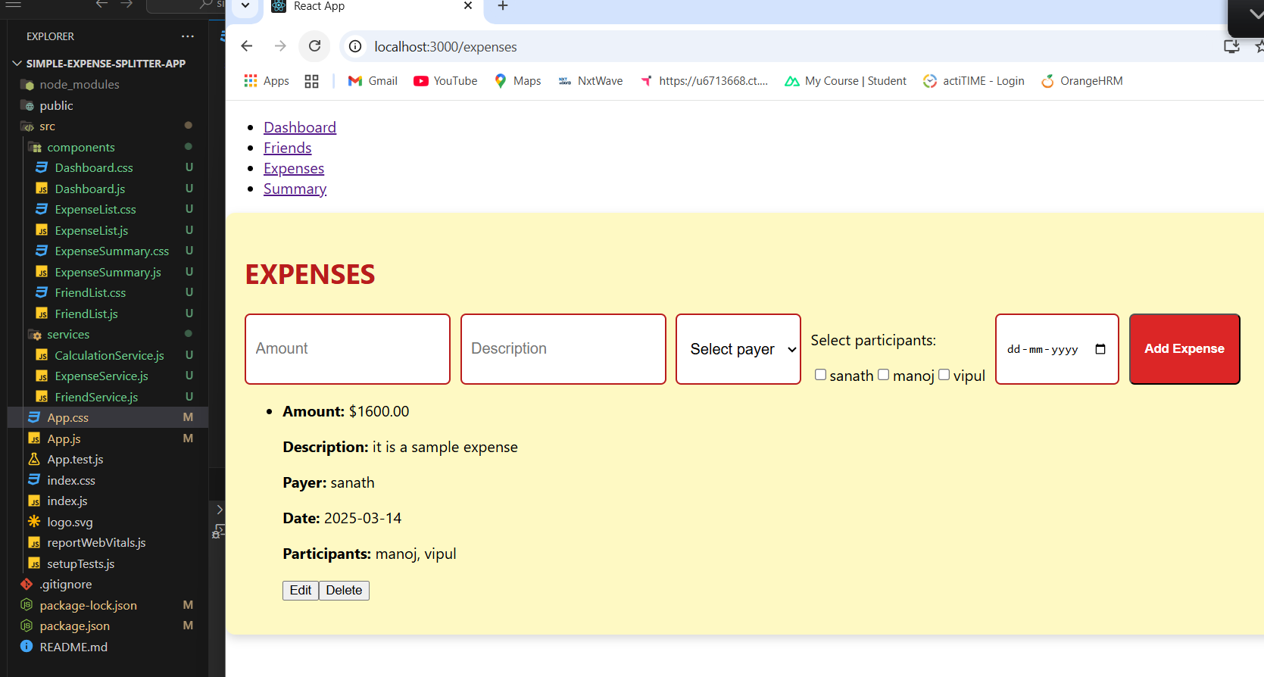

* We can add expenses here

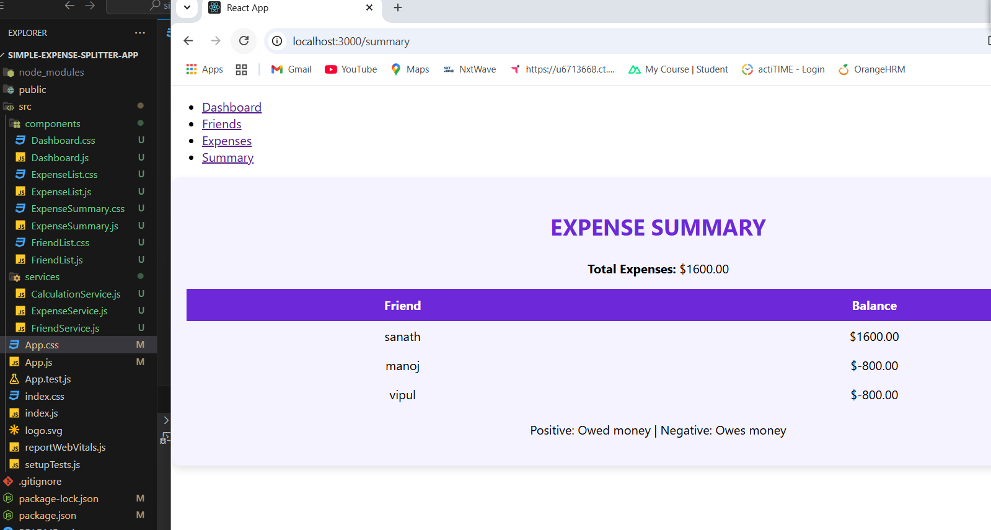

* Now it will calculate and split the amounts in this expense summary

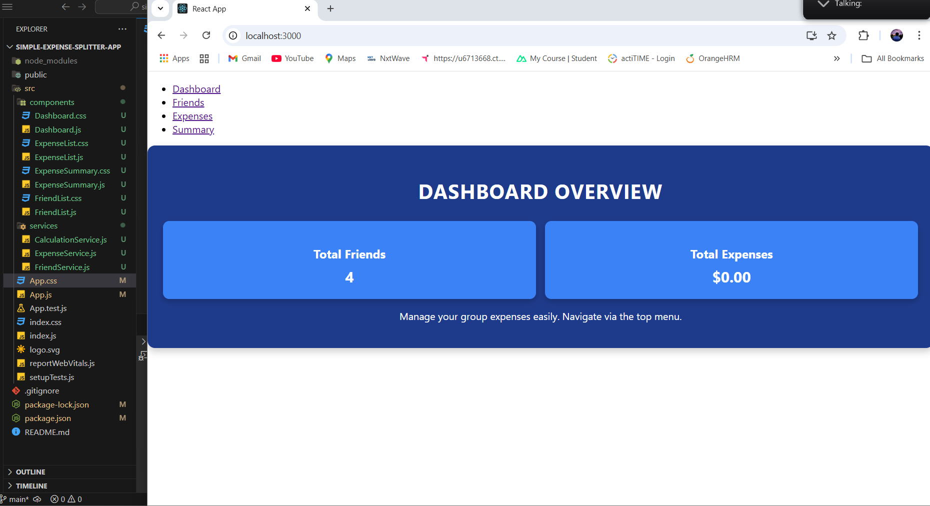

* This is a dashboard overview it will displays the total expenses and total friends