1. Created an Azure Devops account.
2. Created a project named Devopse2_AzureDevops

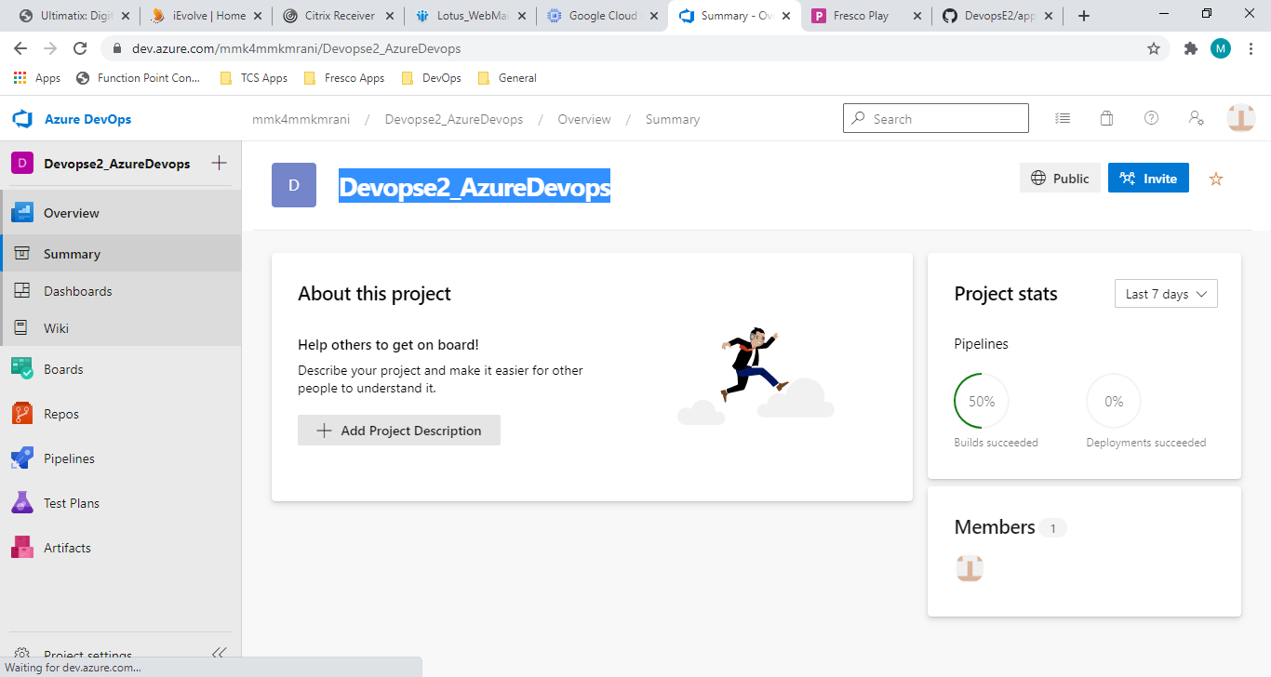

1. Created a pipeline for Continuous Integration

This pipeline does the following:

1. pulls the code from GitHub Repository
2. compiles the code using maven
3. creates a Docker image and then
4. Pushes the Docker image to Dockerhub

As a pre-requisite, the credentials for Docker, GitHub Repository are set via project settings -> Service connections:

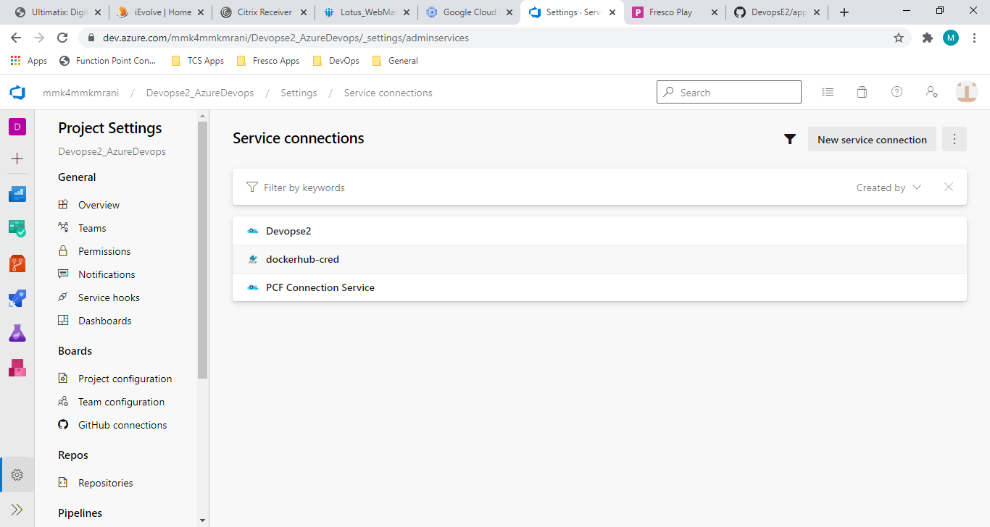

Pipeline steps:

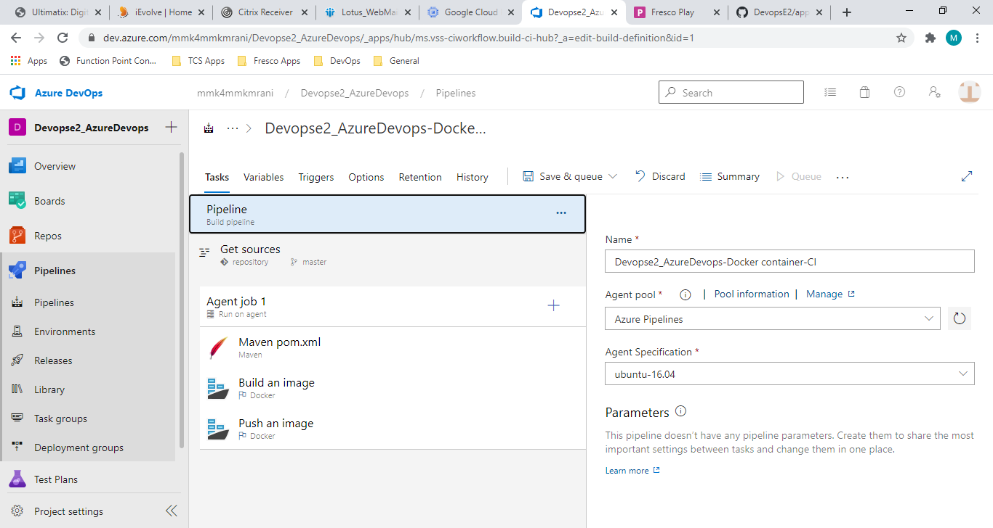

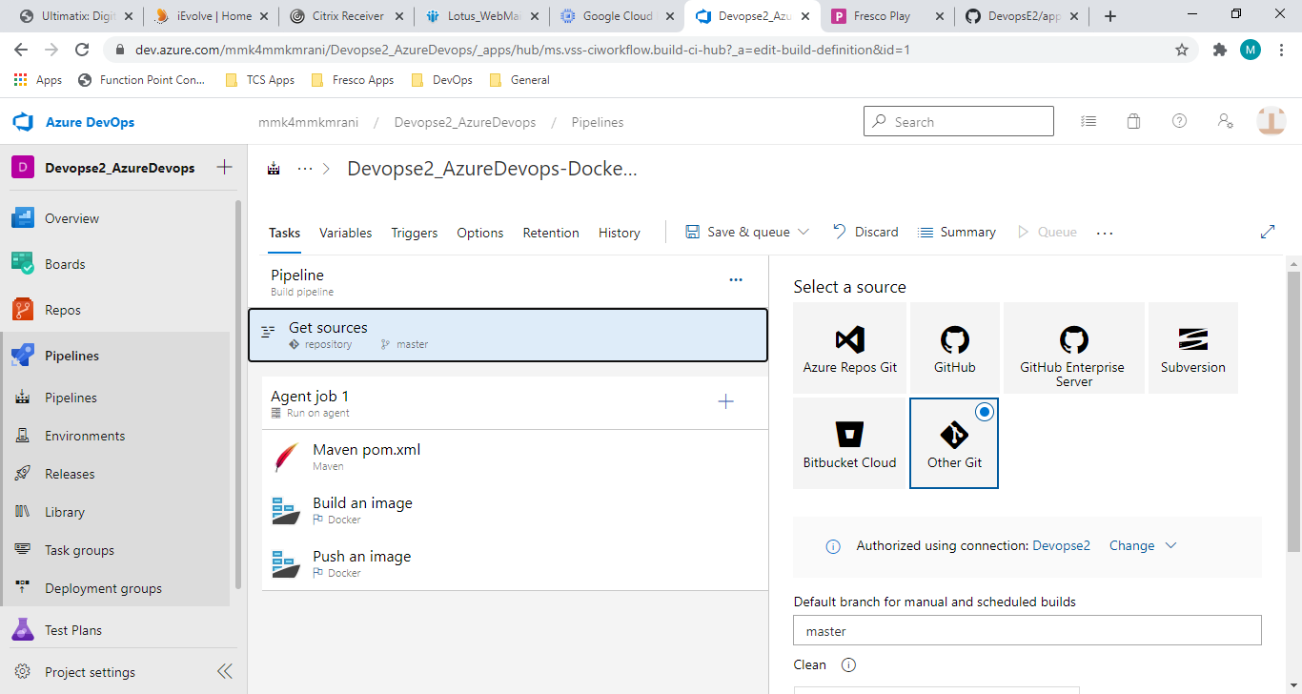

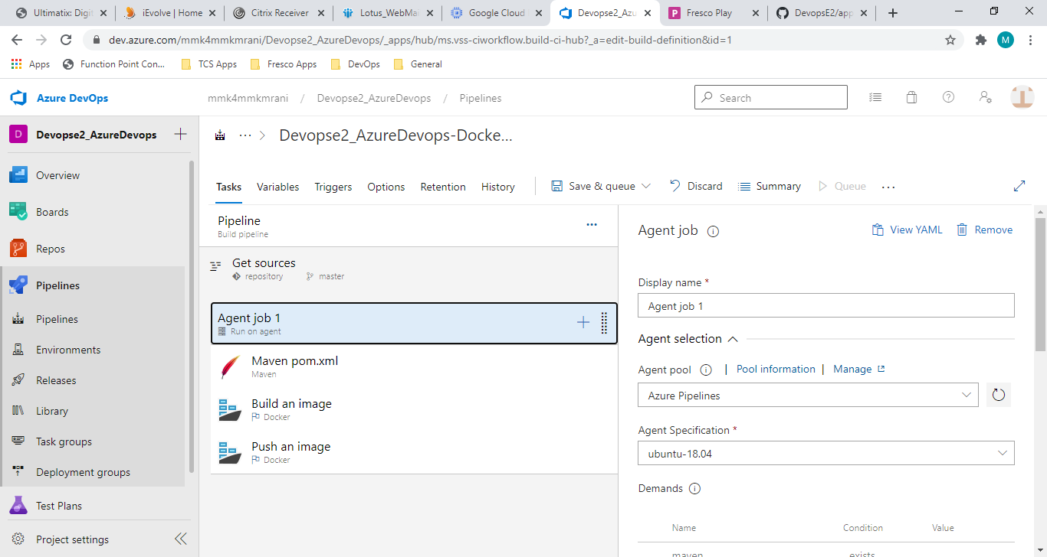

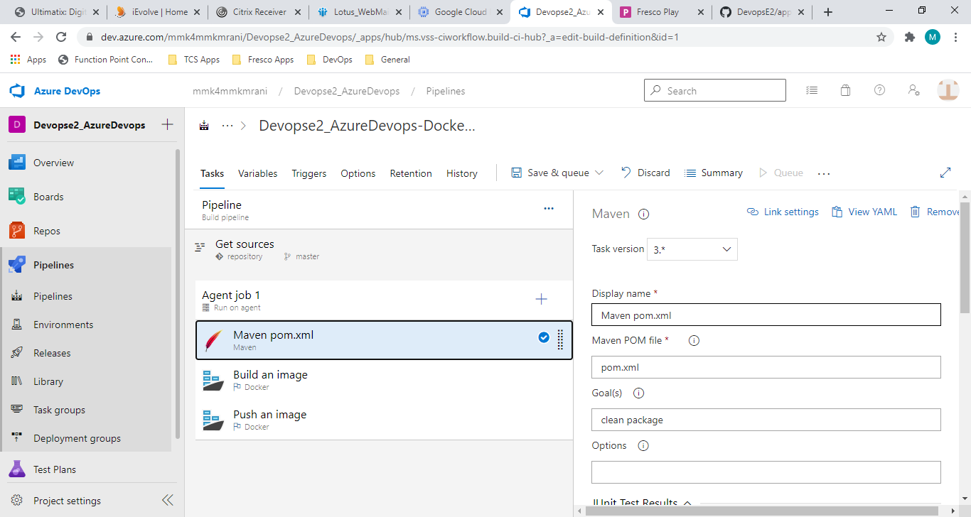

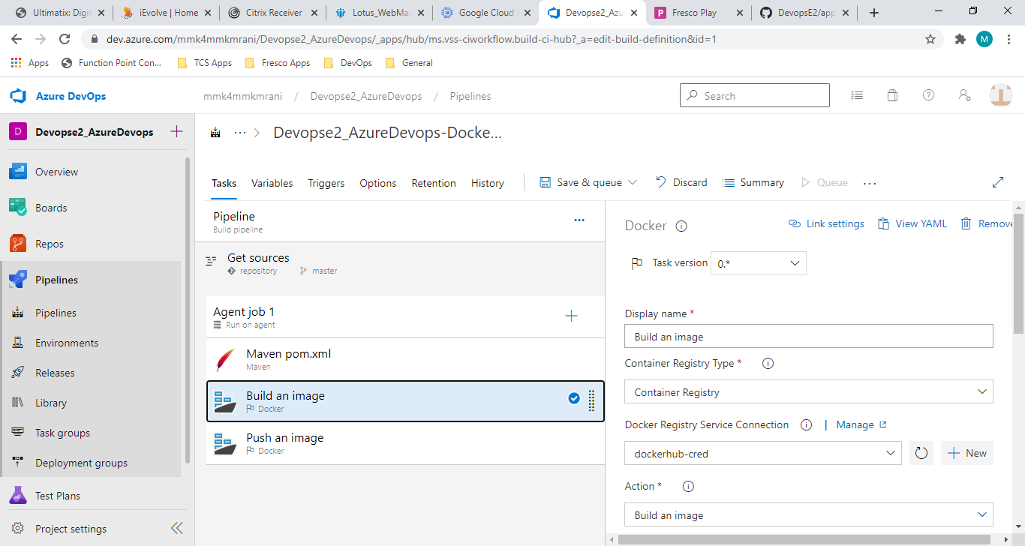

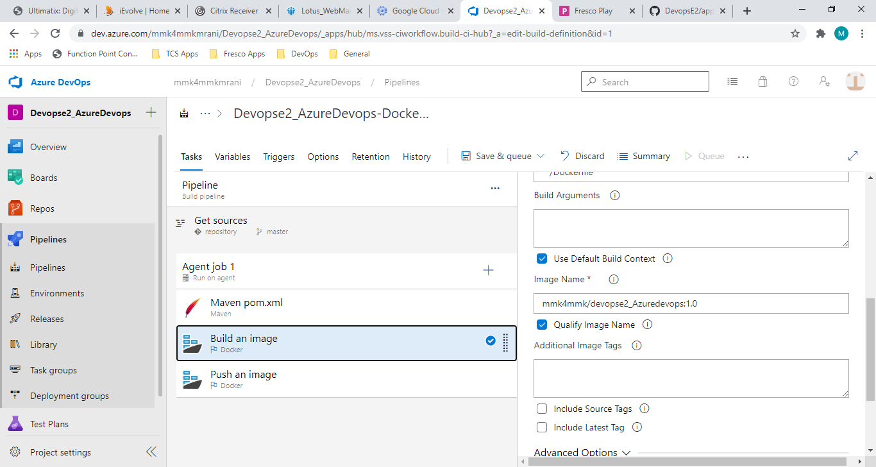

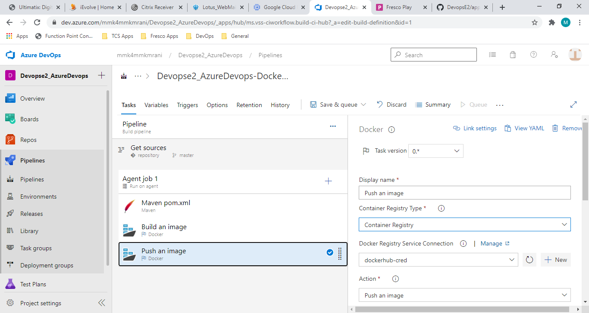

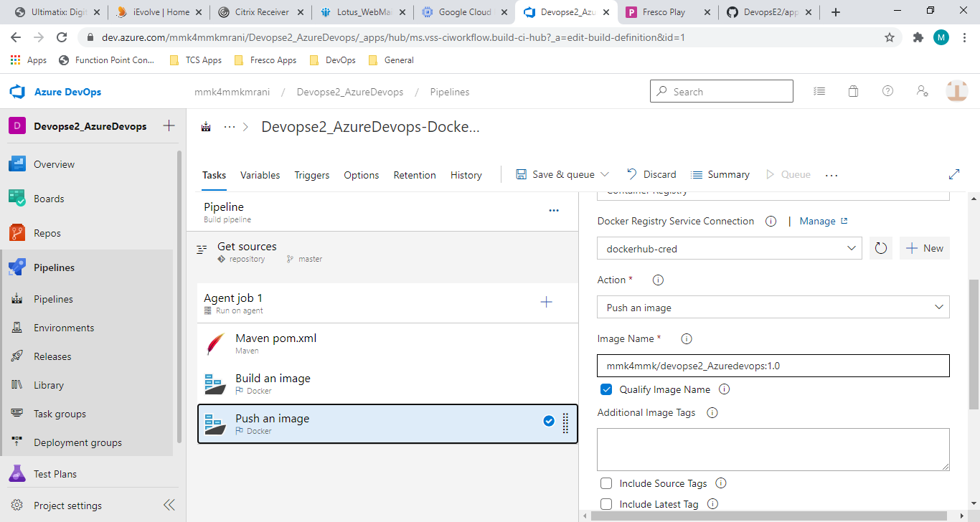

Running the pipeline:

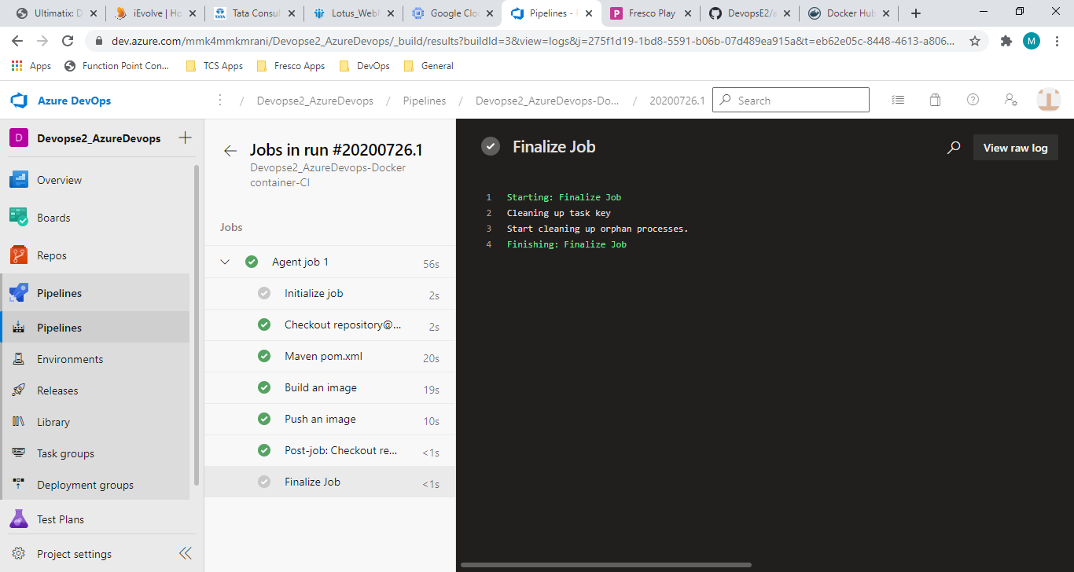

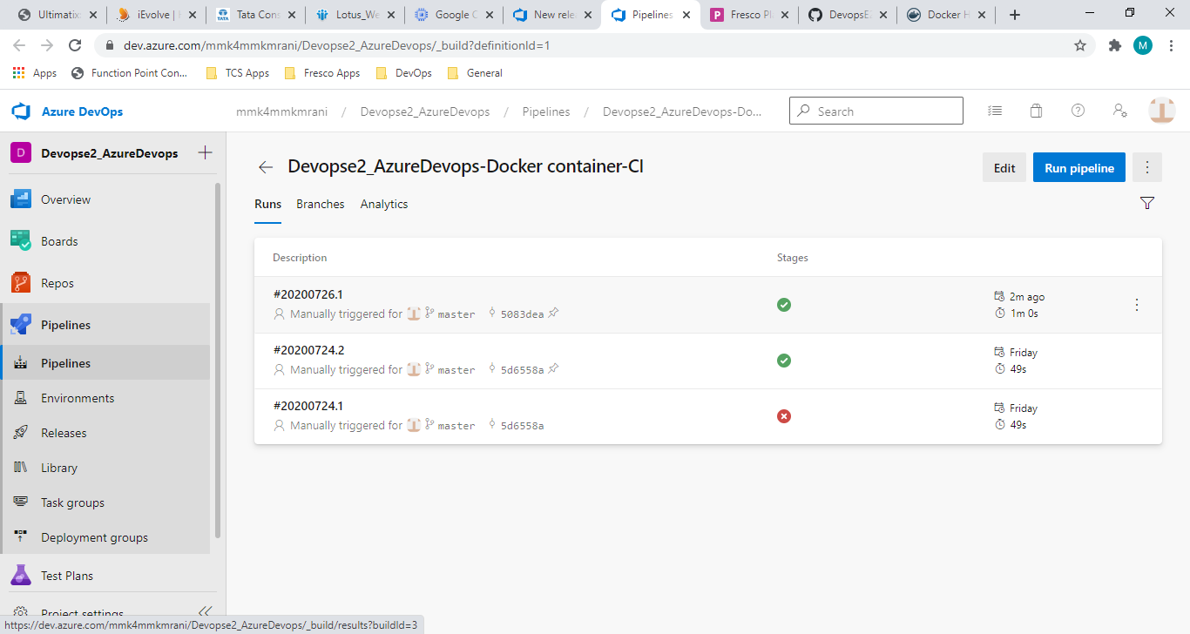

This pipeline is successfully run and the docker image is pushed to dockerhub as well:

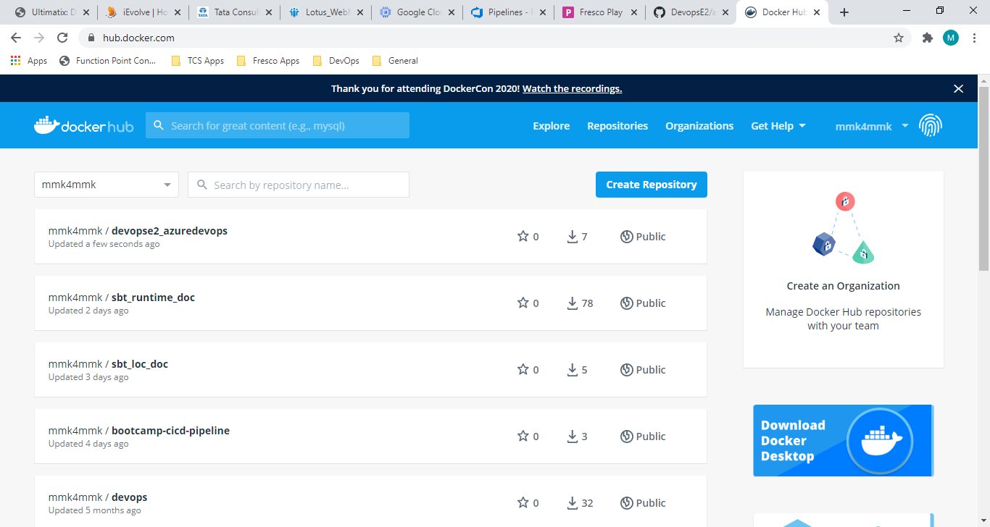

1. Created a Release pipeline for continuous delivery
2. Running the release pipeline:

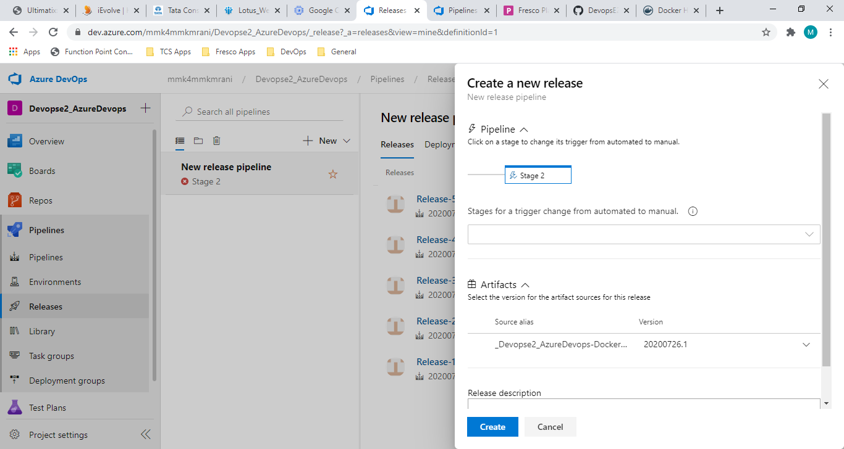

1. Completed the release pipeline and pushed the image to pcf:

