Created this document through the shell:
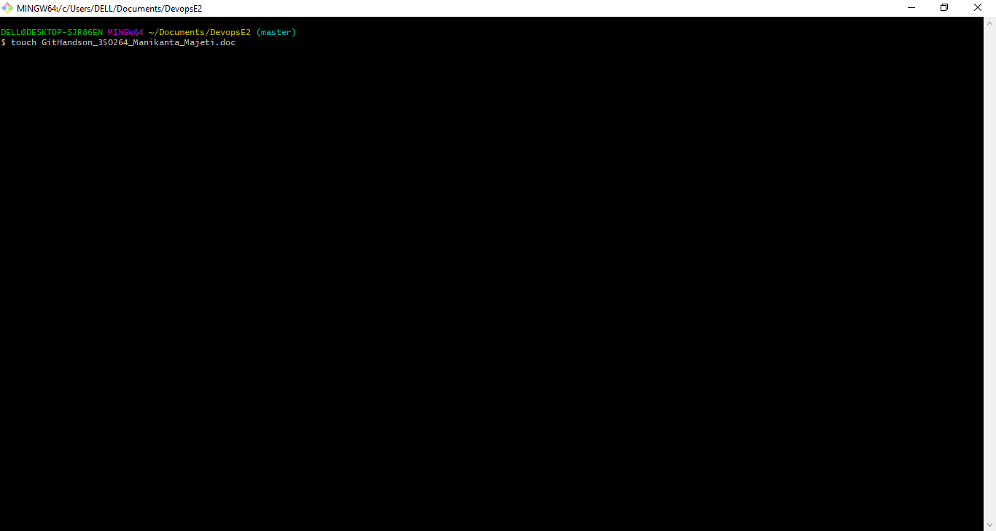
Git version:
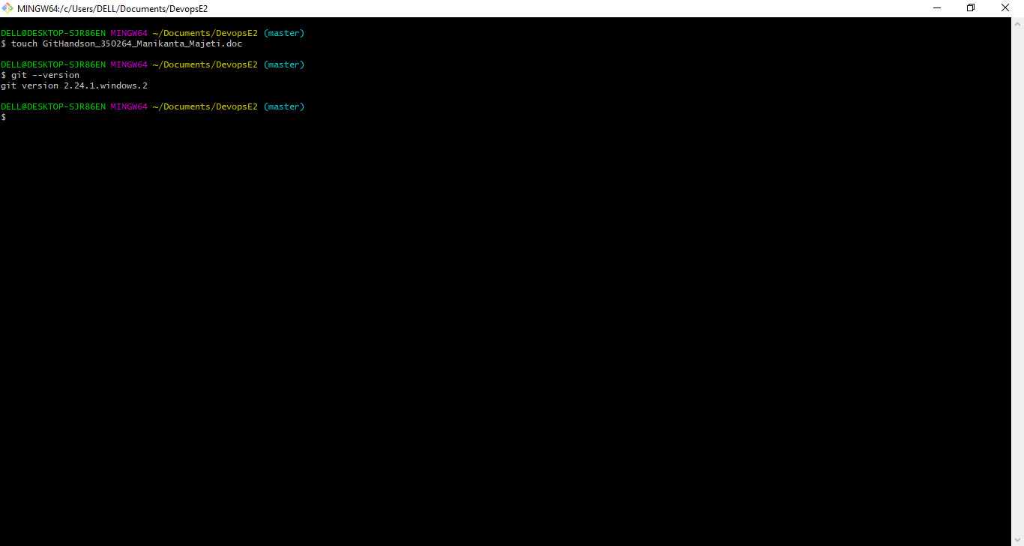
Did the Git initialization already and checking the git status:
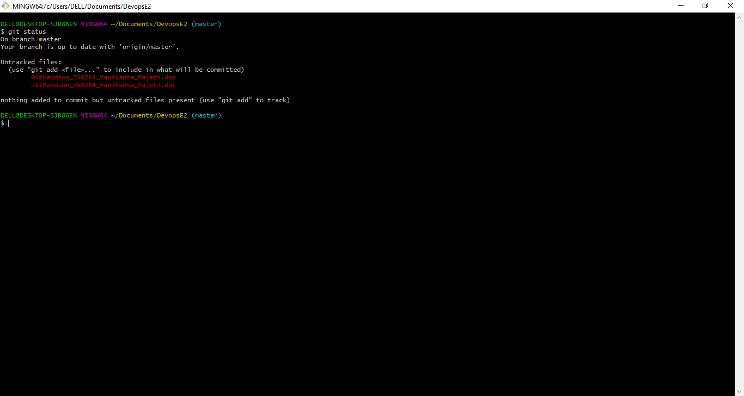
Had already configured the user name and user email. Printing them here:
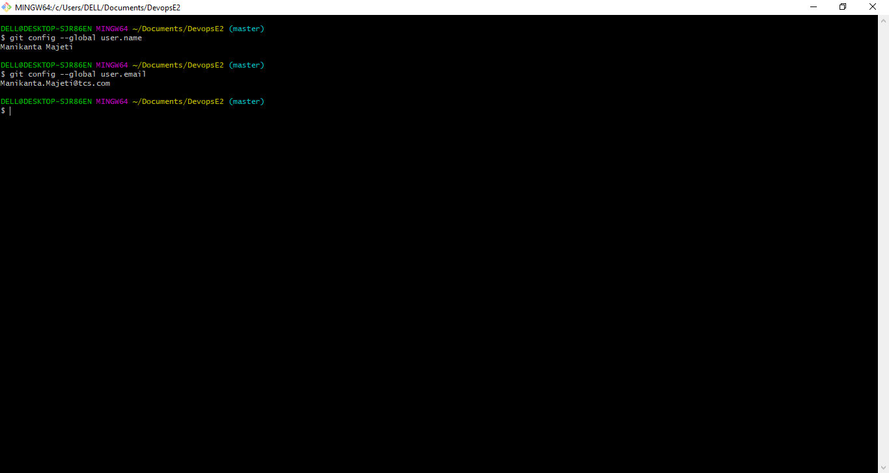
Had already added the remote with name as ‘origin’ and here is the print of it:
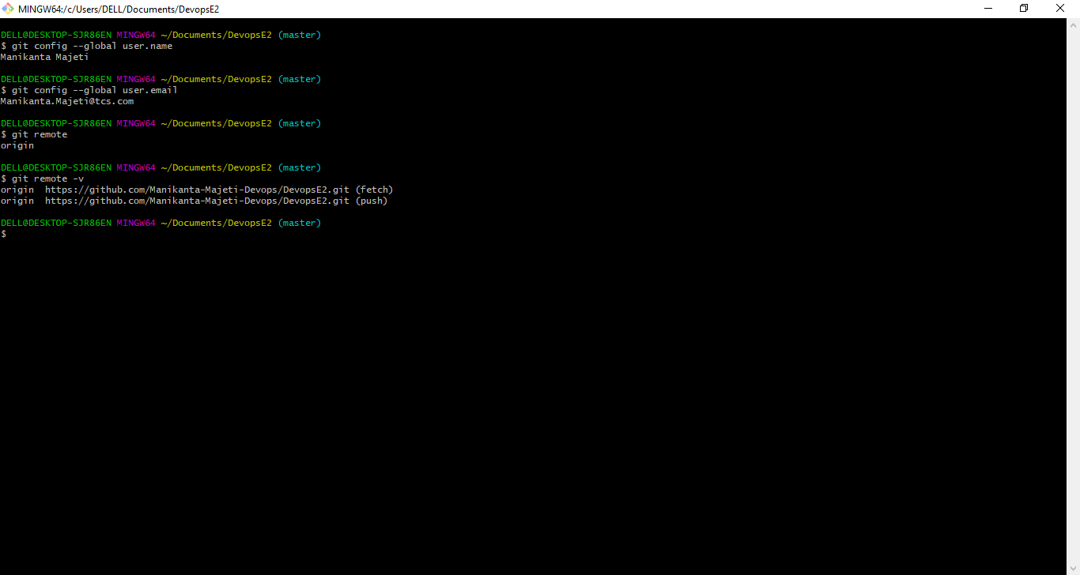
Did the cloning as well already from my GitHub Repository to local machine’s folder:
Here is a print of that folder:
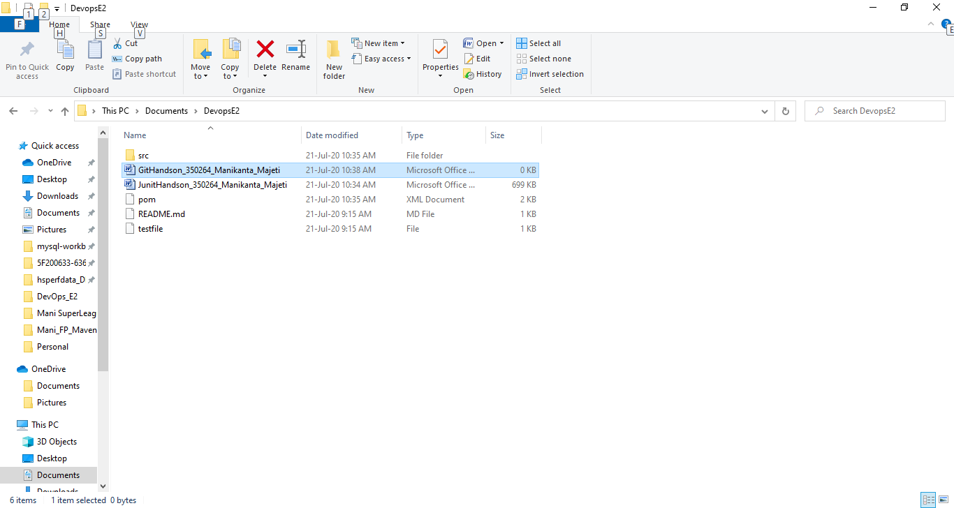

Pull from origin (remote) to local (master):
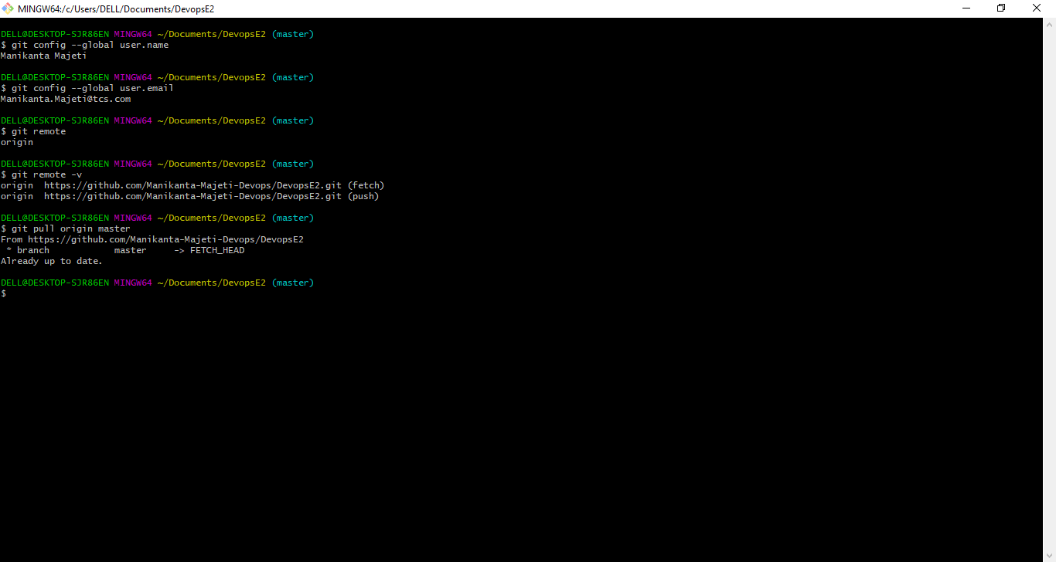
Working with branches:
Listing existing branches. ‘Master’ would be a existing branch in this.
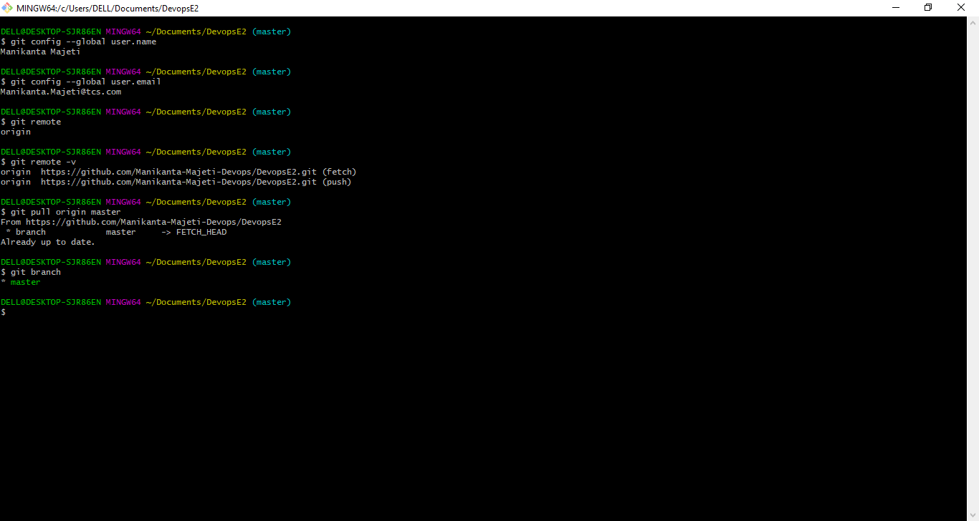
Creating a new branch (mani_branch) and listing down the branches:
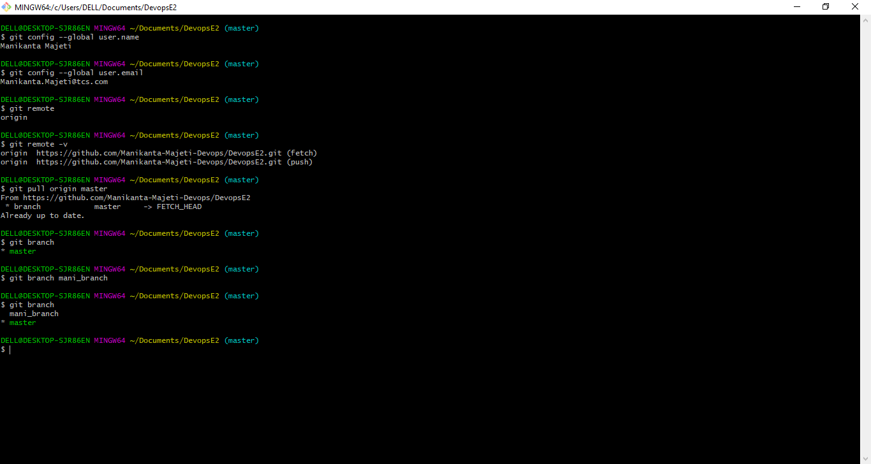
Deleting mani_branch:
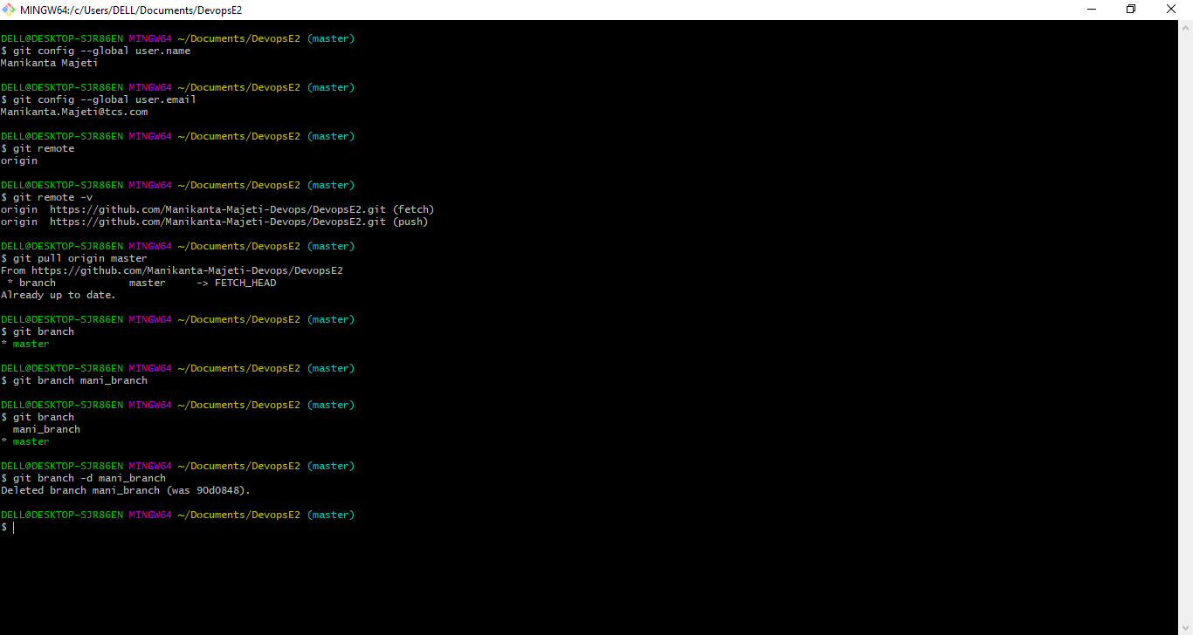
Created the mani_branch again and switched to mani_branch:
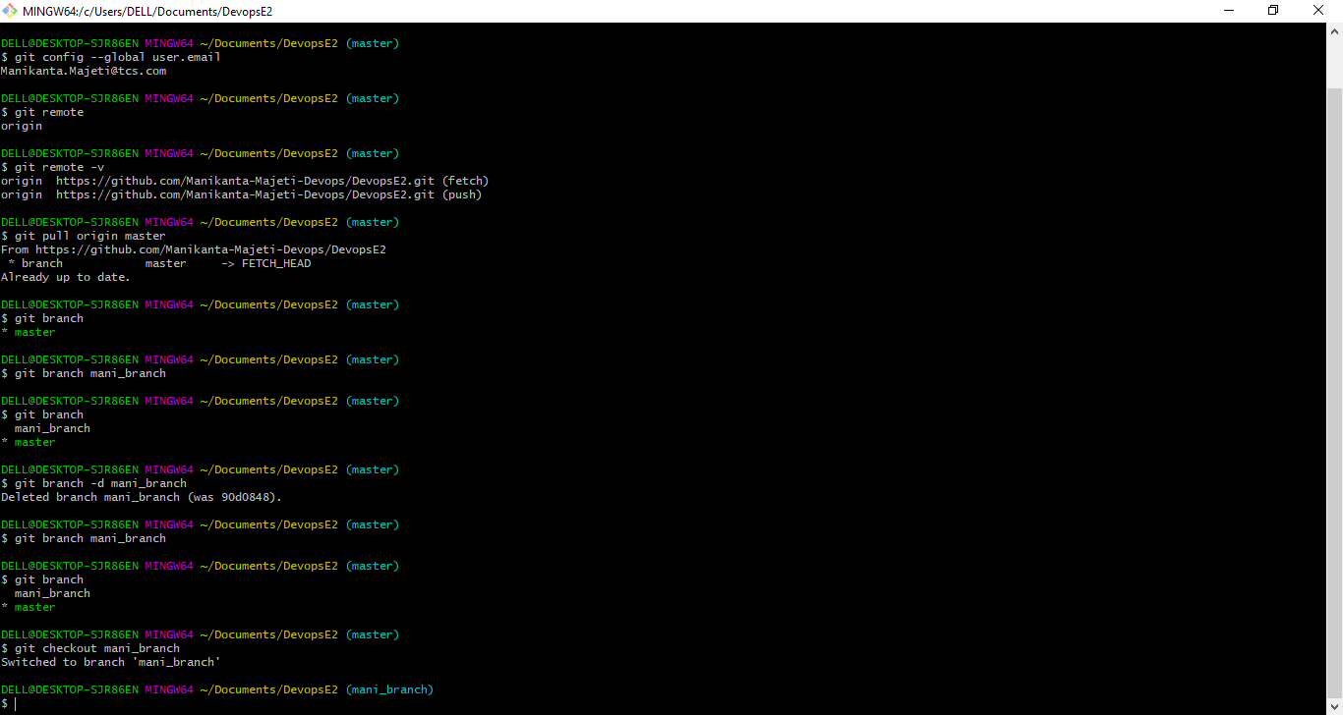
Changing the code now on MessageServiceTest.java from the location: src/test/java/com/MessageServiceTest.java
Just adding a comment and no changes to code though ☺
Did a change in this from “hello world” to “hello world from Mani”
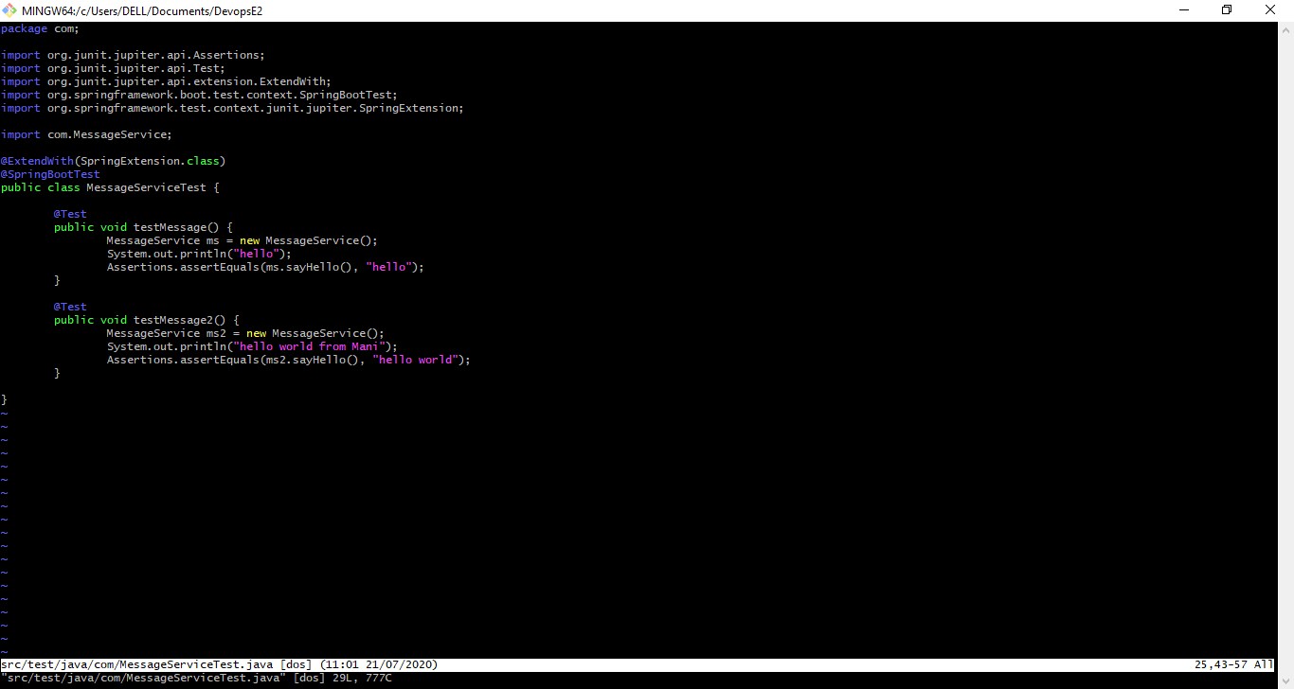
The git status:
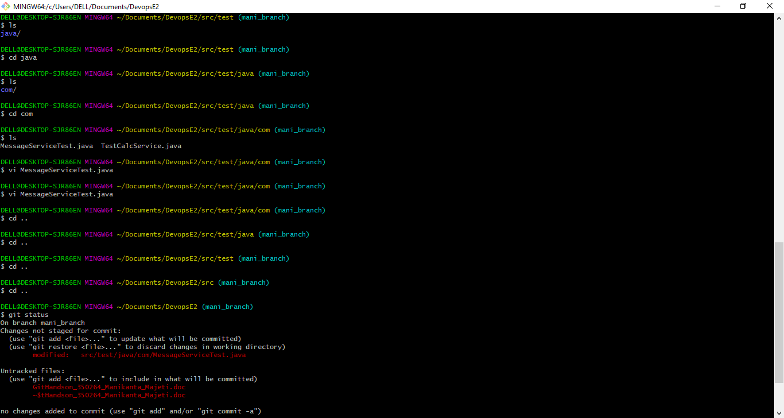
Have added to staging area using git add and then commit:
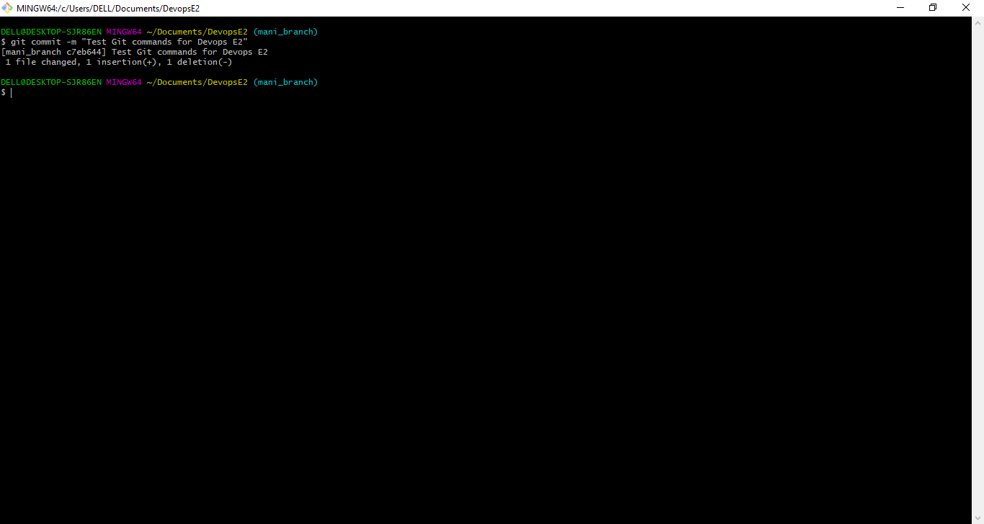
To assure again, seeing git branch – we are on mani_branch:
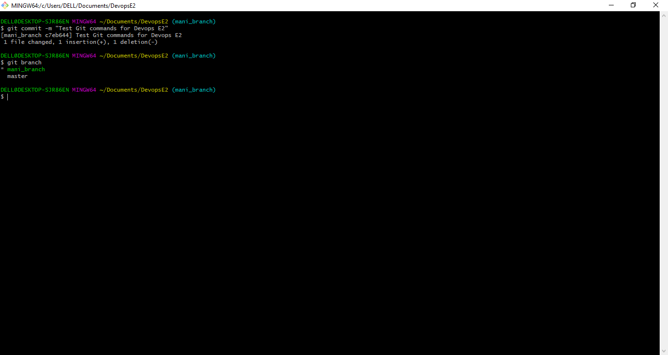
And now switching to ‘Master’ branch so that could pick the changes from mani_branch and merge:
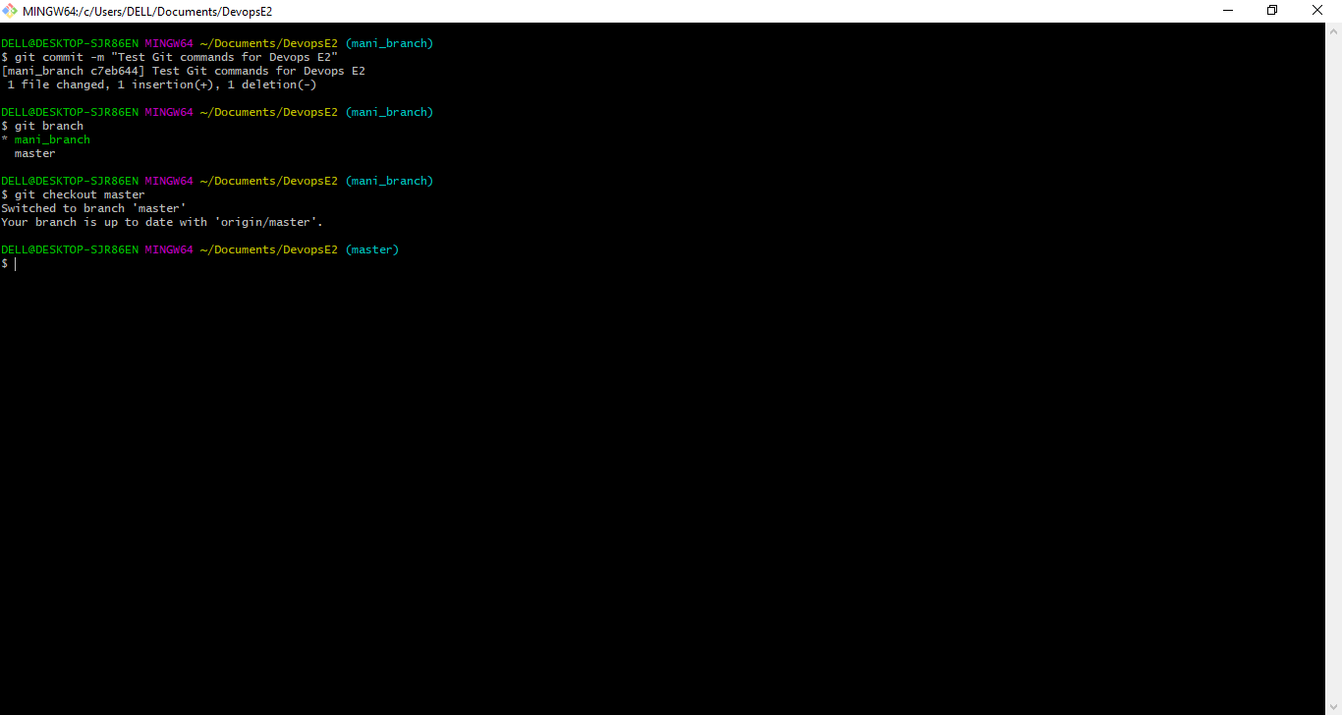
Now, let us merge the mani_branch to master branch:
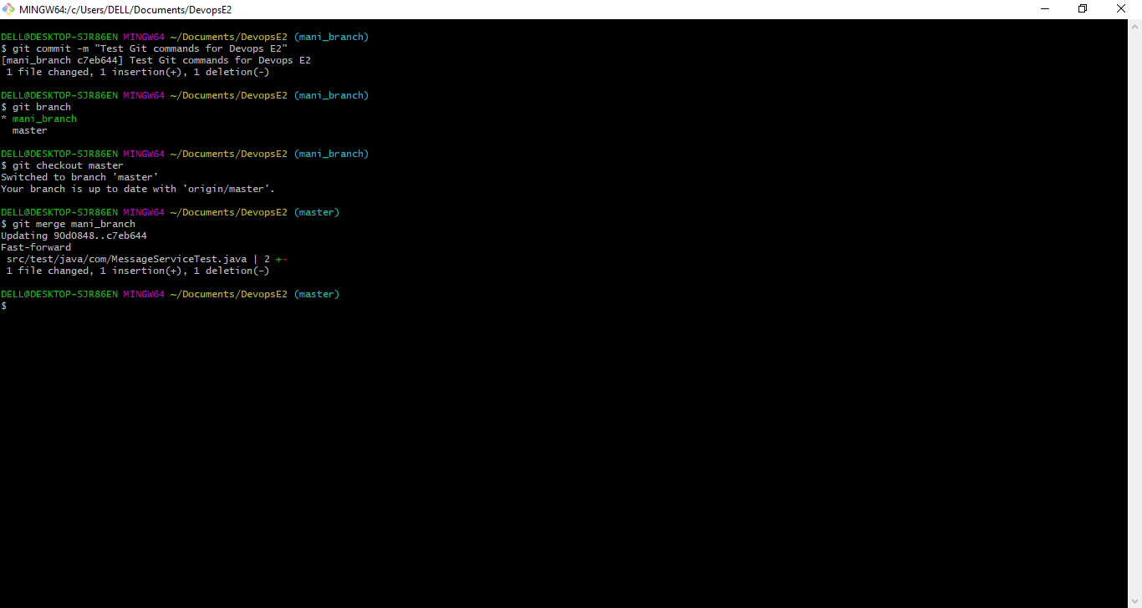
If we check for any working directory changes, there are none to stash 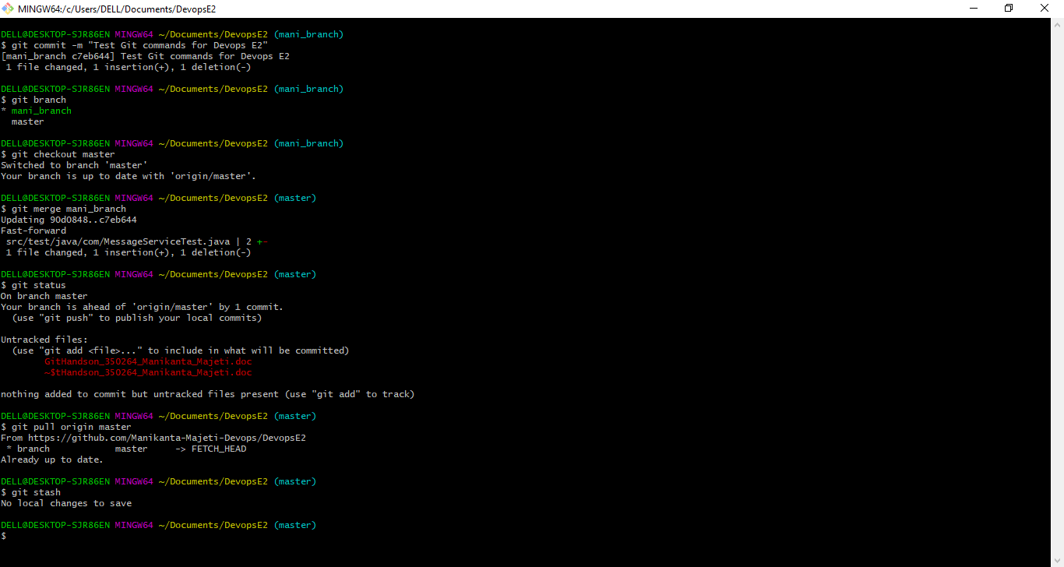
Doing changes again in src/test/java/com/MessageServiceTest.java to go back to “hello world”
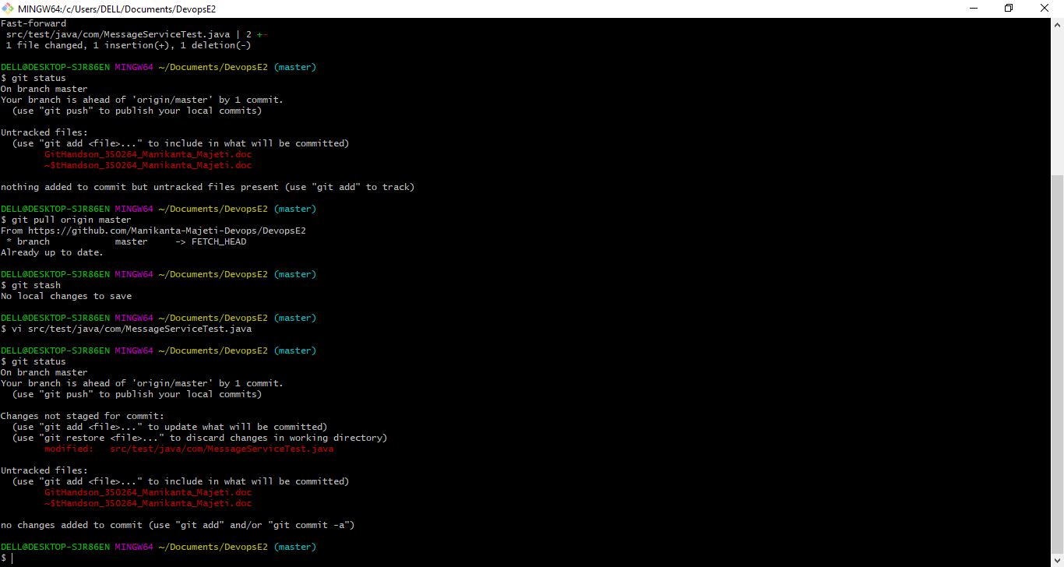
Saved the changes from working directory:
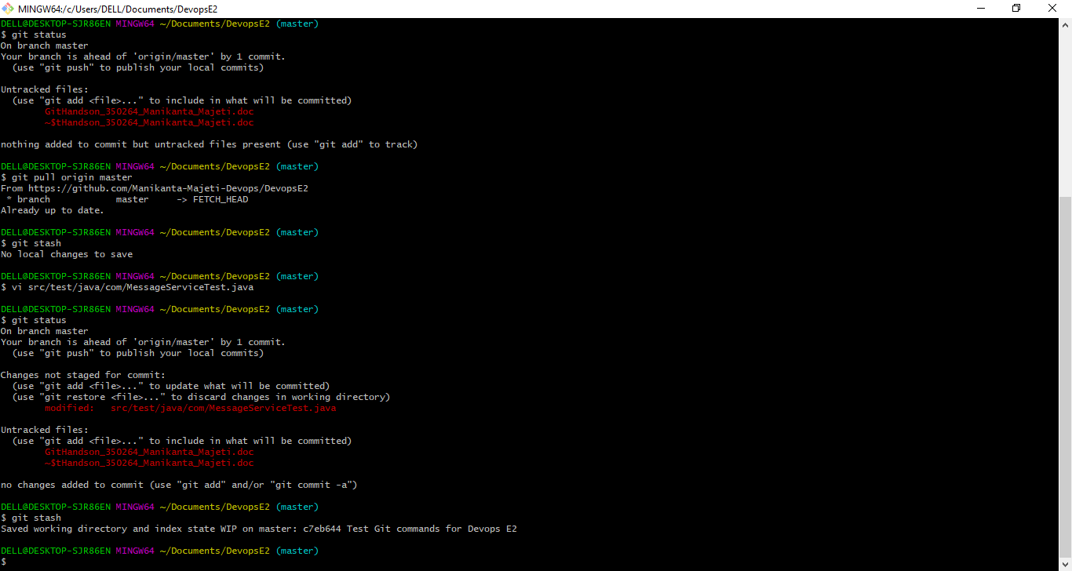
Now clearing up the working directory:
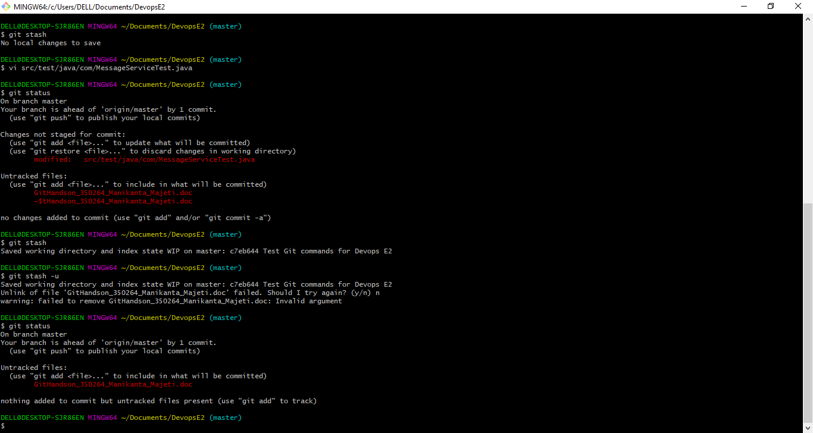
Listing down the saved changes:
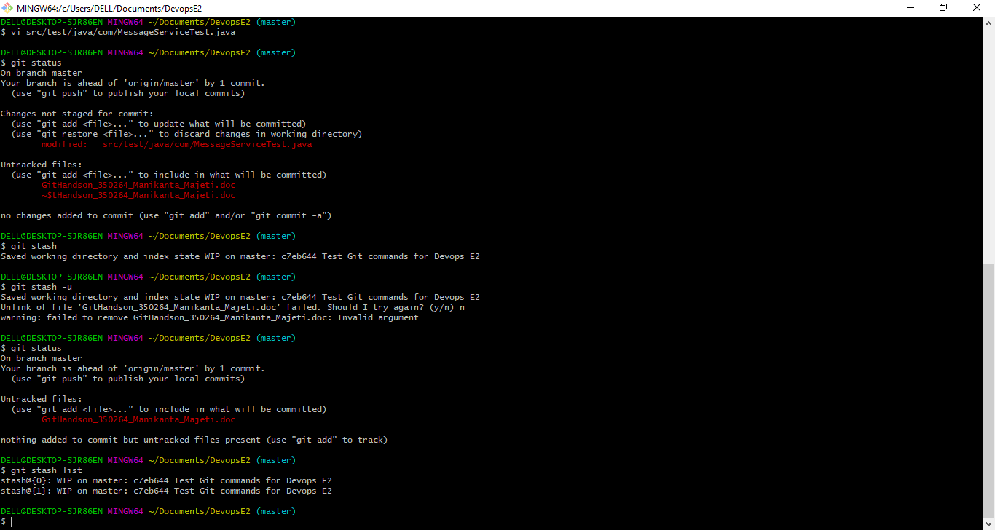
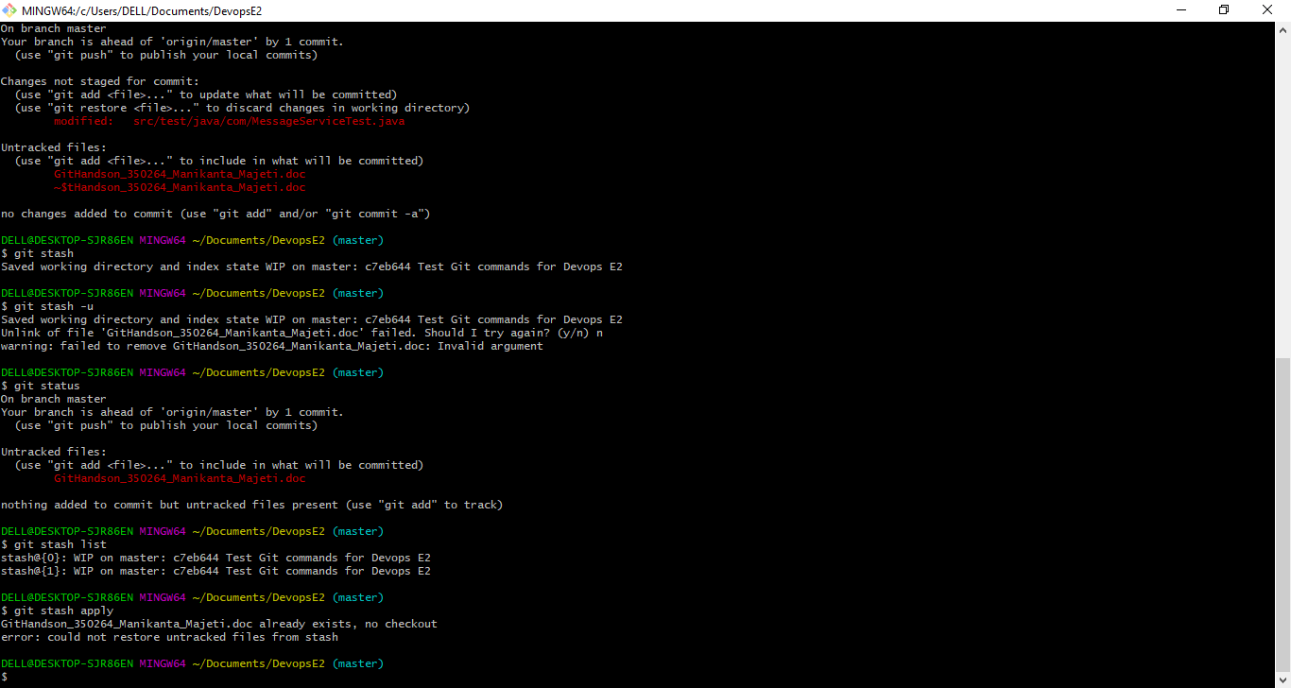
Git log:
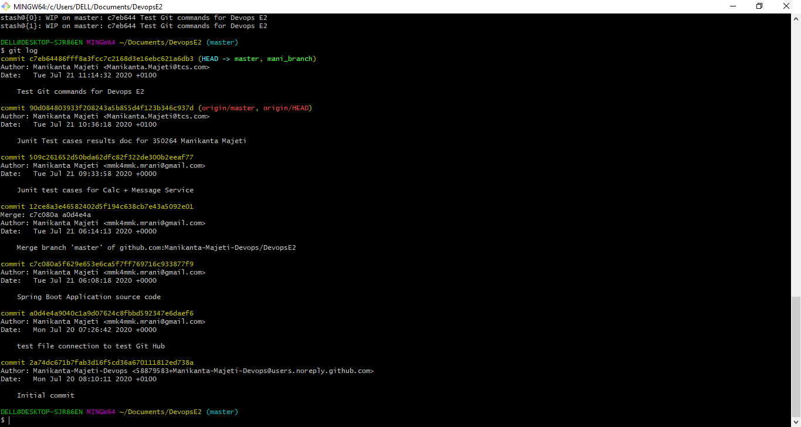
Checking the git log –oneline:
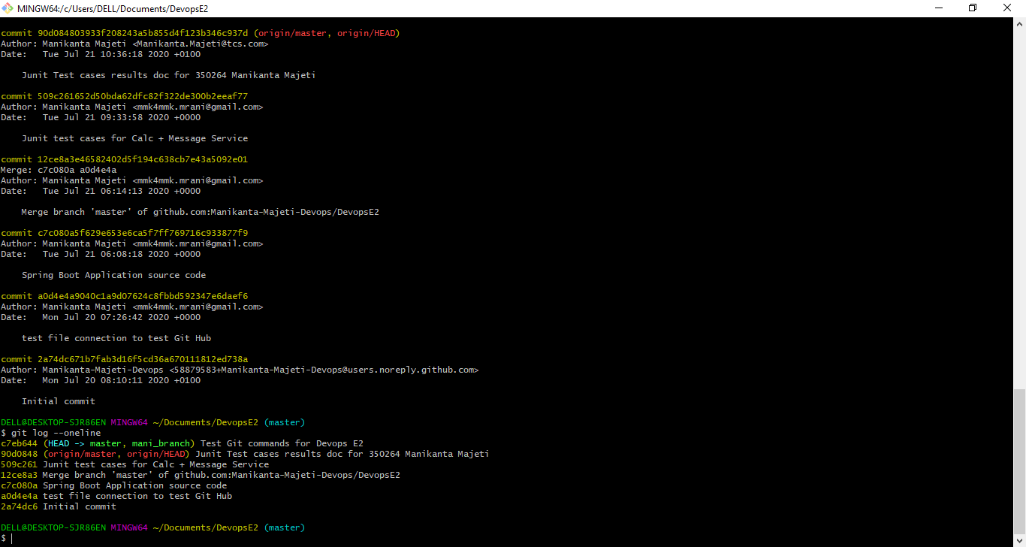
Reverting the changes:
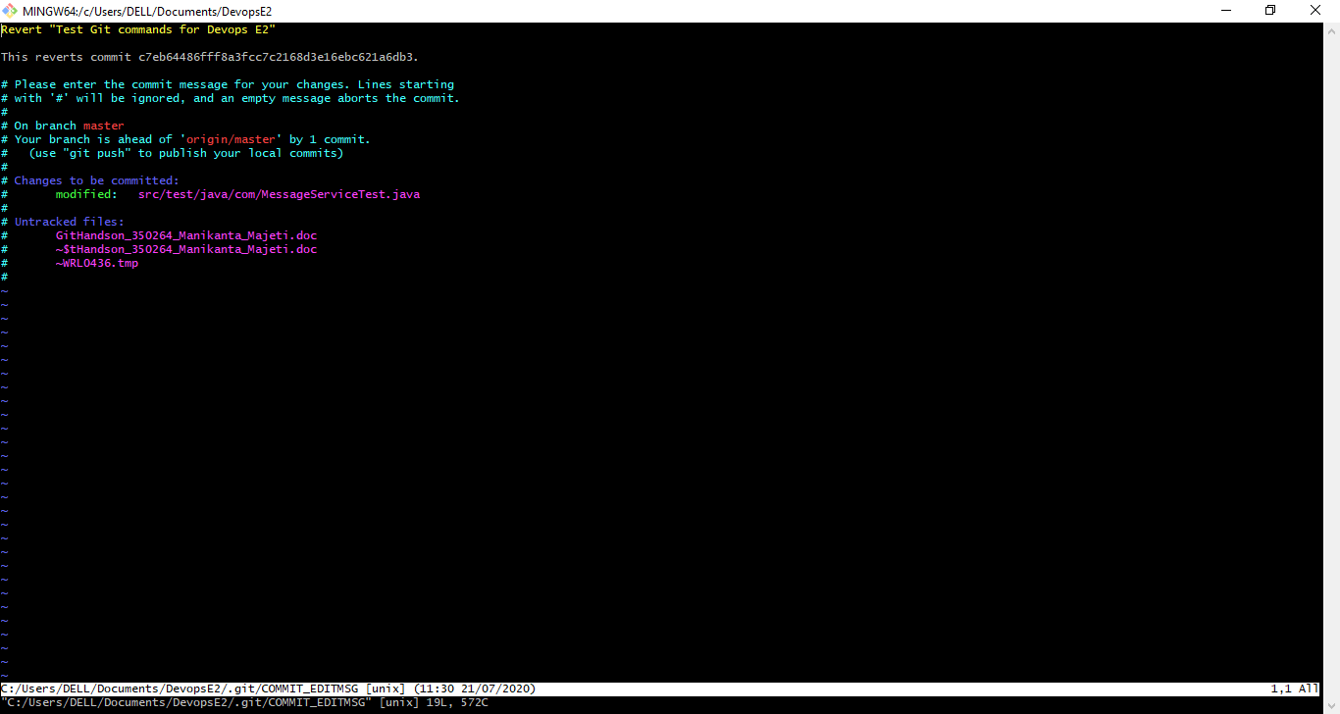
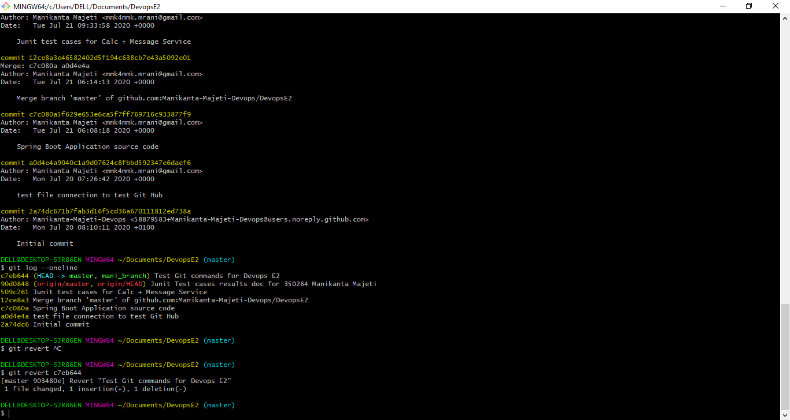
Git log post reverting:
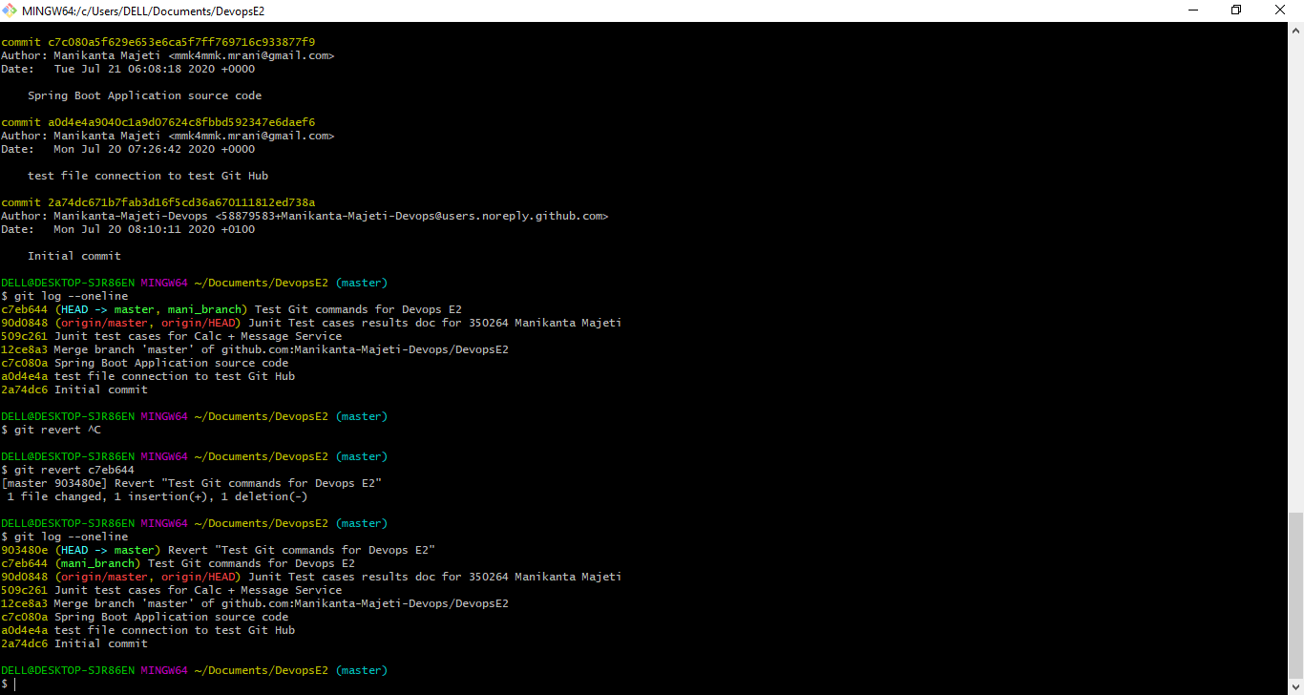
Now, git rebase:
For rebase purpose, create an exact copy of master into new_branch:
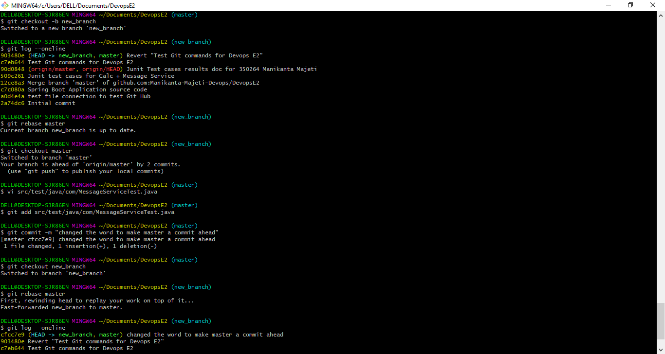
Did a commit in master so that master is ahead of new_branch by one commit:
Git rebase from master to new_branch:

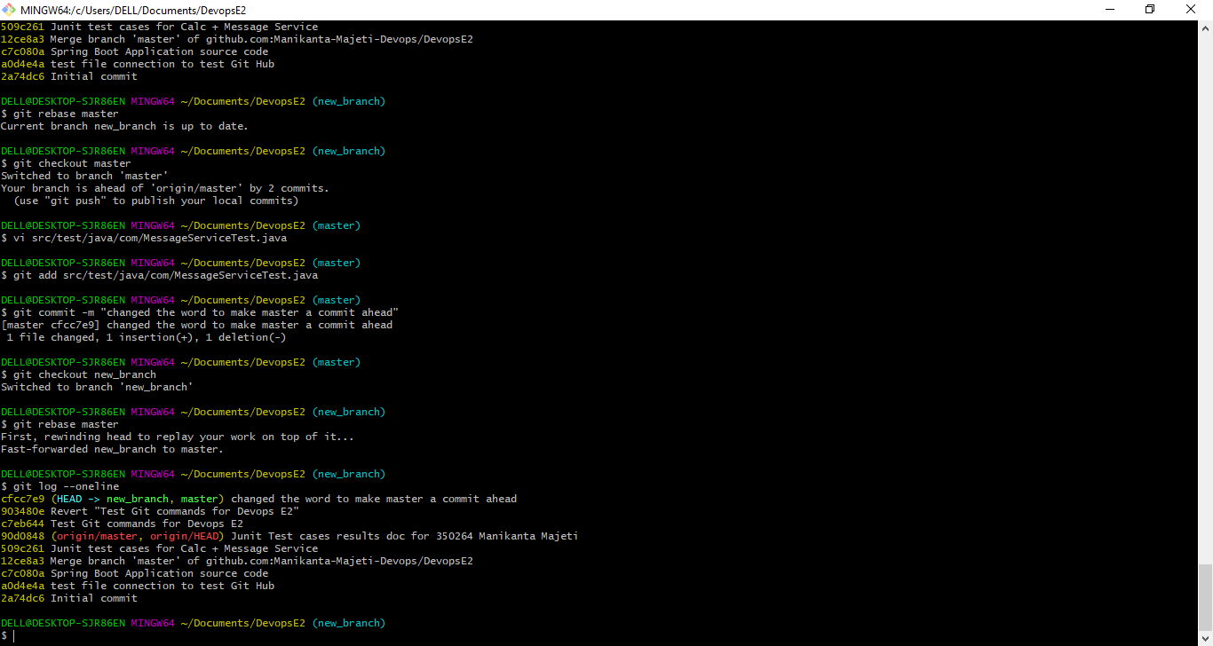
We could see the latest changes of master on to top of new_branch!!
And finally, pushed this document to GitHUB repository through Git:
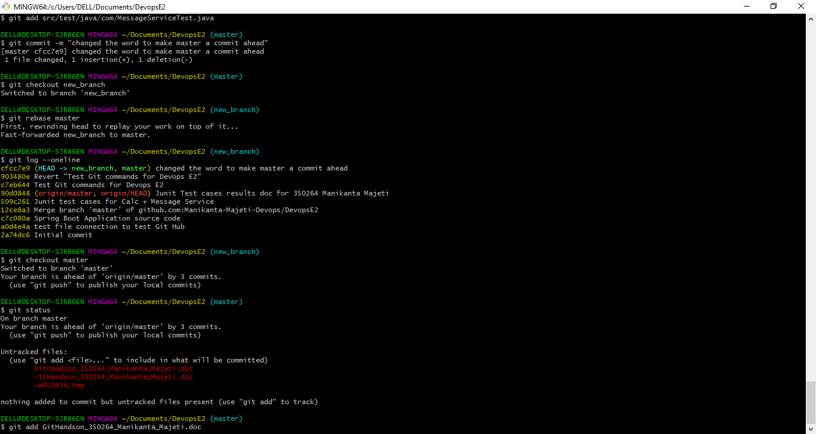
And then committed and pushed to Github.

