Service1: TestMessageService
Test Case 1: Positive test case
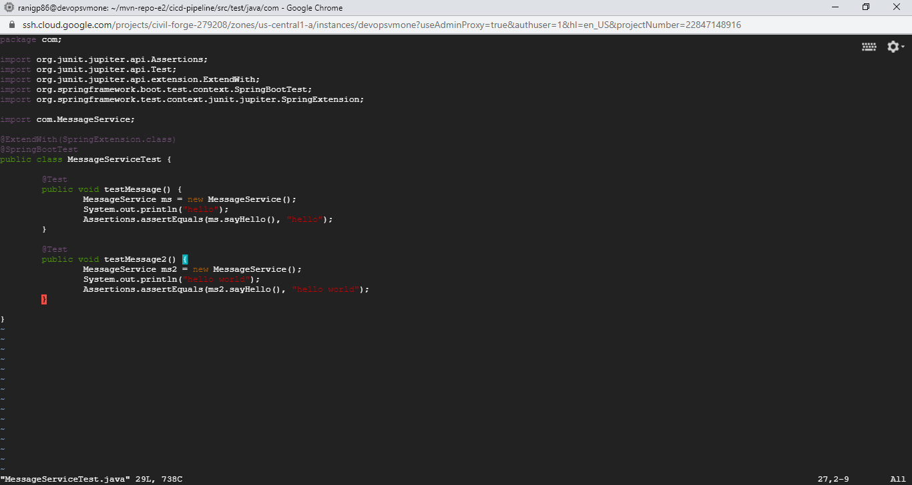
Test Case 2: Intentionally have had written the following script to get a failure case:
Here are the results when we run mvn clean test
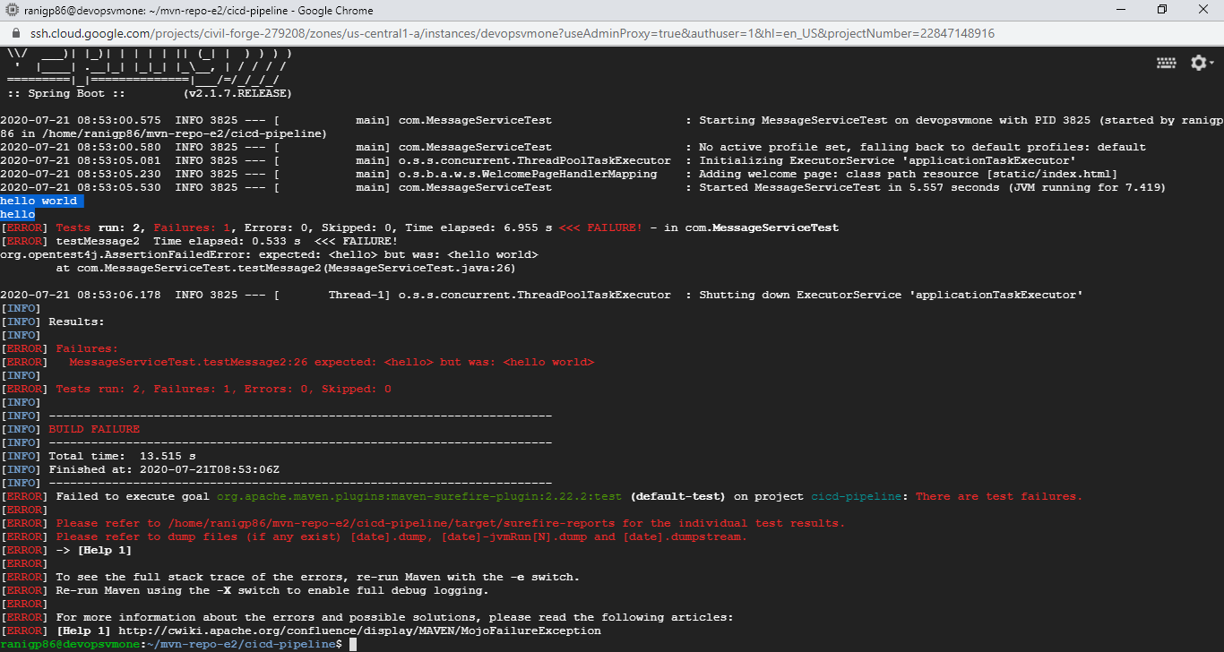
Service2: TestCalcService.
Intentionally had few test cases with a different set of results to see what happens with the code:
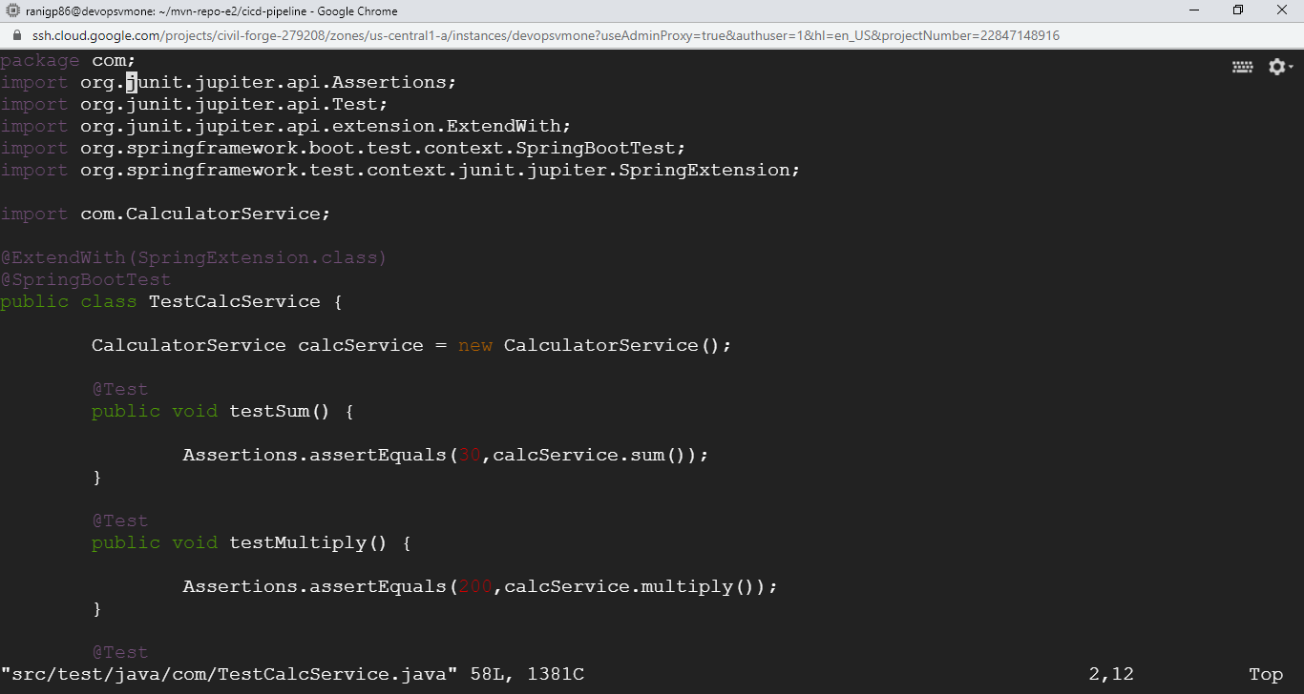
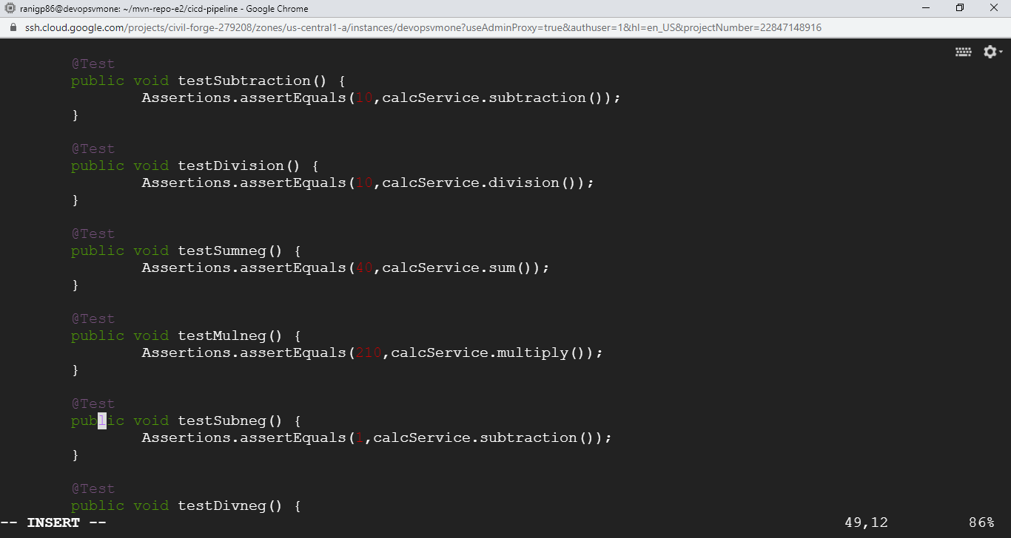
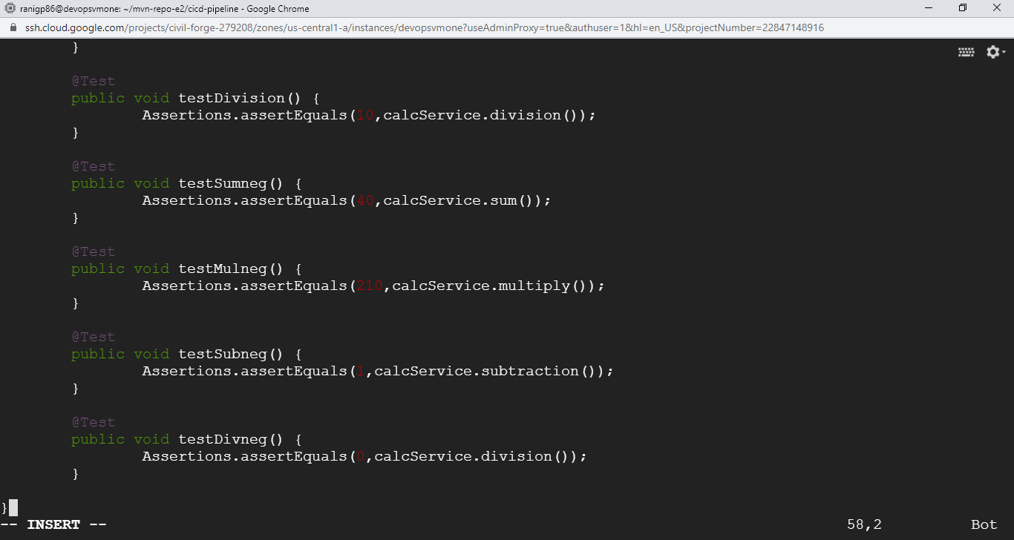

A total of 8 test cases for Test Calc Service + 2 test cases for Test Message Service:
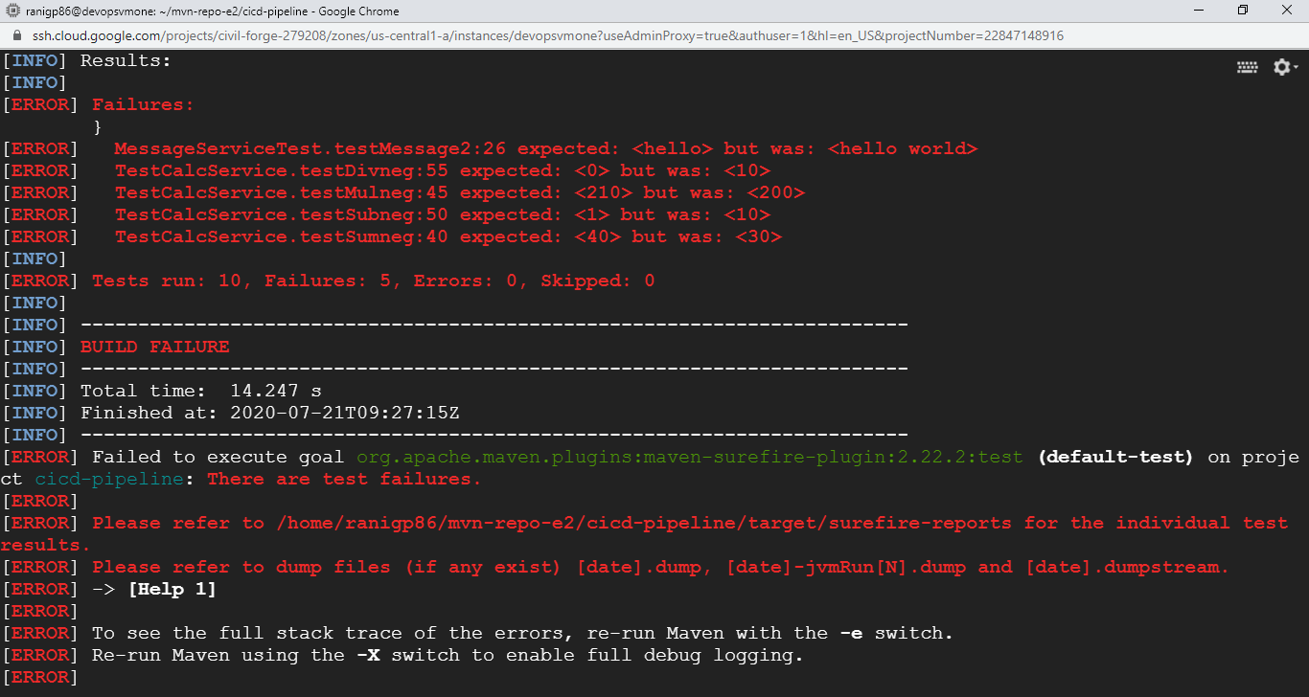
Have pushed this code to GitHub repository as well though it was not tested successfully!!

