1. Cloned the repository from Shubham: https://github.com/shubhamkushwah123/war-test.git
2. Did the compile – mvn clean package – which created a .war file
3. Created a dockerfile. Here is a snapshot of the same:
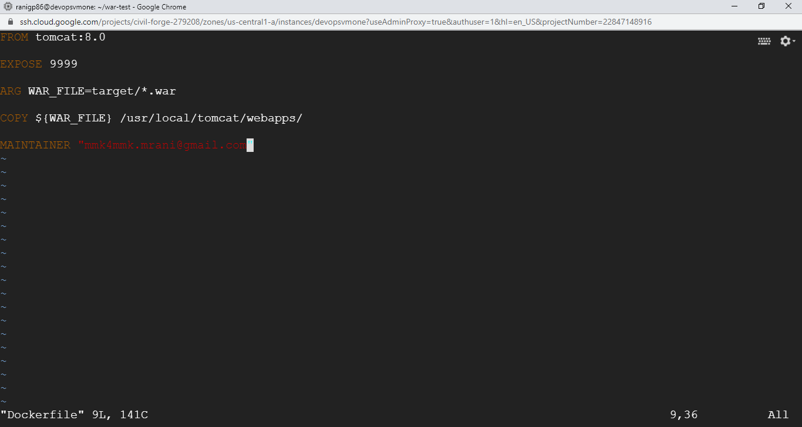
4. Built the Docker image
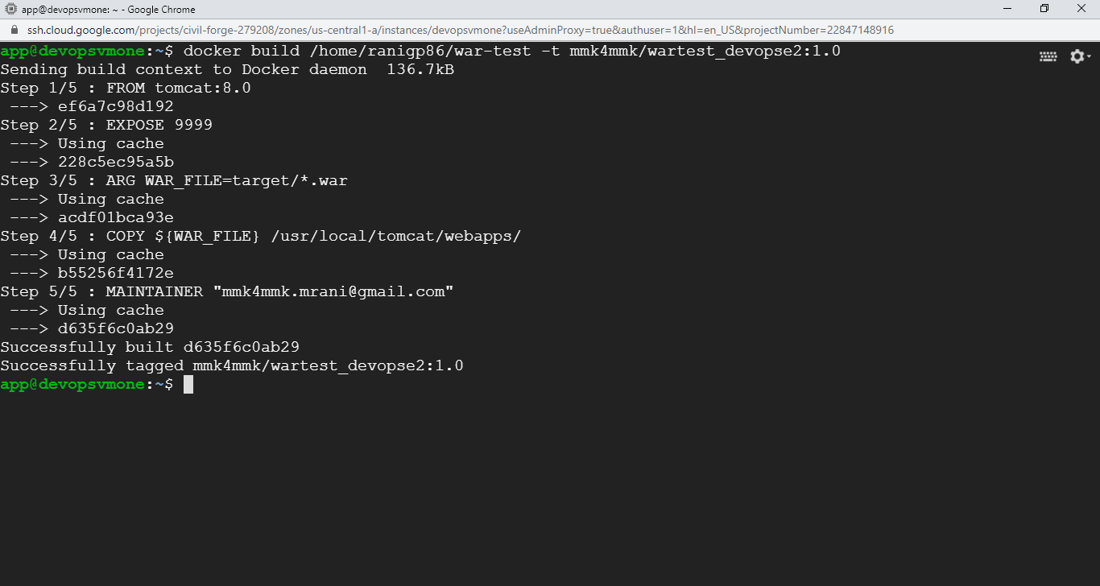
5. Checking for created images: Docker images
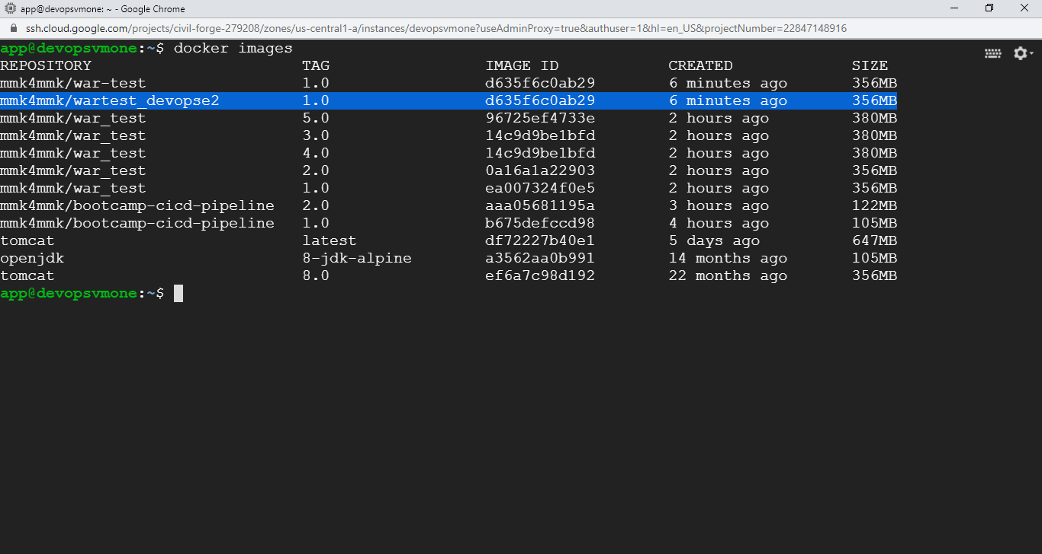
7. Running the Docker image – which becomes a container now. Prior to that checking for any containers running / stopped:
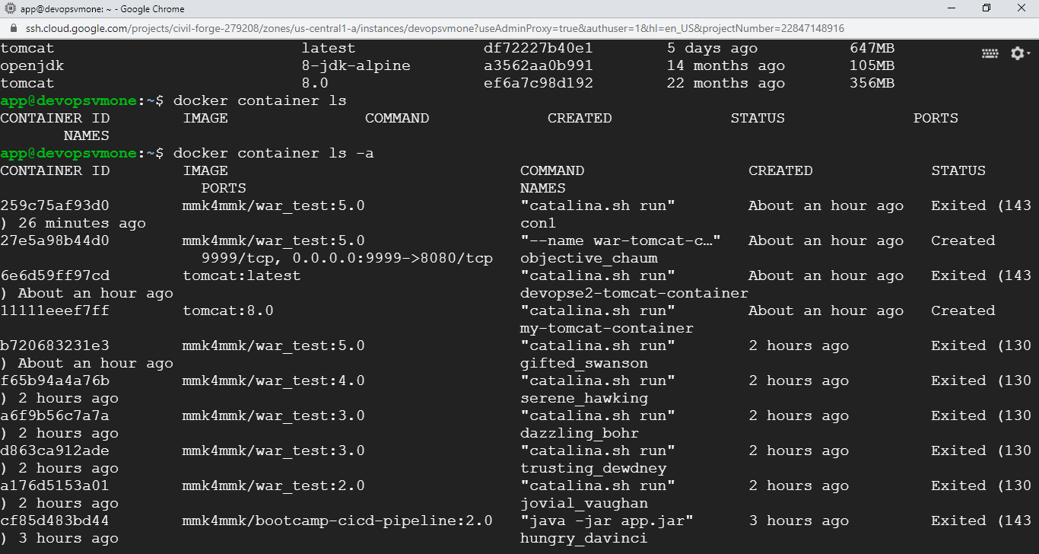
8. Running the Docker Image
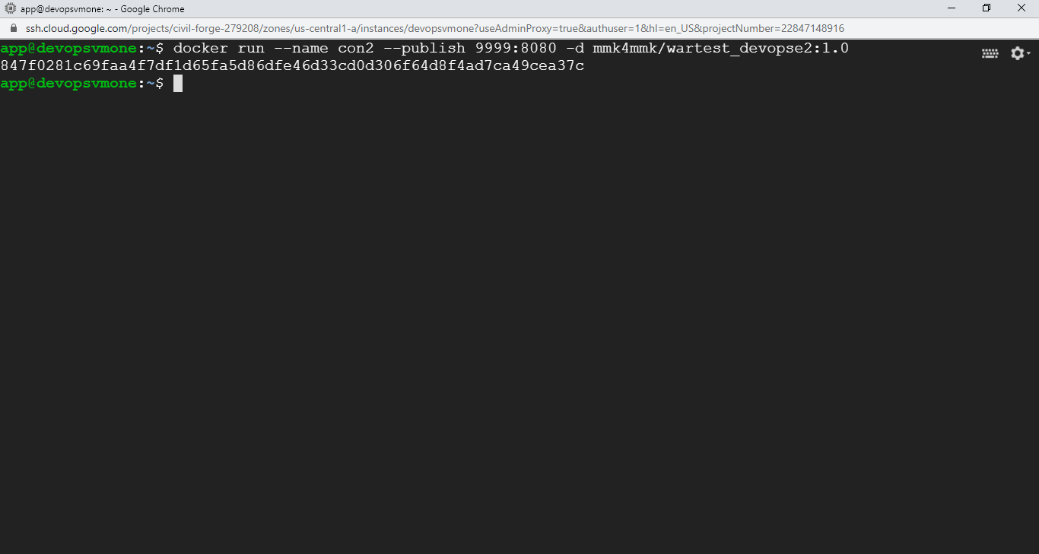
9. Checking on the web side:
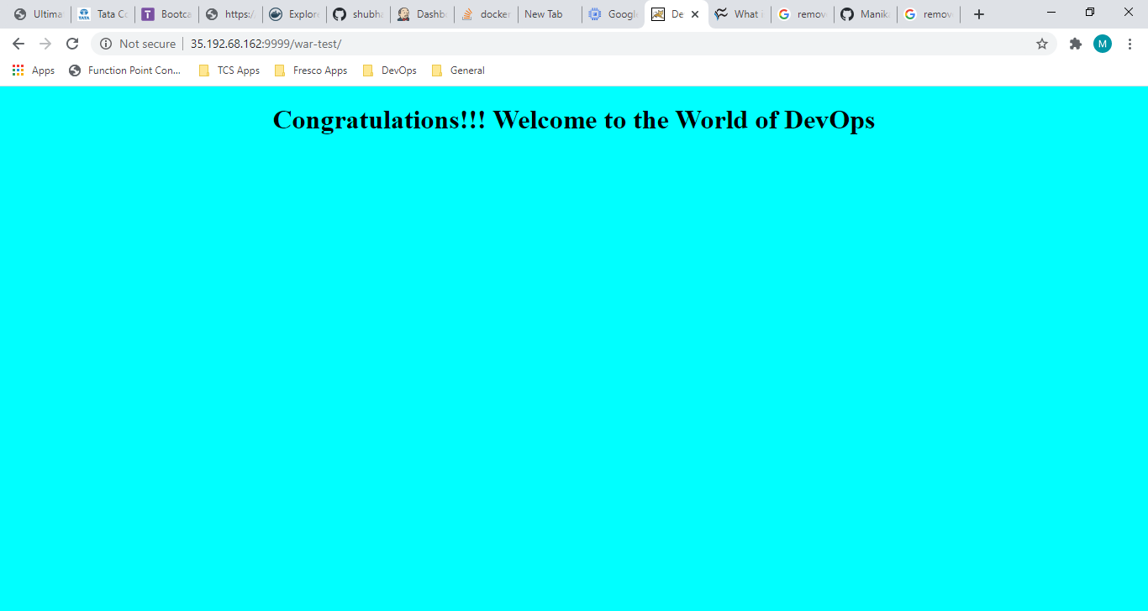

10. Here we go with Docker Compose file:
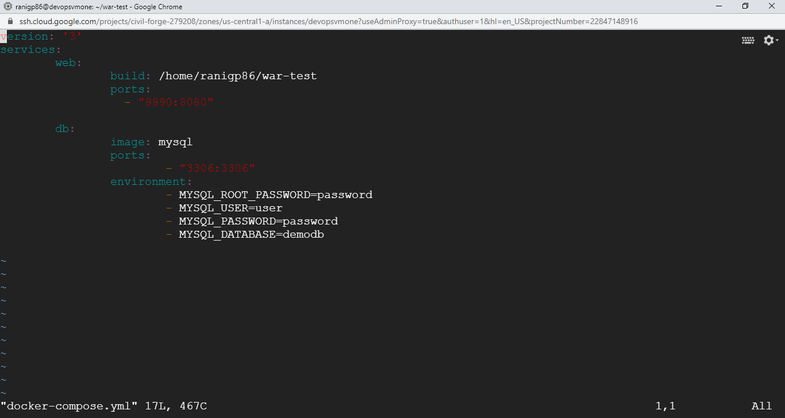

11. Docker-compose now:
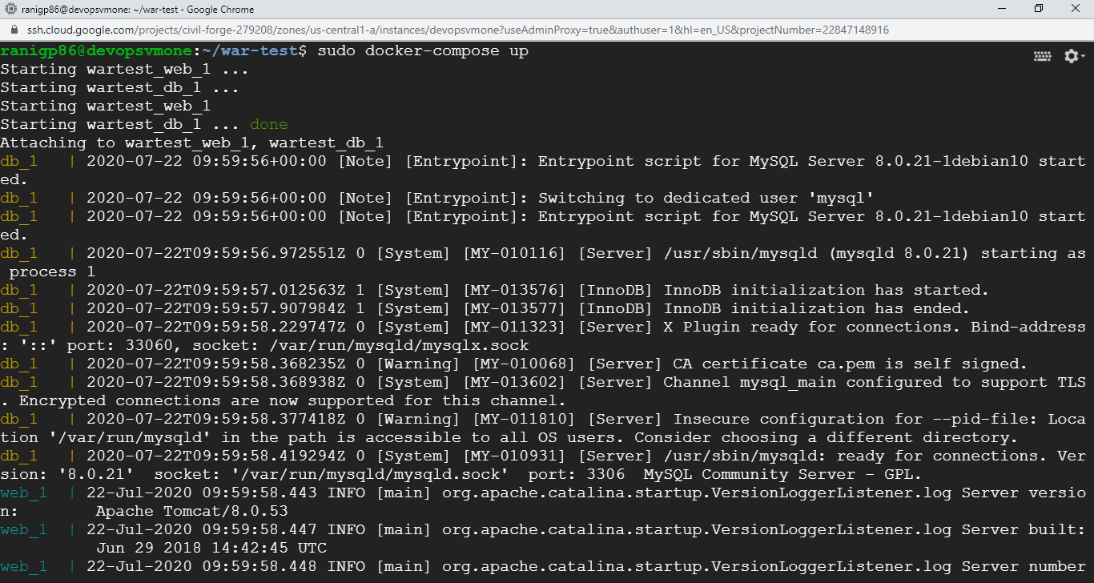
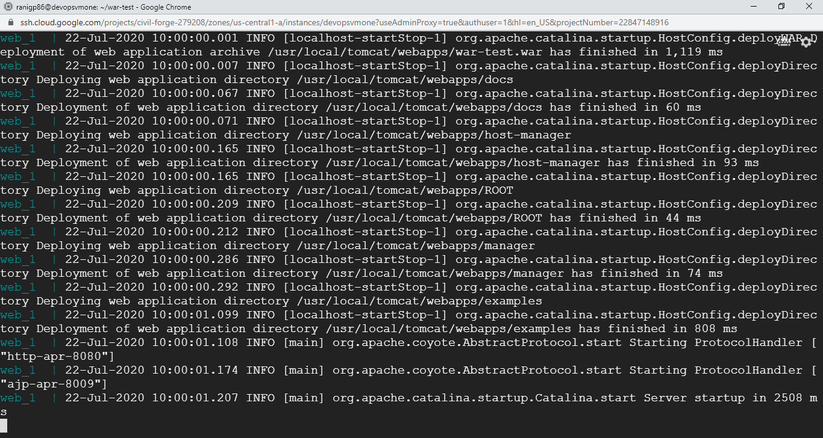
Checking the port 9990:
