Assignment 2:
War-test --> checkout, mvn build & test and deploy to tomcat locally -- again this as well needs to be done using Jenkins pipeline -- however, a screenshot of Jenkins pipeline (groovy script) suffice here and push the screenshot doc as well to GitHub Repo.

Deployment to tomcat locally can be done in two methods:
- Having tomcat locally on the machine and deploying the war file
- Having the tomcat as a docker container and deploying the war file
This document covered both the ways of the deployment.
Everything is written in Jenkinsfile as a groovy script and the same is pushed as well to
https://github.com/Manikanta-Majeti-Devops/war-test.git
Groovy Script for deploying to tomcat on local machine:
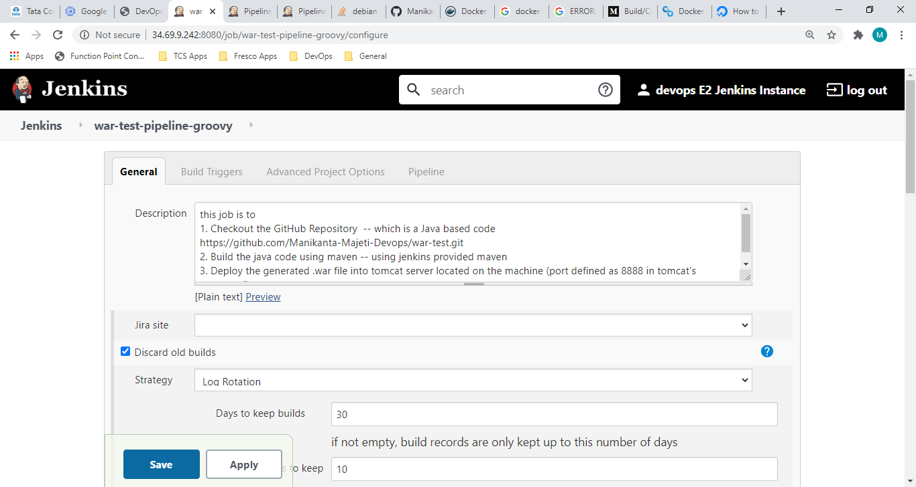

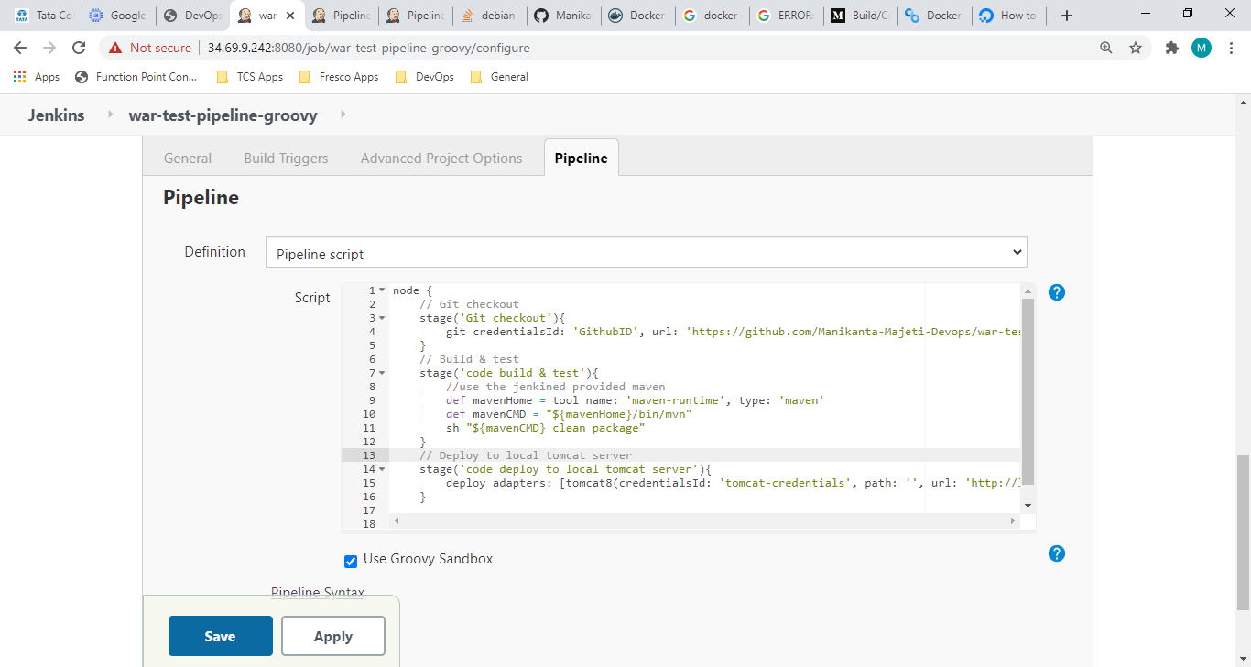

See the context path given below:
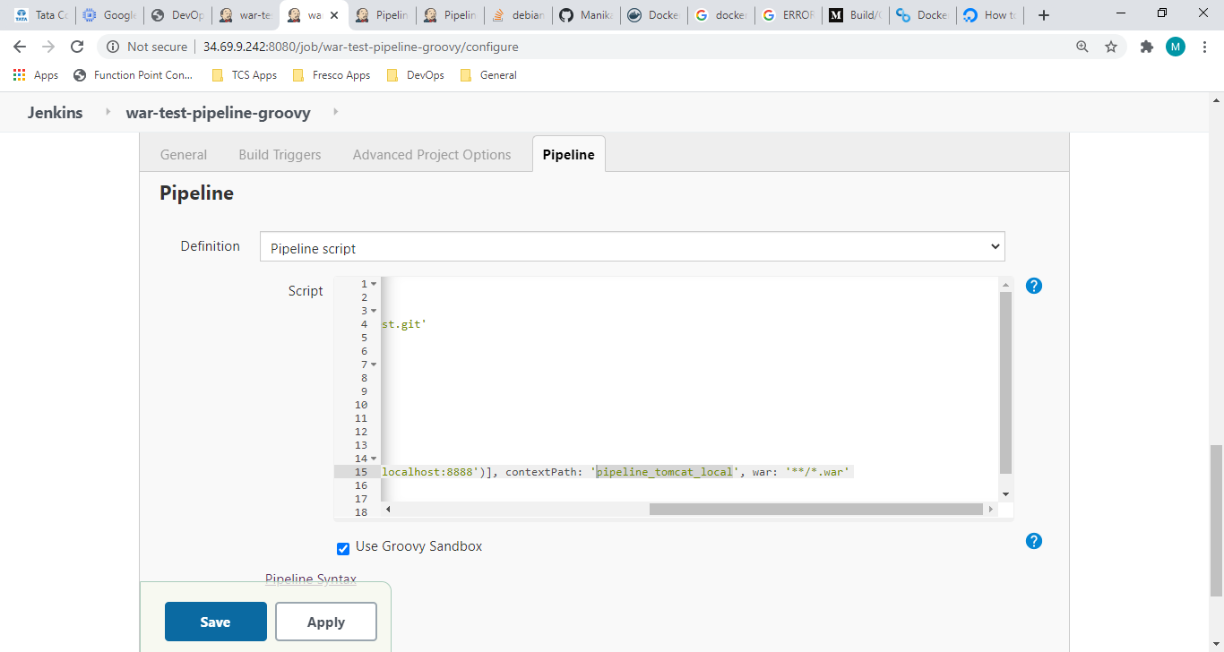
Built the job now:
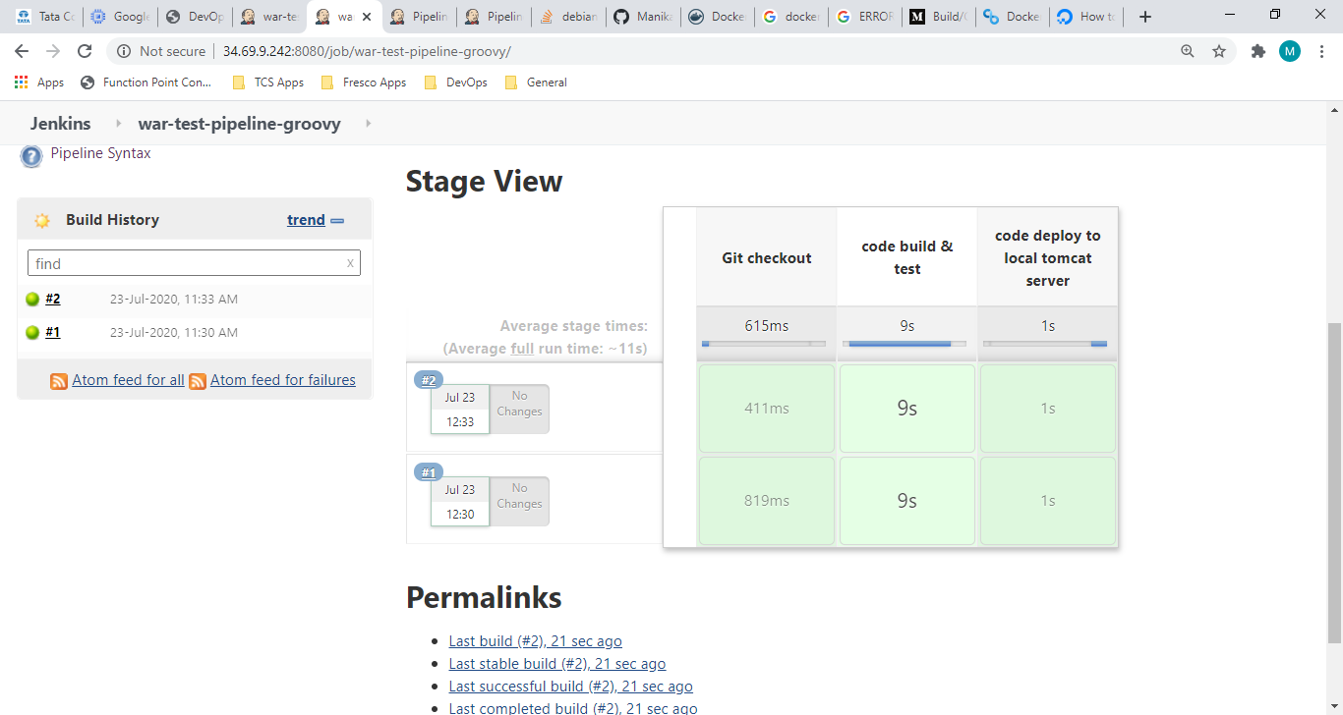
Checking whether the .war is running fine using URL:
Hosting the local tomcat:
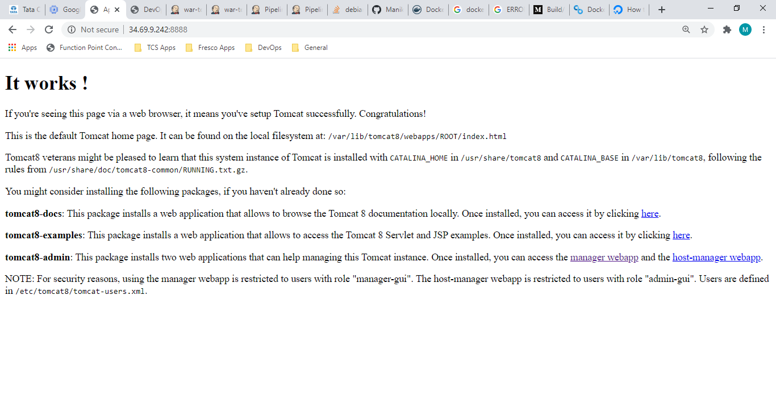
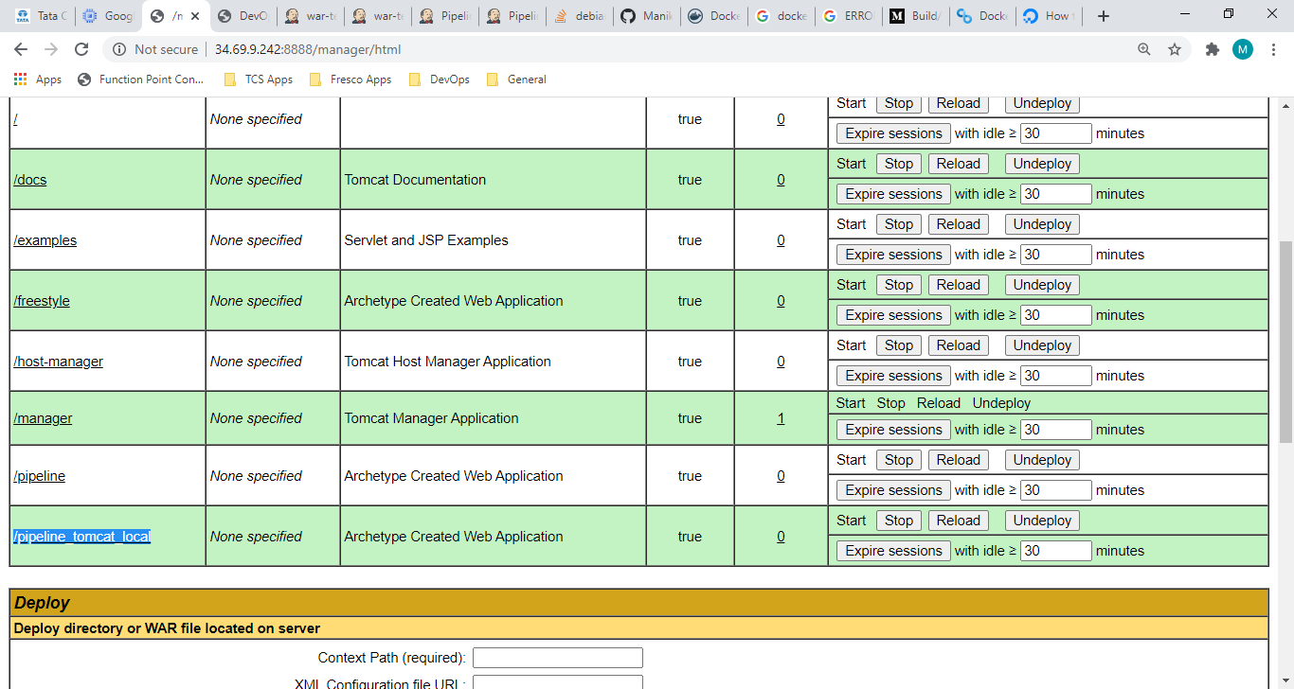
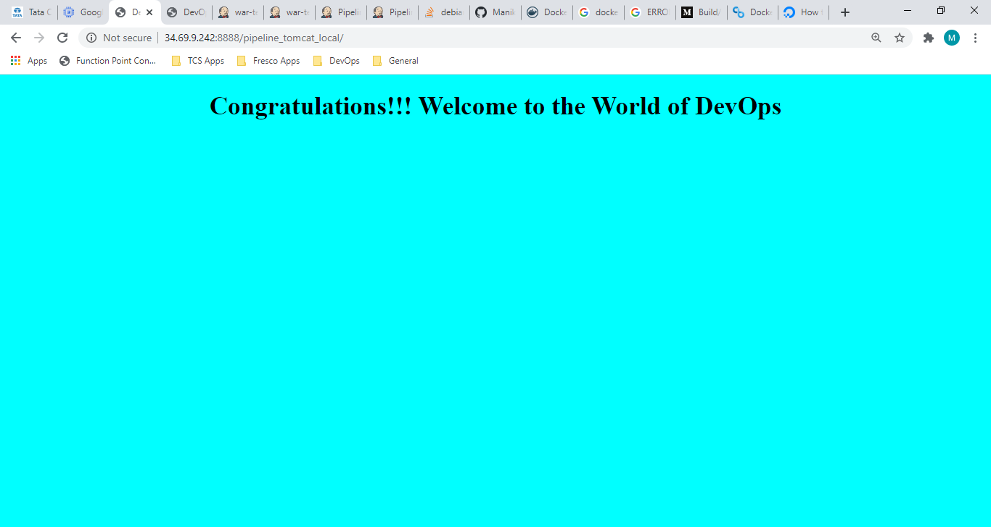

Pushed the Jenkinsfile Groovy Script to GitHub Repository. Name Jenkinsfile_local_tomcat:
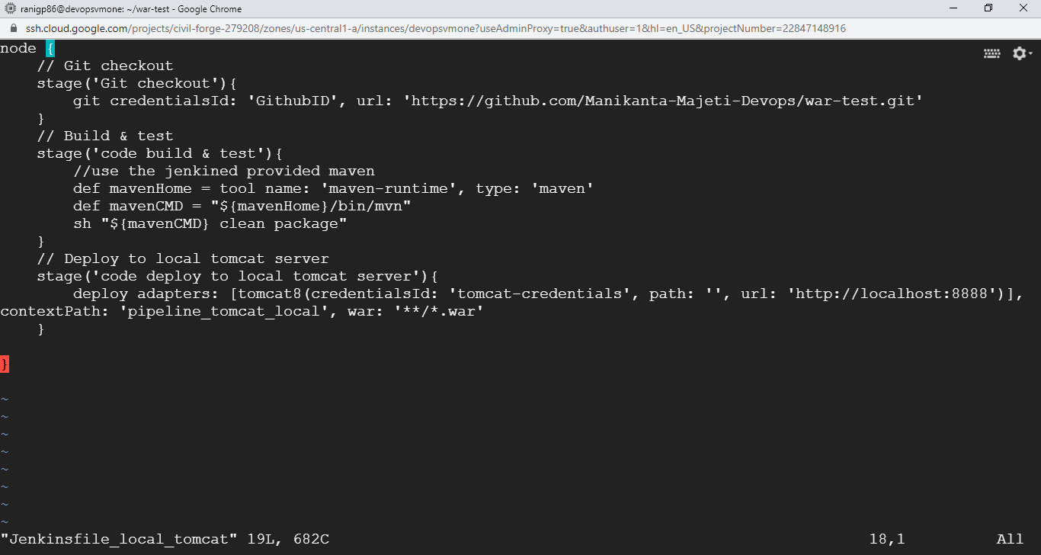

Created a Jenkinsfile for deploying the .war file into Docker contained tomcat server:
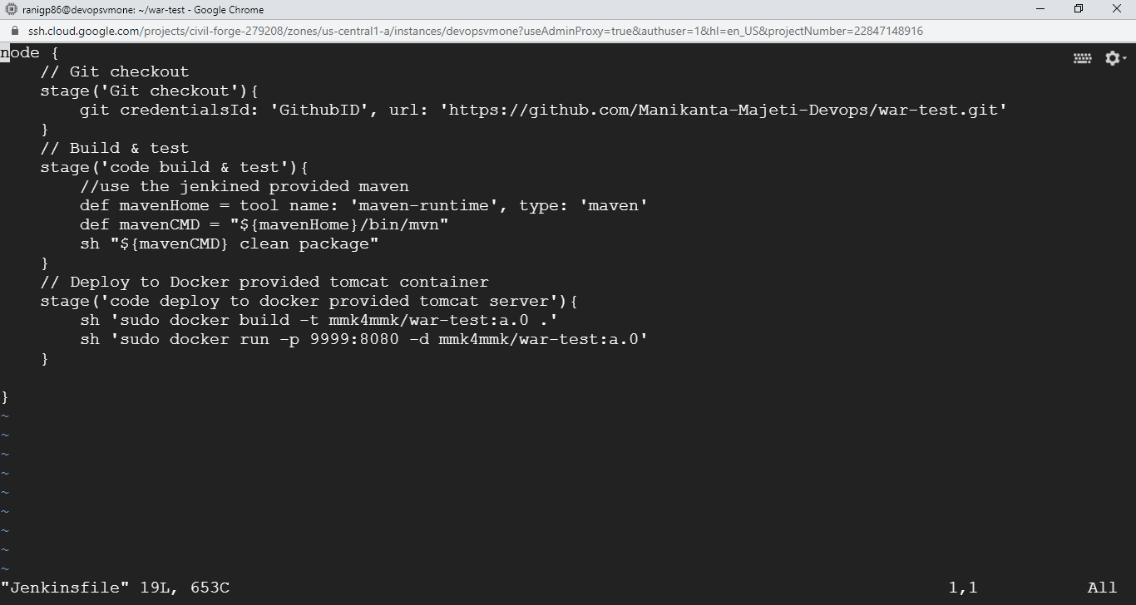
After pushing the Jenkins files to repository, have run the pipeline using Git as below:
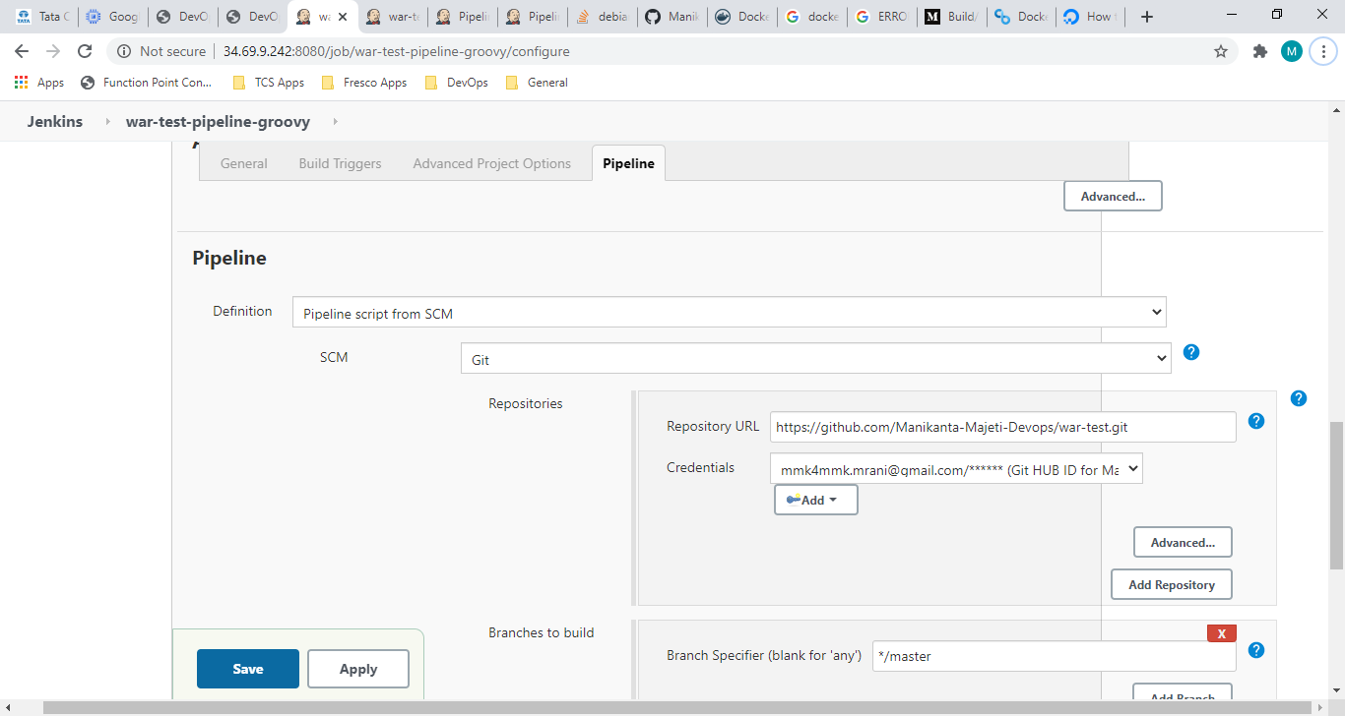

Built (#4) the job now:
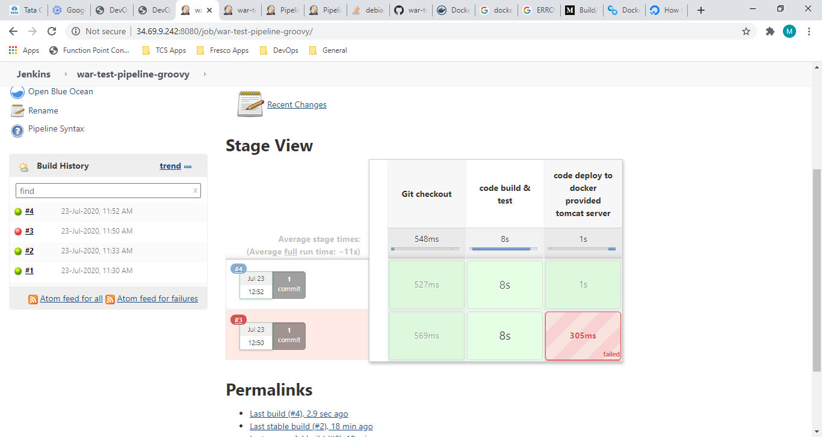
Docker logs from Jenkins:
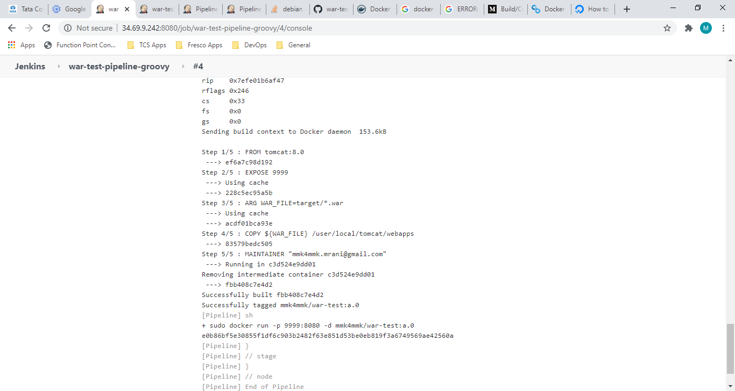
Checking the port 9999 now:
