School of Computer Science and Artificial Intelligence

Lab Assignment # 5.2

Program : B. Tech (CSE)
Specialization :
Course Title : AI Assisted coding
Course Code :
Semester : II
Academic Session : 2025-2026
Name of Student : M . Manikanta
Enrollment No. : 2403A51L12
Batch No. : 51
Date :20-01-2026

Task 1: Secure API Usage
Prompt : Generate a simple REST API for user registration.

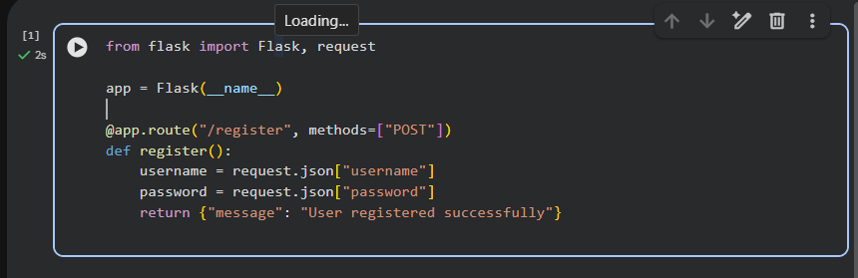

Identified Security Flaws
- No authentication mechanism
- Password stored/used in plain text
- No input validation
- No token-based authentication
- API key handling missing

Corrected Secure Code

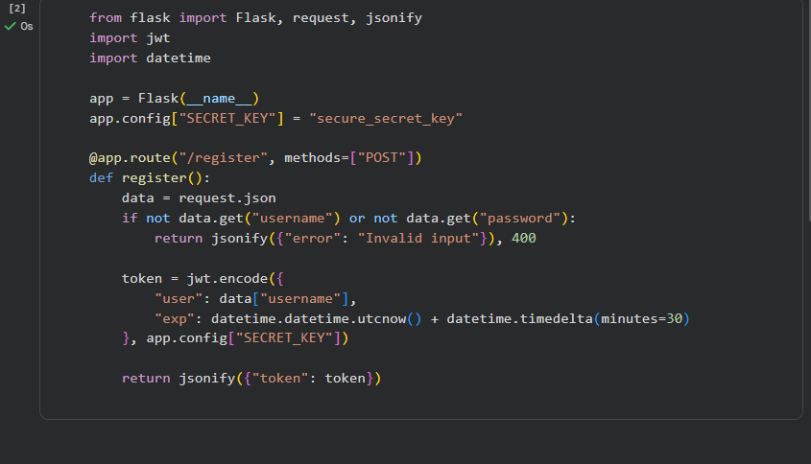

Explanation
- Input validation prevents invalid data
- Token-based authentication improves security
- Secret keys are handled securely
- Avoids insecure coding patterns

Output (Insecure Version):
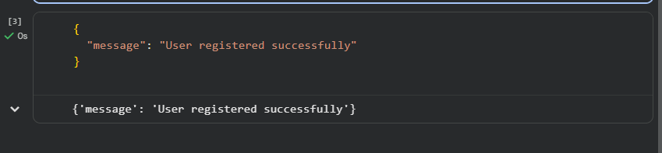

Output (Secure Version with Token):

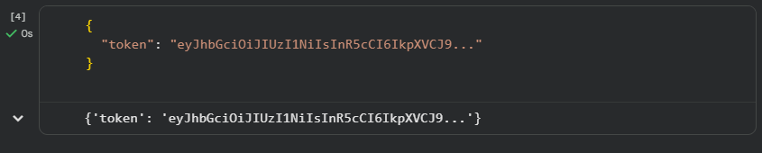

Task 2: Fair Decision Logic (Scholarship Eligibility)
Prompt: Generate a scholarship eligibility checker using academic score, family income, and location.

AI-Generated Code
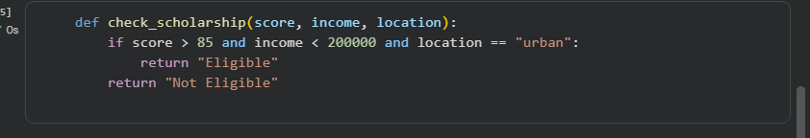

Fairness Issues Identified
- Unfairly favors urban students
- Rural or semi-urban students are disadvantaged
- Location should not be a strict condition
Improved Fair Logic
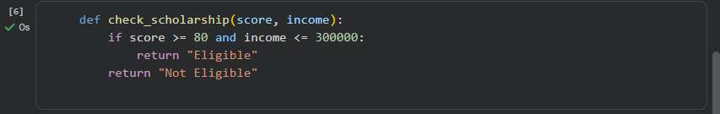

Explanation
The original logic unfairly favored urban students by using location as a strict condition.

This could disadvantage capable students from rural areas.

The revised logic removes location bias and focuses on merit and financial need.
This ensures equitable and inclusive decision-making.

Output (Original Logic):

Output (Improved Fair Logic


Task 3: Explainability (Prime Number Check)

Prompt: Generate a function to check if a number is prime with comments and explanation.

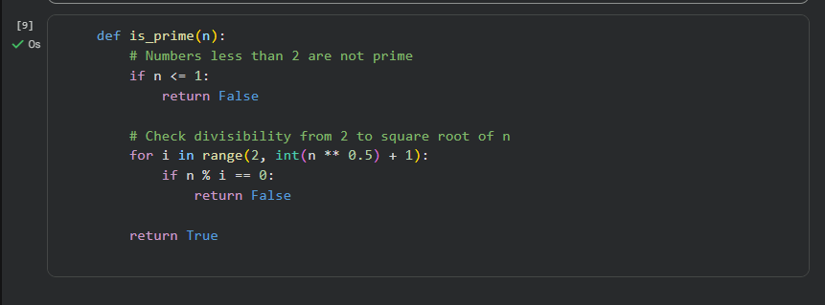

Explanation
- Numbers ≤ 1 are not prime
- Loop checks possible divisors efficiently
- Stops early to improve performance
Assessment of Explainability
- Code comments are clear and accurate
- Logic is easy to understand
- AI explanation improves transparency
Sample Input



Output



Task 4: Ethical Scoring System (Employee Evaluation)

Prompt: Generate an employee performance evaluation system using project completion, teamwork, and attendance.

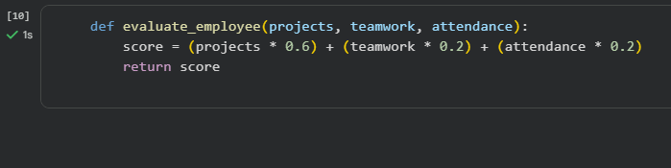

Ethical Analysis
- Project completion has very high weight
- Teamwork and attendance undervalued
- Could unfairly penalize collaborative roles

Balanced Scoring Code

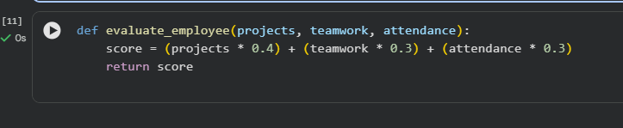

Explanation
The revised logic balances technical performance and teamwork.
This avoids unethical bias toward only output-based evaluation.
The criteria are more justifiable and fair.
Sample Input

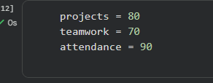

Output:



Output (Balanced Ethical Weighting)



Task 5: Accessibility and Inclusiveness (Feedback Form)

Prompt : Generate a user feedback form application.

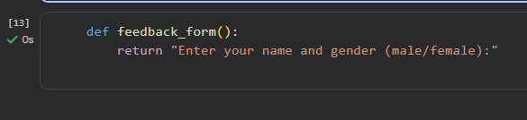

Issues Identified
- Gender options are restrictive
- Language is not inclusive
- Accessibility features missing
Revised Inclusive Form Code

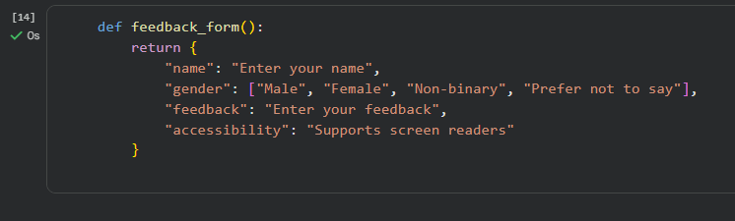

Explanation
- Uses inclusive language
- Avoids exclusionary assumptions
- Supports accessibility needs

Output

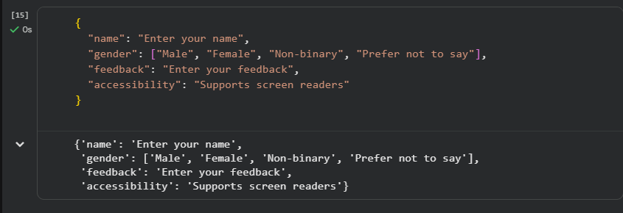

Final Conclusion

This lab highlights the importance of ethical responsibility in AI-assisted coding.
Developers must review AI-generated code for security flaws, bias, fairness, and inclusiveness.
Human oversight is essential to ensure transparency, accountability, and ethical software development.

