School of Computer Science and Artificial Intelligence

Lab Assignment # 6.2

Program : B. Tech (CSE)
Specialization :
Course Title : AI Assisted coding
Course Code :
Semester : II
Academic Session : 2025-2026
Name of Student : M . Manikanta
Enrollment No. : 2403A51L12
Batch No. : 51
Date :23-01-2026

Task Description #1 (AI-Based Code Completion for Conditional

Eligibility Check)
Prompt : “Generate Python code to check voting eligibility based on age and
citizenship.”
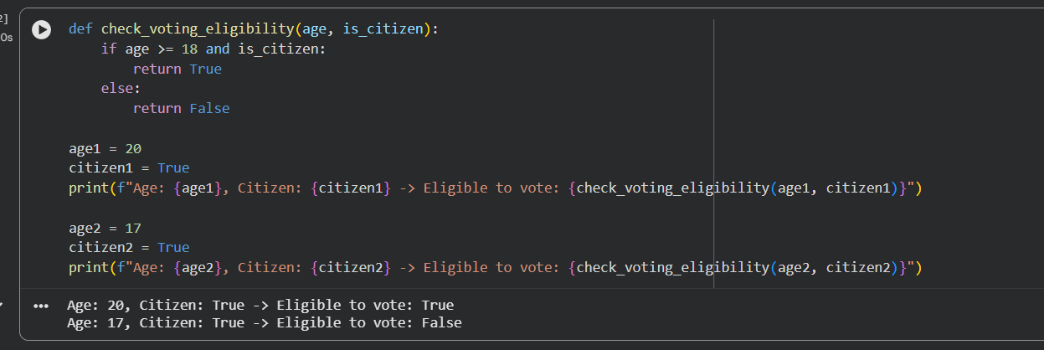

Explanation
- This task involved generating a Python function to determine voting eligibility
- based on age and citizenship status. It demonstrated basic `if-else` conditional logic
- to return True or False based on the input criteria.

Output :
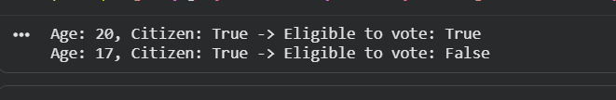

Task Description #2(AI-Based Code Completion for Loop-Based

String Processing)
Prompt: Generate Python code to count vowels and consonants in a string
using a loop.”

Code :

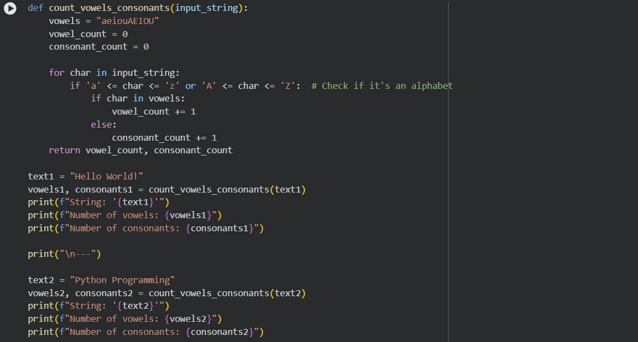

Explanation :

# For this task, a Python function was created to count vowels and consonants in a string.
# It utilized a `for` loop to iterate through each character of the string and conditional

# checks to categorize characters as vowels or consonants.
Output :
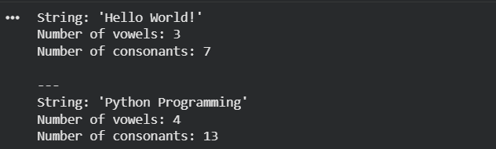

Task Description #3 (AI-Assisted Code Completion Reflection

Task)

Prompt: “Generate a Python program for a library management system

using classes, loops, and conditional statements.”

Code :

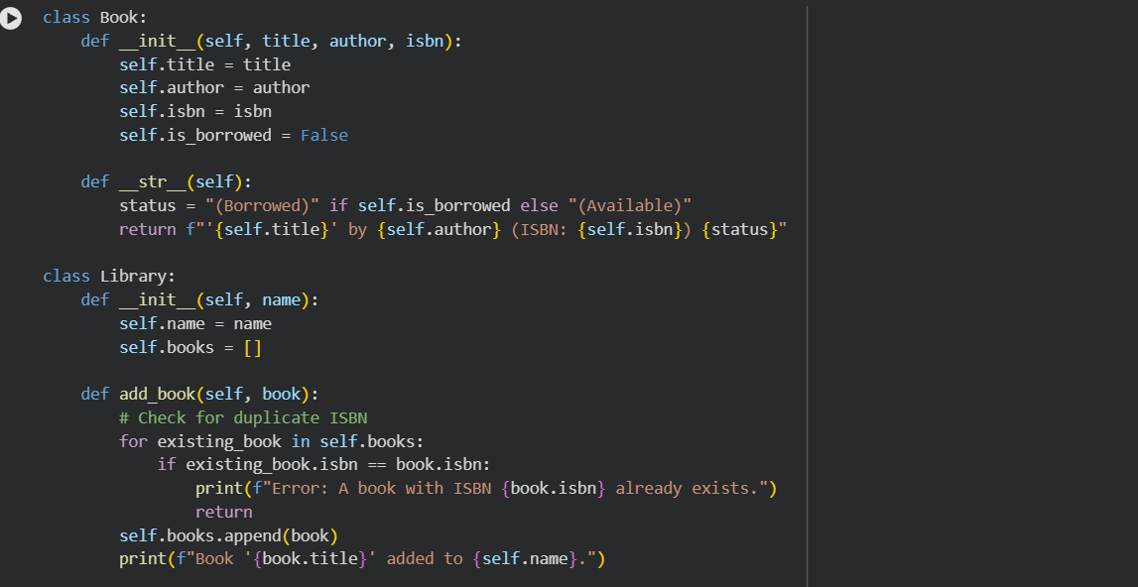
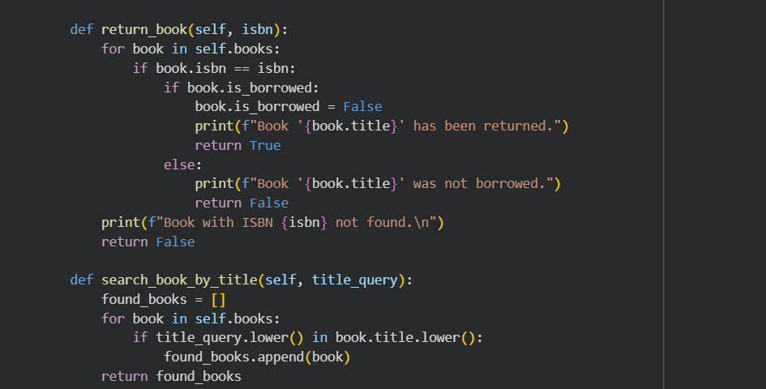

Explanation :
- This task focused on developing a simple library management system using Python classes.

- It showcased object-oriented programming concepts with `Book` and `Library` classes,

- enabling operations like adding books and listing available inventory.

Output :

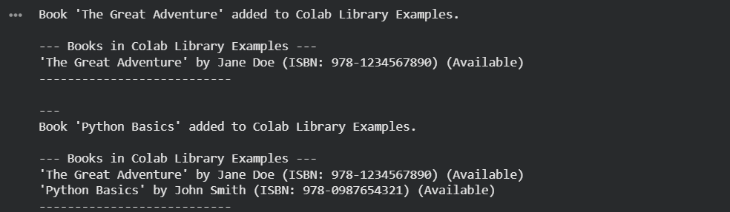

Task 4: Task Description #4 (AI-Assisted Code Completion for Class-

Based Attendance System)

Prompt: “Generate a Python class to mark and display student

attendance using loops.”

Code :
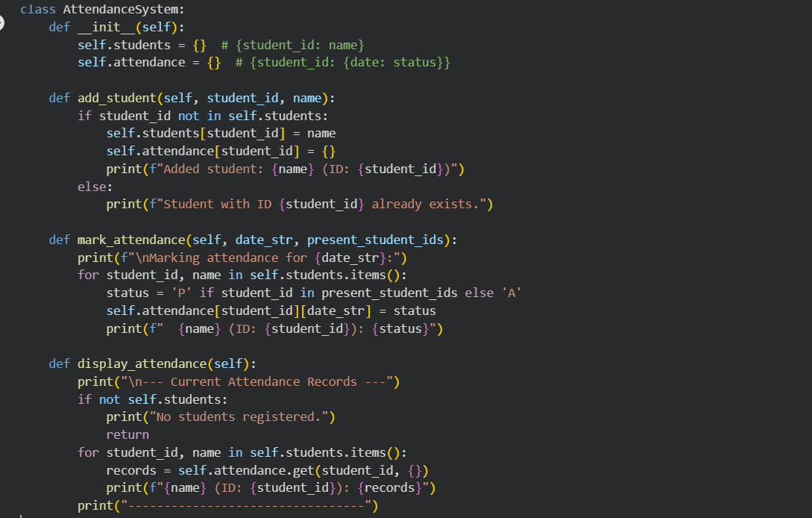

Explanation :

- This task involved building an `AttendanceSystem` class to manage student attendance.

- It used dictionaries for data storage, loops for processing attendance records,

- and conditional logic for marking and displaying various attendance reports.

Output :

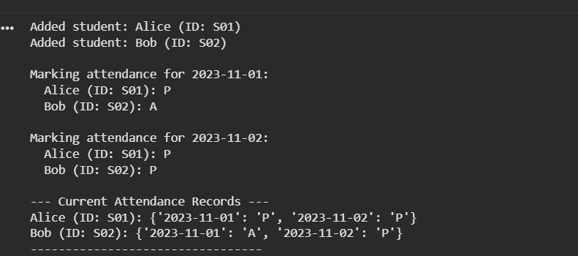

Task 5 : (AI-Based Code Completion for Conditional

Menu Navigation)

Prompt : Generate a Python program using loops and conditionals

to simulate an ATM menu.”

Code :

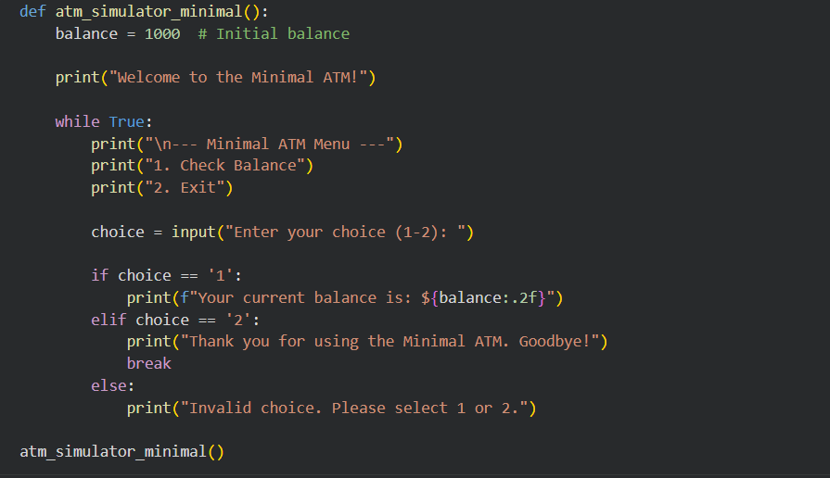

Explanation :

- This task focused on creating an interactive ATM simulator program.

- It employed `while` loops for continuous menu navigation and PIN verification,

- along with `if-elif-else` statements for handling user choices and transaction logic.

Output :

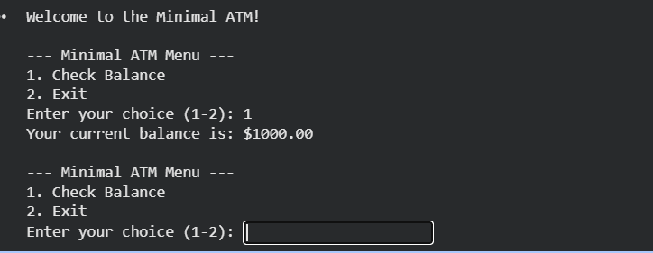

Final Conclusion :

- Throughout these five tasks, we explored fundamental Python programming concepts.

- We implemented conditional logic for voting eligibility, used loops for string processing

- (vowel/consonant counting), and applied object-oriented programming for a library

- and an attendance system. Finally, we created an interactive ATM simulator, demonstrating

- menu navigation with loops and conditional statements, thus covering a broad spectrum of programming constructs.

