**Project 1:Deploying a web server in Windows instance**

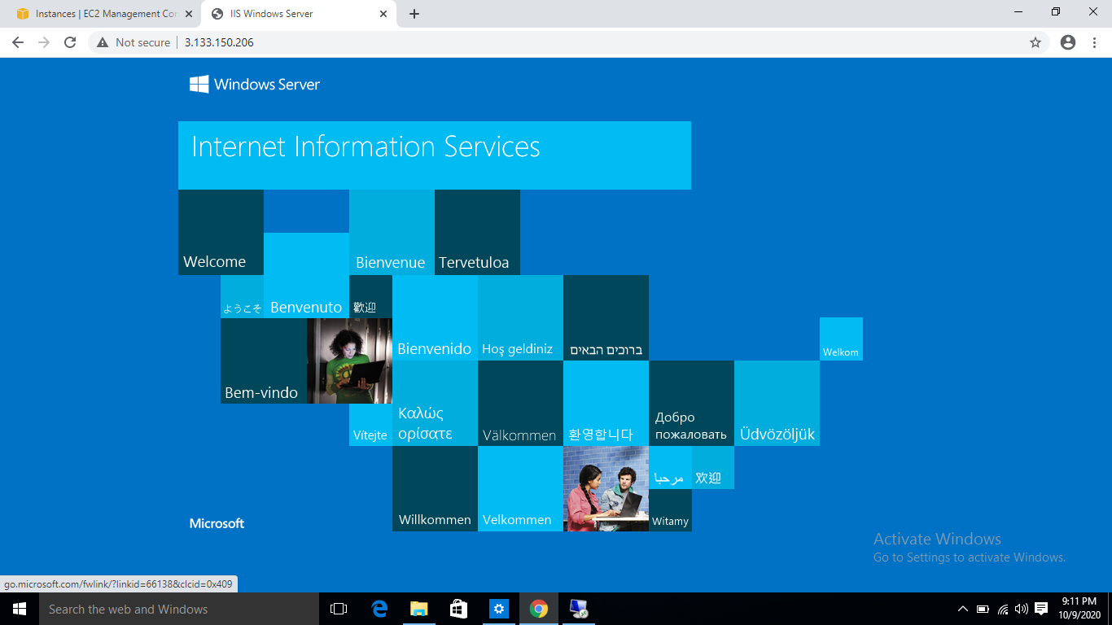

IP Address of the Windows Instance:3.133.150.206

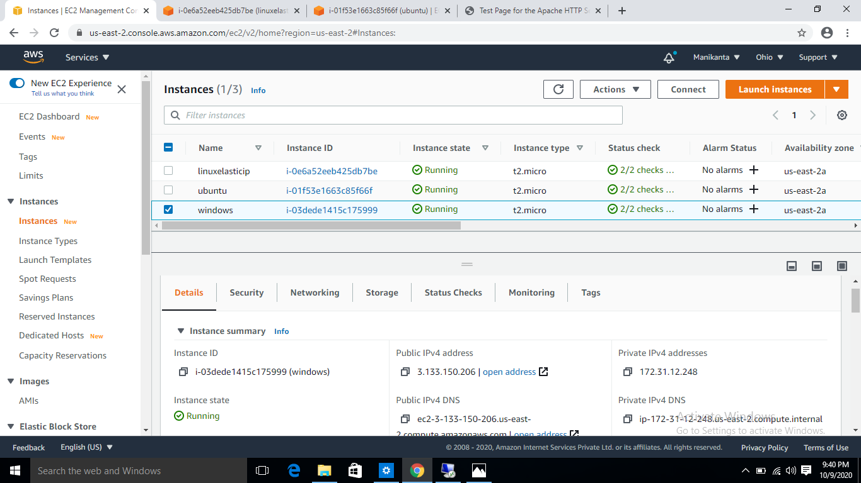

**Project2:Deploying a nginx server on the Ubuntu Instance**

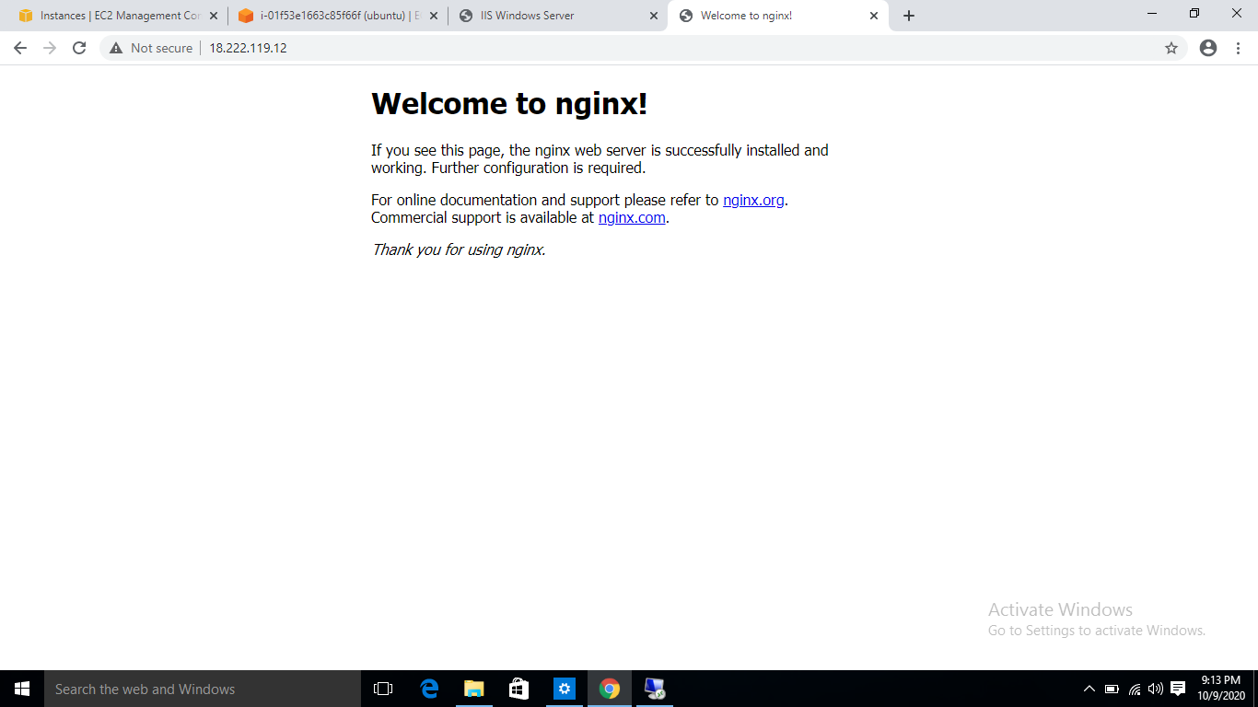

IP Address of Ubuntu Instance:18.222.119.12

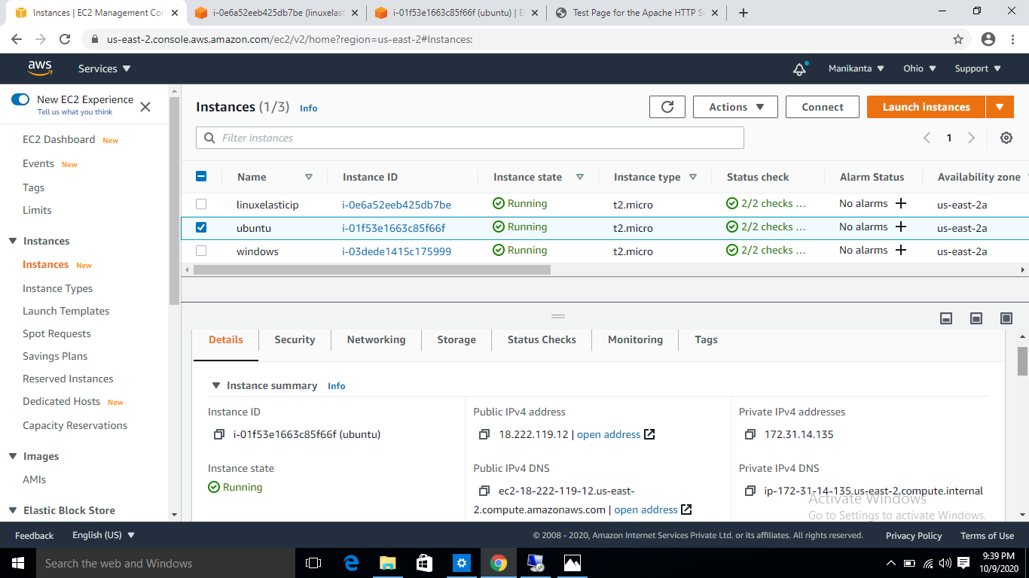

**Project3:Working With Volumes:**

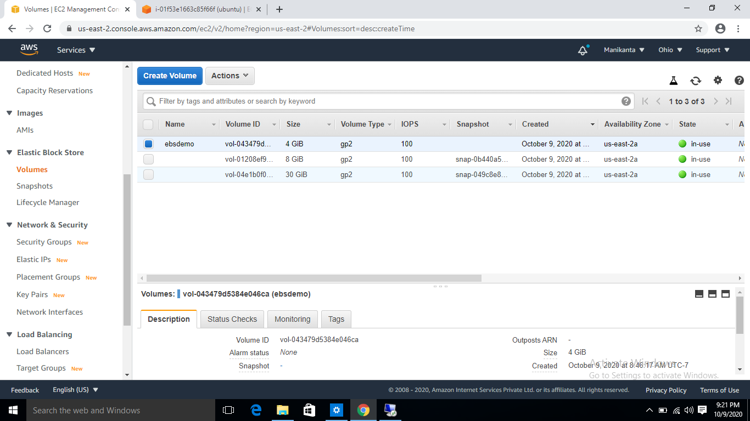

\

This is the demo Volume that I created with 4 Gb.

I connected this ebs volume to the same instance that I created for the windows server.

Ebs Volume connected to windows instance.

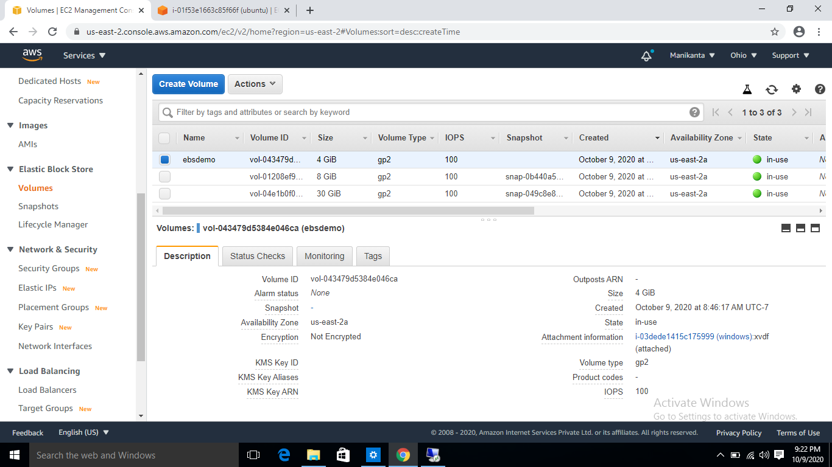

**Project4:Working with Elastic IPS**

Created an linux instance connected to the apache server.

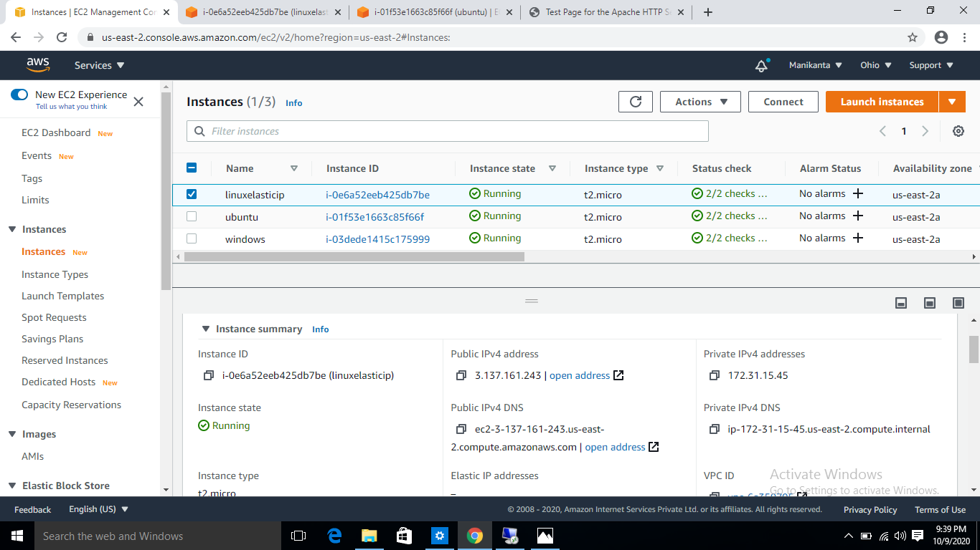

Server Page With The Public ip: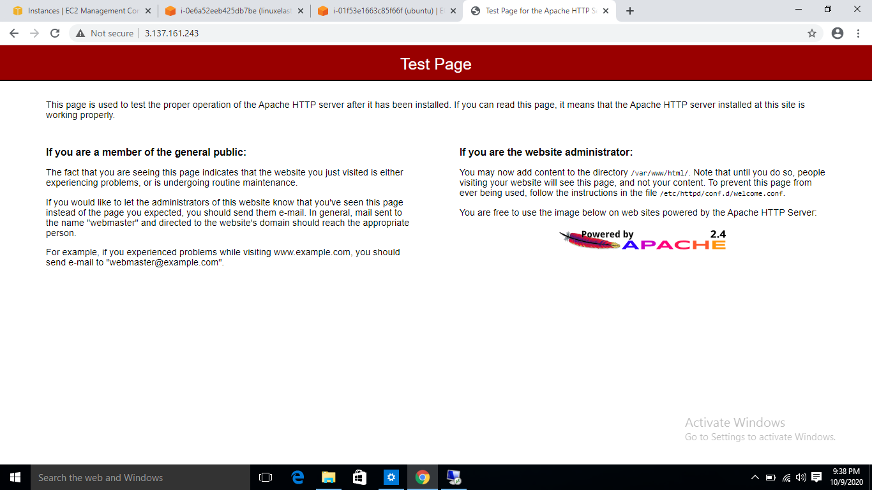 IP Address is 3.137.161.243

This Is The Image Of The Webpage Connected With The ElasticIP:

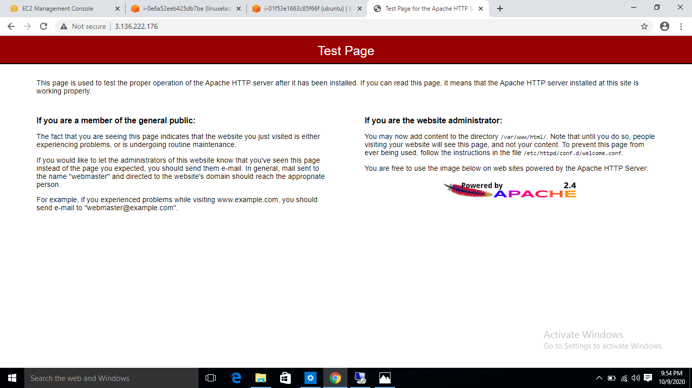

Here The ip is 3.136.222.176

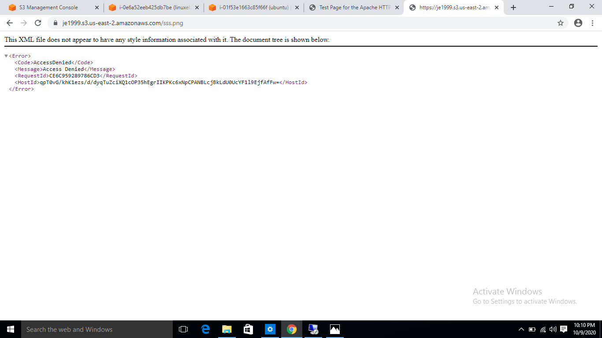**Project5:Working With S3:**

This is the image of the bucket showing error when the bucket Is in private.

After make the Bucket public The image is:

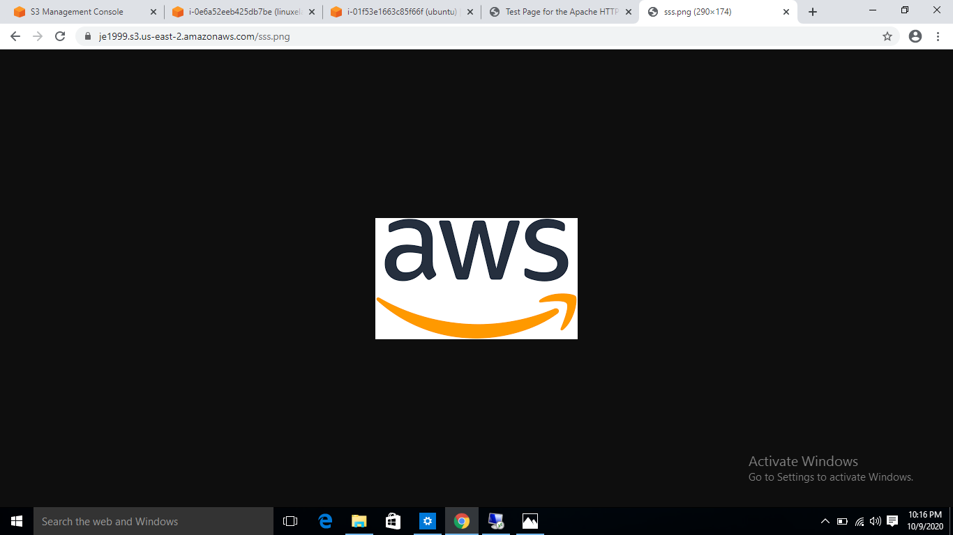

**Working With Static web hosting Of S3:**

This is the image of the web page that is correctly entered.

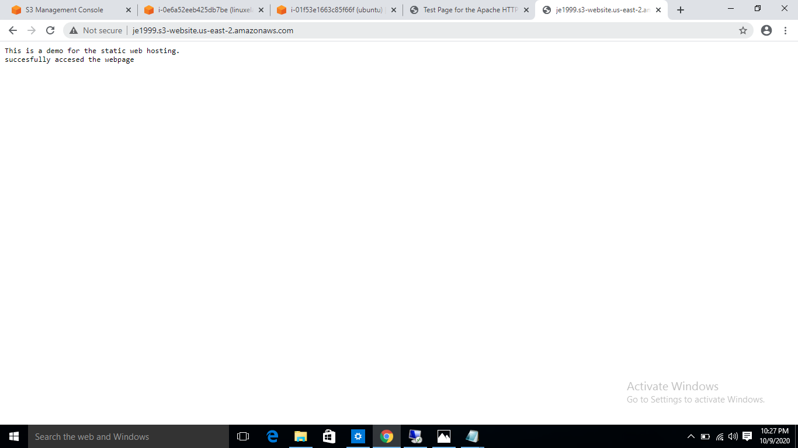

This is the image that is showing error in the web page when the url is entered wrongly.

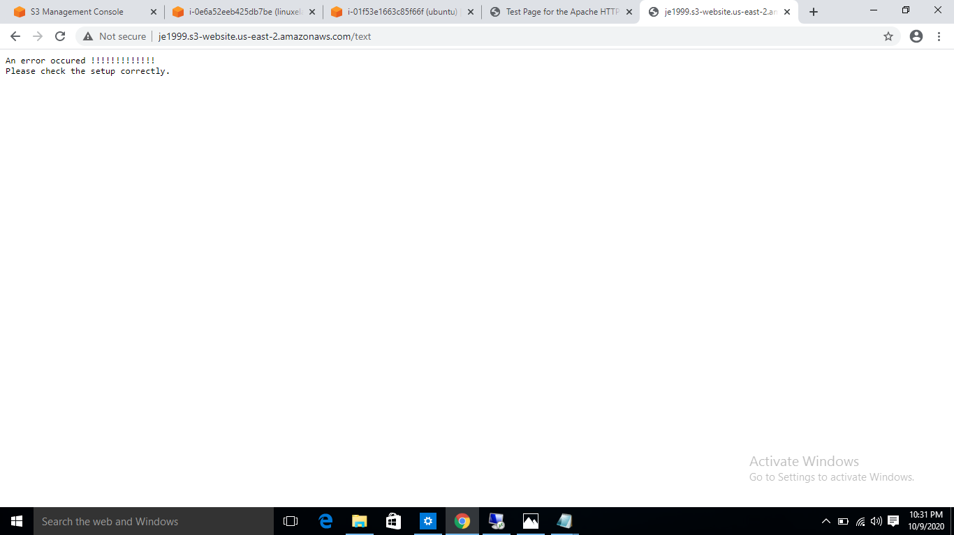

**Working With S3 Versioning:**

This is the image of s3 versioning uploading The versions.

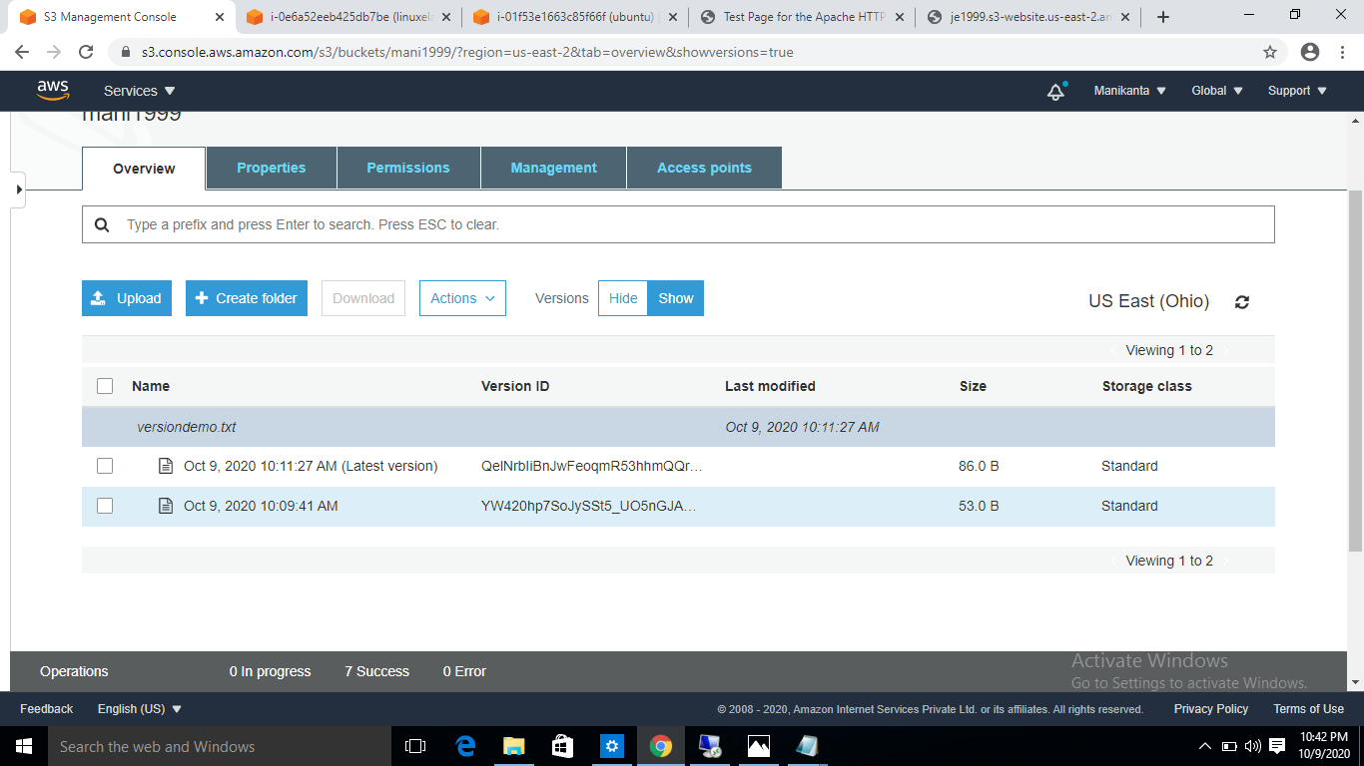

Below is the image of the hiding and deleting the versions .Delete marker is also there.

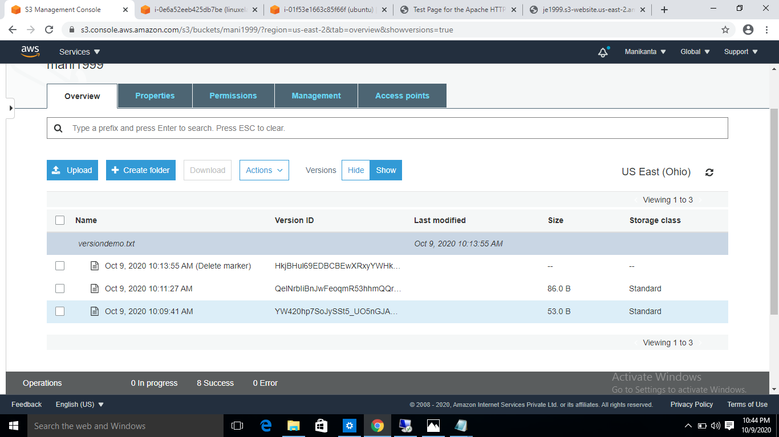

Below is the image of the versions downloaded and again uploaded into the s3 .showing the latest version.

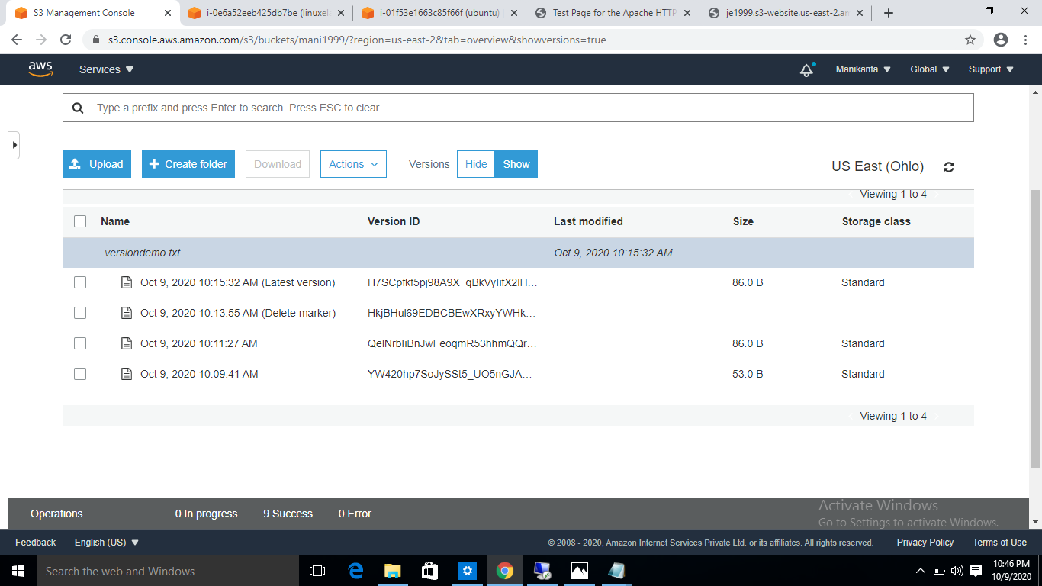

**Life cycle effects on instances:**

**Stop:**This option is used to stop the instance .It will not delete the instance.We can use the instance again by restarting the instance.The data that is stored that will not lost we can access the data when we restart the instance.

**Start:**The start is used to revoke the stopped instance.It will make the instance again into the running status.

**Terminate:**This option makes the instance terminate completely.The data that is present will be lost.The instancve will be released into the shared pool.we cannot restart the instance again but we can create another instance.

**Public Ip:**The ip will be accesed with the user permission.The ip will not be the same when we restart the stop instance.the ip will change because the ip will released into the shared pool and can be accesed by others.

**Private ip:**This is the option to overcome the problem.We can assing a Private and elastic ip to the instace and it will be remained same when the instance is stopped.