**Project1:Boot strap script**

Giving the commands to the user data to up the server when the instance is ready.

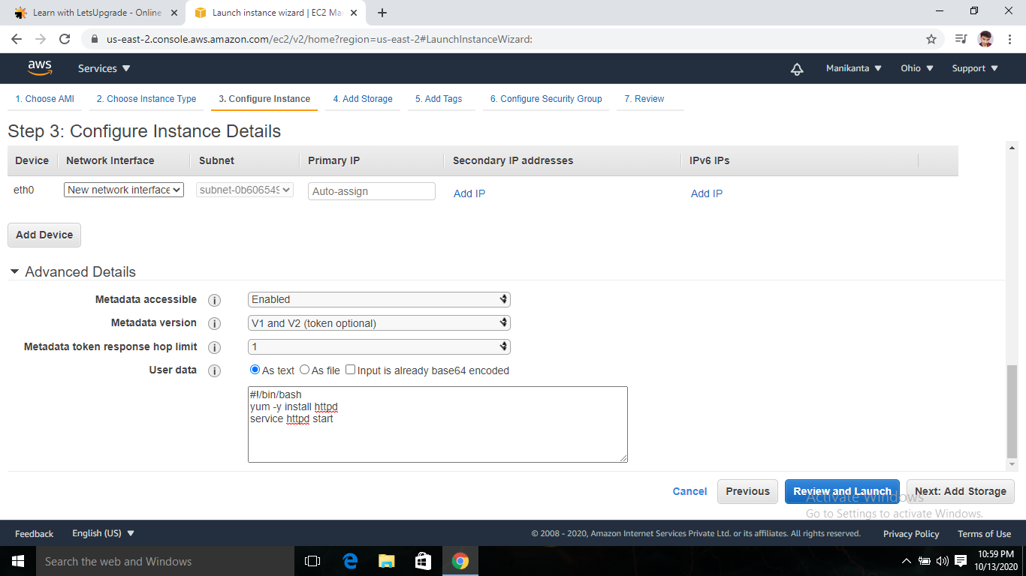

The server deployed sucessfully. IPv4 3.137.162.37

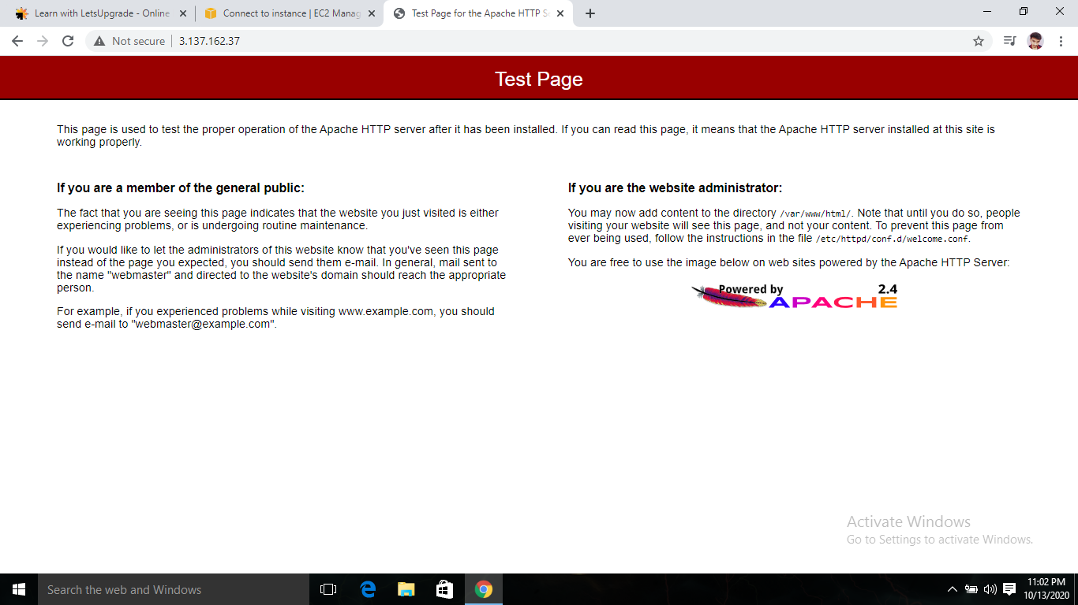

The instance ScreenShot

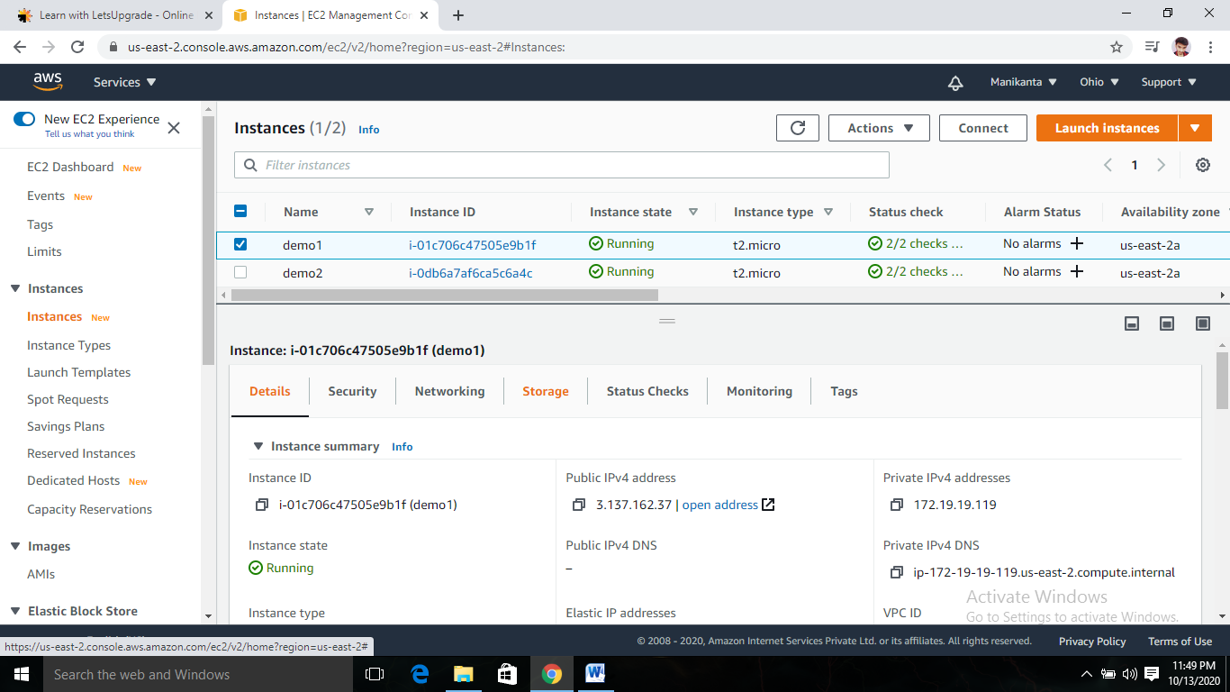

**2 Project Working with s3 and IAM roles:**

Created an IAM role name s3_full_acces.

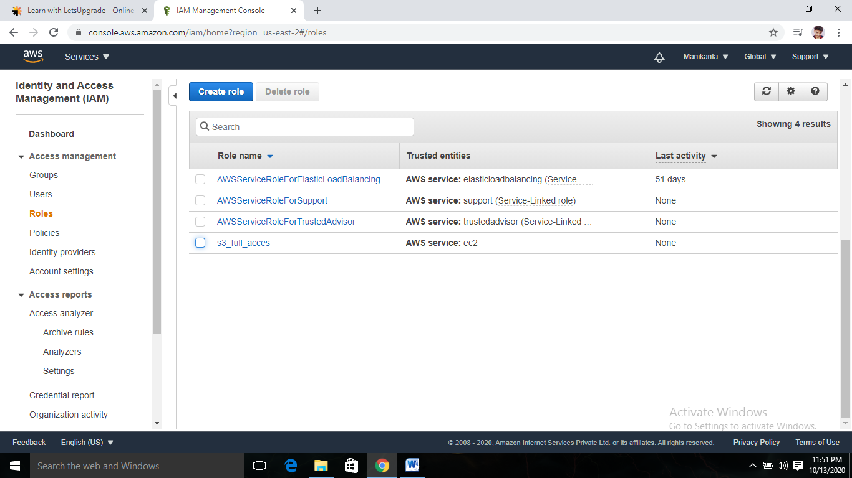

Created an instance to configure the role

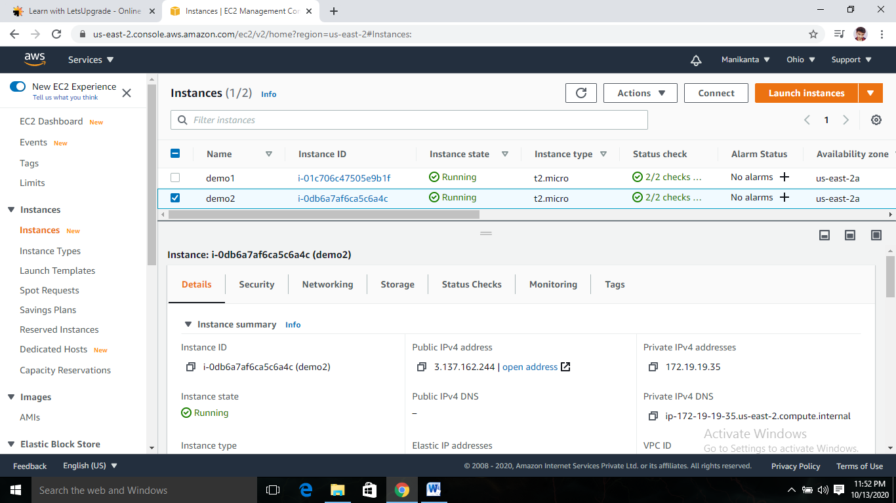

Accesing the aws s3 using ec2 instance

Using commands aws s3 ls Shows the Bucklet list

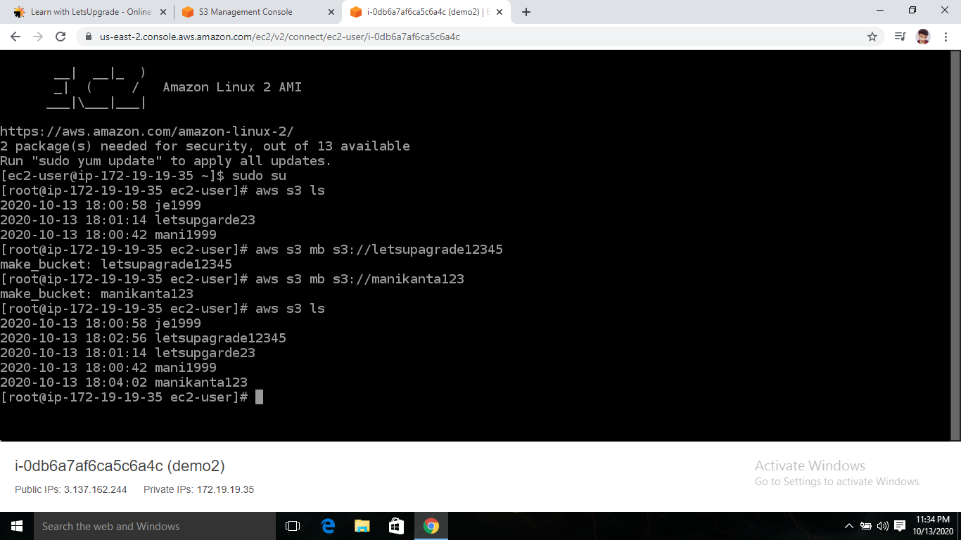

Adding Bucket to s3 using command aws s3 mb s3://bucketname

Created Buckets Named letsupgarde12345 , manikanta123



Created buckets in s3 console

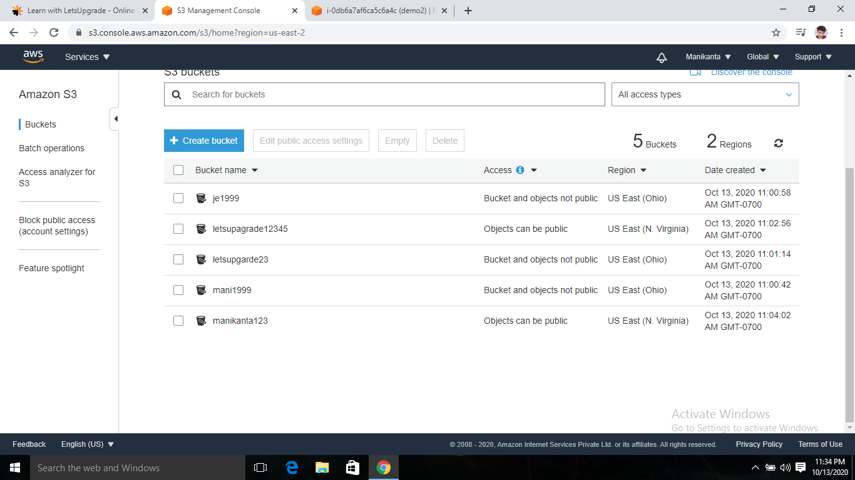

**3:Hosting a website using the bootstrap script on ec2**

User data boot strap script

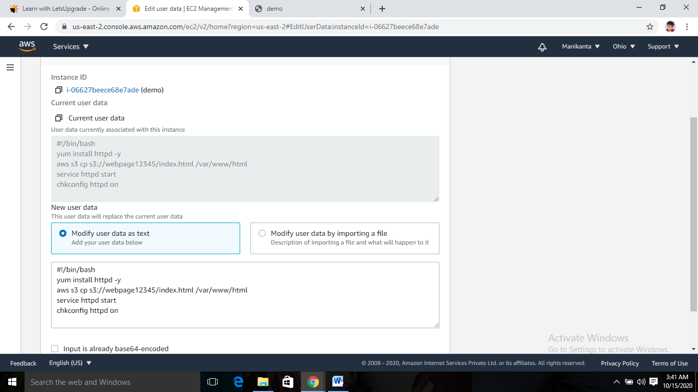

S3 bucket and the file

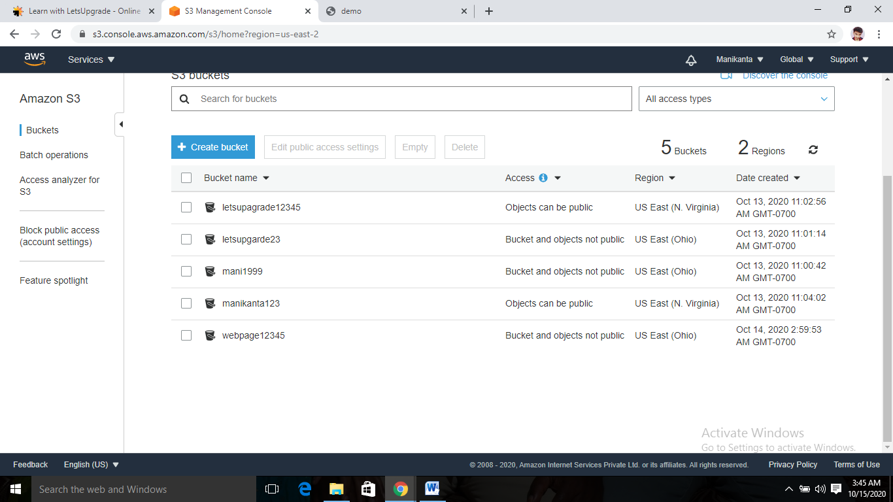

File

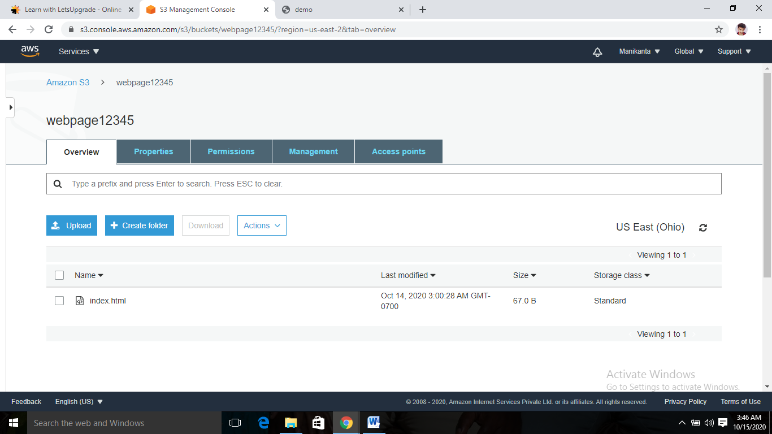

Web page accesing using public ip 3.137.167.50

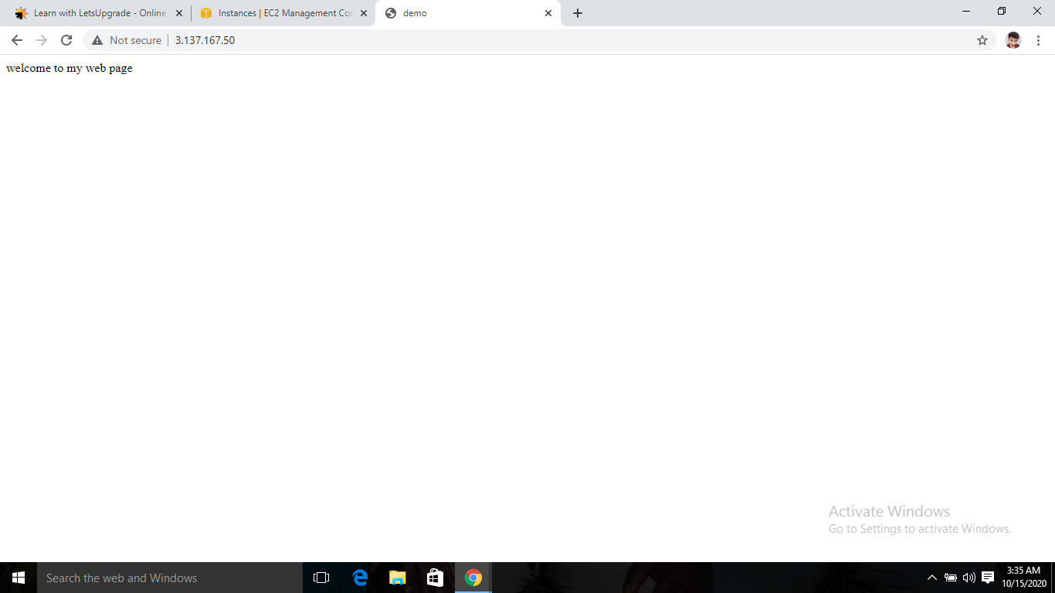

**Project to create a Virtual Private Cloud:**

**1)Creating an vpc:**

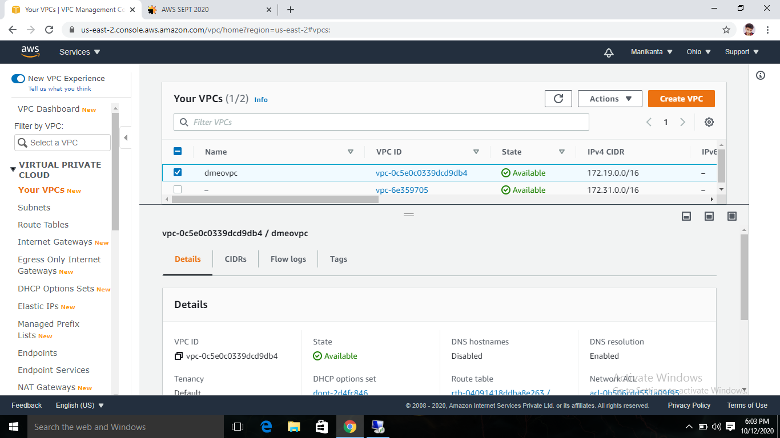

**2)Creating an Internet Gate Way:**

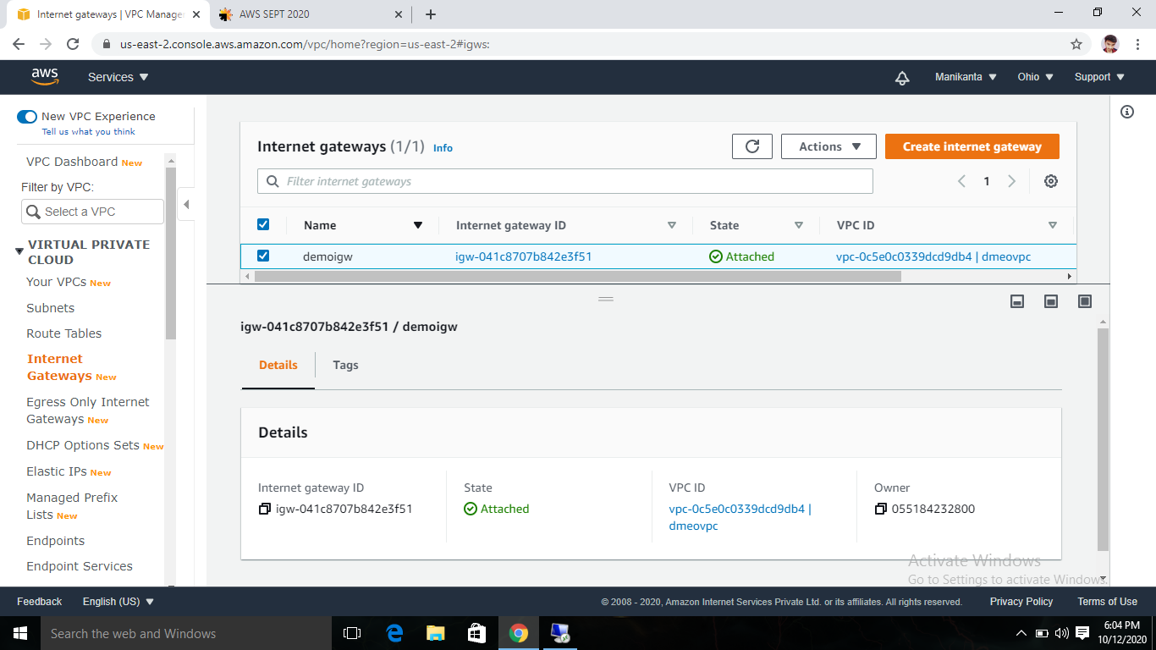

**3)Creating an Routing table:**

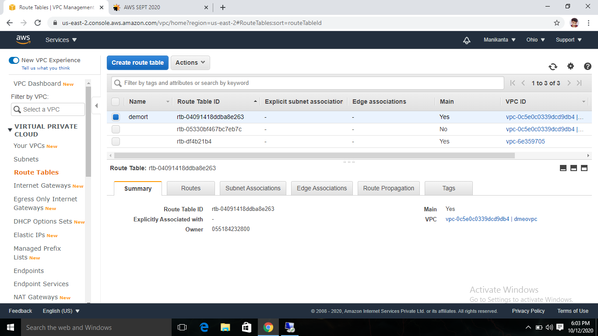

**4)Creating an Subnet:**

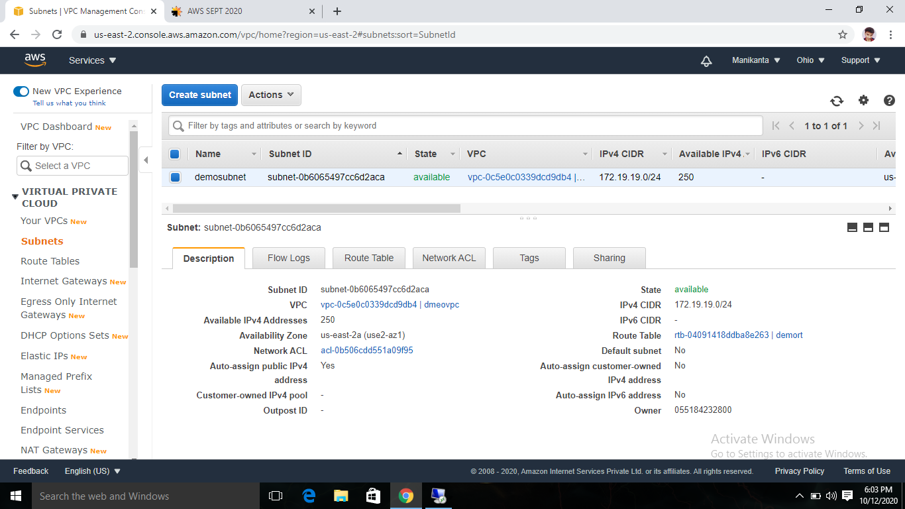

**5)Connecting to the instance:**

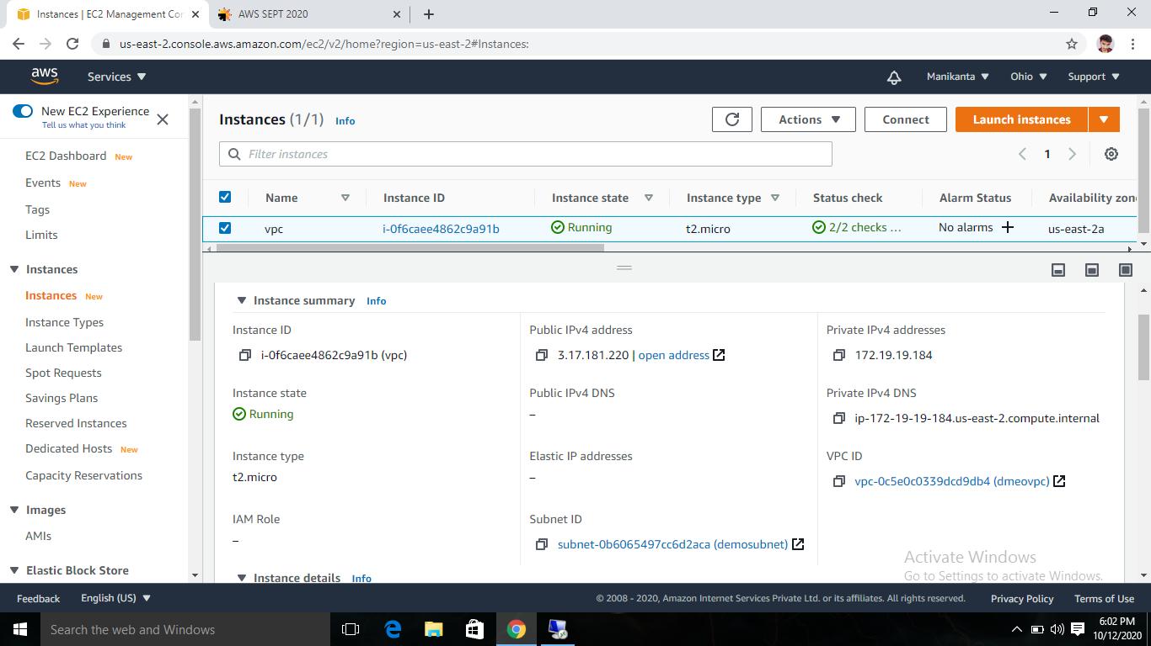

**6)Virtual Machine IP config:**

