Project1: Deploying a Highly Available Web Application and Bastion Host in AWS

Creating a VPC with private and public subnets

1.Creating a vpc with 10.0.0.0/16

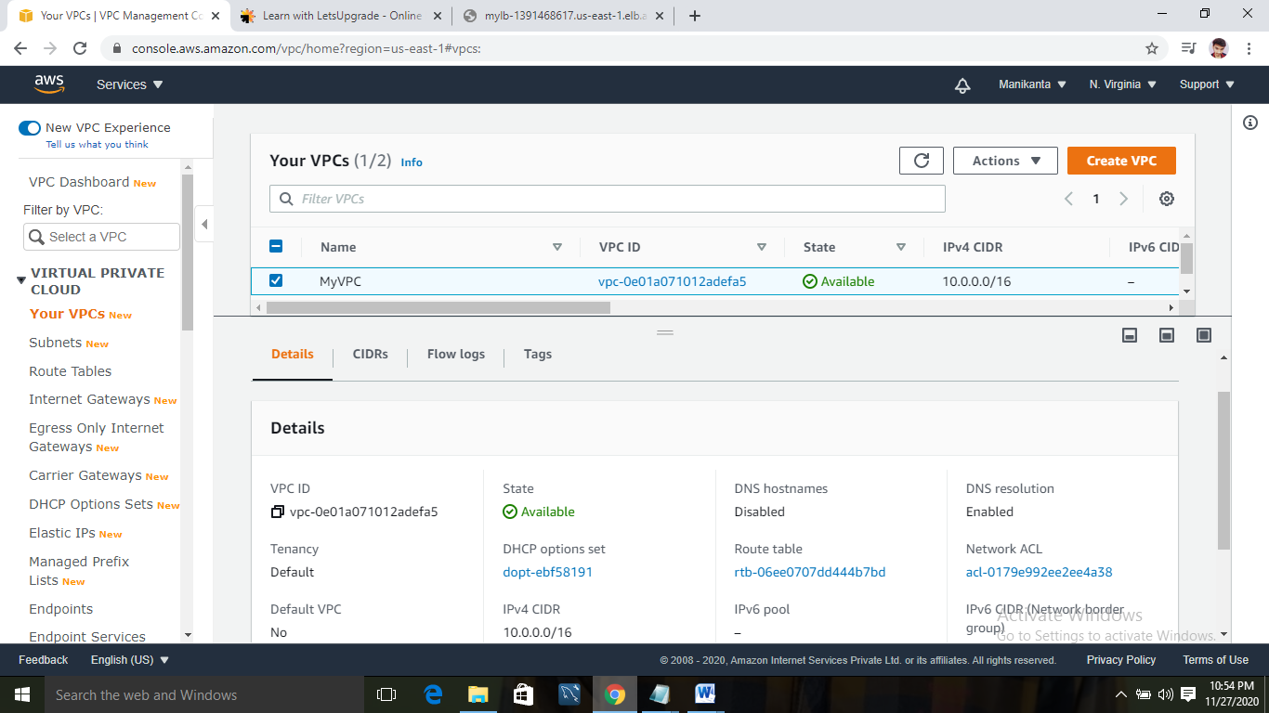

2:creating a public subnet with 10.0.0.0/24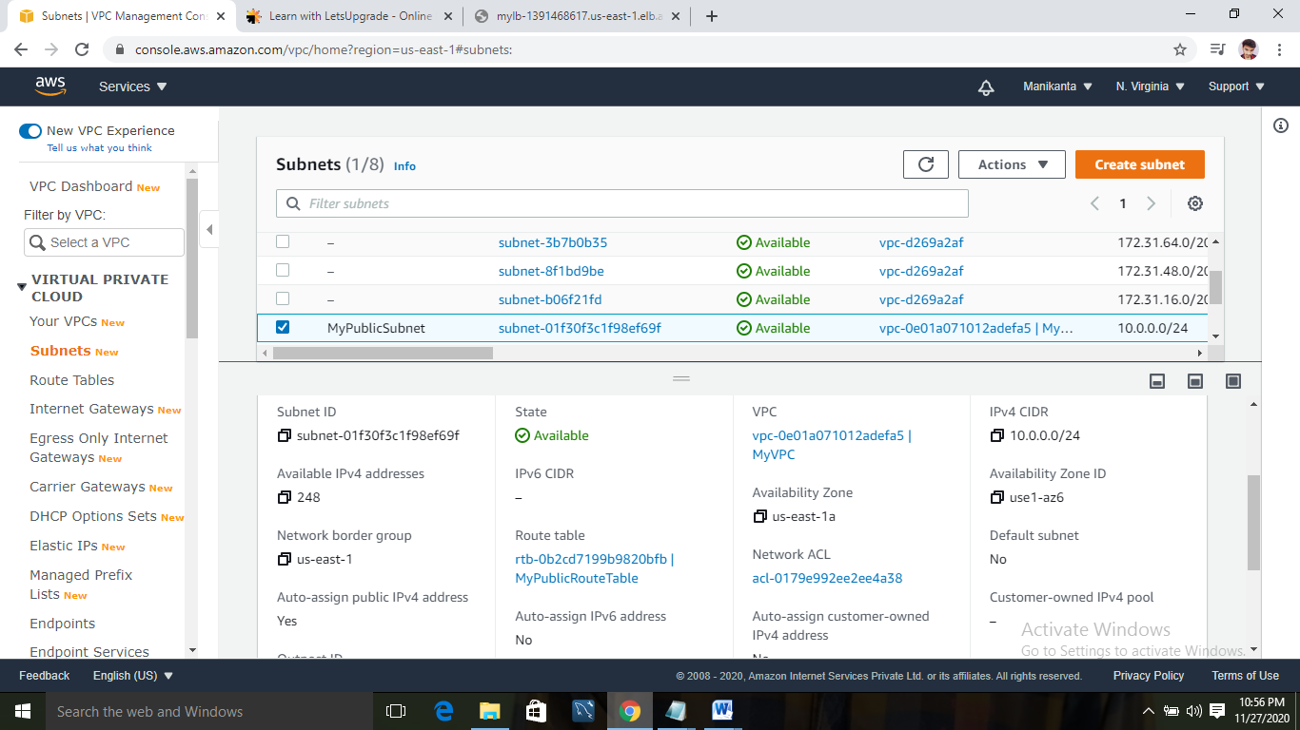

3:Creating a private subnet with 10.0.1.0/24 cidr block

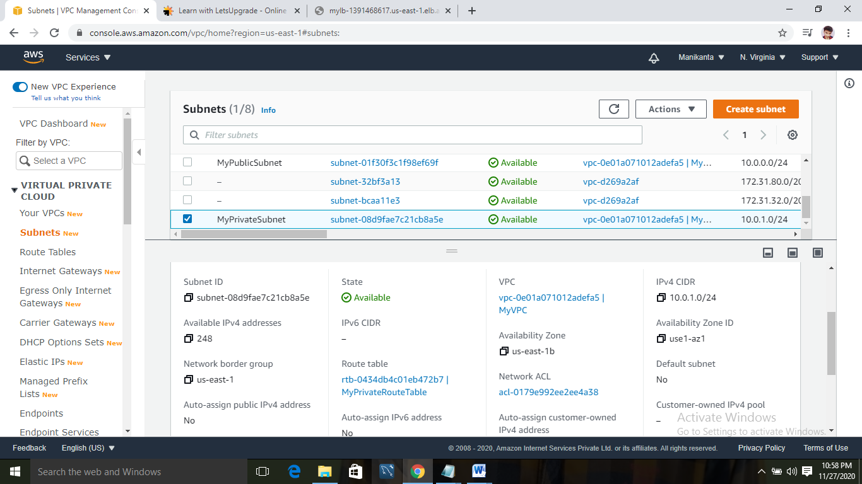

4:Creating a route table for Private and public

Private route table and added asubnet association with created subnet

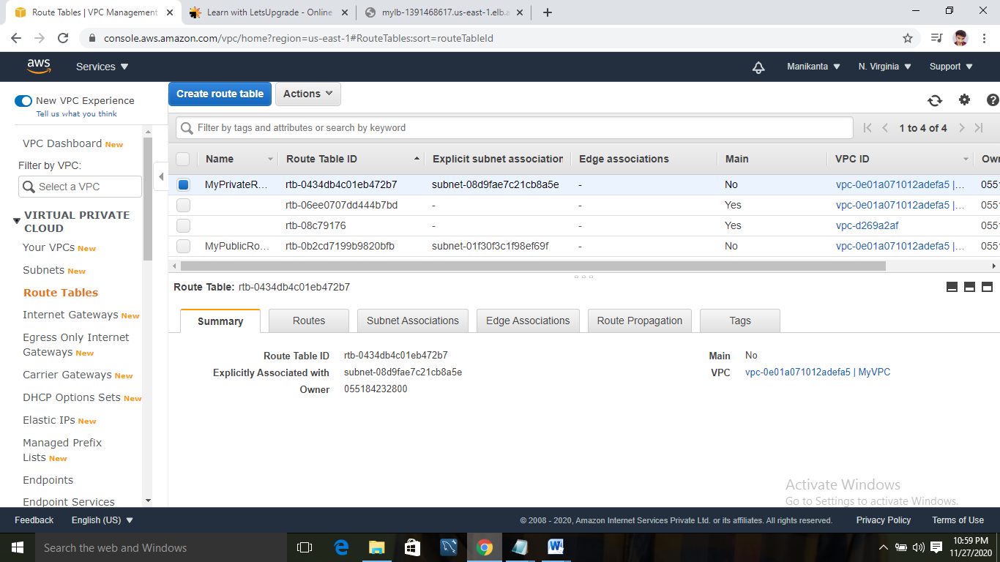

Creating a public route table and associating with public subnet and editing the routes with 0.0.0.0/0 with adding route to Internet gateway

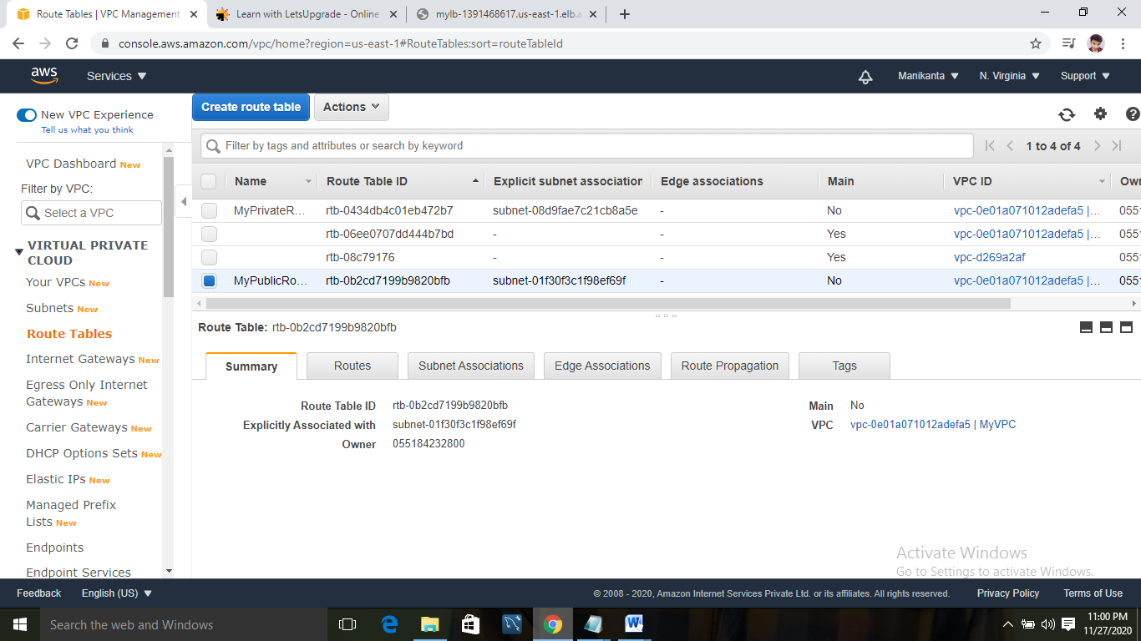

5:Creating Internet gate way:

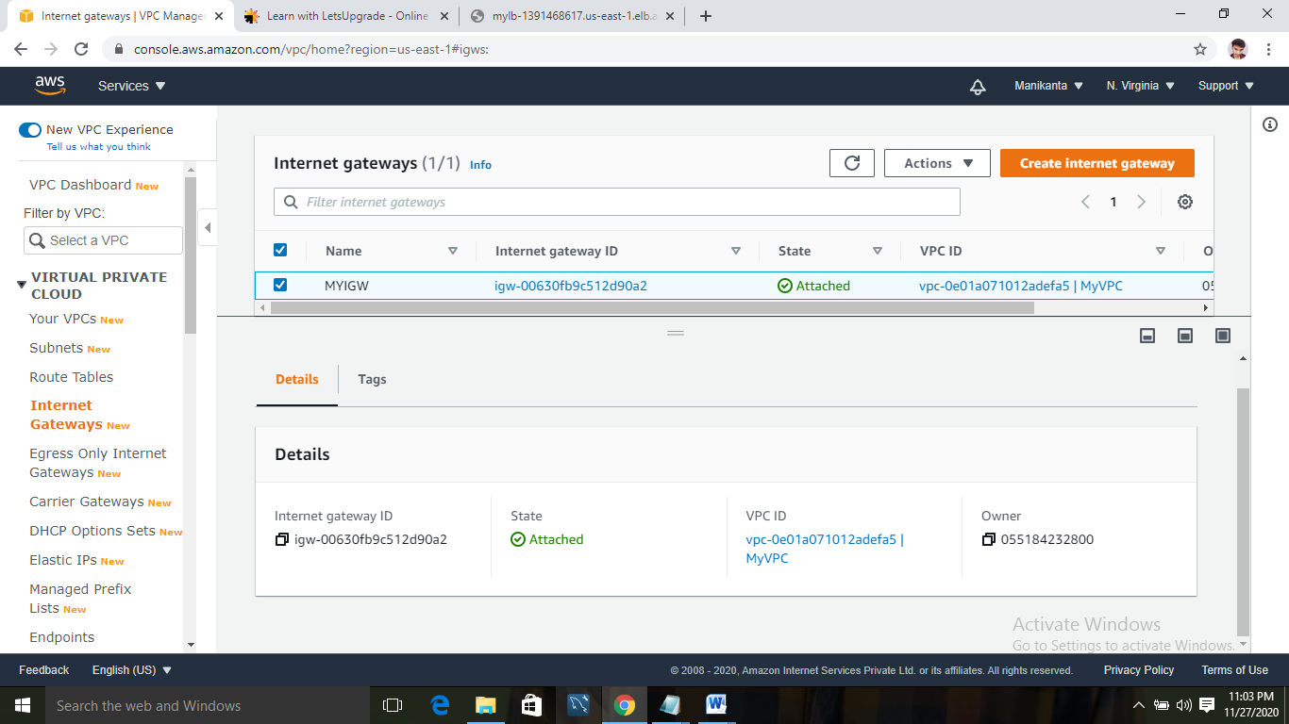

6:Creating a NAT gateway and associating it with the main route table that is created along with the vpc.

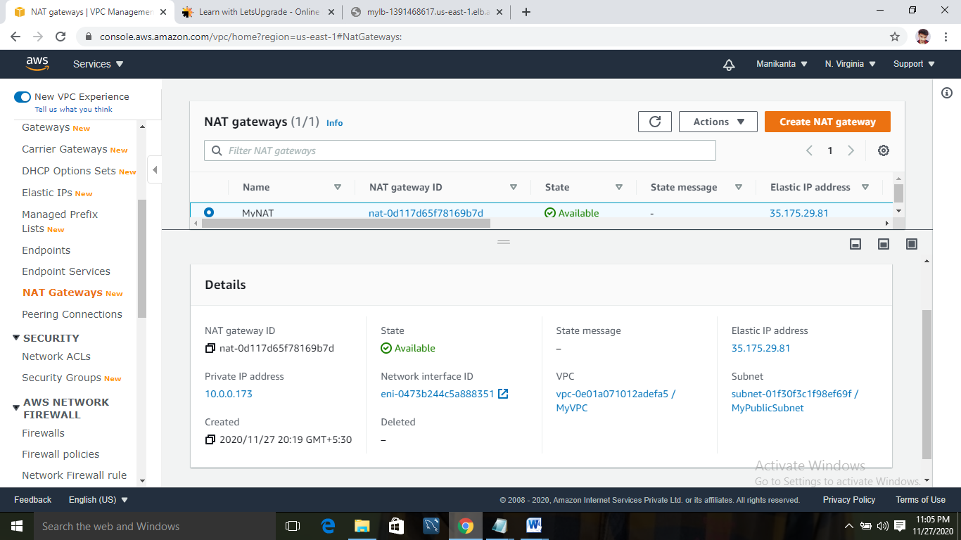

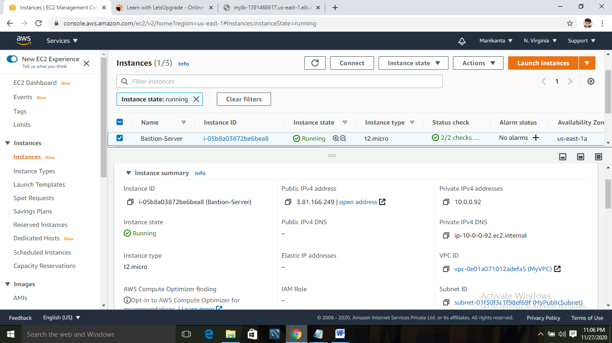7:Creating a bastion server with public subnet and myvpc and giving traffic to ssh

8:Creating a Security group for load balancer:

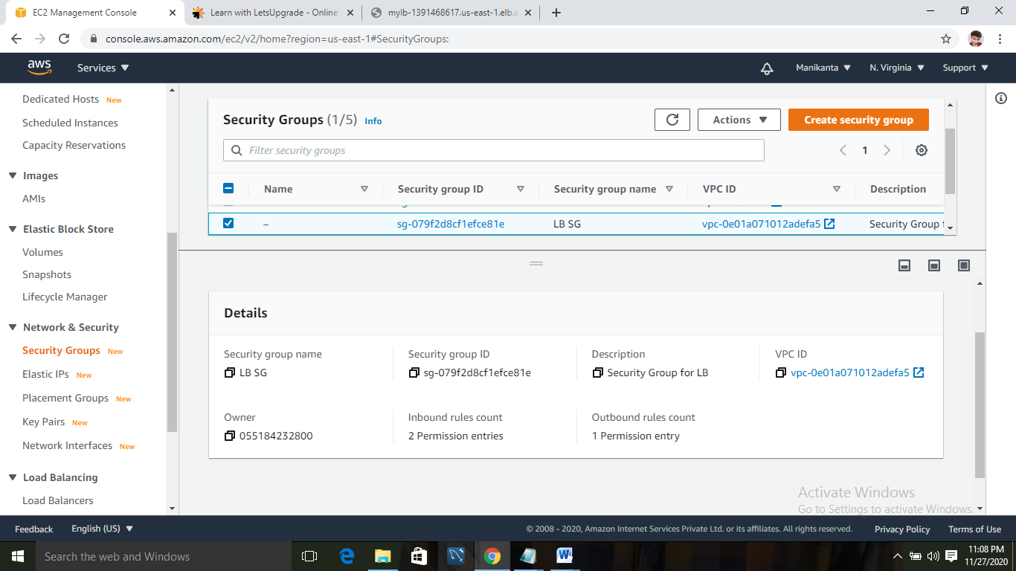

9:Creating two web server and connecting them with myvpc and private subnets and both security group LB and Bastion Sg

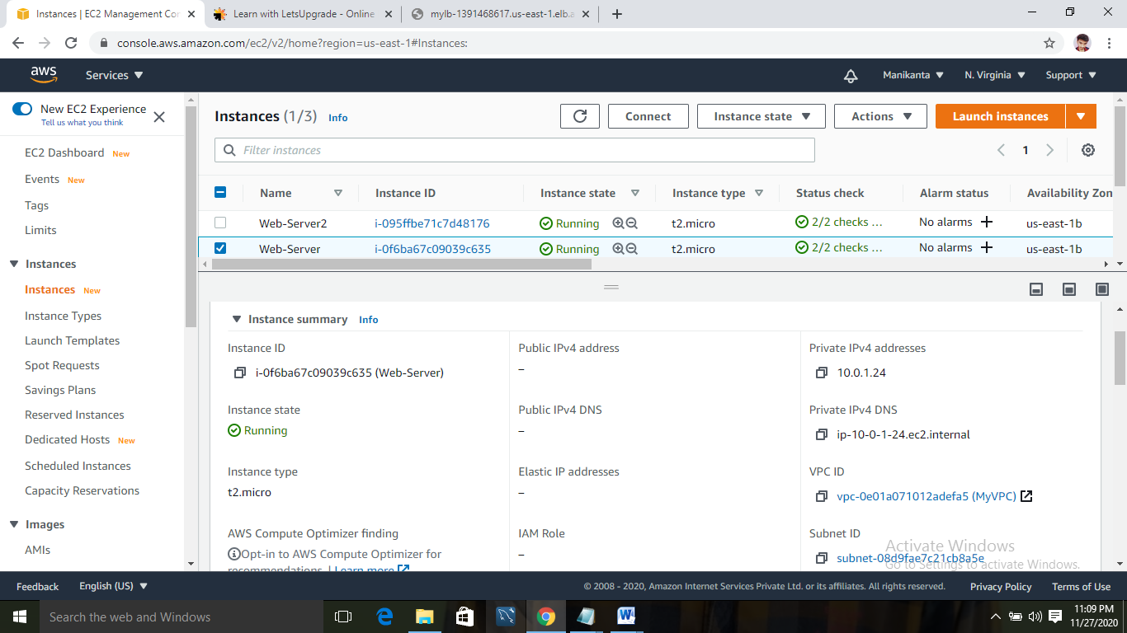

2nd web server with private subnet and myvpc

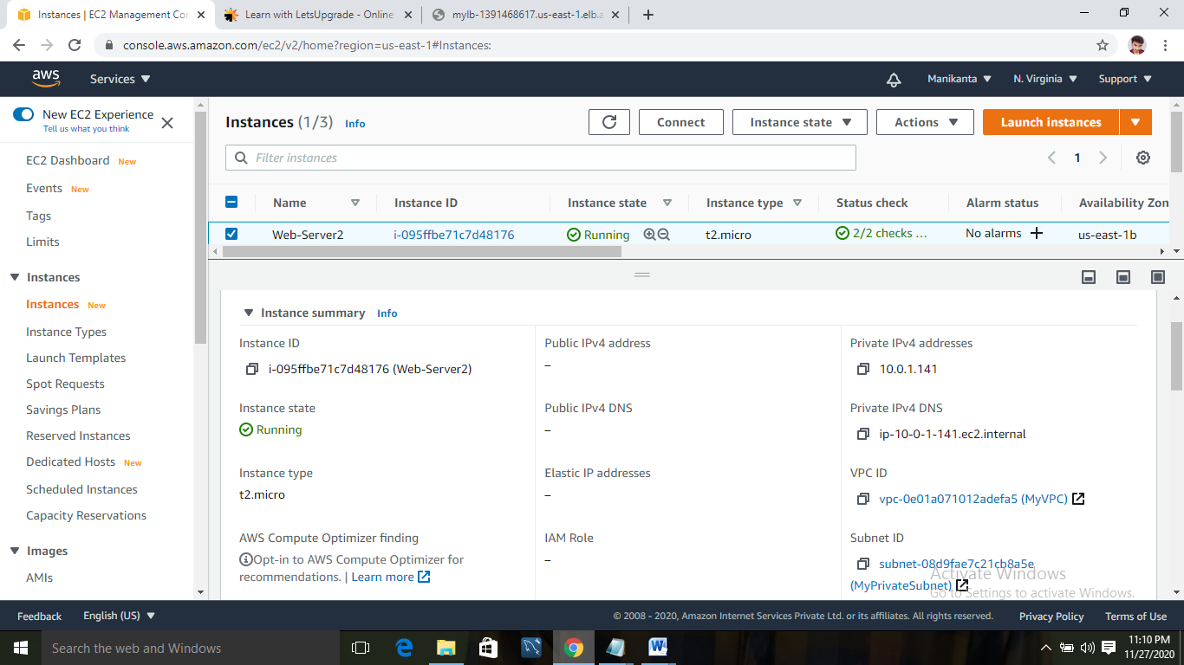

10:Creating a loadbalancer and registering targets to check the status of the servers:

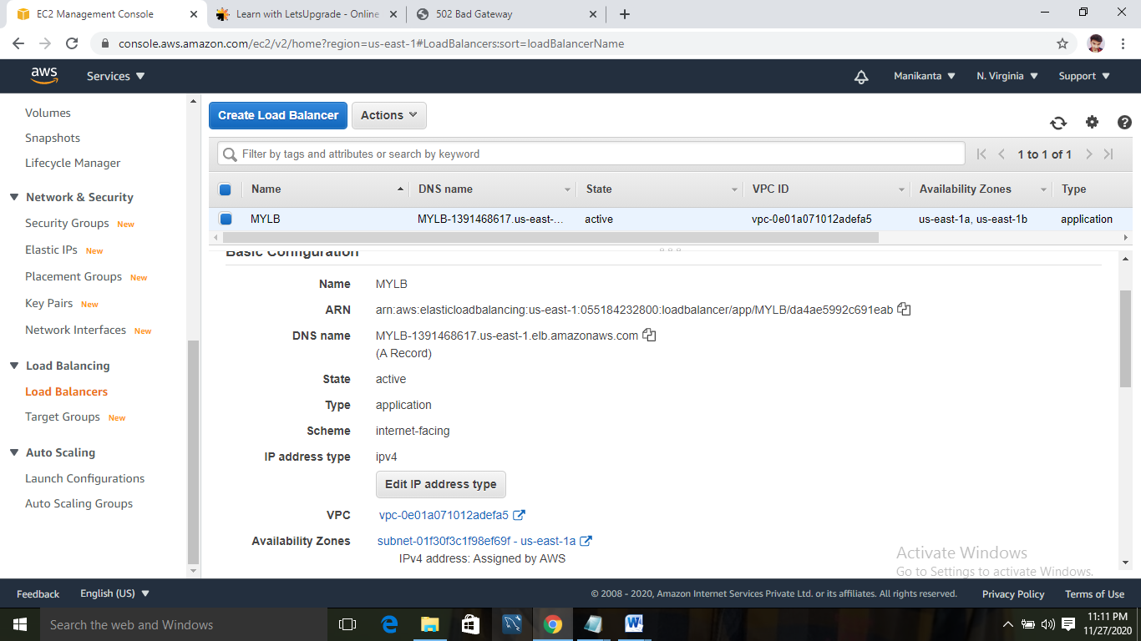

Bastion server connected to the first private web server:

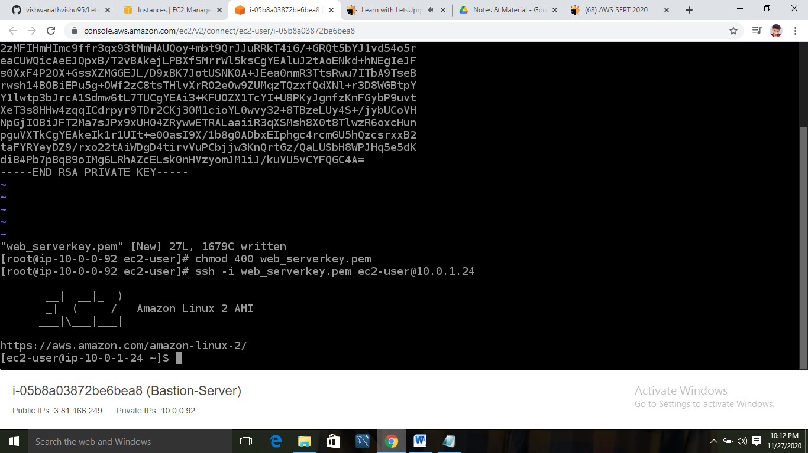

Bastion server connected to the second web server:

