# CS – 314 OPERATING SYSTEMS LAB -9

**Objective**

* Print desired statements whenever a file is created, read, written or deleted.

**Solution**

* To print the desired statement whenever a file is created, we add the following snippet inside the function “common_open()” in the file “open.c” in the directory “/usr/src/minix/servers/vfs”.

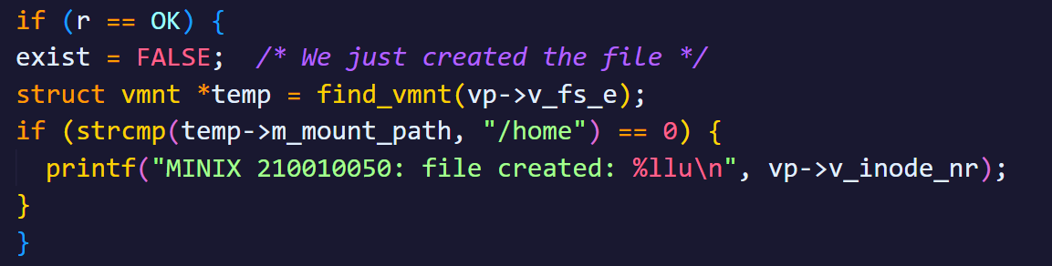

* To print the desired statement whenever a file is read or written, we add the following snippet inside the function “read_write()” in the file “read.c” in the directory “/usr/src/minix/servers/vfs”.

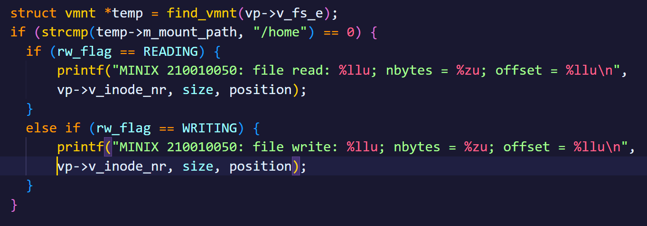

* To print the desired statement whenever a file is deleted, we add the following snippet inside the function “do_unlink()” in the file “link.c” in the directory “/usr/src/minix/servers/vfs”.

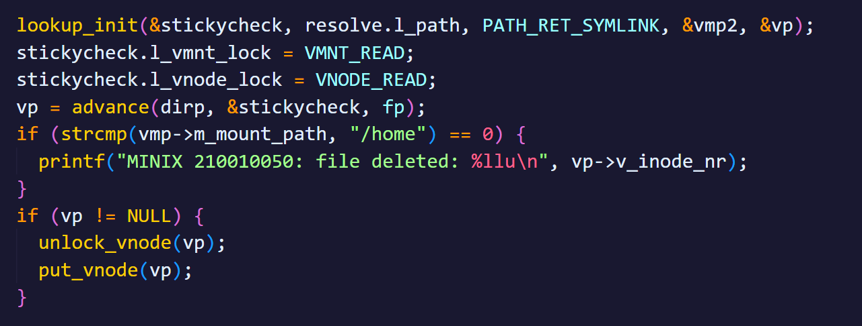

**Results**:

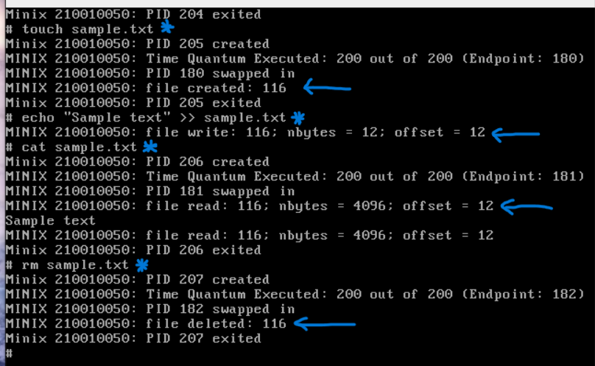

From the above screenshot, we can see that a statement is being printed whenever a file is created, read, written or deleted.