# CS-315 Computer Networks Lab Assignment -1

K.S.N Manikanta(210010050)

Task-1:

(i) $ ping www.google.com: This command sends messages/packets to the web address = www.google.com and measures the round-trip time(rtt) for the packets, i.e the time taken by the packet to go from our computer to the destination(web address) and back to our computer. It also outputs the response time and ttl per packet response and also total time and packet loss percentage along with average, maximum and minimum values of rtt.

(ii) $ traceroute www.google.com: This command shows the route that the packets take to reach the host. It displays all the hops between the source and destination. Each line represents a hop in the route, showing the IP address or hostname, and the round-trip times for packets sent to that hop.

(iii)$ arp: viewing and modifying the local Address Resolution Protocol (ARP) cache, which contains which contains mappings of IP addresses to MAC addresses on a network, i.e, we can view and modify the ARP table entries on the local computer.

(iv)$ ifconfig: This command helps to display or configure network interfaces on our system. It shows information about IP Address and Hardware / MAC address assigned to interfaces. The following information is displayed: Interface names and types, IP Addresses, MAC Addresses, Network Flags, TX and RX Statistics, MTU(Maximum Transmission Unit), and Collisions.

(v)$ hostname: This command displays the hostname of the system which refers to a host and make it usable for the network and people. The hostname is a unique name for a computer or network node in a network. It is used to identify it uniquely over a network.

(vi)

/etc/hostname: This file contains the hostname of the system, which is set during the system configuration and identifies the system within a network.

/etc/hosts: The hosts file is used to map IP addresses to hostnames locally. It's used for hostname resolution before querying DNS servers.

/etc/resolv.conf: This file contains configuration information for domain name resolution. It specifies the DNS servers used by the system and the search domains to look up.

/etc/protocols: It is a file that lists all the protocols supported by the current Linux kernel. It contains mappings of protocol names to their corresponding protocol number. For each protocol, the following information is displayed: official_protocol_name, protocol_number, aliases.

/etc/services: This file contains a list of network services and their associated port numbers used by the system. It associates commonly used services (like HTTP, FTP, SSH) with their respective port numbers.

Task-2:

(i)Hostname= manikantaksn-Inspiron-14-5410. IP address= 10.196.181.60

To get hostname run command: $ hostname. To get IP address run command $ ip addr and check inet in wireless connection.

(ii)Next hop router’s IP address: 10.196.3.250

Next hop router’s MAC address: 02-04-96-9a-82-e8

To get this, run $ traceroute [followed by a domain name], say $ traceroute [www.amazon.in](http://www.amazon.in). Then run $ arp [Ip address] to get the corresponding MAC address from the arp table.

(iii)Local DNS server IP address: 127.0.0.53. Run command $ cat /etc/resolv.conf

(iv) The numbers in the file /etc/protocols represent protocol numbers. The value identifies the protocol in the layer above IP to which the data should be passed. For each protocol, the following information is displayed: official_protocol_name, protocol_number, aliases.

(v)

ssh - Port: 22/tcp. Run command $ grep ssh /etc/services.

ftp - Port: 21/tcp. Run command $ grep ftp /etc/services.

nfs - Port: 2049/tcp , 2049/udp. Run command $ grep nfs /etc/services.

smtp (email) - Port: 25/tcp. Run command $ grep smtp /etc/services.

(vi)We can answer all the above questions for the phone running on android/ios. Hostname and IP Address of phone (android) can be viewed in the about phone section (status information) in settings. DNS server’s IP Address can be viewed by going into wifi settings and then changing IP settings from DHCP to Static.

Task-3:

(i)

ping www.amazon.in =>

--- www.amazon.in ping statistics ---

5 packets transmitted, 5 received, 0% packet loss, time 4006ms

rtt min/avg/max/mdev = 39.324/41.895/47.110/2.724 ms

ping www.iitb.ac.in =>

--- www.iitb.ac.in ping statistics ---

5 packets transmitted, 0 received, 100% packet loss, time 4082ms

(a) The success or failure of the ping command can be determined by whether or not the host responds to the ICMP(Internet Control Message Protocol) packets. If successful, it will display statistics showing the rtt for each packet sent and received. Failure could manifest as timeouts (no response within a specified time), unreachable host errors, or other network-related issues. Ping for www.google.com is a success as there is 0% packet loss. All the transmitted packets were received back whereas for www.iitb.ac.in no packet is received resulting in a failure with 100% packet loss.

(b) Round-trip time (rtt) is the duration in milliseconds (ms) it takes for a network request to go from a starting point to a destination and back again to the starting point. The results of the ping command may vary based on several factors such as network congestion, server responsiveness, distance from the server, and network stability. When executing the ping command, it sends ICMP packets to the specified host and waits for a response. The rtt is very high when the traffic levels are high. It depends on the intermediate routers or servers which progress the signal. rtt will increase If there are more number of hops.

(ii)$ traceroute www.amazon.in

(a) On traceroute we observe three rtt(for three packets) and an IP Address for each hop. We reached the destination in 24 hops. Some of the hops were unknown due to request timed out. The network map is as follows:

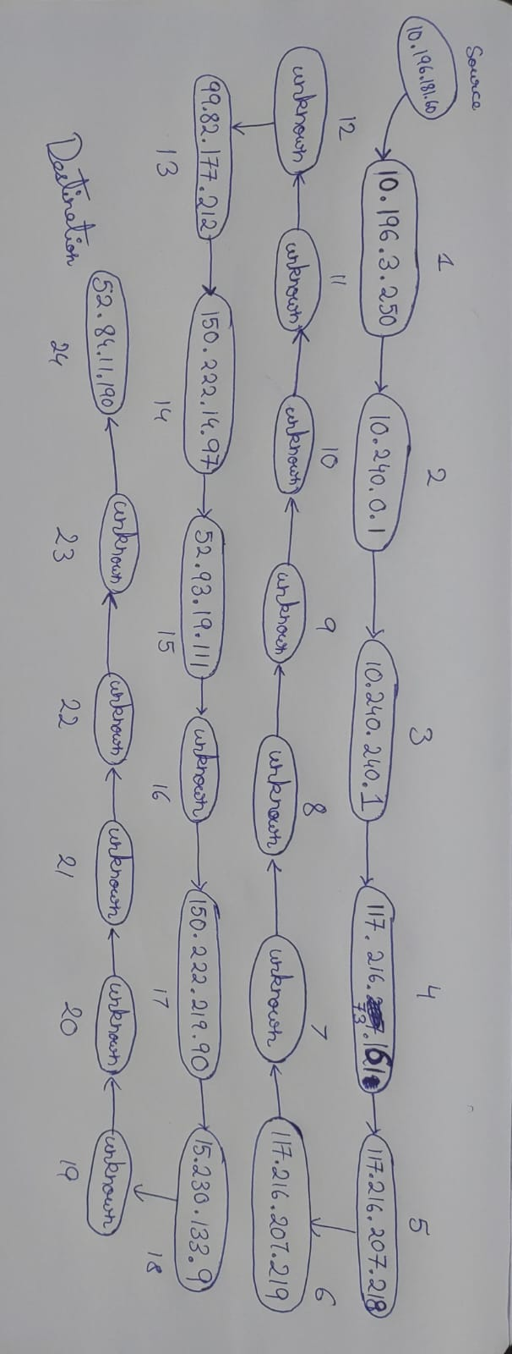

(b)To change the maximum hop number, use the -m option for traceroute: $traceroute -m 20 www.amazon.in sets max hop number to 20.

(c)The three timestamps indicate the round-trip time(rtt) of three different packets sent per ttl increment to each hop. These timestamps indicate how much time it took for the packet to reach the destination and come back to source.

(d)TTL is a value in IP packet headers used to limit the lifespan or hops that a packet can take before being discarded. In Traceroute, the TTL value starts from 1 and increments by 1 for each probe. When a probe is sent, the TTL is set, and each router decrements this value. When the TTL becomes zero, the packet is discarded, and an ICMP Time Exceeded message is sent back to the sender. Traceroute uses this feature to map the route by incrementally increasing the TTL to probe each hop along the path.