# CS-315 COMPUTER NETWORKS LAB-10 (ICMP)

**Part-1**

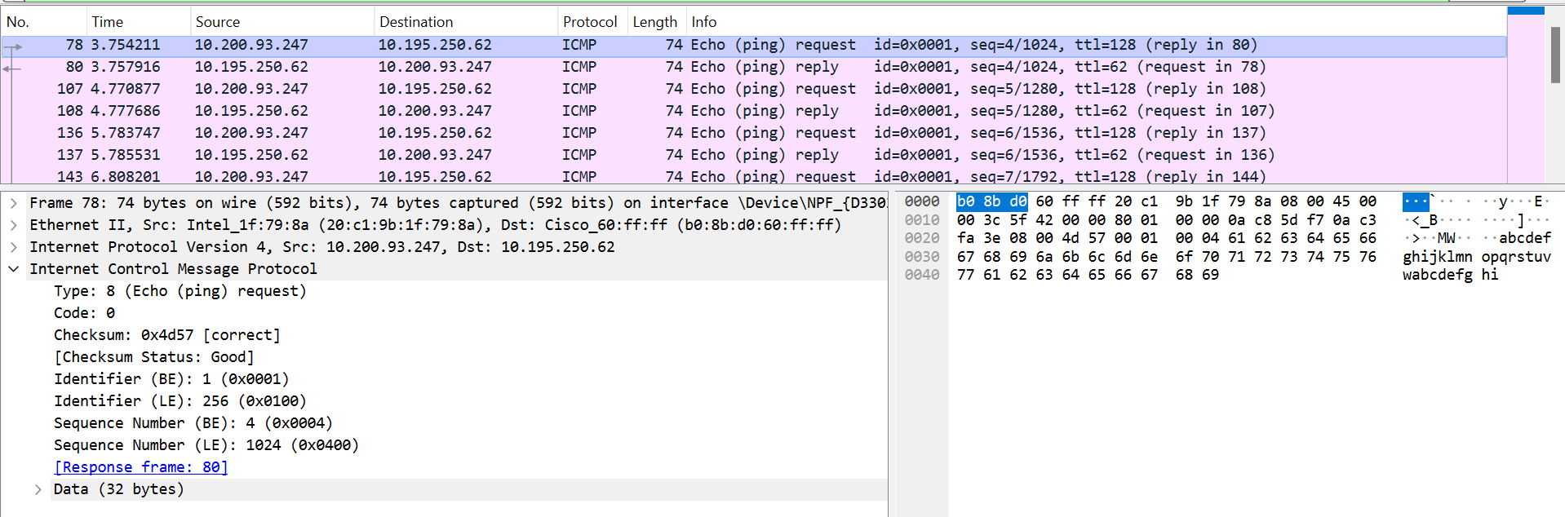

1. The IP address of my host = 10.200.93.247

The IP address of the destination host = 10.195.250.62

1. ICMP is a network layer protocol so it requires only source and destination IP address and does not require source and destination port numbers, which are required only for transport layer protocols.
2. From the screenshot above, the ICMP Type is 8 (Echo (ping) request) and the code is 0. The other fields that this ICMP packet has are Checksum, Identifier (BE), Identifier (LE), Sequence Number (BE) and Sequence Number (LE). As we can see, the checksum, sequence number and identifier field values have 4 hexadecimal digits, which is 16 bits or 2 bytes. Hence, the checksum, sequence number and identifier fields are of 2 bytes in size each.
3. From the screenshot below, for the ping reply packet, the ICMP Type is 0 (Echo (ping) reply) and the code is 0. The other fields that this ICMP packet has are Checksum, Identifier (BE), Identifier (LE), Sequence Number (BE) and Sequence Number (LE). As we can see, the checksum, sequence number and identifier field values have 4 hexadecimal digits, which is 16 bits or 2 bytes. Hence, the checksum, sequence number and identifier fields are of 2 bytes in size each.

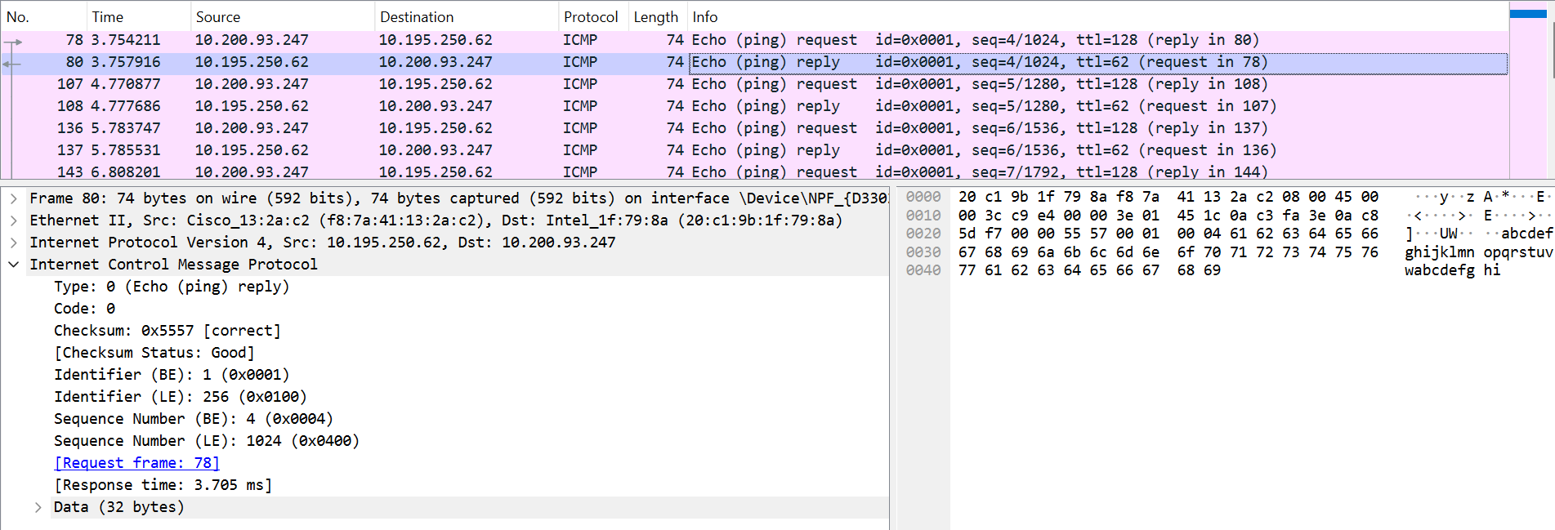

**Part-2**

Windows, by default, uses ICMP for traceroute command.

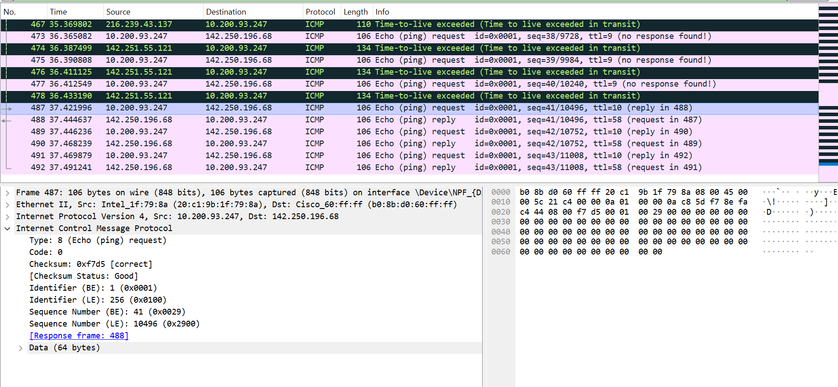

1. The IP address of my host = 10.200.93.247

The IP address of the destination host = 142.250.196.68

1. No, the protocol number would be 17 which is the assigned protocol number for UDP. The protocol number would be 1 in the case of ICMP packets.
2. No, the above screenshot shows that this packet is similar to the ICMP ping query packets in the first part as both have the same fields. The type and code fields in both also have the same values (8 and 0 respectively).
3. Yes, it has more fields. The extra fields are ‘Unused’, the IP layer of the echo request and the ICMP layer of the echo request which includes the fields: type, code, checksum, identifier and sequence number just as any other ICMP packet. Also, the type is changed to 11 (Time-to-live exceeded).

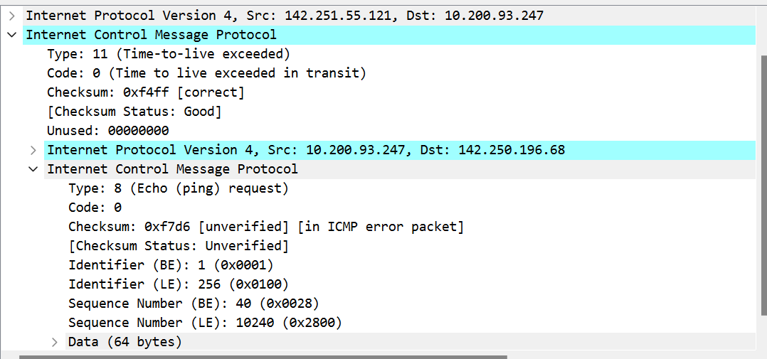

1. These packets are different from the ICMP error packets as we can see the Type is 0 (Echo (ping) reply) unlike 11 (Time-to-live exceeded) in the error packets. Also, unlike the error packets, they do not have an IP layer and an ICMP layer for the echo reply. They do not have the extra ‘Unused’ field like the error packets. These packets are different from the ICMP error packets in the sense that they are responses from the destination host (www.google.com) indicating that the packet has reached the destination. These packets are different from ICMP error packets because they are ICMP Echo Reply packets confirming that the destination host has received the ICMP Echo Request. In contrast, ICMP error packets are packets sent by intermediate routers along the path when they encounter issues forwarding packets to the destination. These packets indicate problems such as unreachable destination, TTL (Time-to-Live) exceeded, or routing changes. 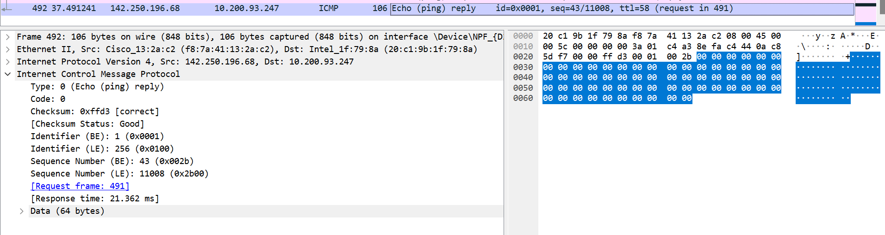
2. Yes, as we can see from the screenshot below, the delay of the link around 4-5-6-7(from hop 4 to hop 7) is significantly longer than others. The delay is noticeably higher compared to the previous ones, indicating a potential bottleneck or increased latency in that particular segment of the network. Dealy increased from 2ms in hop 4 to 17ms in hop 7.

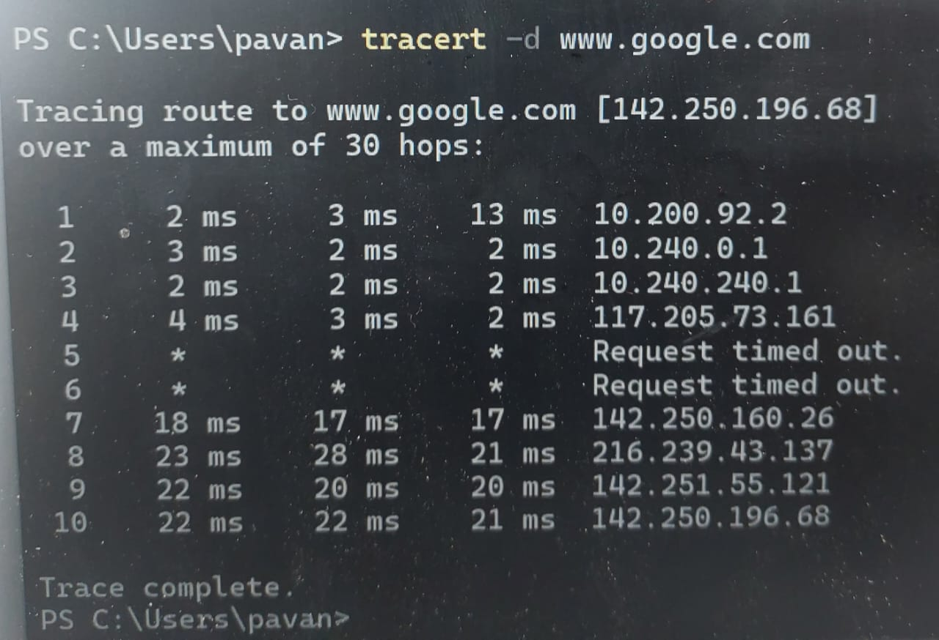

**Part-3**

