# **CS-315 COMPUTER NETWORKS LAB – 11**

**PART-1**

1. The 48-bit Ethernet address of my computer = c4:41:1e:75:b1:52

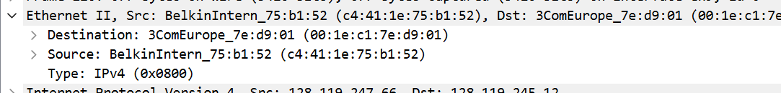

1. The 48-bit destination address in the ethernet frame is 00:1e:c1:7e:d9:01 .No, this is not the ethernet address of gaia.cs.umass.edu. This is the address of the router (gateway to the internet) to which my computer is connected. The device that has this ethernet address is 3ComEurope_7e:d9:01.
2. The hexadecimal value for the two-byte Frame type field in the Ethernet frame carrying the HTTP GET request is 0x0800. The upper layer protocol is IPv4.
3. The ASCII “G” in “GET” appears after 4*16 + 2 = 66 bytes from the very start of the Ethernet frame. It starts from the 67th byte.

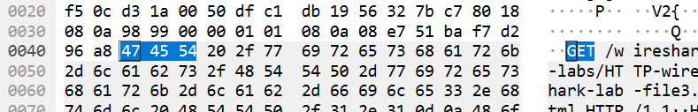

0x0400 = 64(decimal) + 2 bytes (4 hexadecimal digits)

= 66 bytes.

1. The Ethernet source address is 00:1e:c1:7e:d9:01. No, this is neither the Ethernet address of my computer nor that of gaia.cs.umass.edu. This is the address of the router to which my computer is connected. The device that has this ethernet address is 3ComEurope_7e:d9:01.

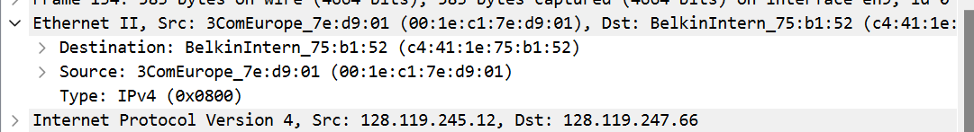

1. The destination address in the Ethernet frame is c4:41:1e:75:b1:52. Yes, this is the Ethernet address of my computer.
2. The hexadecimal value for the two-byte Frame type field is 0x0800. The upper layer protocol is IPv4.
3. The ASCII “O” in “OK” appears after 79 bytes (0x0040 = 64 + 15) from the very start of the Ethernet frame. The ASCII “O” in “OK” appears after 13 bytes (0x0000 = 0 + 13) in the HTTP.

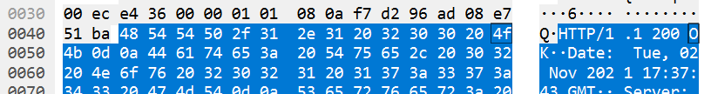



1. Four Ethernet frames (each containing an IP datagram, each containing a TCP segment) carry data that is part of the complete HTTP “OK 200 ...” reply message since there are 4 reassembled TCP segments.

**PART-2**

1. There are 9 entries stored in the ARP cache.

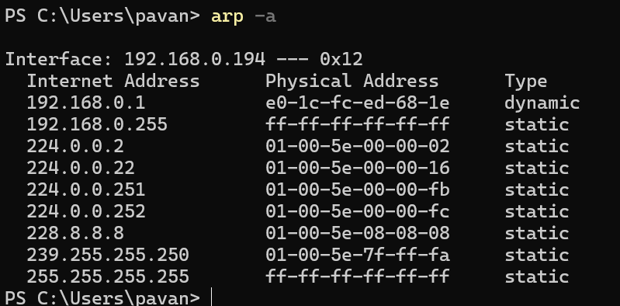

1. ARP cache contains mappings of IP addresses to MAC addresses. In each displayed entry, there is an Internet address (IP address), Physical address (MAC address) and Type (static/dynamic).
2. The hexadecimal value of the source address in the Ethernet frame containing the first ARP request message is c4:41:1e:75:b1:52.
3. The hexadecimal value of the destination address in the Ethernet frame containing the first ARP request message is ff:ff:ff:ff:ff:ff. This is a broadcast message sent to all devices within the local network segment. This is the address of the router to which my computer is connected.

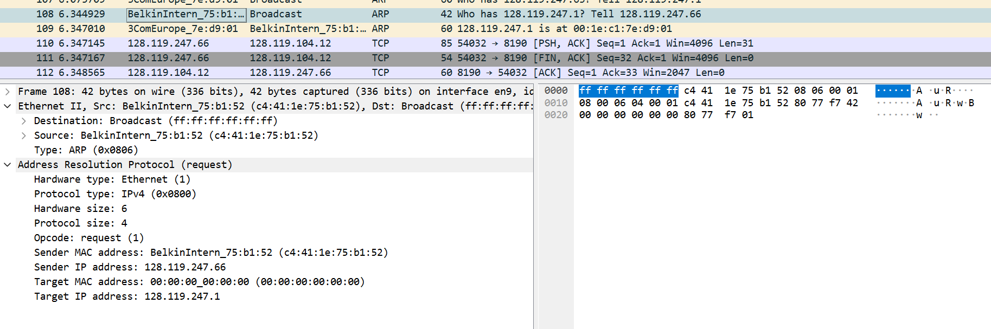

1. The hexadecimal value for the two-byte Ethernet Frame type field is 0x0806. The upper layer protocol is ARP.
2. The ARP opcode field begins after 20 bytes from the very beginning of the Ethernet frame. 0x0010 = 16 + 4 (8 hexadecimal digits) = 20, i.e, it begins from 21st byte.
3. The value of the opcode field within the ARP request message is request (1).
4. Yes, as we can see in the screenshot above. The value is 128.119.247.66.
5. The IP address of the device whose corresponding Ethernet address is being requested in the ARP request message is 128.119.247.1, which is the Target IP address as we can see in the screenshot above.

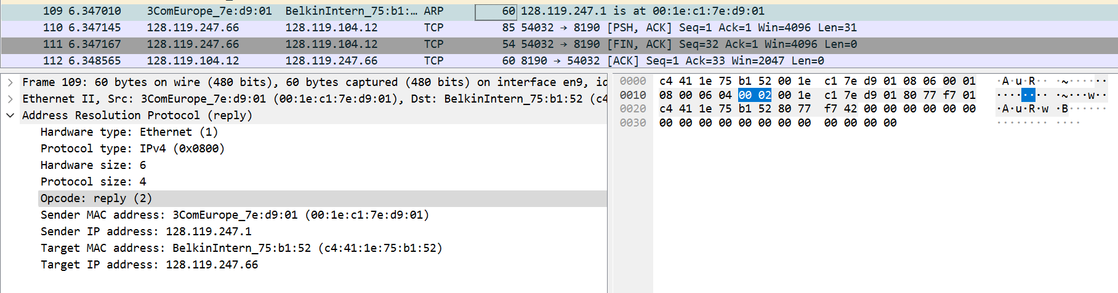

1. The value of the opcode field within the ARP reply message received is reply (2).
2. The Ethernet address corresponding to the IP address (128.119.247.1) that was specified in the ARP request message is 00:1e:c1:7e:d9:01.
3. There are no ARP replies in this trace, because we are not at all the machines that sent the request. The ARP request is broadcast, which is sent to all devices within the local network segment, but the ARP reply is sent back directly to the sender’s Ethernet address.