# CS-315 COMPUTER NETWORKS LAB-12 (WIFI)

**PART-1**

1. The SSIDs of the two access points that are issuing most of the beacon frames in this trace are 30 Munroe St and linksys12.

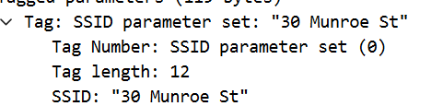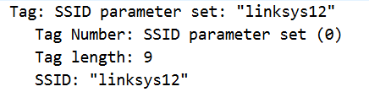

1. The beacon interval in the linksys_ses_24086 access point is 0.102400 seconds. The beacon interval in the 30 Munroe St. access point also is 0.102400 seconds.

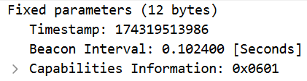 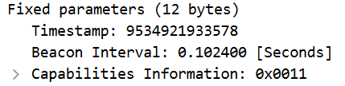

1. The source MAC address on the beacon frame from 30 Munroe St is 00:16:b6:f7:1d:51.



1. The destination MAC address on the beacon frame from 30 Munroe St is ff:ff:ff:ff:ff:ff.



1. The MAC BSS ID on the beacon frame from 30 Munroe St is 00:16:b6:f7:1d:51.



1. Supported Rates: 1(B), 2(B), 5.5(B), 11(B), [Mbit/sec]

Extended Supported Rates: 6(B), 9, 12(B), 18, 24(B), 36, 48, 54, [Mbit/sec]. These rates represent the data rates at which the access point can communicate with wireless devices. The "B" designation indicates that these rates are as per the 802.11b standard.

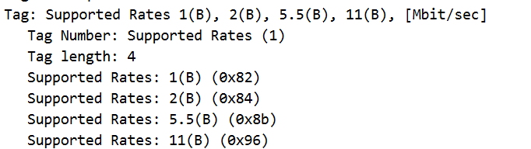

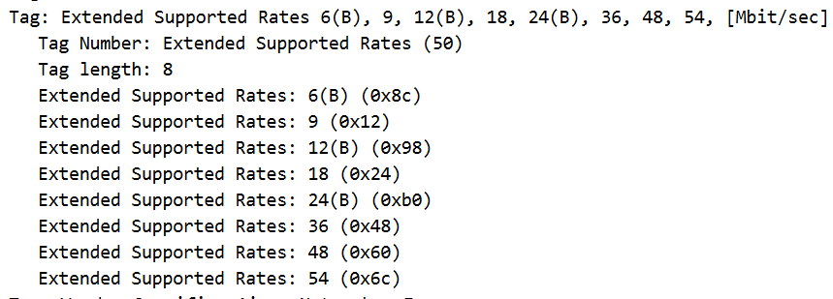

**Part-2:**

1. The 3 MAC address fields in the 802.11 frame are:

Source address: 00:13:02:d1:b6:4f

Destination address: 00:16:b6:f4:eb:a8

BSS Id: 00:16:b6:f7:1d:51

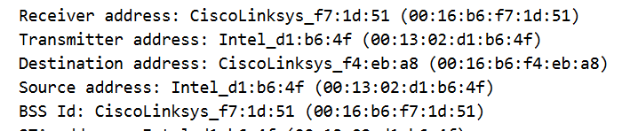

The source address (00:13:02:d1:b6:4f) corresponds to the wireless host. The BSS Id (00:16:b6:f7:1d:51) corresponds to the access point. The Destination Address (00:16:b6:f4:eb:a8) corresponds to the first-hop router. The IP address of the wireless host = 192.168.1.109 and the Destination IP address = 128.119.245.12.

1. The 3 MAC address fields in the 802.11 frame are:

Source address: 00:16:b6:f4:eb:a8

Destination address: 91:2a:b0:49:b6:4f

BSS Id: 00:16:b6:f7:1d:51

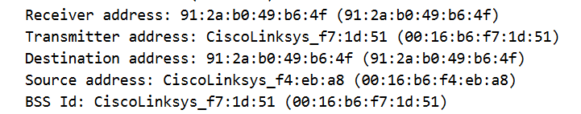

The source address (00:16:b6:f4:eb:a8) corresponds to the first-hop router. The BSS Id (00:16:b6:f7:1d:51) corresponds to the access point. The Destination Address (91:2a:b0:49:b6:4f) corresponds to the wireless host. The IP address of the server sending the TCP SYNACK is 128.119.245.12.

**Part-3:**

1. At t=49.583615, in packet no. 1733, the host sends a DHCP release message to the DHCP server in the network signaling that the host is leaving and wants to end the association with the AP. At t=49.609617, in packet no. 1735, the host sends a Deauthentication message. We expected to see a Disassociation request frame to have been sent, but it can’t be seen here.



1. A total of 15 Authentication messages are sent from the wireless host to the linksys_ses_24086 AP starting at around t=49. The packet numbers are 1740, 1741, 1742, 1744, 1746, 1749, 1821, 1822, 1921, 1922, 1923, 1924, 2122, 2123 and 2124.
2. The host wants the authentication to be open as we can see below the Authentication algorithm is set to Open System (0).



1. No, as the AP is probably ignoring requests from open access as it may have been configured to require a key for connecting.
2. At t = 63.168087, an Authentication frame is sent from the wireless host (00:13:02:d1:b6:4f) to 30 Munroe St. AP(MAC address = 00:16:b6:f7:1d:51). At t = 63.169071, an Authentication reply is sent from that AP to the host reply.



1. At t = 63.169910, an ASSOCIATE REQUEST is sent from the host (00:13:02:d1:b6:4f) to 30 Munroe St AP. The corresponding ASSOCIATE RESPONSE is sent at t = 63.192101.



1. Both the host and the AP are willing to use the following transmission rates: 1(B), 2(B), 5.5(B), 11(B), 6(B), 9, 12(B), 18, 24(B), 36, 48, 54, [Mbit/sec].





**Part-4:**

1. For the PROBE REQUEST sent at t = 2.297613, the MAC address of the sender(source) is 00:12:f0:1f:57:13, destination(receiver) is ff:ff:ff:ff:ff:ff and BSS ID is ff:ff:ff:ff:ff:ff. For the PROBE RESPONSE received at t = 2.300697, the MAC address of the sender(source) is 00:16:b6:f7:1d:51, destination(receiver) is 00:12:f0:1f:57:13 and BSS ID is 00:16:b6:f7:1d:51. Probe Request frames are sent by client devices to search for available networks, while Probe Response frames are sent by access points to provide information about their network in response to Probe Requests. These frames facilitate the process of discovering and connecting to wireless networks. In short, A probe request is used by a host in active scanning to find an access point and a probe response is sent by the access point back to the host.



Request:

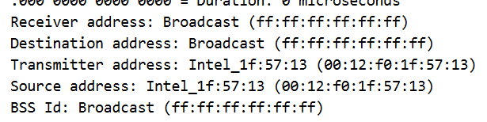

Response:

