# CS-315 COMPUTER NETWORKS LAB (NS3)

K.S.N Manikanta (210010050)

**Part-1**

2. Screenshot of animator tool.

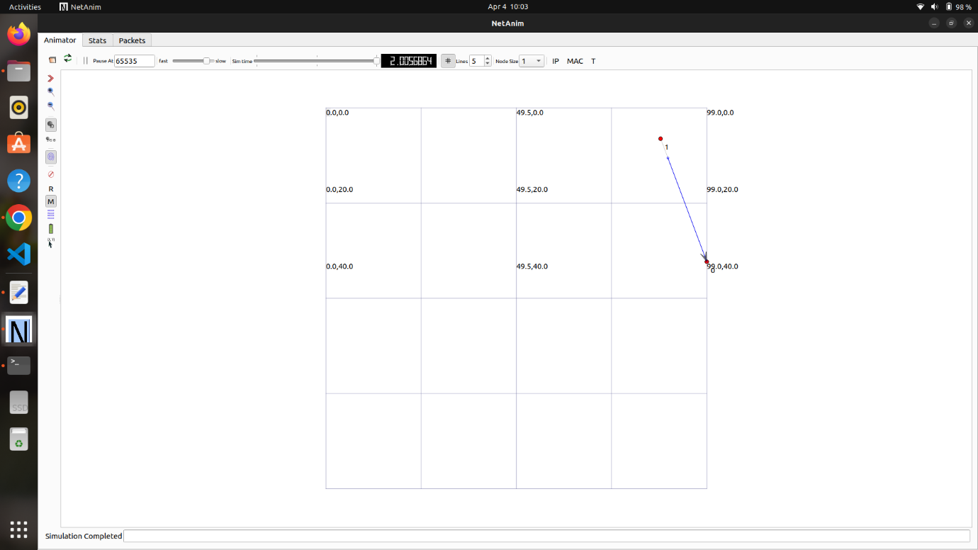

3. Screenshot of the statistics:

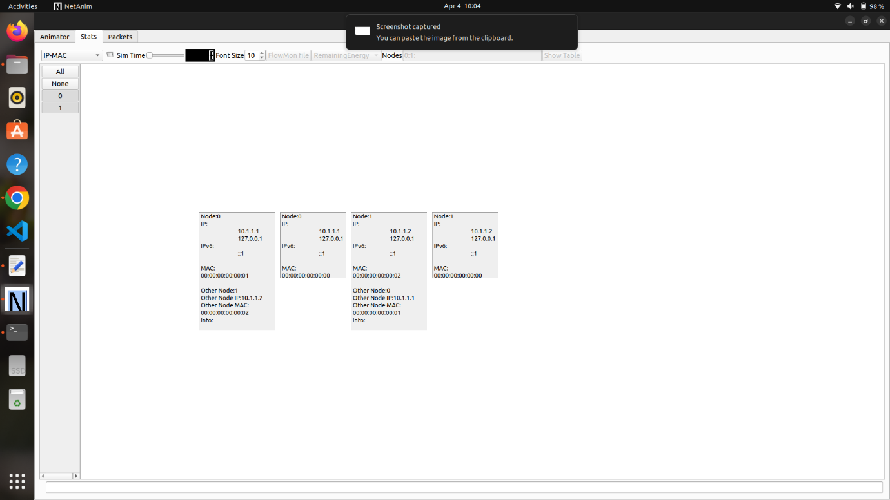

**Part-2**

2. Screenshot of the results:

