PART - 1

1) Black colour can mean any one of the following(5): 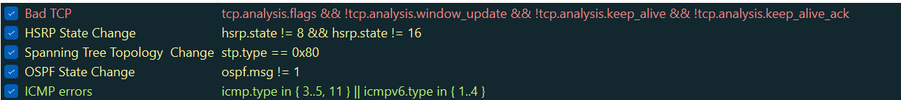

This information about Coloring rules can be seen by going to View => Coloring Rules. Black colour identifies TCP packets with problems and issues like packets being delivered out-of-order.

2) To filter the list of outgoing http traffic:

-> http.request.method == "GET" or http.request.method == "POST"

or we can even simply put filter: http

3) Why does DNS use Follow UDP stream?: DNS (Domain Name System) uses UDP (User Datagram Protocol) because UDP is a connectionless protocol that does not establish a persistent connection between the sender and receiver and DNS queries and responses are typically short-lived and can fit within a single UDP packet. Using Follow UDP Stream allows us to follow the flow of communication for a specific DNS transaction, thus making it faster and more efficient.

Why does HTTP use Follow TCP stream?: HTTP (Hypertext Transfer Protocol) uses TCP (Transmission Control Protocol) as TCP is a connection-oriented protocol that establishes a reliable, ordered, and error-checked connection between the sender and receiver and HTTP transactions involve multiple packets exchanged between the client and server. Using Follow TCP Stream in Wireshark lets you see the entire conversation between the client and server for a specific HTTP connection.

PART – 2

Using [www.amazon.in](http://www.amazon.in/)

1) TCP = Transmission Control Protocol,   
 HTTP = Hyper Text Transfer Protocol,   
 OCSP = Online Certificate Status Protocol,   
 TLSv1.2, TLSv1.3= Transport Layer Security,   
 DNS = Domain Name Server,   
 ICMPv6 = Internet Control Message Protocol,   
 QUIC = Quick UDP Internet Connections,   
 SSLv2 = Secure Sockets Layer,   
 ARP = Address Resolution Protocol.

2) Time taken from HTTP GET message to HTTP OK reply = 22:23:56.258323070 - 22:23:56.239175270 = 0.19147800 seconds



3) Internet address of my computer= 10.240.16.112  
 IP address of URL = 34.107.221.82

4) No 71,83 is HTTP GET message and No 73,88 is HTTP OK message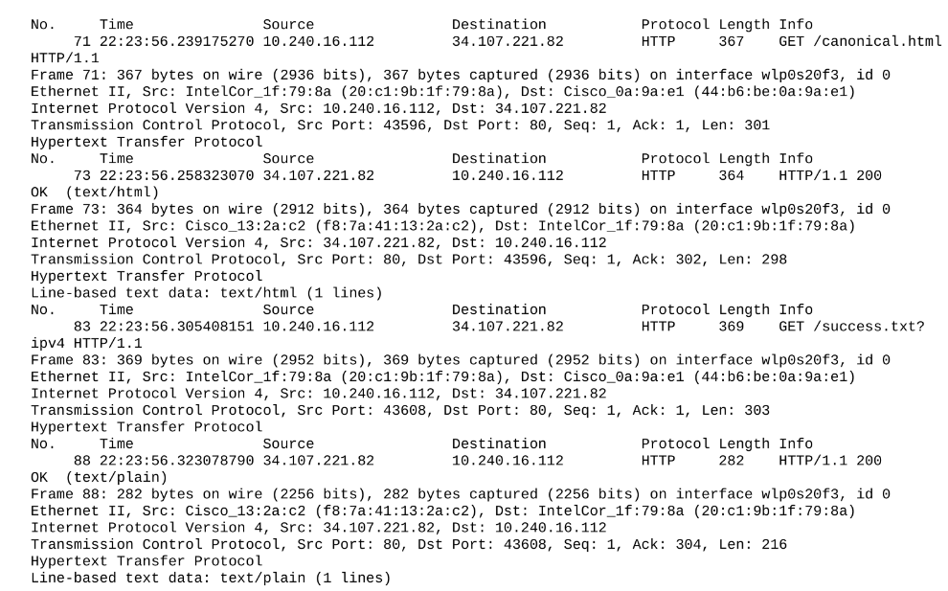

5)

These results from above were obtained from Firefox.





But, when tried with both Google Chrome and Brave browsers, no HTTP packet was captured by wireshark

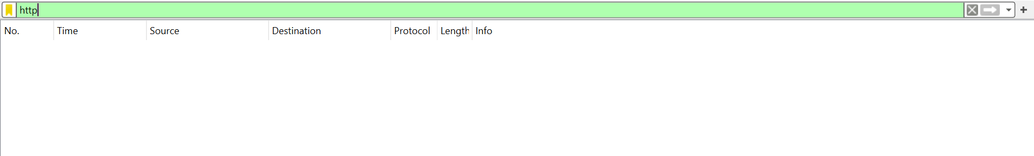

We see this blank list for both chrome and brave browser. The following may be some of the reasons why we are not able to see http protocol packets:

1. Encrypted Traffic (HTTPS): Chrome and Brave use HTTPS (SSL/TLS) to encrypt the data transmitted between the browser and the server. Wireshark won't be able to decrypt this traffic unless you have the private key for the SSL/TLS connection, which is typically not accessible. You might see only encrypted data in the packets.
2. Browser Configuration: Some browsers have security features that can prevent capturing of certain types of traffic. For example, Chrome has features like QUIC (Quick UDP Internet Connections) that may not be fully supported or captured by Wireshark.
3. Browser Preferences: These browsers might have preferences or settings related to network protocols or proxy configurations that could impact packet capture. Check the browser settings to ensure it allows the capturing of network packets.
4. Protocol or Port Changes: These browsers are constantly evolving, and new protocols or changes in the default ports they use might impact the visibility of certain packets. Check the documentation of the browsers for any recent changes.