# CS-315: COMPUTER NETWORKS LAB ASSIGNMENT 3

PART-1:

1. My browser is running http version 1.1 and the server is also running http version 1.1 =>

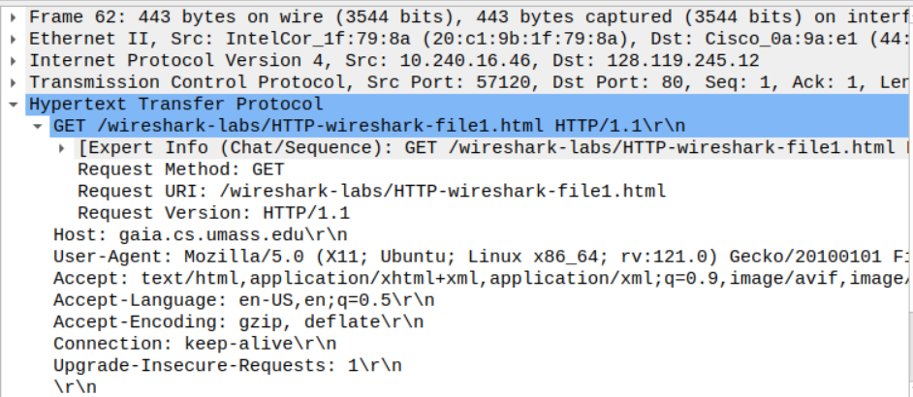

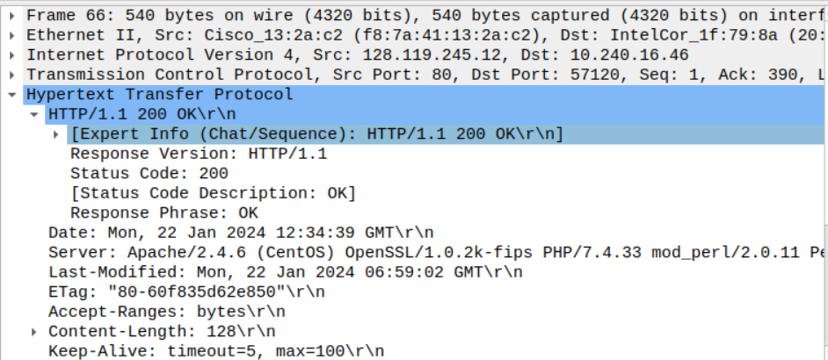

1. Accepted-Languages: en-US, en



1. My computer IP address: 10.240.16.46

IP address of gaia.cs.umass.edu server: 128.119.245.12



1. Status code: 200

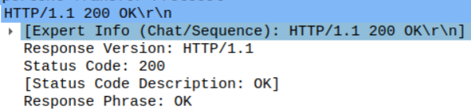

1. The HTML file that I was retrieving was last modified on Mon, 22 Jan 2024 06:59:02 GMT.



1. Size/Bytes of content = 128 bytes[can be seen below in the screenshot as content length]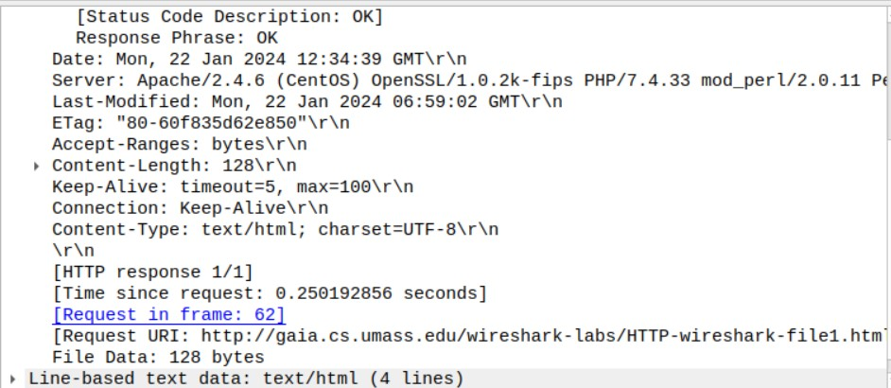
2. No, all the headers are displayed in the packet listing window since here we can see all the content that we see on the web page of the given URL.

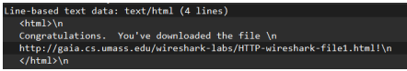

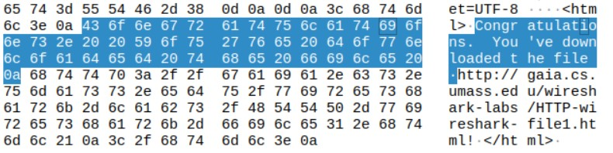

PART-2:

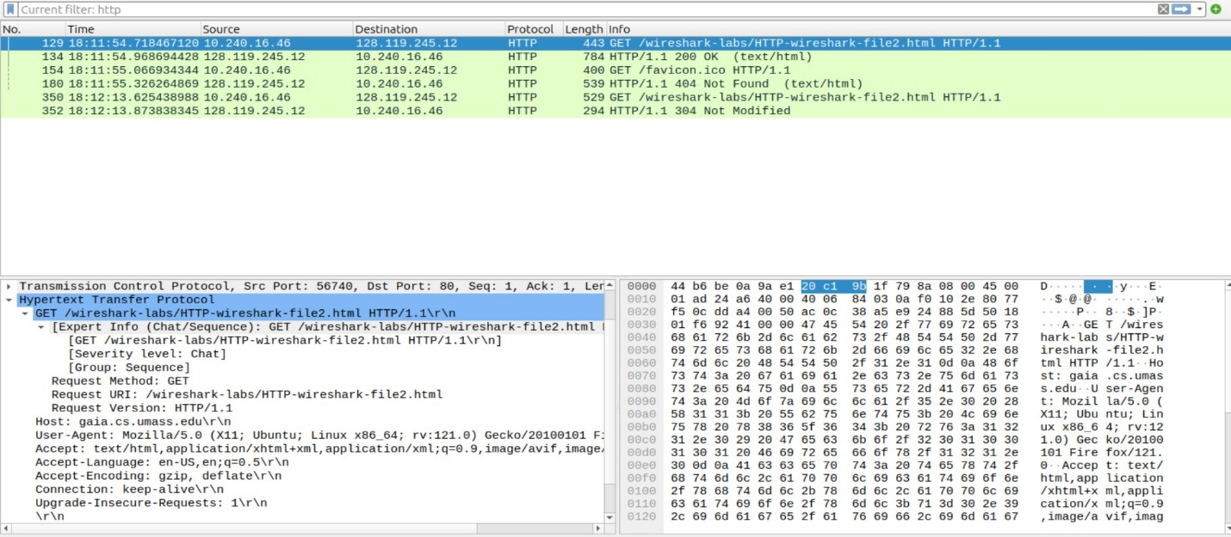

1. No, there is no ‘IF-MODIFIED-SINCE’ line in the HTTP GET request as we can see above.
2. Yes, the server explicitly returns the contents of the file. As we can see a Line-based text data section which has the same content that we saw on the web page of the given URL.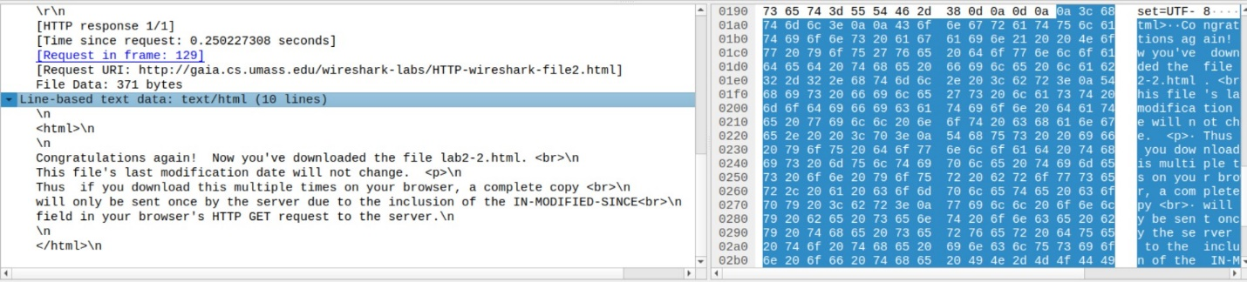
3. Yes, there is an ‘IF-MODIFIED-SINCE’ line in the HTTP GET. The information that follows the header is the time and date[can be seen below] of the last modification of the file from the previous get request.

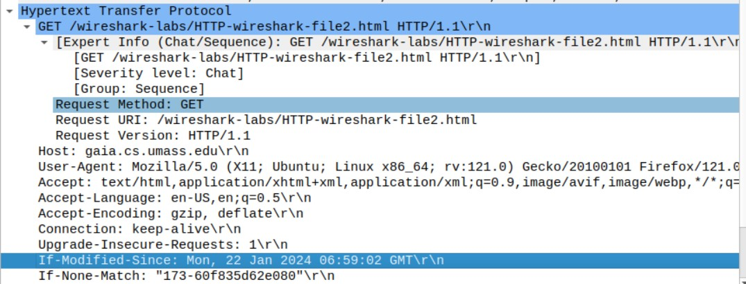

1. The status code and phrase returned from the server is ‘HTTP/1.1 304 Not Modified’. No, the server didn’t return the contents of the file as the browser loaded it from its cache.

PART-3:

1. My browser sent one HTTP GET request message(ignoring the request for favicon). Packet number 232 in the trace contains the GET message for the Bill or Rights.

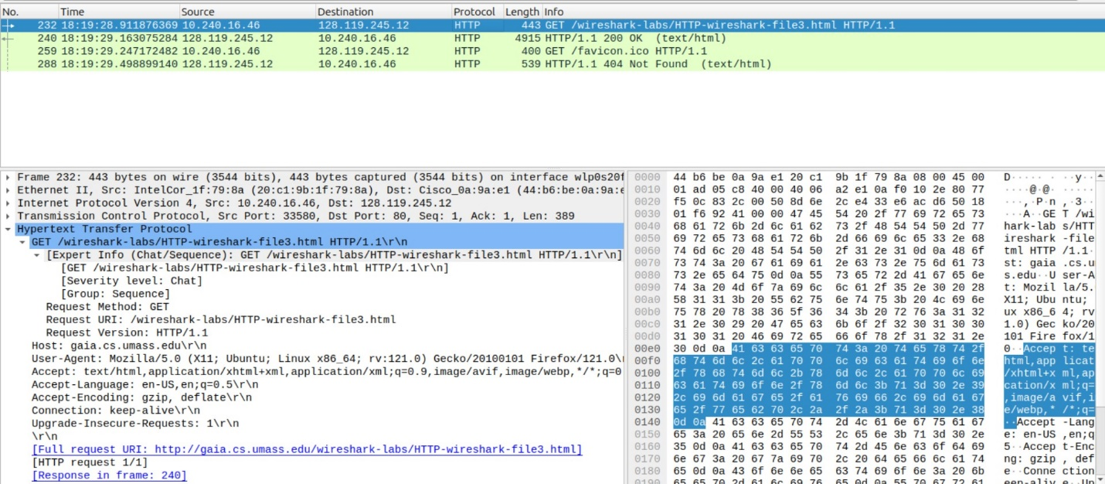

1. Packet number 240 in the trace contains the status code and phrase associated with the response to the HTTP GET request.

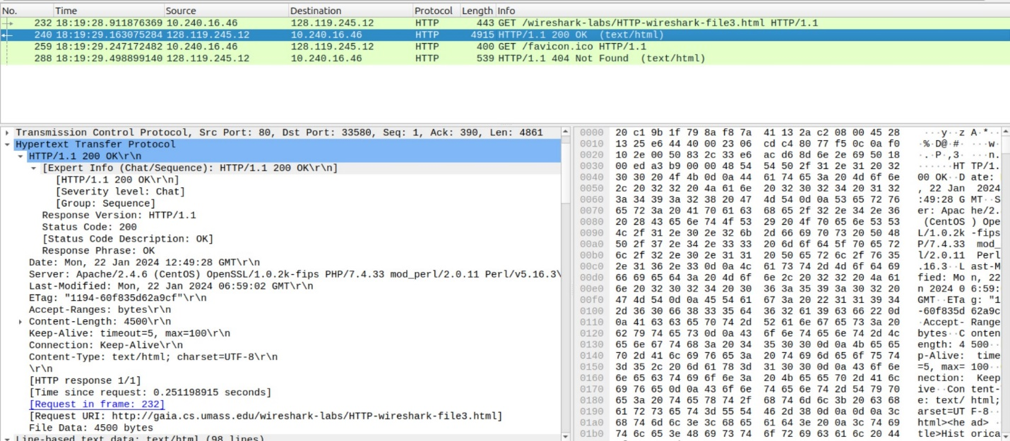

1. Status Code: 200; Phrase in the Response: OK [Can be seen above from the screenshot]

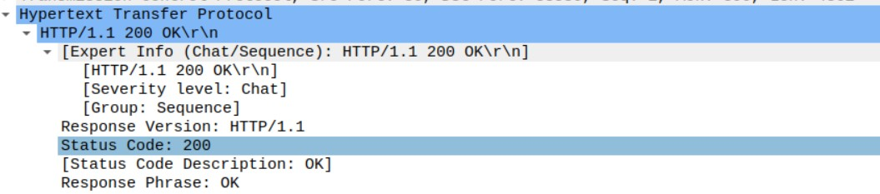

1. The data was sent in 4 TCP segments to the browser, then reassembled.

PART-4:

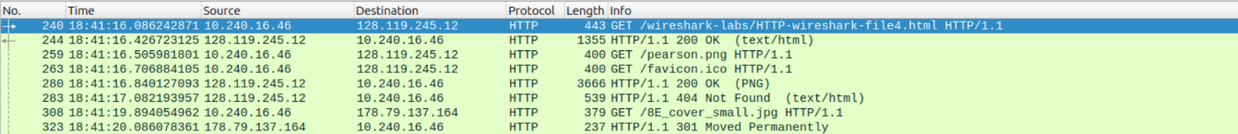

1. My browser sent 3 HTTP GET request messages(ignoring the one for favicon). The internet addresses to which the GET requests were sent: 1) 128.119.245.12 (1st GET – Page Address)

2) 128.119.245.12 (2nd GET – pearson.png)

3) 178.79.137.164 (3rd GET – 8E_cover_small.jpg)

2. The browser downloaded the images serially because we can see from the screenshot above that the request for the second image was sent only after a response for the first image was received after sending the request for the first image, i.e., the second image was only requested after the first image came back. Also, the images were transmitted over two TCP connections, so we can say that they were downloaded serially.

PART-5:

1. Status code: 401; Phrase: Unauthorized



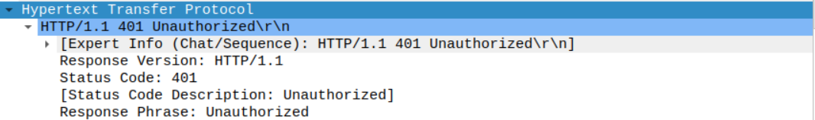

1. As we can see in the screenshot below, a new field (Authorization) is included in the HTTP GET message=> Authorization: Basic

