# CS-315 COMPUTER NETWORKS LAB-4

**PART-1**

1. IP address of web server: 10.250.200.3, IP address of [www.iitdh.ac.in](http://www.iitdh.ac.in) : 10.195.250.62

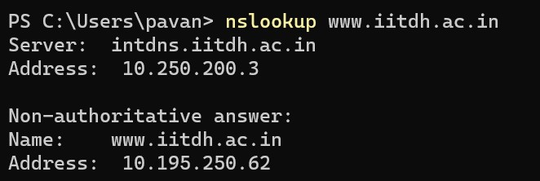

1. There are 4 DNS servers for google

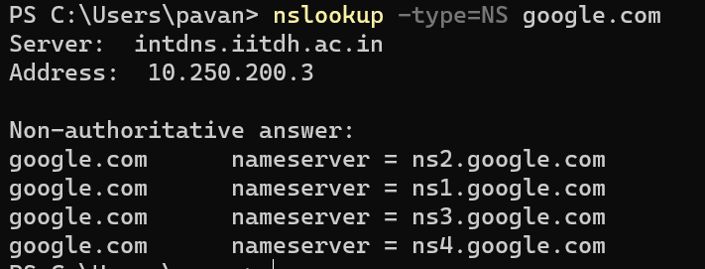

1. IPv4 address: 142.250.193.133, IPv6 address: 2404:6800:4007:820::2005

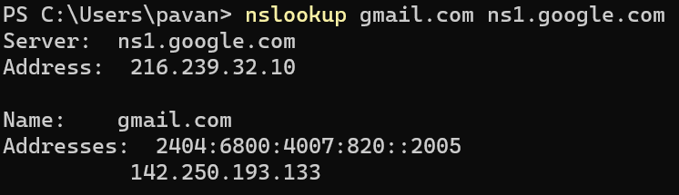

**PART-2**

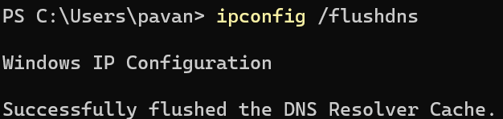

**PART-3**

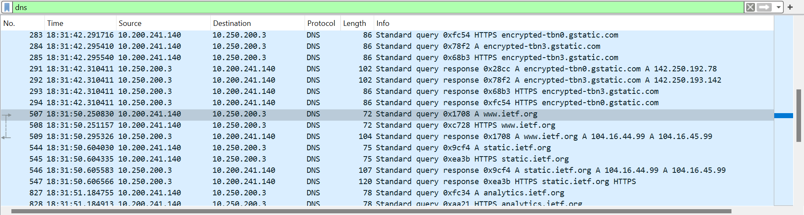

1. Packet No. : 283, 284, 285, 507, 508, 544, 545 are Query messages

Packet No. : 291, 292, 293, 294, 509, 546, 547 are Response messages

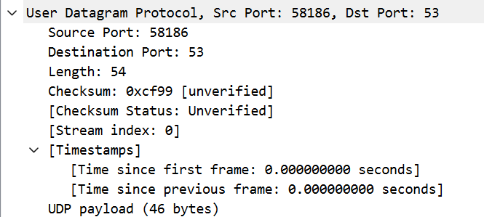

The packets are sent over UDP

1. Destination port: 53(& Source port: 49664) for Query message,

Source port: 53(& Destination port: 49664) for Response message

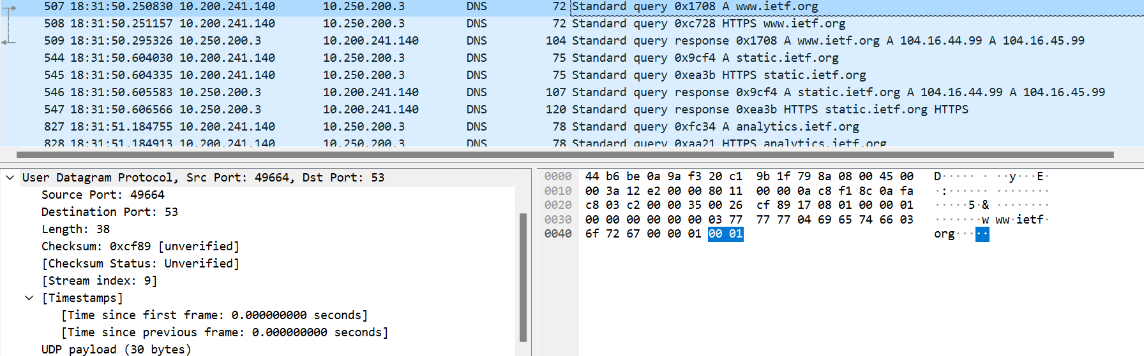

1. The DNS query is sent to the IP address : 10.250.200.3



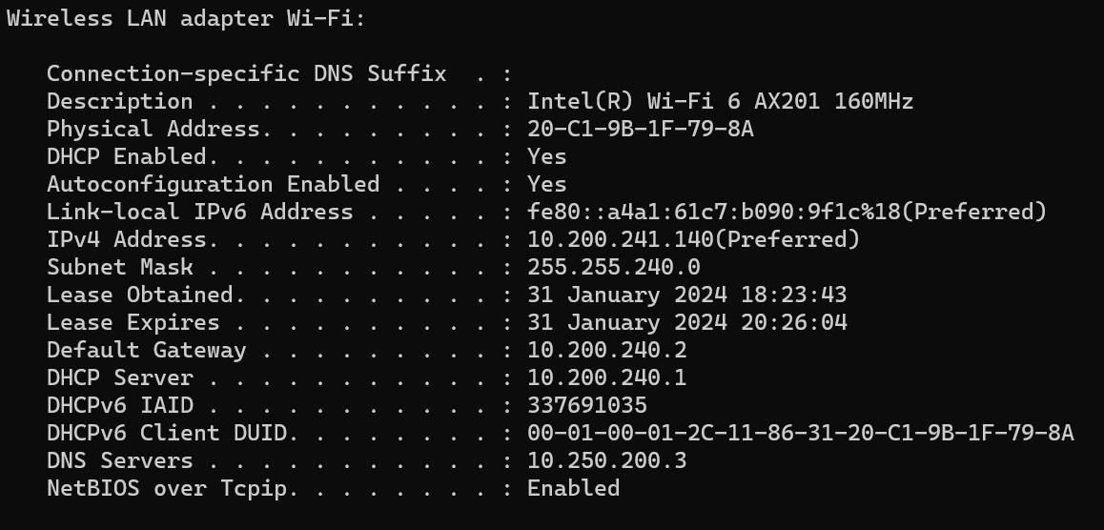

We can see DNS server as 10.250.200.3 from above. So, Yes, these two IP addresses are same.

1. DNS query Type : A, It does not contain any answers

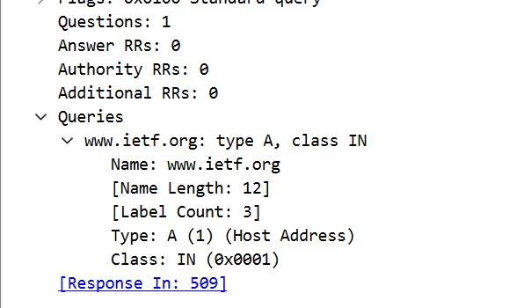

1. Two answers are provided. The answers contain: Name(www.ietf.org), Type(A), Class(IN), Time to live(300), Data length(4), Address(104.16.44.99)

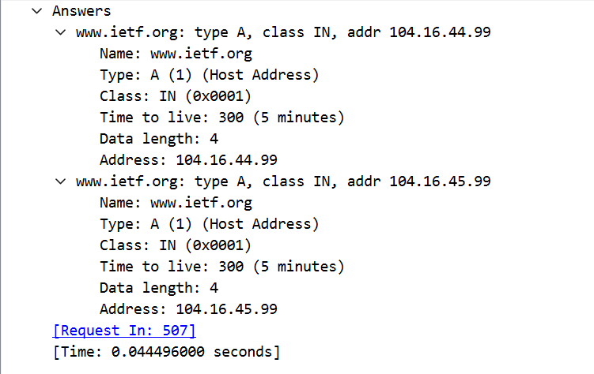

1. The destination address of the TCP SYN packet sent by the host is 104.16.44.99 . This address corresponds to the address in the Answers field in DNS message (from above screenshot).
2. No, as we can see no DNS packets for retrieving images in the packet viewing list.

**PART-4**

**(1)**

1. Destination port: 53(& Source port: 58108) for Query message, Source port: 53(& Destination port: 58108) for Response message

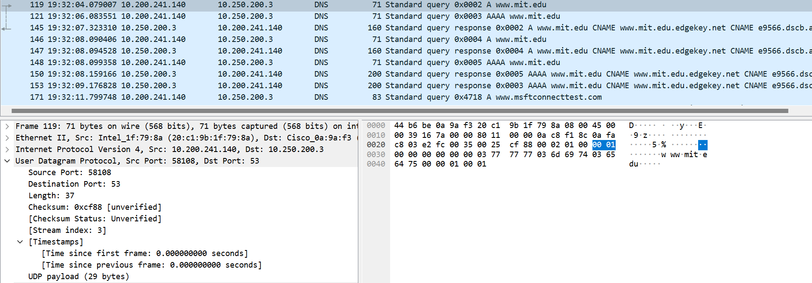

1. The DNS query is sent to IP address : 10.250.200.3





We can see DNS server as 10.250.200.3 from above. So, Yes, these two IP addresses are same.

1. DNS Query Type : A, Does not contain any answers.

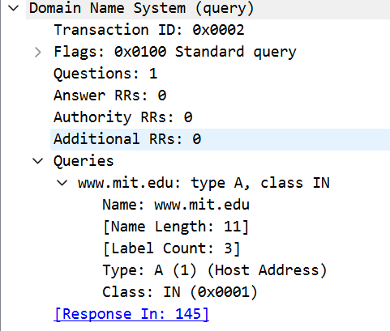

1. Three answers are provided. The answers contain: Name, Type, Class, Time to live, Data length, CNAME/Address
2. Screenshot:

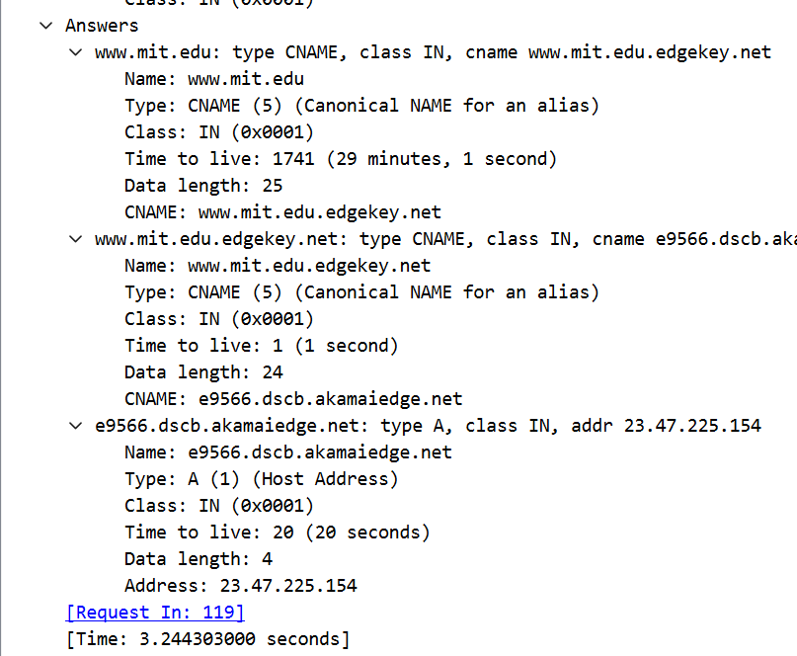

**(2)**

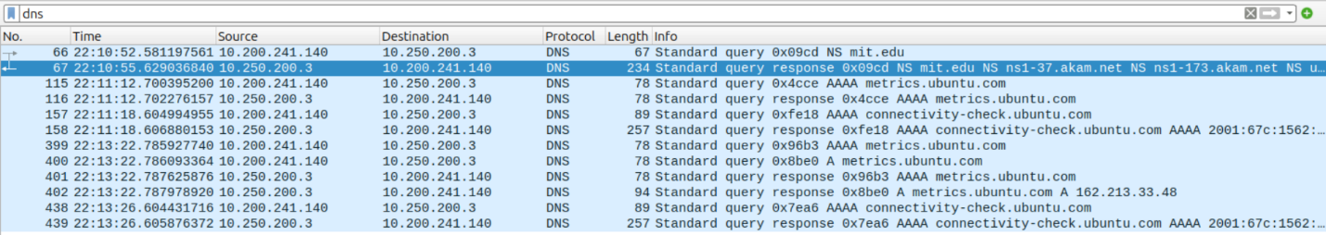

1. IP address: 10.250.200.3



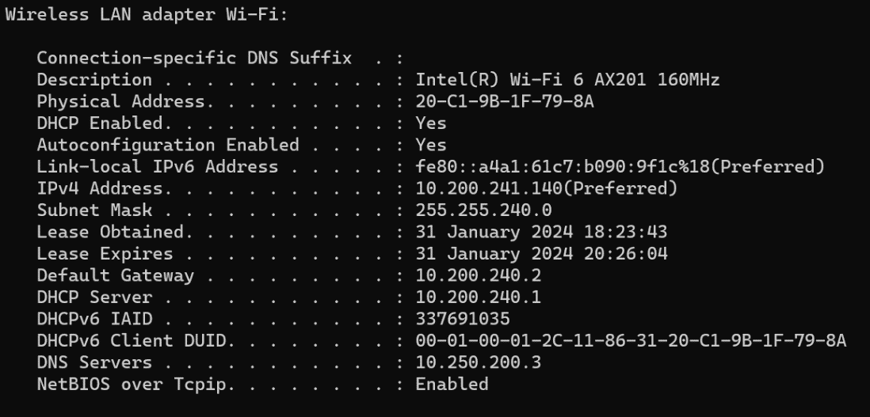

We can see DNS server as 10.250.200.3 from above. So, Yes, these two IP addresses are same.

1. DNS query Type: NS, It does not contain any answers

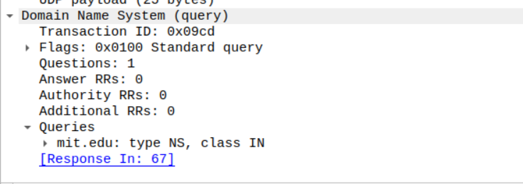

3. The response message provided 8 MIT nameservers – ns1-173.akam.net, use5.akam.net, asia2.akam.net, eur5.akam.net, usw2.akam.net, asia1.akam.net, use2.akam.net; No the response message does not provide the IP addresses of the MIT nameservers.

4. Screenshot:

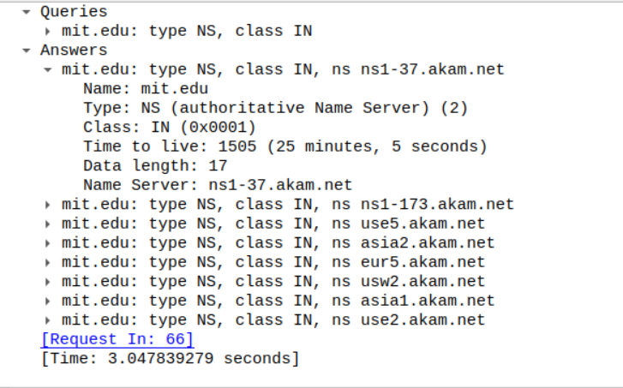

**(3)**

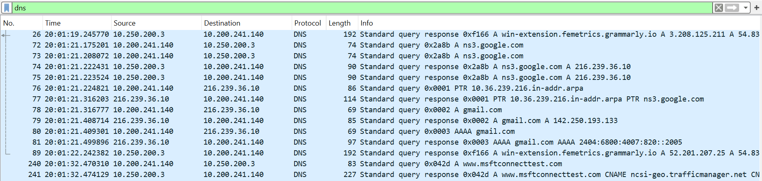

1. 

 We can see DNS server as 10.250.200.3 from above. So, Yes, these two IP addresses are same.

1. DNS Query Type: A, Does not contain any answers

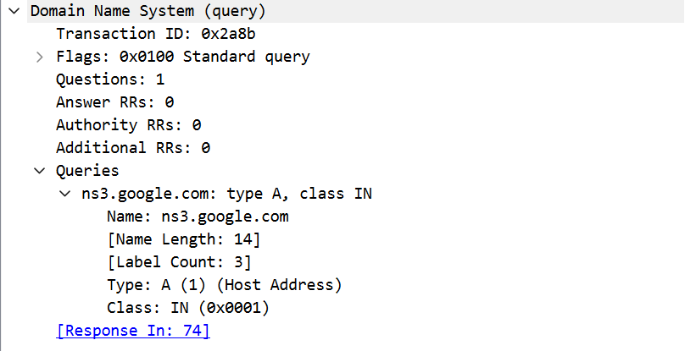

1. 1 answer is provided. It contains Name, Type, Class, Time to live, Data length, Address.
2. Screenshot:

