# CS-315 Computer Networks Lab-5 (TCP)

PART-2



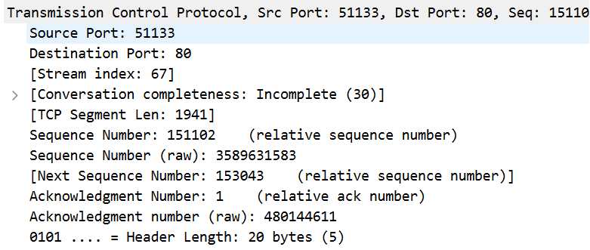

1. Source IP address = 192.168.0.194

TCP Port Number = 51133

1. Gaia.cs.umass.edu IP address = 128.119.245.112

TCP Port Number = 80

PART-3



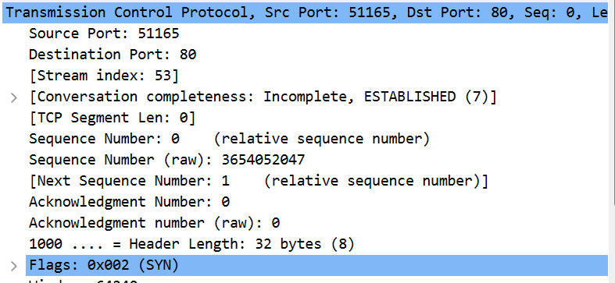

1. Sequence number of TCP SYN segment = 0(Relative) and 3654052047(raw).

The segment that identifies the segment as SYN is the SYN flag(0x002), as we can see from the screenshot above.

1. Sequence number of TCP SYNACK segment = 0(Relative) and 2783335425(raw).

The flags segment contains the SYN and ACK flags (0x012 – set to 1) which identify the TCP packet(from the screenshot) as the SYNACK.

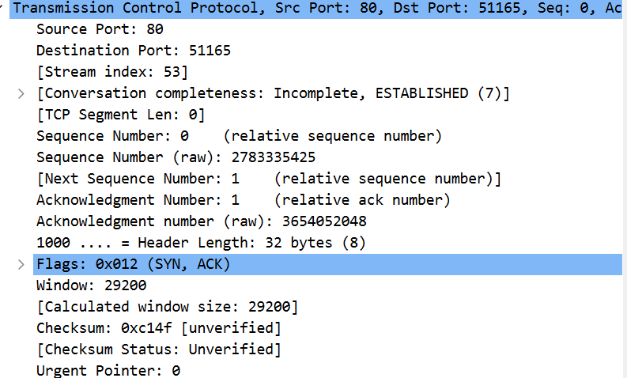

Value of acknowledgement field = 1(relative) and 3654052048(raw).

By adding 1 to the initial sequence number of the SYN segment from the client computer, gaia.cs.umass.edu calculates the value of the Acknowledgement field in the SYNACK segment.

1. Sequence Number = 1(Relative) and 3589480482(raw).

TCP Payload contains 721 bytes of data.

No, all of the data in the transferred file alice.txt did not fit into this single segment. There are a total of 55 segments.

1. (i) Time = 7th Feb, 2024 20:55:14.415125 IST



(ii) Time = 7th Feb, 2024 20:55:14.699291 IST



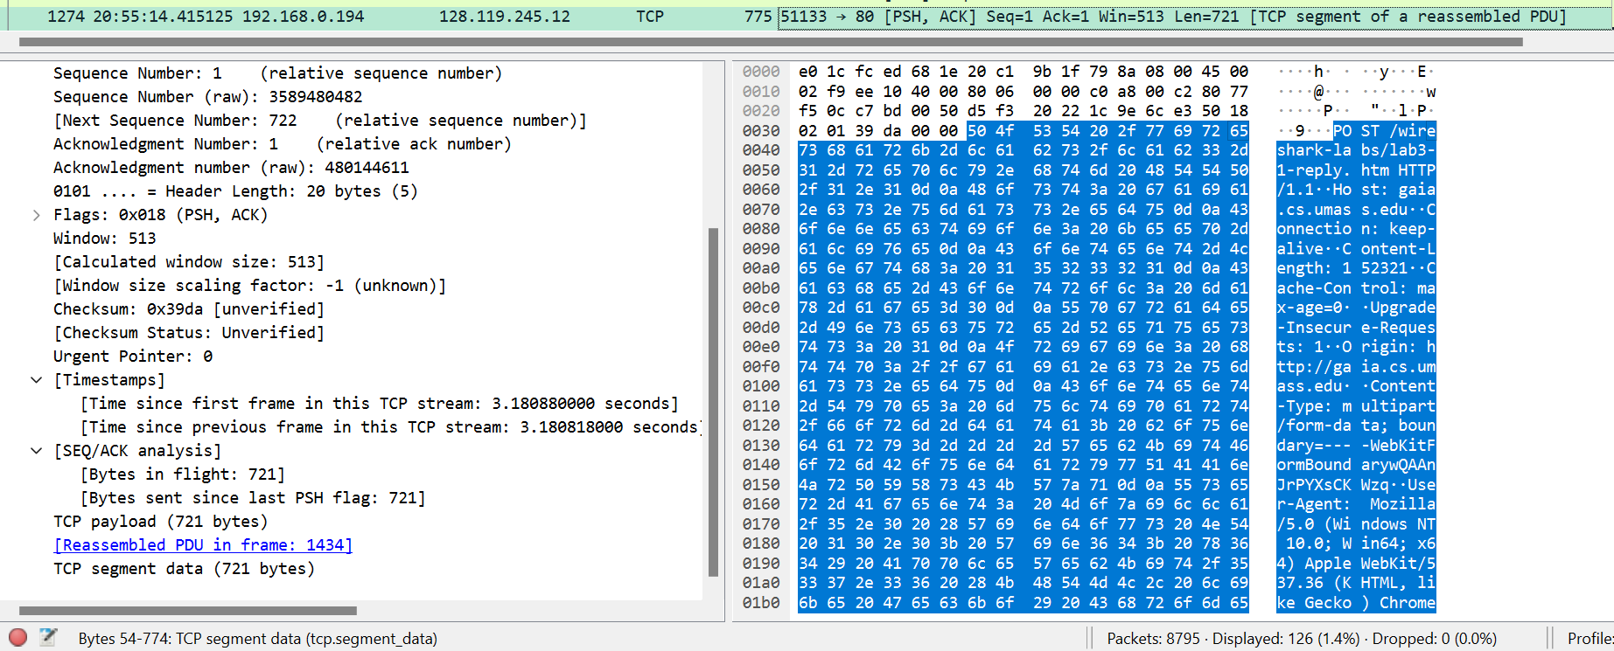

(iii) RTT for this first data-containing segment = 0.284166 seconds



(iv) RTT for 2nd data-carrying TCP segment and its ACK = 0.284011 seconds



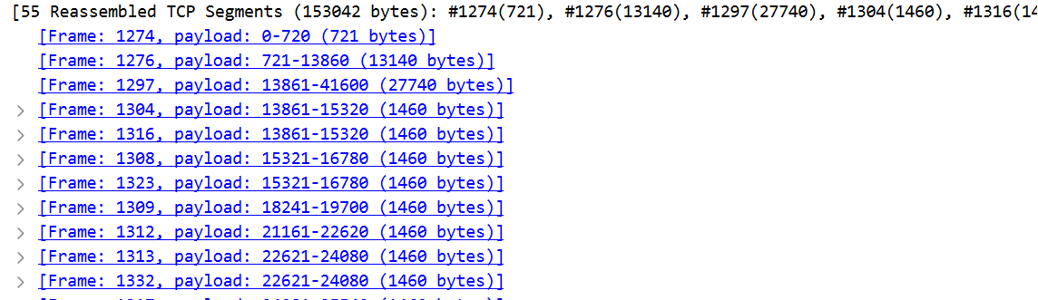

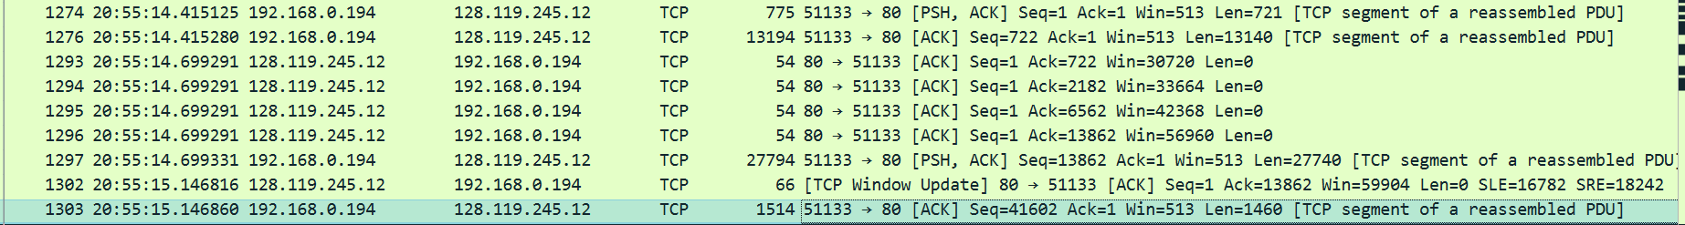

Header length = 20 bytes

1st segment = 721 + 20 = 741 bytes

2nd segment = 13140 + 20 = 13160 bytes

3rd segment = 27740 + 20 = 27760 bytes

4th segment = 1460 + 20 = 1480 bytes

1. Minimum amount of available buffer space = 513 bytes [can be seen from the screenshot from win field: Win=513]. No, the lack of receiver buffer space never throttles the sender for these first four data-carrying segments.
2. Yes,

By typing "tcp.analysis.retransmission" in the filter field.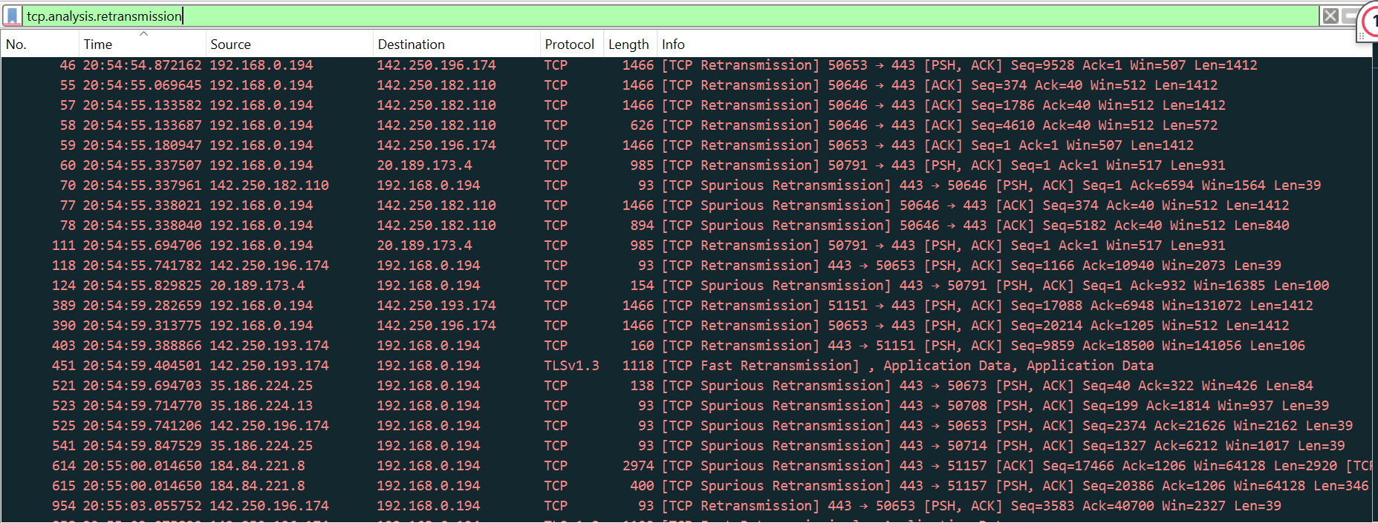

1. 1460 bytes,

Yes, the receiver is ACKing every other received segment among these first ten data-carrying segments. The difference between the acknowledged sequence numbers of two consecutive ACKs indicates the data received by the server between these two ACKs. By inspecting the amount of acknowledged data by each ACK, there are cases where the receiver is ACKing every other segment.

1. Throughput = Total data sent / Total time

= (152562-1) / (17.331907 – 14.415125)

= 152561 / 2.916782

= 52,304.560299673 bytes per second

~ 52.3 KB/s

To calculate this, find the total data transmitted which can be computed by the difference between the sequence number of the first TCP segment(=1) and the acknowledged sequence number of the last ACK(=152562). The time taken will be the time between the first segment and the last segment.

PART-4

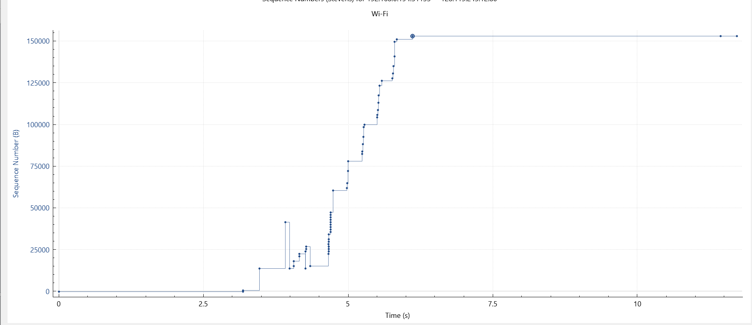

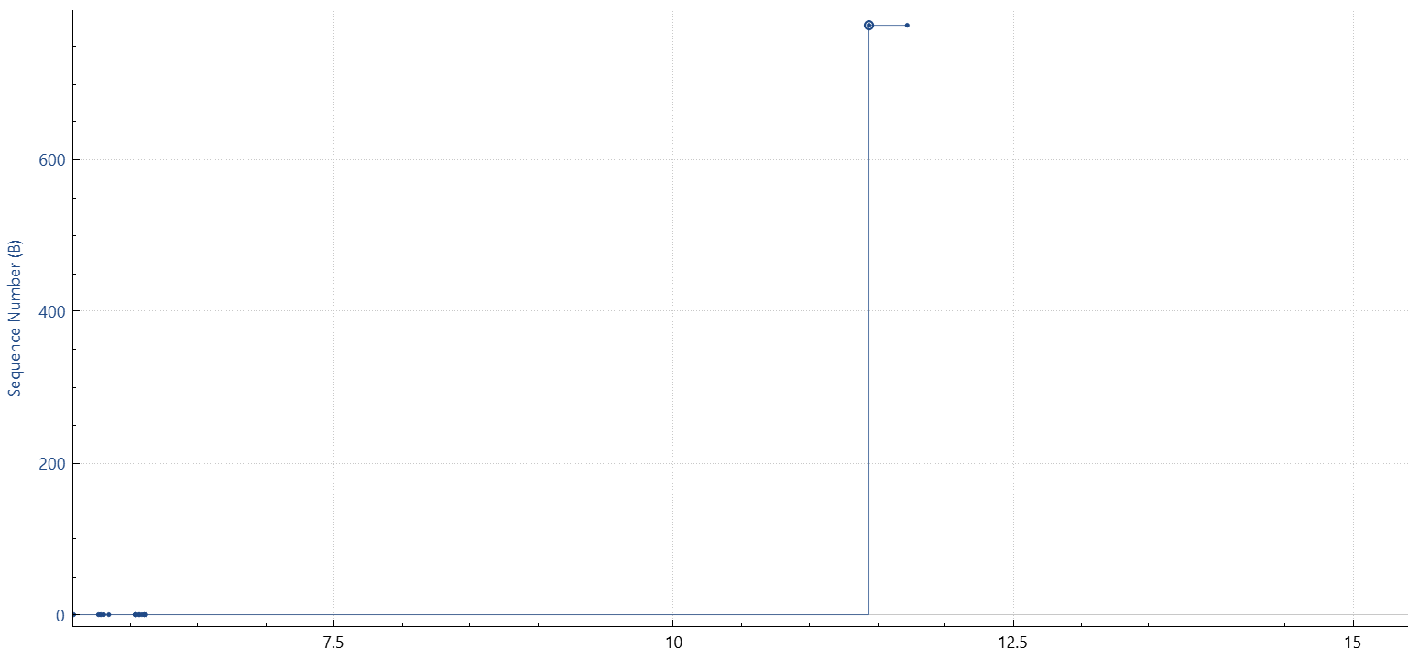

The slow start phase begins at t=0 and ends at roughly t=11.5 seconds

So, congestion avoidance takes over at t=11.5 seconds.