# CS-315 COMPUTER NETWORKS LAB-6

**PART-1**

1. The packet number of the trace is 60. The type of application-layer protocol message being carried in this UDP segment is DNS.



The UDP header has 4 primary fields: Source port, Destination port, Length and Checksum.

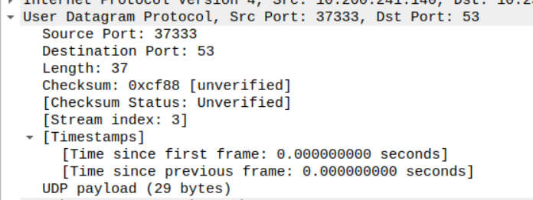

1. The screenshot below shows that each field in the header has a size of 2 bytes (4 hexadecimal digits). There are 4 fields in the header as discussed above. Hence the header has a size of 8 bytes. Every field has a size of 2 bytes. It can also be confirmed from the value of checksum field = 0xcf88 which has 4 hexadecimal digits, hence 2 bytes.

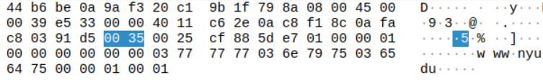

1. The value in the length field is the length of the UDP message which is the sum of the length of the UDP header and the length of the UDP payload. From the screenshot below, we can see that the UDP payload is 29 bytes and the header as discussed above is 8 bytes. Total sum = 37 bytes which is the same as the value in the length field.



1. From the discussions above, we know that the checksum field, like other fields, has a size of 2 bytes which is 4 hexadecimal digits. So the maximum value would be FFFF which is 65535 bytes. Since the header has a size of 8 bytes. The maximum size of the payload would be 65535-8 = 65527 bytes.
2. From the discussions above, we know that every field has a size of 2 bytes which is 4 hexadecimal digits. So, the source port number will also have a maximum value of FFFF which is 65535. Hence, the largest possible source port number is 65535.
3. Protocol Number for UDP = 17 as seen in the screenshot below.

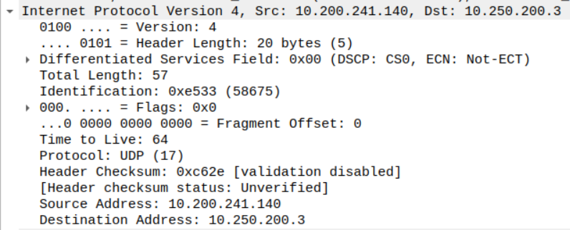

1. The packet number of the first(query) UDP packet is 60 and the packet number of the second(response) UDP packet is 82.





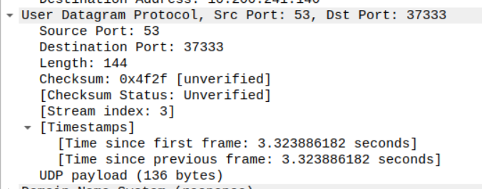

In the first UDP packet, we see that the source port is 37333 and the destination port is 53. In the second UDP packet, we see that the source port is 53 and the destination port is 37333. So, The source port of the first(query) UDP packet sent by the host is the same as the destination port of the second(response) UDP packet, and the destination port of the first(query) UDP packet sent by the host is the same as the source port of the second(response) UDP packet.