# CS-315 COMPUTER NETWORKS LAB-7 (IP)

**PART-1**

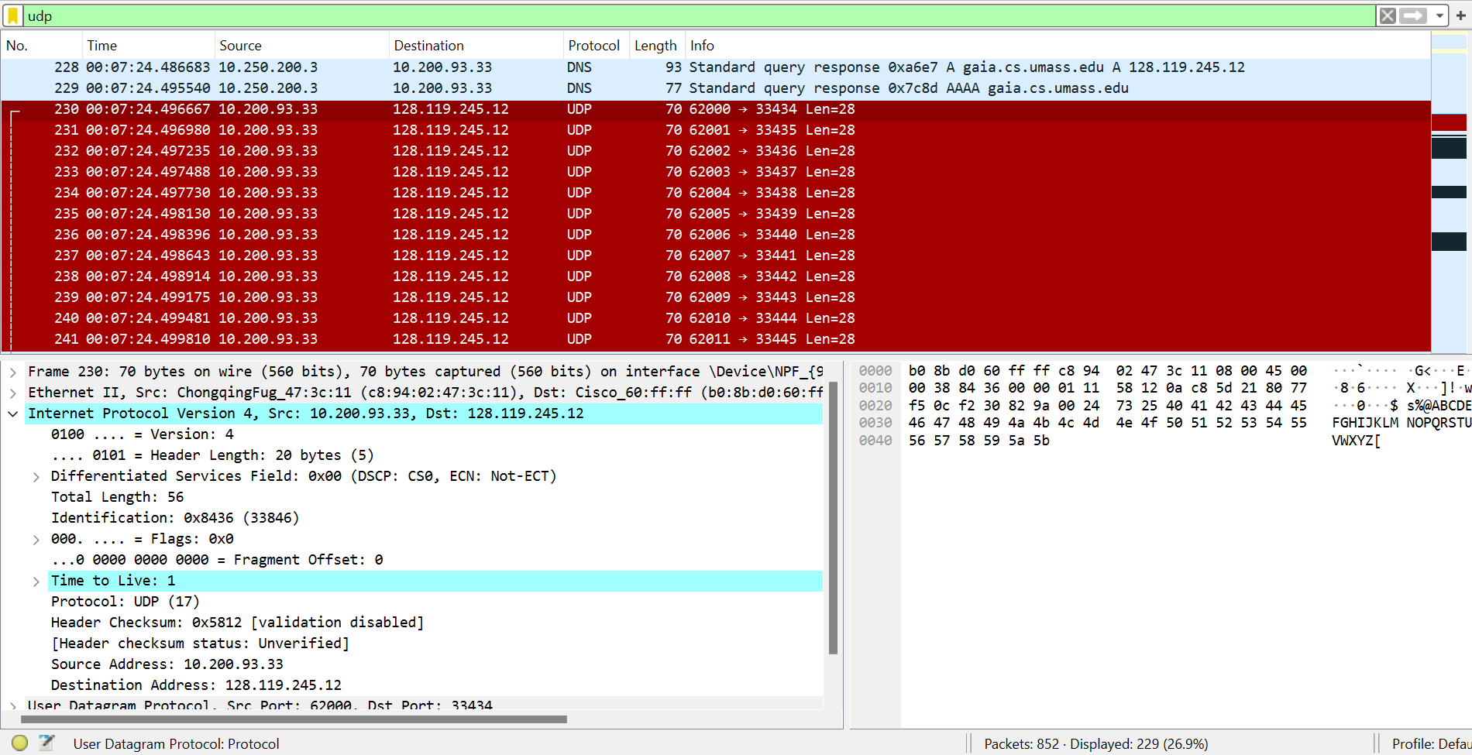

1. IP address of my computer = **10.200.93.33**
2. Value of time-to-live(TTL) field = **1**
3. **UDP(17)** is the value in the upper layer protocol field.
4. **20 bytes**(can be seen in the Header Length field)
5. **36 bytes**, since the total length is 56 bytes and the header length is 20 bytes, the payload will be 56 – 20 = 36 bytes.
6. **No**, the IP datagram has not been fragmented because we can see the flags field is not set, i.e., inside the flags field, the More fragments flag is not set. Also, Fragment Offset = 0.
7. **Header checksum, Time to Live(TTL), and Identification** fields always change from one datagram to another. These fields change because the traceroute intentionally manipulates them to probe the network path to a destination. Header checksum changes since the header changes for each IP datagram. The identification field is unique for each IP datagram. So, the Identification field value changes. TTL value changes because each packet traceroute sends has an incrementally higher TTL value, allowing it to discover the path packets take to reach the destination and the maximum number of hops required to reach it.
8. **Version, Header Length, Differentiated Services Field, Total Length, Flags, Fragment Offset, Protocol, Source address and Destination address** fields do not change. These fields remain constant because they represent fixed parameters of the communication session or properties of the destination that are unaffected by the traceroute process. Version and Header length does not change since we are using IPv4 and the same protocol for all. The protocol and Services field do not change as we are using the same protocol for all. Source and Destination address are understandably the same. Since there are no fragments, the Flags and Fragment offset will be the same(=zero) for all.
9. The values in the Identification field of the IP datagrams are **sequential**, the value in each subsequent datagram **increases by 1** from the previous one(**serial increment**).
10. Protocol = **ICMP(1).**
11. For all ICMP packets having the **same source address(same router)**, Yes, the Identification value is in sequential order(serial increment - increasing by 1 from previous ones). Yes, the **behaviour is similar** to that in question 9.
12. No, the values are **not similar** across all of the ICMP packets from all of the routers. Only packets having the same source address(same router) have similar values in the TTL field.

**PART-2**

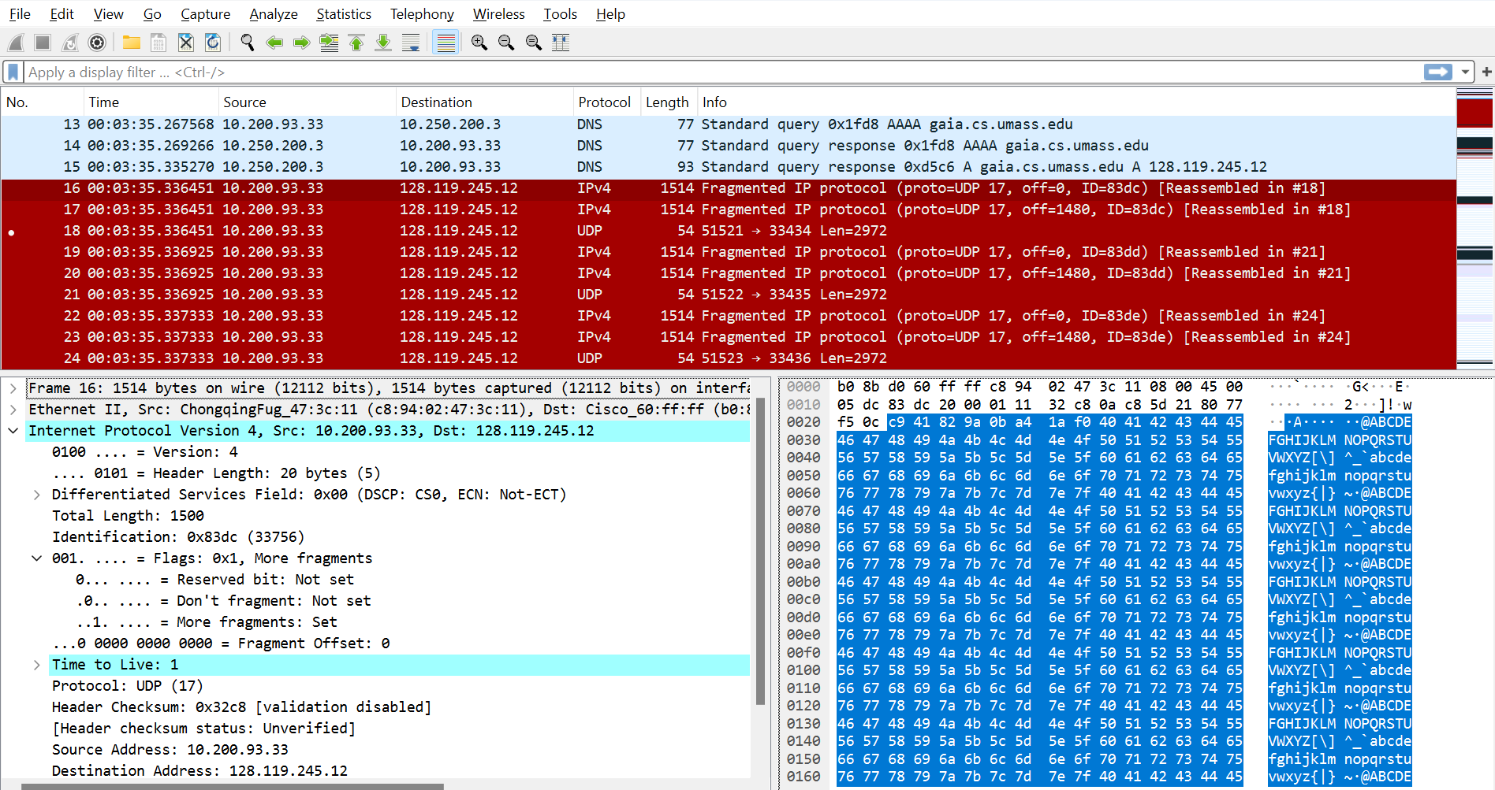

1. Packet no **16** is the first IP datagram containing the first part of the segment sent to 128.119.245.12 sent by my computer. Packets **16, 17, and 18** are three IP datagrams created by fragmenting the first single 3000-byte UDP segment sent to 128.119.145.12. **Yes**, **the segment has been fragmented** across more than one IP datagram because we can see that the More fragments flag is set.
2. We can see inside the flags field that the **‘More fragments’ flag field is set(to 1)** which indicates that this datagram has been fragmented.
3. If the **Fragment offset** in the IP header is set to **0(zero),** it indicates that this is the first fragment. If it is not zero, then it indicates that it is a later fragment.
4. **1500 bytes**, as we can see from the screenshot above in the Total Length field.
5. **Fragment Offset and Header Checksum** are the fields that change in the IP header between the first and second fragment.
6. Packet no **18** is the IP datagram containing the third fragment of the original UDP segment. The **‘More fragments’ flag field for this packet is not set and the ‘Fragment Offset’ value is not equal to zero** which indicates that this is the last fragment of that segment. 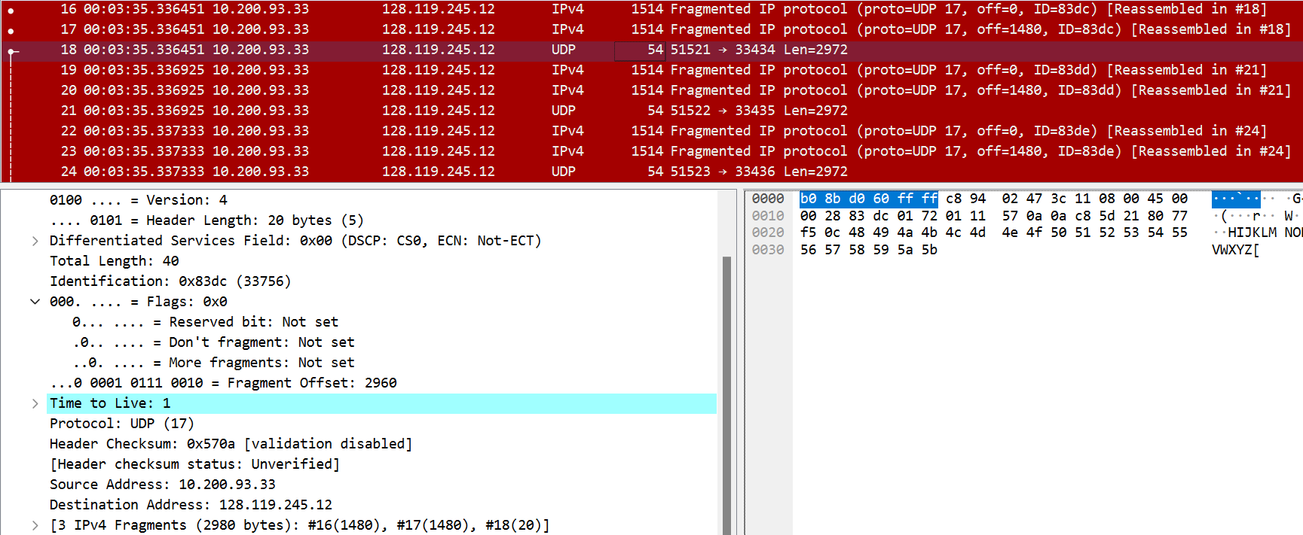

**PART-3**

1. Source IPv6 address = **2601:193:8302:4620:215c:f5ae:8b40:a27a**
2. Destination IPv6 address = **2001:558:feed::1**
3. From the below screenshot, we can see the value of the flow label = **0x63ed0**
4. **37** **bytes** (can be seen in Payload length field)
5. **UDP(17)** is the upper layer protocol.

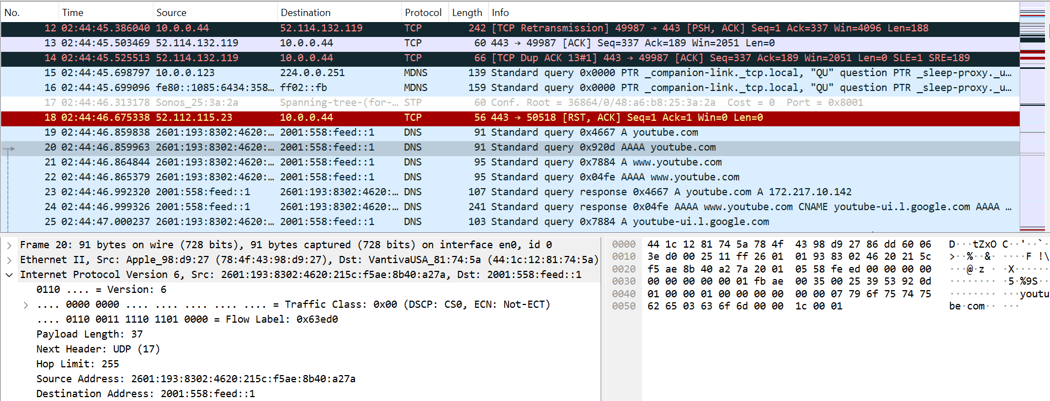

1. **One** IPv6 address is returned in the response(Packet No 27) to this AAAA request. 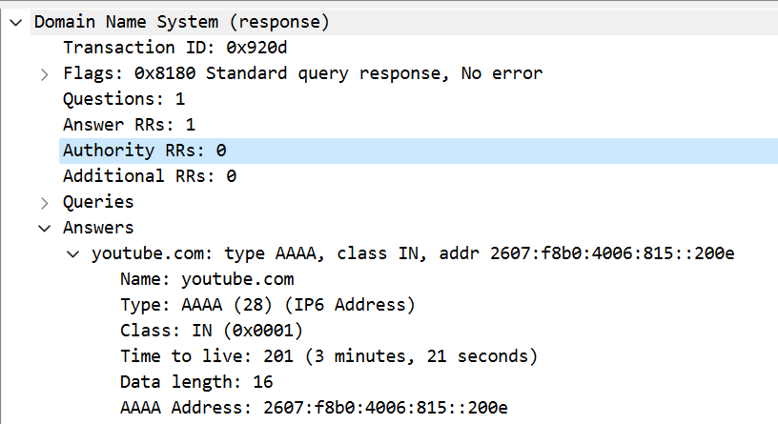
2. **2607:f8b0:4006:815::200e** is the first of the IPv6 addresses returned by the DNS for youtube.com in the response (packet no. 27) to the DNS AAAA request made in the 20th packet. But, considering all received DNS responses, the first would be **2607:f8b0:4006:806::200e** which is in the DNS response in packet 24 (response to DNS request made in packet no. 22 and not packet no. 20).