# CS-315 COMPUTER NETWORKS LAB-8 (NAT & SMTP)

**PART-1 (NAT):**

Inside:

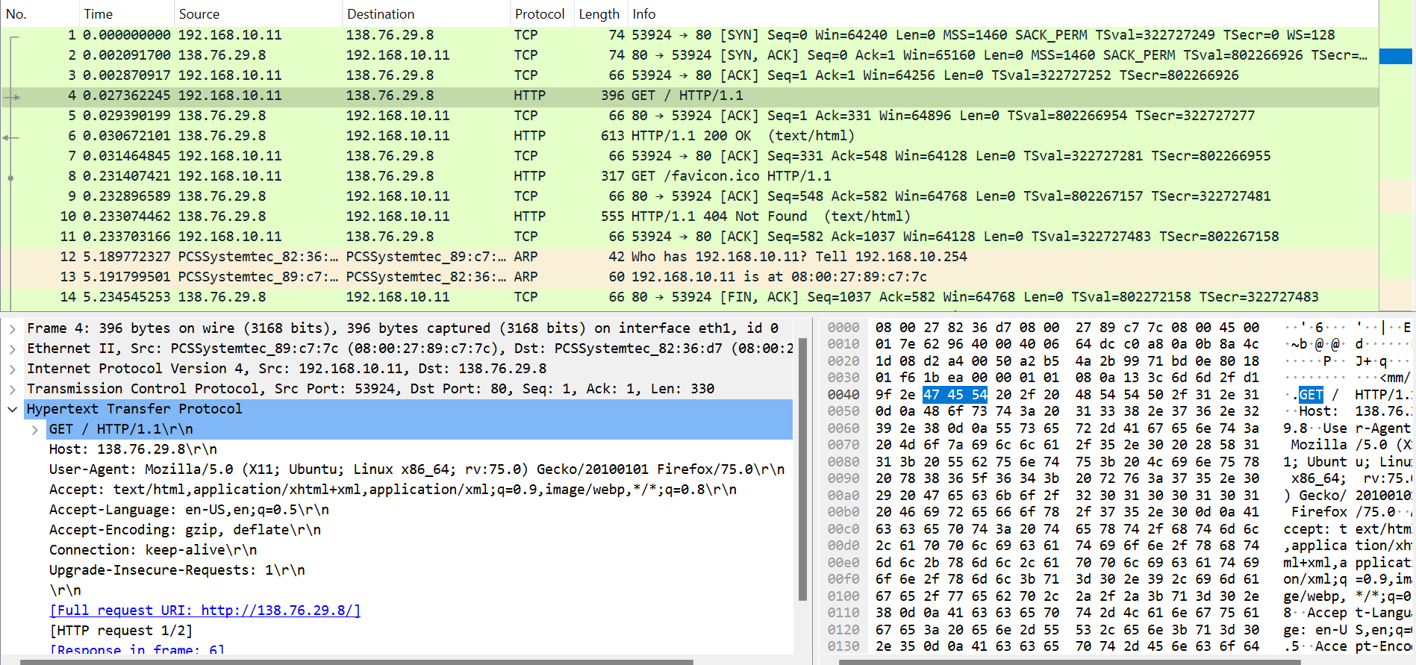

1. IP Address of the client = 192.168.10.11

TCP Source port no = 53924

IP Address of the (destination)server = 138.76.29.8

TCP Destination port no = 80

1. From the above screenshot, the HTTP GET was captured at t=0.027362245 and the HTTP OK was captured at t=0.030672101[time from first packet capture (from screenshot)].
2. Source IP address = 138.76.29.8

Destination IP address = 192.168.10.11

TCP Source port no = 80

TCP Destination port no = 53924

Outside:

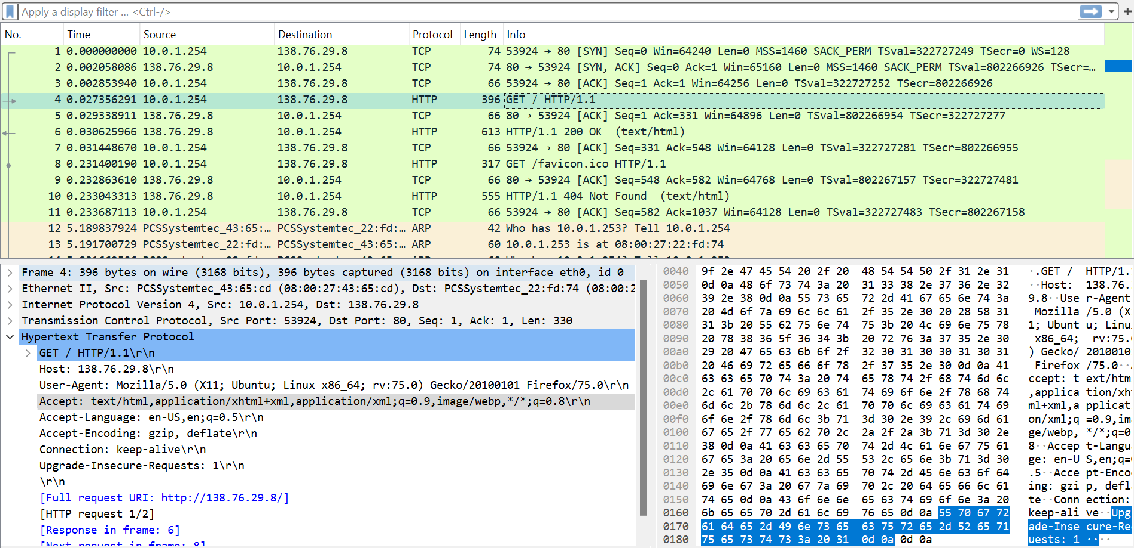

1. From the above screenshot, the time at which the HTTP GET message appears is t = 0.027356291 [time from first packet capture (from screenshot)]
2. Source IP address = 10.0.1.254

Destination IP address = 138.76.29.8

Source port no = 53924

Destination port no = 80

1. Among the four fields, the Source IP address is different from the answer in question 1.
2. We can see in the above two screenshots that no fields were changed in the HTTP GET message.
3. Among the given/following fields, only the (Header)Checksum is changed in the IP datagram.

Inside: 

Outside: 

1. From the above screenshot, the time at which the HTTP OK message appears is t = 0.030625966 [time from first packet capture (from screenshot)].
2. Source IP address = 138.76.29.8

Destination IP address = 10.0.1.254

Source port no = 80

Destination port no = 53924

1. Source IP address = 138.76.29.8

Destination IP address = 192.168.10.11

Source Port no = 80

Destination Port no = 53924

**PART-2 (SMTP)**

Below are the screenshots proving successful mail delivery.

