# CS-315 COMPUTER NETWORKS LAB-9 (DHCP)

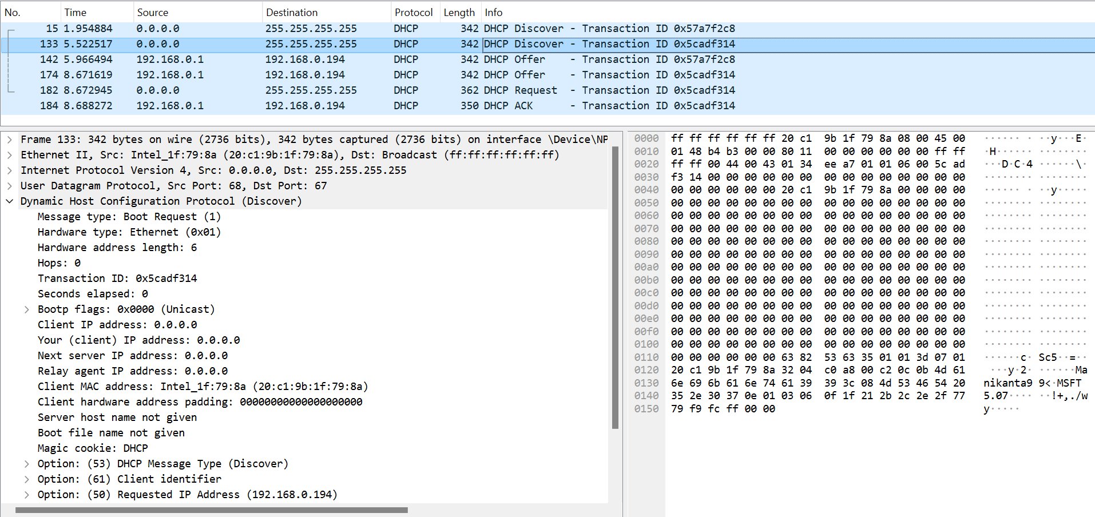

1. **UDP**, as we can see in the screenshot above.
2. **Source IP address = 0.0.0.0** [can be seen in the screenshot above].  
   The speciality of this IP address is that it is used by a client/device when it doesn't have a configured IP address yet or when it wants to request a new IP address from a DHCP server. In the context of DHCP (Dynamic Host Configuration Protocol), the 0.0.0.0 address in the source field indicates to the DHCP server that the device sending the Discover message does not have an assigned IP address and is seeking one. This allows the DHCP server to allocate an available IP address from its pool and assign it to the requesting device. In short, the source hasn’t been allotted any IP address yet and therefore it is using the default IP address as 0.0.0.0.
3. **Destination IP address = 255.255.255.255** [from screenshot].  
   The speciality of this IP address is that it represents the broadcast address in IPv4 networks. This means that just like a network broadcast IP this message will be transmitted to all network adapters on the local network segment. When a device sends a DHCP Discover message, it doesn't yet know the IP address of the DHCP server. Therefore, it sends the Discover message to the broadcast address 255.255.255.255, indicating that it wants any DHCP server on the network to respond.
4. Value in the transaction ID field = **0x5cadf314** [from screenshot]
5. Other than the IP address, the 5 pieces of information the client is suggesting or requesting to receive are DHCP message type, Client identifier, Host Name, Vendor class identifier**,** and **Parameter Request List – Subnet Mask, Router, Domain Name Server, Domain Name, Static Route etc**.  
   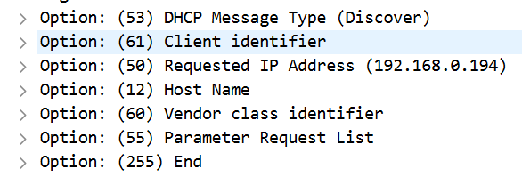

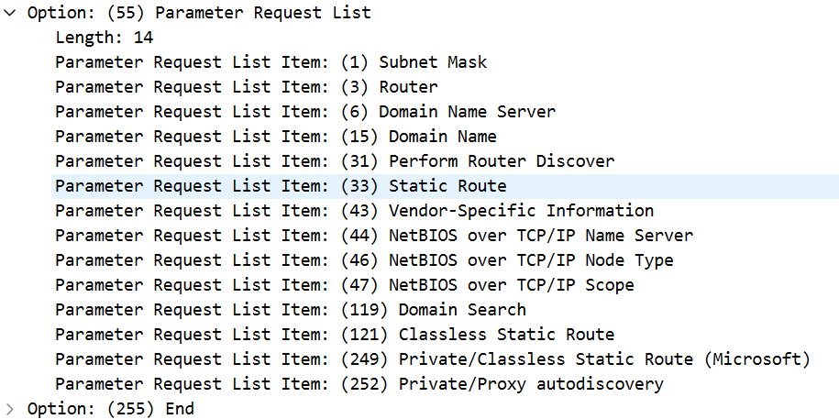

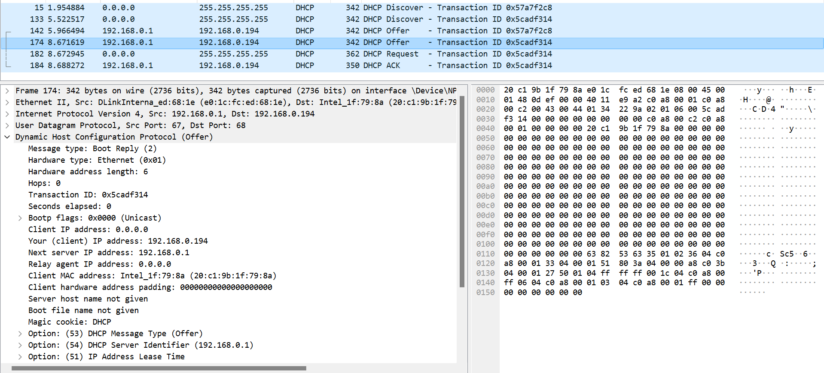

1. We know this Offer message is being sent in response to the DHCP Discover message we studied above because both messages **share the** **same Transaction ID: 0x5cadf314**.
2. **Source IP address = 192.168.0.1** [from screenshot above].  
   The speciality of this address is that it represents the DHCP server. DHCP server sends an Offer message using its own IP address as the source to indicate to the client where the offer is coming from.
3. **Destination IP address = 192.168.0.194** [from screenshot above].  
   The speciality of this address is that it is the IP address of the client to which the DHCP server is sending the offer, i.e., This is the new IP address that will be allotted to the client.
4. The pieces of information that the DHCP server is providing to the DHCP client in the DHCP Offer message are DHCP Message Type, DHCP Server Identifier, **IP Address Lease Time, Renewal Time Value, Rebinding Time Value, Subnet mask, Broadcast Address, Domain Name Server and Router.**

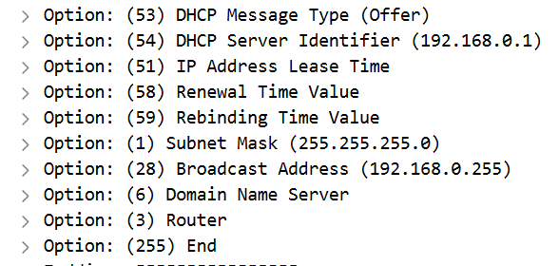

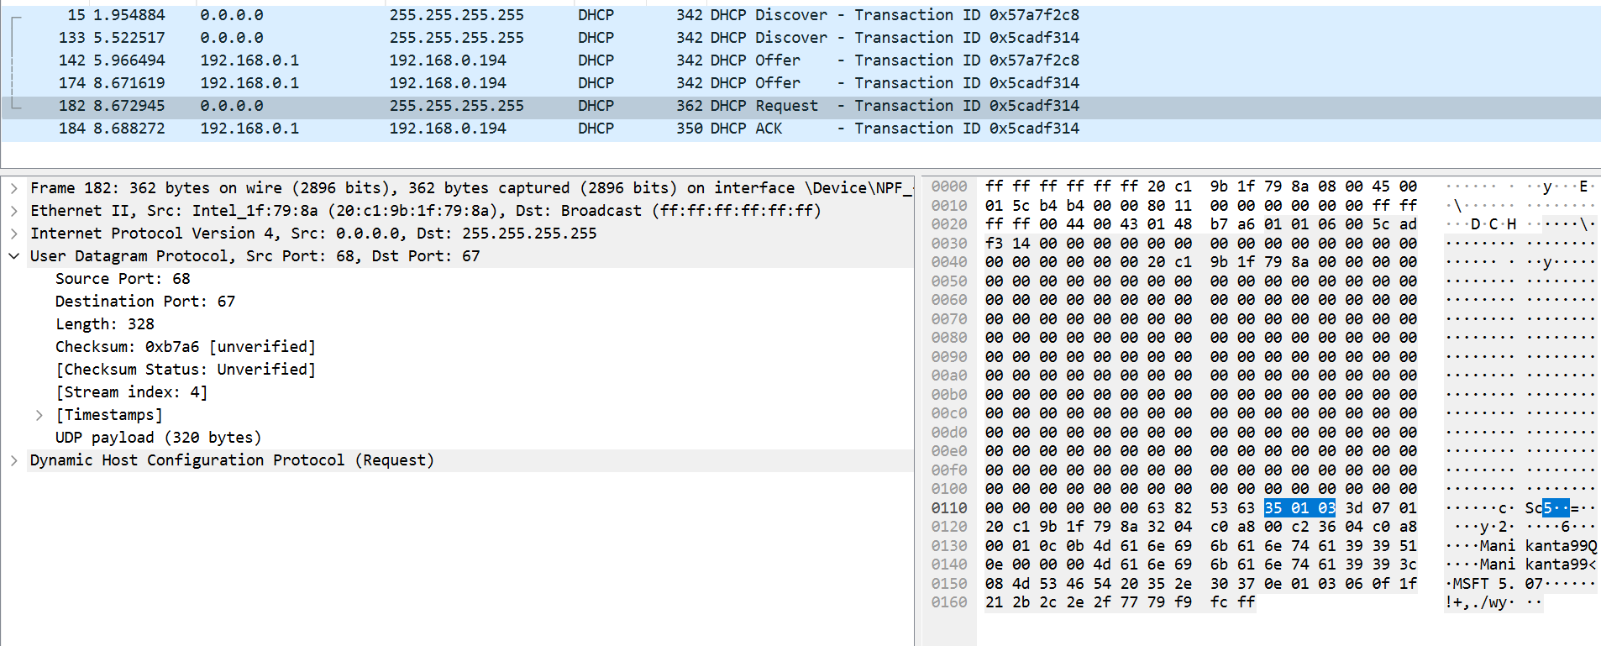

1. **UDP source port no. = 68** & **destination port no. = 67**.
2. **Source IP address = 0.0.0.0** [from screenshot above].   
   The speciality of this IP address is that it signifies that the client does not have a configured IP address yet or that it is requesting a new IP address from a DHCP server. The source IP address is set to 0.0.0.0 by the client to indicate its desire to acquire an IP address dynamically.
3. **Destination IP address = 255.255.255.255**[from screenshot]. The speciality of this IP address is that it represents the broadcast address in IPv4 networks. When a client sends a DHCP Request message, it does not yet know the IP address of the DHCP server that made the offer. Therefore, it sends the Discover message to the broadcast address 255.255.255.255, indicating that it wants any DHCP server on the network to respond.
4. Value in the transaction ID field = **0x5cadf314**. Yes, it matches the transaction IDs of the earlier Discover and Offer messages that we studied above.
5. No differences can be seen between the entries in the ‘parameter request list’ option in this Request message and the same list option in the earlier Discover message.

The parameter request list of the DHCP request message is:

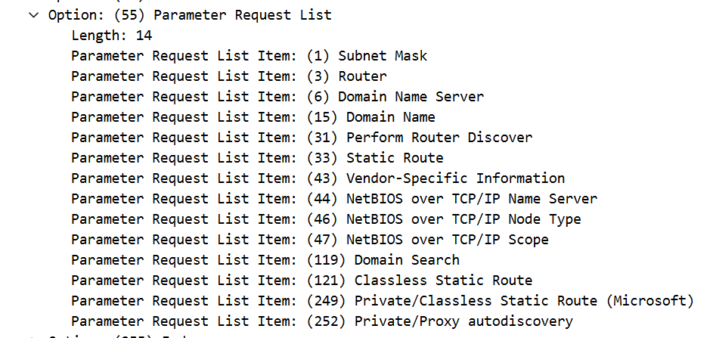

The parameter request list of the earlier DHCP discover message is:

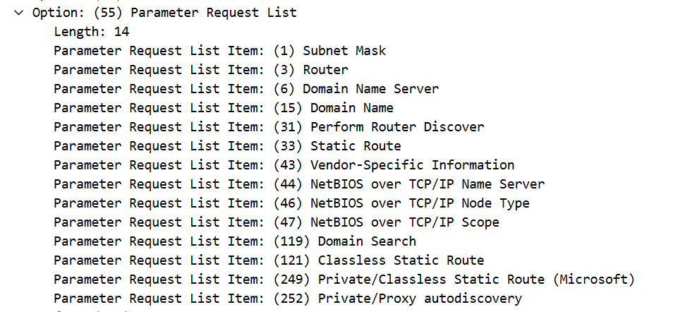

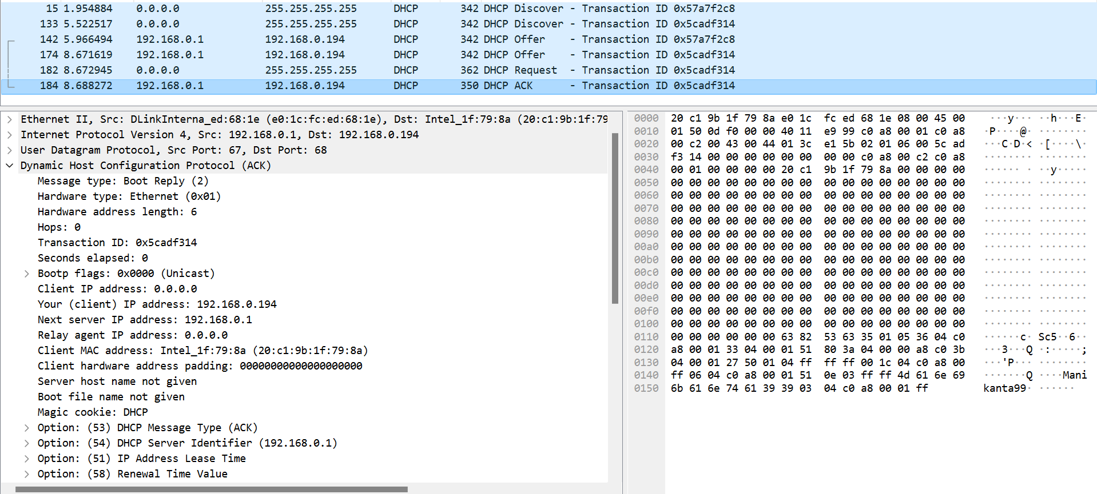

1. **Source IP address = 192.168.0.1.**   
   The speciality of this IP address is that it is the IP address of the DHCP server. The DHCP server sends ACK messages to confirm that it has assigned an IP address to the client and to provide other network configuration information. Therefore, the source IP address of the DHCP server indicates that the ACK message is coming from the DHCP server.
2. **Destination IP address = 192.168.0.194**.   
   The speciality of this IP address is that it is the IP address that would be assigned to the client. The DHCP server sends the ACK message directly to the client's IP address to confirm the assignment of the IP address and provide network configuration parameters.
3. The field in the DHCP ACK message that contains the assigned client IP address is "**Your (client) IP address**". This field contains the value "192.168.0.194", which is the IP address assigned to the client by the DHCP server.
4. The DHCP server assigned this IP address to the client for **86400 seconds or 1 day**.  
   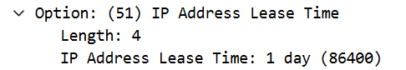
5. The IP address of the first-hop router on the default path from the client to the rest of the Internet is **192.168.0.1** as seen in the screenshots below.

 