Implementation and Optimization of the Ring Token Protocol

**Authors:**

Sanchi Sujith Kumar (Roll No: 210010047),

Sree Naga Manikanta Katta (Roll No: 210010050),

Revanth Palaparthi (Roll No: 210010043),

4th year Students, Department of Computer Science and Engineering,

Indian Institute of Technology, Dharwad

**Internship at Defence Research and Development Laboratory (DRDL), Hyderabad**

**Under the guidance of**

**Mr. Deepanshu Dixit  
Scientist-C**

**May – June 2024**

**Abstract**

This report presents the implementation and optimization of the Ring Token Protocol, a method used for network communication in token ring networks. We aimed to reduce the total time taken for data transfer per packet by streaming multiple packets together. Our results demonstrate a significant improvement in efficiency, suggesting that this optimization technique can effectively enhance the performance of token ring networks.

**Table of Contents**

1. Introduction
2. Methodology
3. Code Snippets
4. Results
5. Discussion
6. Conclusion

**1. Introduction**

**Background**

The ring token protocol is a well-established method used in token ring networks to manage the transmission of data packets. In this protocol, a token circulates around the network with nodes interconnected in a ring topology, granting the holder permission to send data and enabling token-based data transmission. This ensures orderly and collision-free communication among nodes.

**Problem Statement**

Despite its advantages, the Ring Token Protocol often suffers from inefficiencies due to idle times when nodes wait for the token to arrive. These idle times can significantly increase the total data transfer time, especially under high traffic conditions. Therefore, there is a need for optimization.

**Objective**

This project aims to optimize the ring token protocol by allowing multiple packets, destined for the same node, to stream together in groups, thereby reducing idle times and improving overall data transfer efficiency.

**Scope**

This report covers the implementation of the ring token protocol, the optimization technique, and the performance evaluation of the optimized protocol. The scope is limited to a simulated network environment with 5 terminals on a single PC.

**2. Methodology**

**Implementation Details**

The Ring Token Protocol was implemented using Python. The simulation environment consisted of a network of nodes. Each node, implemented through a terminal or command-line interface and connected via TCP sockets to other nodes, could send and receive packets according to the Ring Token Protocol rules.

**Optimization Technique**

For optimization, instead of sending one packet at a time, multiple packets destined for the same node are sent together. The sender node sends the token to the receiver node to notify it of the arriving packets, and then the packets are transmitted to the receiver node in a batch.

**Why This Technique**

This technique was chosen for its capability to reduce node idle times and improve Round-Trip Time (RTT) for a packet. By sending multiple packets destined for the same node together in a batch, the receiving node spends less time waiting for the token to arrive between each packet transmission, thereby reducing its idle time. Additionally, since multiple packets are transmitted in a single batch, the RTT for each packet is reduced as they are delivered more quickly to the destination node. Consequently, this approach results in overall faster data transfer and improved network efficiency, minimizing idle time and enhancing throughput.

**Implementation Steps**

1. The sender initiates the process by sending the token to the receiver node. The token contains information about the receiver node's identity and the number of packets that are about to be transmitted.
2. Following the token transmission, the sender proceeds to send the packets. Upon reception, the receiver node reads the data contained within each packet.
3. Upon receiving the packets, the receiver node sends an acknowledgment (ACK) along with the token back to the sender.
4. If the sender receives the ACK, it prepares to send packets to the next receiver node. However, if there is no acknowledgment received, indicating that some packets were not received or acknowledged, the sender retransmits the unreceived packets to the involved receiver node.
5. In the optimized protocol, a constant variable was introduced to define the maximum number of packets that the sender can transmit to a receiver in a single batch. This variable acts as a threshold to control the number of packets grouped together for transmission, thereby ensuring that the network remains efficient and does not become overloaded with excessively large batches.
6. Additionally, a node is not allowed to hold the token beyond a predetermined threshold value. This threshold ensures that no single node monopolizes the token, which could otherwise lead to inefficiencies and increased latency for other nodes waiting to transmit their data. By enforcing this limit, the protocol maintains a balanced and fair distribution of network resources, preventing delays and promoting smooth data flow across the network.
7. In the optimized protocol, the sender follows a round-robin format while transmitting packets to the receiver nodes. This means that if the sender sends a batch of packets to node X, it will not send any additional packets to node X until it has sent packets or a batch to the other nodes in the network. This approach ensures a fair distribution of network resources and prevents any single node from dominating the communication channel, thereby promoting balanced and efficient data transmission.

**3. Code Snippets**

**base_station.py**

This file will be run first and kept undisturbed. It accepts new connections and ensures they are integrated into the ring, allowing it to expand. The connection is managed in a decentralized manner as per the protocol. Additionally, it sends the token to the first connected node.

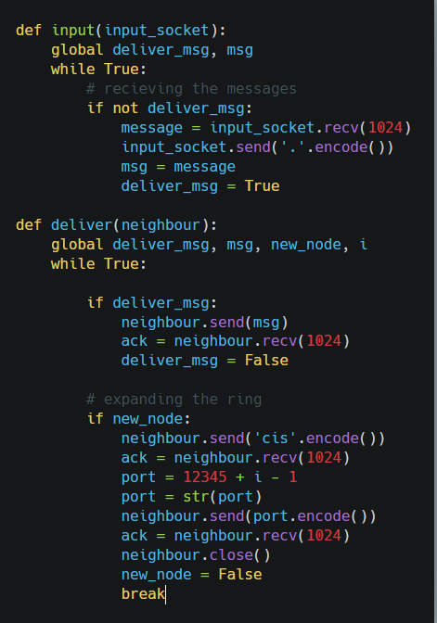

**Figure 1: input() function**

The **input()** function just delivers the message to next node.



**Figure 2: deliver() function**

The **deliver()** function sends the port number to the newly connected node whenever a new connection is established.

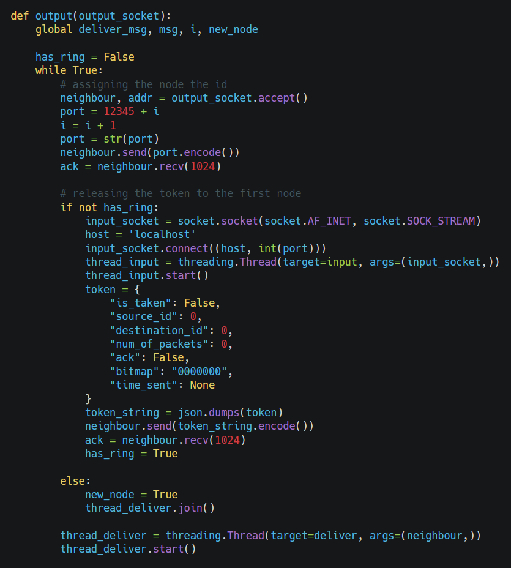

**Figure 3: output() function**

The **output()** function expands the ring through new connections and in case of the first node connection, it also releases the token to that node.

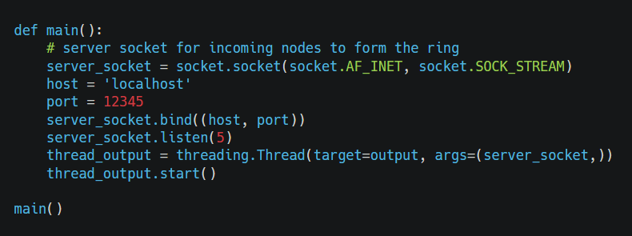

**Figure 4: main() function**

**node.py**  
Each node is implemented through a terminal/command-line interface, facilitating protocol execution. Upon execution of this file, the node establishes a connection with the base station, which assigns it a port and ID. Through this initial connection, the ring network connections are established. The node is equipped with an input socket for sending tokens and data, as well as an output socket for receiving them.

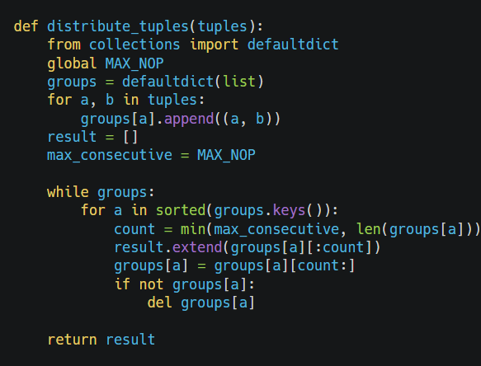

**Figure 5: distribute_tuples() function**

The **distribute_tuples()** function distributes the tuples evenly to ensure a round-robin type format while delivering messages.

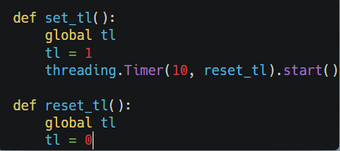

**Figure 6: set_tl() and reset_tl() functions**

The **set_tl()** and **reset_tl()** functions ensure fairness in token handling, so that each token gets an equal share of the token. It ensures that once a node releases the token, it wont be able to reaquire it until some time has passed.

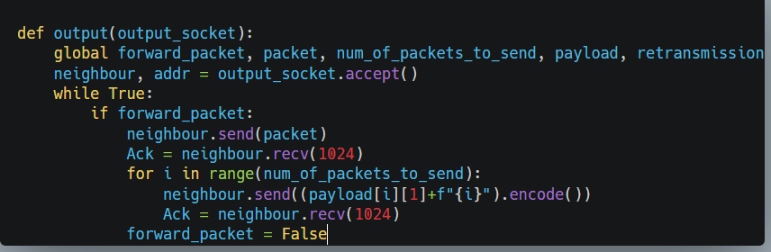

**Figure 7: output() function**

The **output()** function just delivers the token and packets(if any) to the neighbouring node.

All snippets below are part of the **inputsocket()** function.

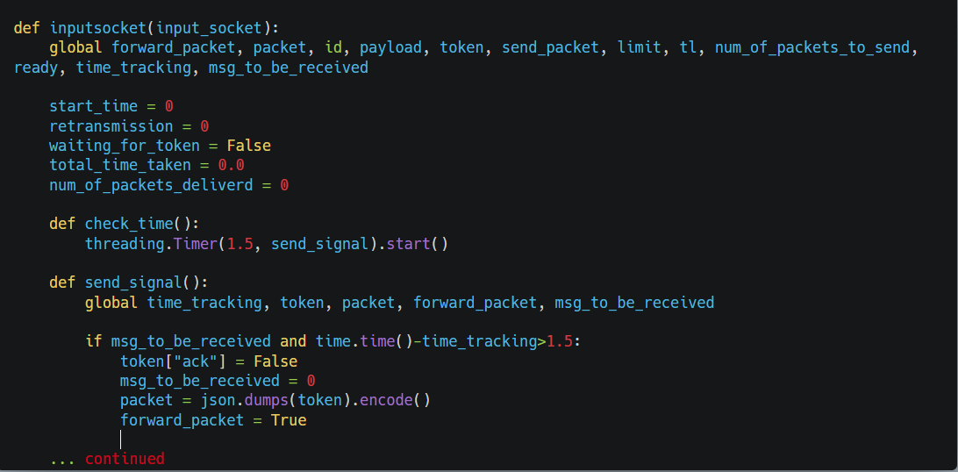

**Figure 8: input_socket() function part-1**

The **check_time()** and **send_signal()** functions send the token back to the sender without acknowledgment if the packets have not arrived within the specified waiting time.

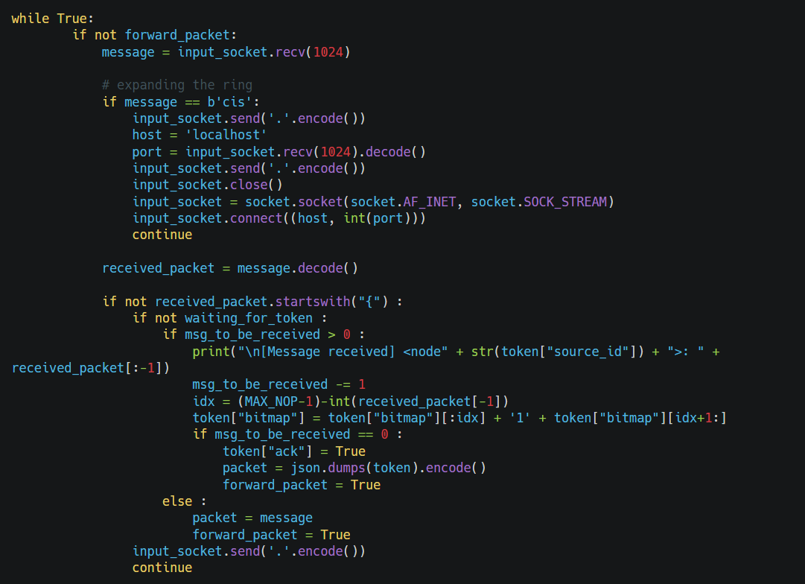

**Figure 9: input_socket() function part-2**

The first ‘if’ block helps in expanding the ring by receiving the port number and establishing connections.  
The second ‘if’ block handles the packets received.

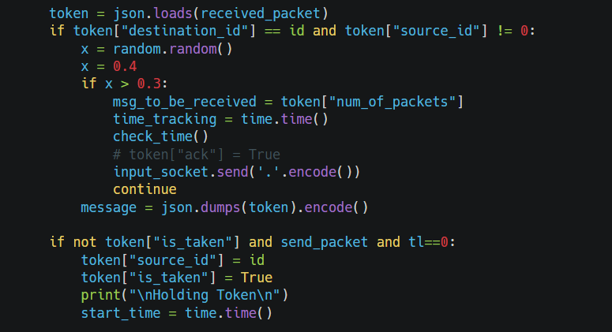 **Figure 10: input_socket() function part-3**

Here, the 1st ‘if’ block handles the case when the token reaches the intended destination node.  
2nd ‘if’ block helps in acquiring the token if it is not held by any other node.

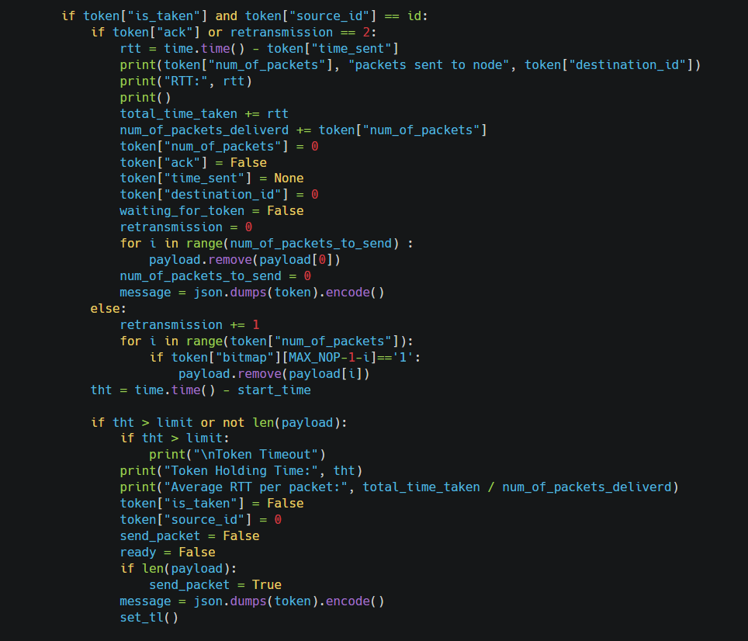

**Figure 11: input_socket() function part-4**

This ‘if’ block handles the case when token arrives back at the sender node and checks if acknowledgement has been received. If not, it retransmits the packets which have not be acked. If all packets have received acknowledgement, then it removes those packets from the buffer. In case, the node holds the token for more than the threshold time, token timeout is signalled and the token is released.

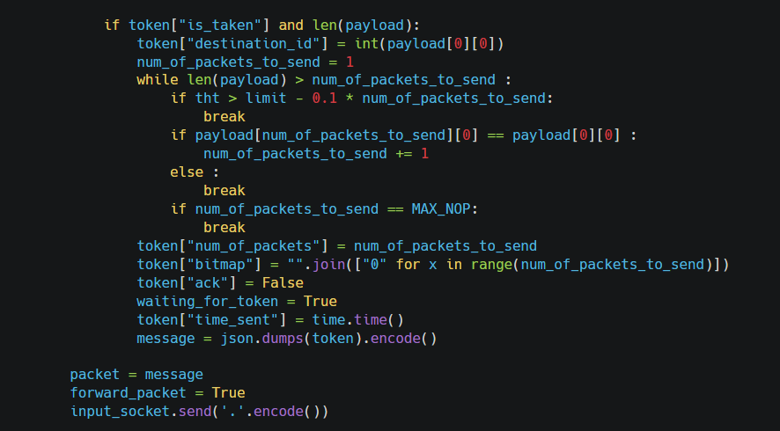

**Figure 12: input_socket() function part-5**

This ‘if’ block takes care of setting the token parameters like the destination_id, number of packets to be sent, bitmap etc.

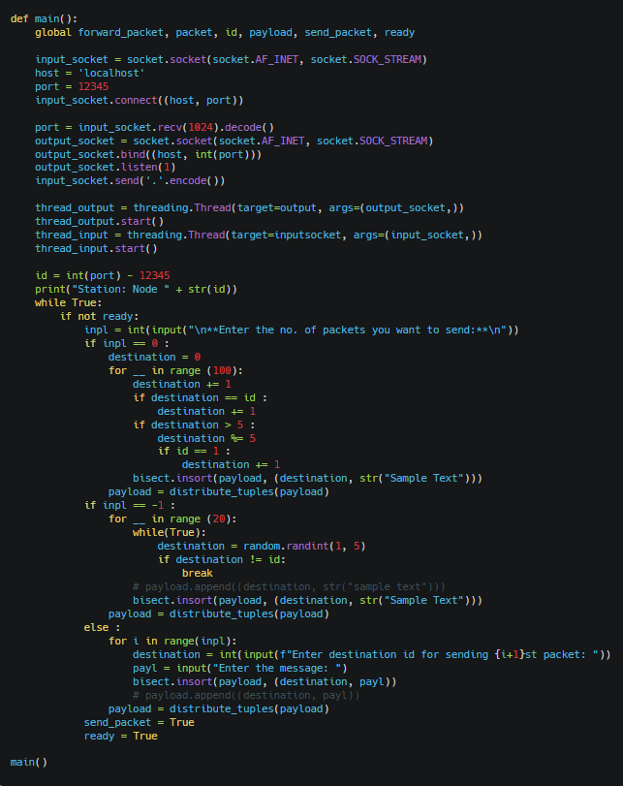 **Figure 13: main() function**

**4. Results**

**Performance Metrics**

The primary metric used to evaluate performance was the total time taken for data transfer per packet, i.e., Latency. We measured this time by recording the timestamp when each packet was sent and when the acknowledgment (ACK) for it was received. This allowed us to calculate the Round-Trip Time (RTT) for the batch of packets, providing insight into the efficiency of the transmission process.

**Data Analysis**

Data was collected over multiple simulation runs, comparing the performance of the standard protocol and the optimized protocol with 5 nodes in the simulated environment, implemented through terminals/command-line interfaces. The final reported value is the average obtained from all simulation runs. Each node was configured to send 300 packets during the simulation runs. A total of 1500 packets were transmitted during each simulation run.

**Comparison**

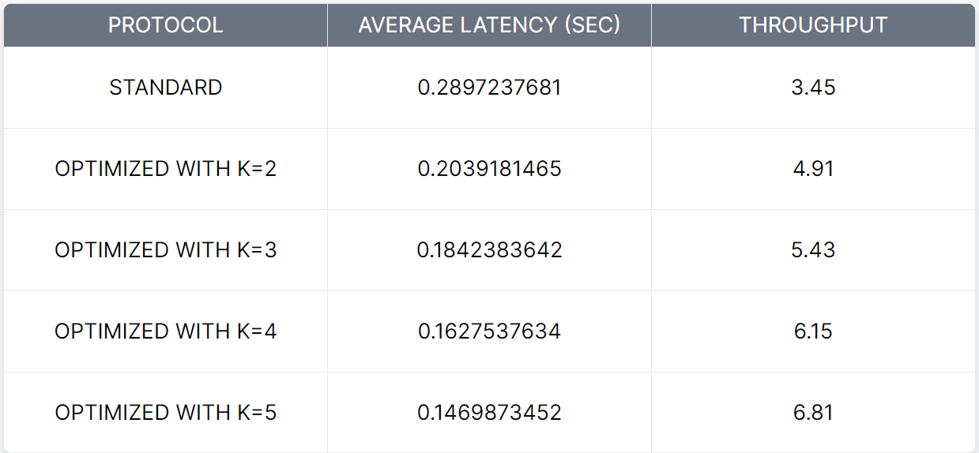

**Table 1: Average Latency and Throughput Comparison**

Here, 𝐾 represents the maximum number of packets that a sender can transmit in a single batch. Average latency refers to the time taken for data transfer per packet. Throughput is defined as the average number of packets transmitted per second. The standard protocol has 𝐾 =1 by default.

**Screenshot of Results**

**Optimized Protocol**

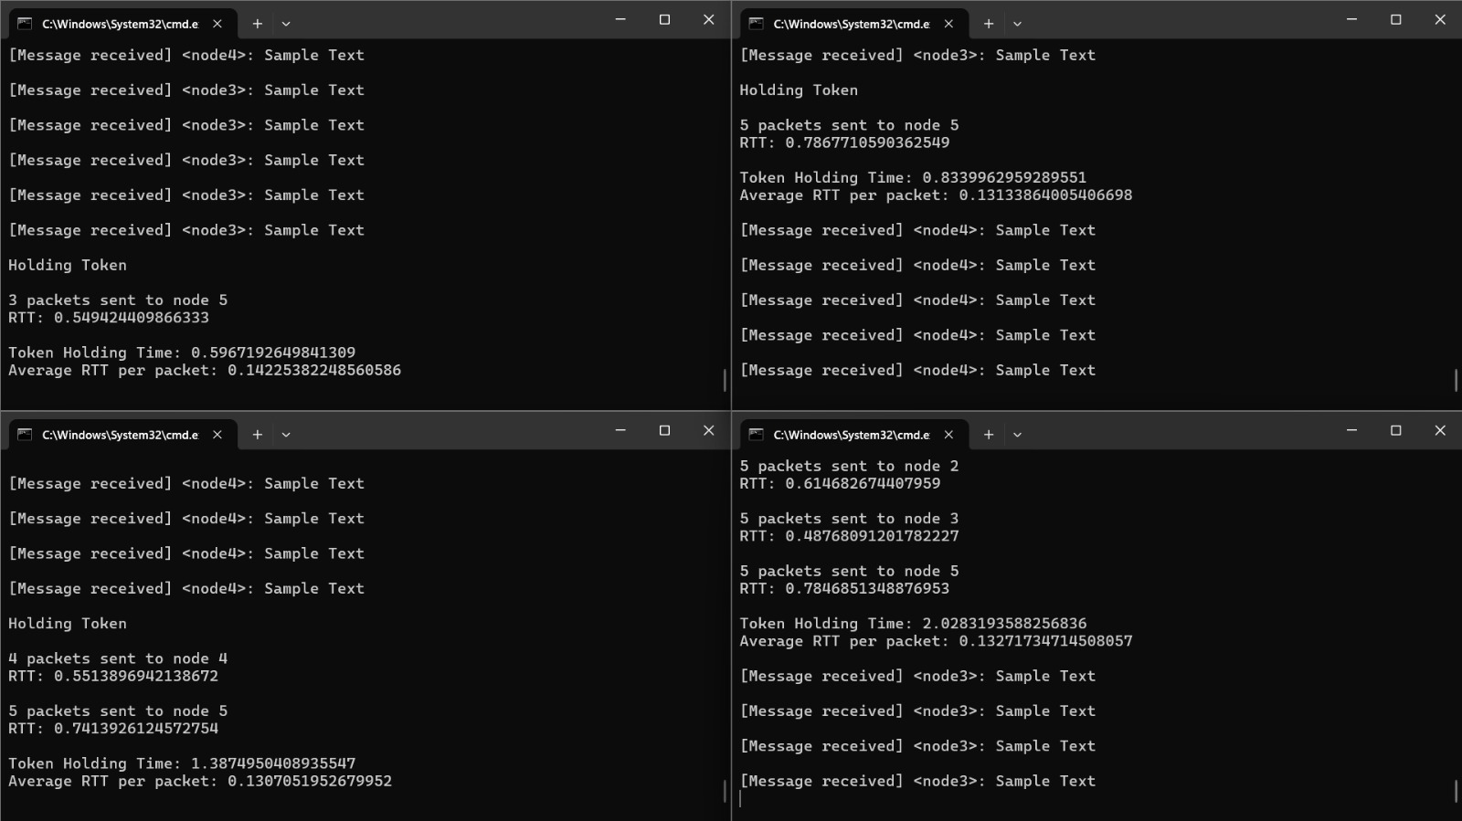

**Figure 14: Results of Optimized Protocol**

**Standard Protocol**

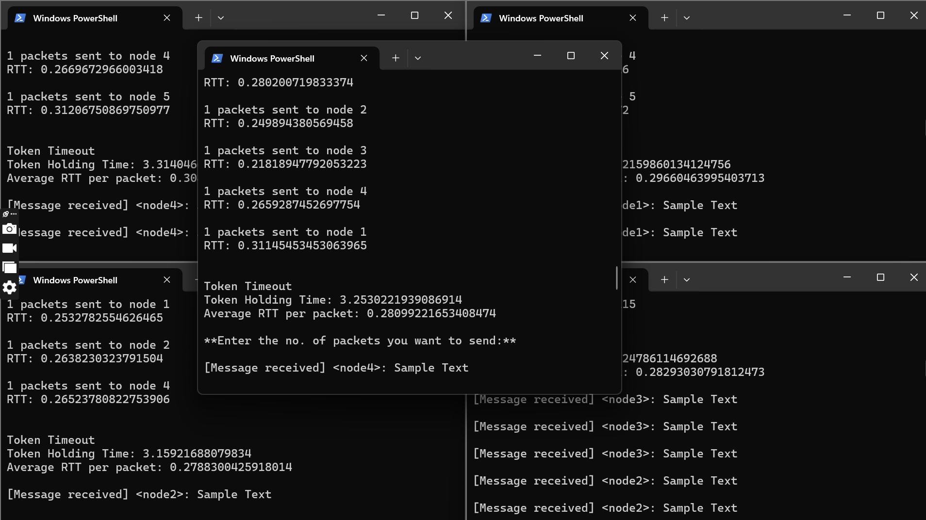

**Figure 15: Results of Standard Protocol**

**5. Discussion**

**Interpretation of Results**

The results of the experiments demonstrate a significant reduction in the total time taken for data transfer per packet, with reductions of up to 50% observed in the best-case scenario, following the implementation of the optimization technique. We observed a maximum of 50% increase in throughput and a 50% reduction in average latency. This reduction in time suggests a substantial improvement in efficiency within the network. Specifically, the strategy of streaming packets behind the token emerges as a key factor contributing to this enhanced efficiency. By transmitting multiple packets destined for the same node in a batch, the network experiences less idle time and achieves more streamlined packet delivery. Consequently, this optimization has proven effective in addressing the inefficiencies inherent in the standard protocol, paving the way for smoother and more efficient data transmission.

**Limitations**

1. Not suitable for two-way communication scenarios, where a sender transmits one packet and then awaits a response from the receiver. In such cases, the optimized protocol's batch transmission approach may introduce delays, as the sender cannot send additional packets until the token is returned. This waiting period can impact real-time or interactive applications where immediate responses are expected, potentially leading to performance degradation or increased latency.
2. In instances where there is only one packet destined for a node, the optimized protocol operates similarly to the standard protocol. Since there are no additional packets to aggregate into a batch, the benefits of batch transmission are not realized. Consequently, the optimization's advantages are limited in scenarios with minimal packet traffic, and the performance remains comparable to that of the standard protocol.
3. Another limitation is that while holding the token, the sender cannot dynamically add more packets into its buffer for transmission. This static nature of packet transmission during token possession may lead to underutilization of network resources, especially in situations where additional packets become available for transmission after the token has been acquired. As a result, the protocol may not fully capitalize on opportunities to optimize data transfer efficiency during periods of token possession.
4. To achieve O(1) time complexity while sending each batch of packets, we arrange the packets in order during the initial addition to the buffer. This approach ensures efficient transmission later but introduces a preprocessing bottleneck. Consequently, the time spent arranging packets in the buffer initially is critical to maintaining overall efficiency during the sending phase.

These limitations underscore the importance of considering the specific requirements and characteristics of the network environment when implementing and assessing optimization strategies.

**6. Conclusion**

The optimization of the Ring Token Protocol by streaming multiple packets destined for the same node together has proven to enhance network performance significantly. This approach reduces the overhead of frequent token passing and improves overall network throughput and latency. Future work may explore further enhancements, such as adaptive thresholding for packet grouping and dynamic token management strategies.