TEAM 12
Autonomous Business Intelligence Agent
A natural-language analytics agent that writes, validates and executes SQL, then returns a charted, written finding
Project Report
Team Members
Baliji Manikanta — Data & Database Engineering
Nikesh Kumar Nirala — Retrieval / RAG Engineering
Sravani Gollapudi — SQL Generation & Safety
Dhruv Bansal — Analytics & Visualisation
Shreyas Nitin Shimpi — Integration, UI & QA

Dataset: Northwind (SQLite, 13 tables) · Model: Groq openai/gpt-oss-20b · Interface: Streamlit

Contents
1. Executive Summary
2. Problem Statement
3. Objectives
4. System Architecture
5. Implementation
6. Evaluation Methodology
7. Results
8. Impact
9. Limitations and Future Work
10. Team and Contributions
A. Appendix A — Configuration Reference
B. Appendix B — Worked Example

1. Executive Summary
The Autonomous Business Intelligence Agent answers business questions asked in plain English. A user types a question such as "which five countries generate the most revenue?"; the system retrieves the relevant portion of the database schema, writes a SQL query, validates it, executes it against the Northwind database, and returns three things together: a written executive finding, a chart chosen to suit the shape of the answer, and the exact SQL that produced it.
The system removes the dependency on a SQL-literate analyst for routine questions. The person asking needs no knowledge of joins, aggregate functions, or the schema; the answer arrives in seconds rather than after a ticket queue. Crucially, the generated SQL is always shown, so the answer can be audited rather than taken on trust.

Headline results
The agent was measured against a twelve-case evaluation suite in which every question is paired with hand-written reference SQL. Grading compares returned values against that reference, never the text of the query, because many different queries correctly answer the same question.
Metric | Result | What it measures
Execution rate | 12 / 12 (100%) | Generated SQL ran without error
Answer accuracy | 12 / 12 (100%) | Results matched hand-written reference SQL
Numeric grounding | 94% | Figures in the summary traceable to returned data
Comparison integrity | 12 / 12 (100%) | Relative percentages computed against the correct base
Chart-form suitability | 12 / 12 (100%) | Visualisation matched the shape of the result
Mean cost | 1,298 tokens / question | Two model calls: generation and synthesis
Mean latency | 2.3 seconds / question | End to end, question to rendered answer

Every question in the suite executed successfully and returned the correct answer. The system is safe by construction rather than by instruction: the database connection is opened in SQLite's read-only mode, so a write is refused by the driver itself, independent of anything the language model produces.

2. Problem Statement
Organisations accumulate operational data far faster than they accumulate the ability to interrogate it. A mid-sized company running an order-management system holds every fact needed to answer which products drive revenue, which markets are concentrating, and which staff carry disproportionate workload. In practice those questions go unanswered, not because the data is missing but because reaching it requires a specific and scarce skill.

2.1 The access bottleneck
Answering even a simple business question against a normalised relational schema requires the asker to know which tables hold the facts, how those tables join, which column carries the price actually charged as opposed to the list price, and how to express the aggregation. The Northwind schema used in this project is deliberately representative: revenue is not a column anywhere. It must be computed as unit price multiplied by quantity, adjusted for a per-line discount, drawn from an order-line table whose name contains a space and therefore requires quoting. A business user cannot reasonably be expected to know this. An analyst who does know it becomes a queue.
The consequence is a two-tier organisation. Questions that justify a ticket get answered. Questions that are merely useful — the exploratory follow-up, the sanity check before a meeting, the hunch worth five minutes — do not get asked at all. The cost is invisible precisely because it takes the form of analysis that never happened.

2.2 Why conventional tooling does not close the gap
Dashboards answer questions decided in advance. They are effective for monitoring known indicators and ineffective for the open-ended question, because any question outside the dashboard's design requires a return to the analyst. Self-service query builders lower the syntax barrier but not the schema barrier: a user still has to know which table to start from and how the joins work.
Applying a general-purpose language model directly to the problem introduces different failures. A model given a plain question and a schema will produce plausible SQL, but plausibility is not correctness. Three failure modes matter specifically:
- Silent semantic error — the query executes and returns a number that answers a different question than the one asked;
- Hard failure — the model references a column that does not exist, and the user receives a database stack trace rather than an answer;
- Fabricated narrative — the written interpretation contains figures that are not present in, and cannot be derived from, the query result.
A system intended for business use must address all three. It is not sufficient to generate SQL; the system must validate what it generated, recover when execution fails, and be measurable on whether its written output is faithful to the data it retrieved.

2.3 Safety as a first-order requirement
Any system that executes model-generated code against a production database is a security surface. Instructing a model not to issue destructive statements is not a control, because the instruction is advisory and the model's output is not guaranteed. The problem statement therefore includes a constraint: read-only access must be enforced by the execution layer, not requested in a prompt.

3. Objectives
The project set six objectives. Each is stated with the criterion by which it was judged met.

3.1 Primary objectives
- Natural-language to SQL. Accept a business question in unconstrained natural language and return a correct, executable SQL query against the Northwind schema, with no requirement that the user know the schema. Criterion: correct results on a reference-graded evaluation suite.
- Targeted schema retrieval. Supply the model with only the portion of the schema relevant to the question, rather than the entire database definition, so that prompt size stays bounded as the schema grows. Criterion: retrieval returns the tables required to answer, within a fixed top-k budget.
- Enforced read-only execution. Guarantee that no statement able to modify the database can execute, irrespective of model output. Criterion: enforcement at the database-connection layer, verified independently of prompt content.
- Grounded written analysis. Produce a written executive summary whose every stated figure is traceable to the query result. Criterion: a measurable grounding rate, not a subjective reading.
- Automatic visualisation. Select a visualisation that suits the shape of the result, including recognising when the correct visualisation is a single number rather than a chart. Criterion: chart-form suitability measured per case.
- Measurable quality. Make quality measurable and regressions detectable, so that a change to a prompt or a component can be assessed against evidence. Criterion: a repeatable harness producing per-case and aggregate metrics.

3.2 Secondary objectives
- Resilience — recover automatically from a failed query rather than surfacing a database error to the user.
- Cost discipline — keep per-question token consumption bounded and predictable, and avoid paying the model twice for the same question.
- Auditability — present the interaction as a conversation, with the generated SQL always available for inspection alongside the answer.
- Modularity — keep retrieval, generation, execution, visualisation and synthesis in separate modules so each can be tested and replaced independently.

3.3 Explicit non-objectives
Scope was bounded deliberately. The system does not write to the database under any circumstance. It does not perform predictive modelling or forecasting; it reports what the data contains. It does not maintain analytical state across turns — each question is answered independently, so a follow-up must be self-contained. It targets SQLite and the Northwind schema, and is not positioned as a general cross-dialect translation layer.

4. System Architecture
The system is organised into four layers. A presentation layer carries the conversational interface. A single orchestration module sequences the work. Four core components each own one responsibility. Beneath them sit the database, the external model service, the configuration and the evaluation harness. Components do not call one another: all sequencing passes through the orchestrator, so any component can be tested or replaced in isolation.
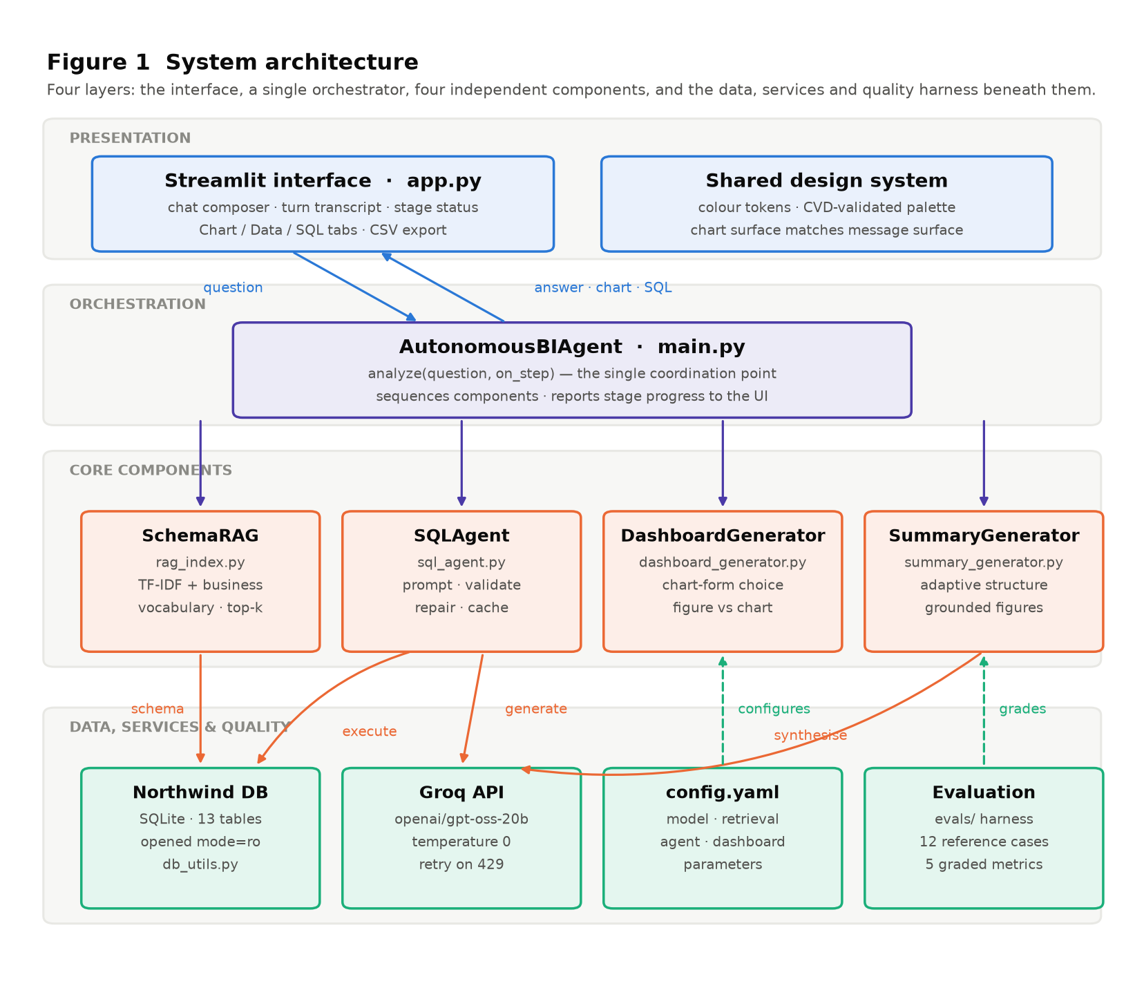
Figure 1 — Full system architecture. Solid arrows carry data and control; dashed arrows show configuration and grading. Only SQLAgent and SummaryGenerator reach the model service, and only SchemaRAG and SQLAgent reach the database.

4.1 Layer responsibilities
Layer | Contents | Responsibility
Presentation | app.py, shared design tokens | Accepts the question, renders the answer, chart, table and SQL; reports stage progress
Orchestration | main.py — AutonomousBIAgent | Sequences the pipeline and emits stage callbacks; the only module aware of all components
Core components | SchemaRAG, SQLAgent, DashboardGenerator, SummaryGenerator | One responsibility each, with no direct dependency between them
Data and services | Northwind SQLite, Groq API, config.yaml, evals/ | Read-only data access, model inference, external parameters, and graded quality measurement

4.2 Request path
Within that structure, a question follows a six-stage path. Each stage has a defined input and output and can be exercised in isolation.
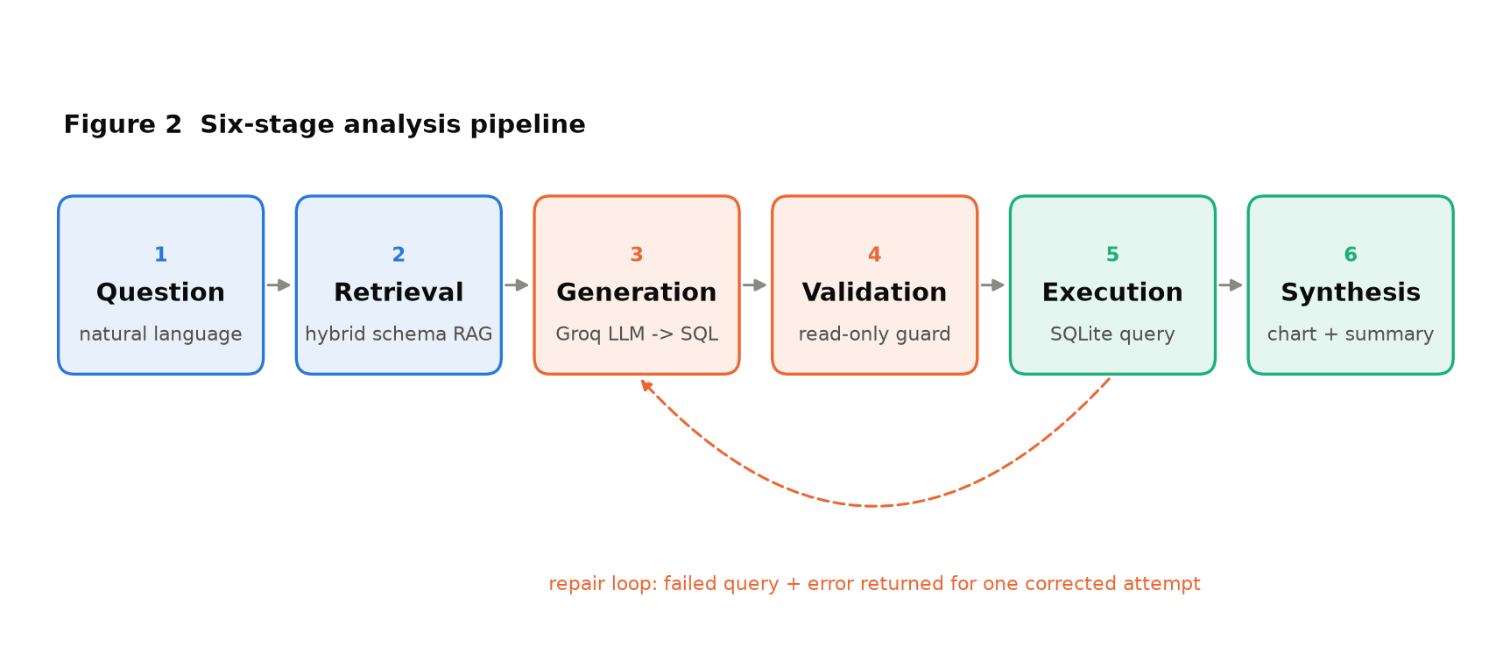
Figure 2 — The six pipeline stages. The dashed return path is the repair loop, which re-enters generation once when a query fails validation or execution.

4.3 Stage 1 — Question intake
The interface accepts a question as free text. It is checked only for emptiness; no parsing, keyword extraction or template matching is applied. The question is passed unmodified to retrieval, so that phrasing carries into the prompt intact.

4.4 Stage 2 — Hybrid schema retrieval
Supplying an entire schema to the model scales badly and dilutes attention. Retrieval instead selects the tables likely to be needed. Two signals are combined.
The first is lexical. Each table is rendered as a document containing its name and column names, indexed with TF-IDF over unigrams and bigrams; the question is scored against this index by cosine similarity. This handles direct vocabulary overlap — a question mentioning "products" matches the Products table.
The second signal is domain knowledge, and exists because lexical similarity alone fails on business vocabulary. A question about "revenue" contains no token matching any table name, yet requires the order-line table. A curated mapping associates business concepts — sales, customer, shipping, time, category — with the tables and columns that serve them. Matches are scored by specificity: an exact table name scores highest, a concept appearing inside a table name next, then a column match, then a partial column match.
The two scores combine, with the domain score weighted to adjust rather than dominate the lexical ranking, and the highest-scoring tables up to a configured limit form the schema context. Only table and column names are passed forward; no rows leave the database at this stage.

4.5 Stage 3 — SQL generation
The retrieved schema and the question are assembled into a prompt and sent to the language model at temperature zero, so that the same question yields the same query. The prompt carries only guidance that the code cannot enforce for itself. Prohibitions on destructive statements are deliberately absent — those are enforced downstream, and a prompt is not a security boundary. What the prompt does carry is schema-specific knowledge that determines whether an answer is right or merely plausible:
- the order-line table name contains a space and must be double-quoted;
- revenue is unit price times quantity adjusted for the line discount, taken from the order line rather than the product record, because the order line holds the price actually charged;
- a ranking must return the entity's name, not only its identifier, so the result is readable and charts label correctly.
The response is stripped of any markdown fencing the model may add, leaving a bare statement.

4.6 Stage 4 — Validation
Validation is deterministic and independent of the model. A candidate query must begin with SELECT or WITH. It is then scanned for statement keywords capable of modification — insert, update, delete, drop, alter, create, replace, attach, detach, pragma — and rejected if any appears as a whole word. Rejection raises an error that enters the repair loop rather than reaching the user.

4.7 Stage 5 — Execution and the repair loop
The validated query executes against the Northwind database over a connection opened in SQLite's read-only URI mode. This is the decisive control: a write is refused by the database driver itself. The keyword checks in the preceding stage are a second layer, not the primary one.
Where a query fails — an invalid column, a malformed join, a rejected keyword — the failure is not surfaced. The failed query, the database's own error message, the retrieved schema and the original question are returned to the model for one corrected attempt. Including the original question in that repair request is essential: without it a repair can produce syntactically valid SQL that answers a different question than the one asked. Results are capped at a configured row limit before leaving this stage.

4.8 Stage 6 — Synthesis
Synthesis produces the two artefacts the user reads: a chart and a written finding.
Chart selection is driven by the shape of the result rather than by a fixed preference. A result carrying a category and a measure becomes a bar chart, drawn horizontally so that category labels read flat rather than rotated. Two measures become a scatter plot; a single measure becomes a distribution. A single-row result is recognised as a number rather than a chart and rendered as a headline figure, because a one-bar bar chart conveys nothing that the number does not. The measure column is chosen by excluding identifier-like columns, so that a result containing both a product identifier and a sales total charts the total.
The written summary is generated from the question and a compact rendering of the result. Its structure adapts to the result: a single-row answer receives a finding and an interpretation, while a multi-row answer additionally receives the figures that carry it and a closing observation. Where the result exceeds the preview budget, exact column totals across all rows are supplied alongside the truncated preview, so that any share or percentage is computed against the true denominator rather than the visible subset.

4.9 Interface layer
The interface is a conversational surface. Each exchange appears as a turn: the question, a progress indicator naming the pipeline stage currently executing, and then the answer. The answer presents the written finding first, with the chart, the full result table with CSV export, and the generated SQL available as tabs beneath it. Placing the SQL one click from every answer is a deliberate auditability decision — the user can always check what was actually computed.

5. Implementation

5.1 Technology stack
Layer | Technology | Rationale
Interface | Streamlit | Chat primitives and stateful reruns without a separate frontend build
Orchestration | Python 3.14 | Single coordinating module over independent components
Language model | Groq, openai/gpt-oss-20b | Low-latency inference; deterministic at temperature zero
Retrieval | scikit-learn TF-IDF | Transparent, inspectable scoring; no embedding service dependency
Database | SQLite (Northwind) | Self-contained; supports read-only connection mode
Data handling | pandas | Result frames shared between charting and synthesis
Visualisation | Plotly | Interactive charts embedded directly in the interface
Configuration | YAML | Model, retrieval and agent parameters external to code

5.2 Module layout
Module | Responsibility
app.py | Conversational interface, turn state, result presentation
main.py | Pipeline orchestration and stage reporting
src/rag_index.py | Hybrid schema retrieval
src/sql_agent.py | Prompting, validation, repair loop, generation cache
src/db_utils.py | Read-only connection, schema extraction, query execution
src/dashboard_generator.py | Chart-form selection and rendering
src/summary_generator.py | Executive summary synthesis
evals/ | Evaluation cases and grading harness
config/config.yaml | Model, retrieval and agent parameters

5.3 Determinism and reproducibility
Generation runs at temperature zero throughout. The same question against the same schema produces the same SQL, which makes behaviour reproducible and makes the evaluation suite meaningful as a regression check. Reasoning effort on the synthesis call is set low: the summary performs arithmetic over a small set of retrieved figures and does not require extended deliberation.

5.4 Cost controls
Three mechanisms bound cost. Retrieval limits the schema sent to the model to the tables actually needed. The result preview supplied to synthesis is a compact comma-separated rendering with floating-point values rounded, rather than a width-padded table. A generation cache keyed on the question returns previously validated SQL without a model call; the query is always re-executed, so cached SQL never serves stale data.

5.5 Failure handling
The pipeline treats three classes of failure distinctly. A query failure enters the repair loop and is usually resolved without the user seeing it. A transport failure such as an API rate limit is retried with backoff by the client. A configuration failure — an absent API key, a missing database file — is reported immediately and explicitly, because no retry can resolve it.

6. Evaluation Methodology
A system that produces fluent output is difficult to assess by inspection, because fluency is not accuracy. A wrong answer expressed confidently reads much like a right one. The project therefore treats evaluation as a deliverable in its own right, with a harness that grades the agent against independent ground truth.

6.1 Design principle: grade results, not queries
Each evaluation case pairs a natural-language question with reference SQL written by hand. Grading compares the values the agent returned against the values the reference returns — never the text of the two queries. This is essential, because many different queries answer the same question correctly: joins may be ordered differently, aggregation may be expressed differently, columns may be aliased differently. Comparing query text would reject correct answers.
Reference SQL is executed against the live database each time the suite runs, so expected values are never hard-coded. The suite therefore remains valid if the underlying data changes.

6.2 Comparison modes
Mode | Applies to | Comparison rule
scalar | Single-value answers such as counts | Numeric equality within relative tolerance
ranked | Top-N questions where order is the answer | Ordered labels and values must match position by position
set | Grouped aggregations without inherent order | Same row count; measure values match as a multiset

Entity labels are matched permissively. An employee correctly identified by surname, by forename, or by both names identifies the same row, so a label match succeeds if the expected label appears in any text cell of the corresponding row. The measure column is identified using the same rules the charting component applies, so the evaluation and the product agree on which column constitutes the answer.

6.3 Metrics
Five metrics are recorded per case.
- Execution. whether the generated SQL ran without raising. This isolates hard failures from wrong answers.
- Accuracy. whether returned values matched the reference under the case's comparison mode. This is the primary measure of correctness.
- Numeric grounding. the proportion of numeric figures in the written summary that are traceable to the returned data. Candidates include the values themselves, their compact renderings, column totals, row counts, pairwise differences and shares of total. A figure matching none of these is reported as unverified. The metric is a review signal rather than a pass criterion, because a legitimately derived figure may fall outside the enumerated families.
- Comparison integrity. whether relative percentages are computed against the correct base. A statement that one value is a given percentage higher than another must divide by the value compared against. A percentage matching the difference over the larger value instead indicates a mis-based claim — arithmetic that is internally correct but attached to the wrong denominator. Numeric grounding cannot detect this, since the figure is genuinely traceable; only the sentence is wrong.
- Chart-form suitability. whether the visualisation matched the result shape: a single-row result must render as a figure rather than a chart, and a multi-row result must produce a chart.
Token consumption, wall-clock latency and the number of model calls are recorded alongside. The call count is diagnostic: more than two calls in a case indicates that the repair loop was exercised.

6.4 Case coverage
The suite contains twelve cases spanning the question types the system is intended to serve: simple counts, filtered counts, revenue rankings over multi-table joins, grouped aggregations, and averages across a join. Several cases deliberately target the schema's known traps — the quoted order-line table, the discount-adjusted revenue formula, and the distinction between the order-line price and the product list price.

6.5 Operational integrity of the harness
Two properties keep the measurement honest. Failures are attributed to the pipeline stage that actually failed, using the stage callback the orchestrator emits, so that a synthesis failure is never reported as a SQL failure. And API rate limiting is distinguished from agent failure: a per-minute cap is waited out and the case retried, while an exhausted daily quota halts the run with an explicit message rather than recording a run of zeros that would read as catastrophic regression.

7. Results
The figures below are from a complete run of the evaluation suite against the delivered system.

7.1 Aggregate results
Metric | Result
Execution rate | 12 / 12 (100%)
Answer accuracy | 12 / 12 (100%)
Numeric grounding | 94% of stated figures traceable
Comparison integrity | 12 / 12 (100%)
Chart-form suitability | 12 / 12 (100%)
Repair loop invocations | 0 of 12 cases
Total cost | 15,575 tokens across 12 questions
Mean cost | 1,298 tokens per question
Mean latency | 2.3 seconds per question

Every case executed and returned the correct answer. No case required the repair loop, indicating that first-pass generation was correct throughout this run; the loop remains as a recovery path and has been verified independently.

7.2 Per-case results
Case | Mode | Rows | Exec | Correct | Ground | Tokens | Sec
count customers | scalar | 1 | pass | pass | 100% | 871 | 1.2
count products | scalar | 1 | pass | pass | 100% | 957 | 1.5
count orders | scalar | 1 | pass | pass | 100% | 890 | 1.0
top5 products revenue | ranked | 5 | pass | pass | 80% | 1,698 | 5.1
top5 countries revenue | ranked | 5 | pass | pass | 100% | 1,622 | 2.8
top3 customers revenue | ranked | 3 | pass | pass | 90% | 1,718 | 4.5
top employee orders | ranked | 1 | pass | pass | 100% | 1,048 | 1.4
avg freight by shipper | set | 3 | pass | pass | 89% | 1,389 | 1.8
customers per country | set | 22 | pass | pass | 67% | 1,399 | 1.5
products per category | set | 8 | pass | pass | 100% | 1,486 | 1.7
discontinued products | scalar | 1 | pass | pass | 100% | 864 | 1.0
top3 categories revenue | ranked | 3 | pass | pass | 100% | 1,633 | 4.4

7.3 Cost distribution
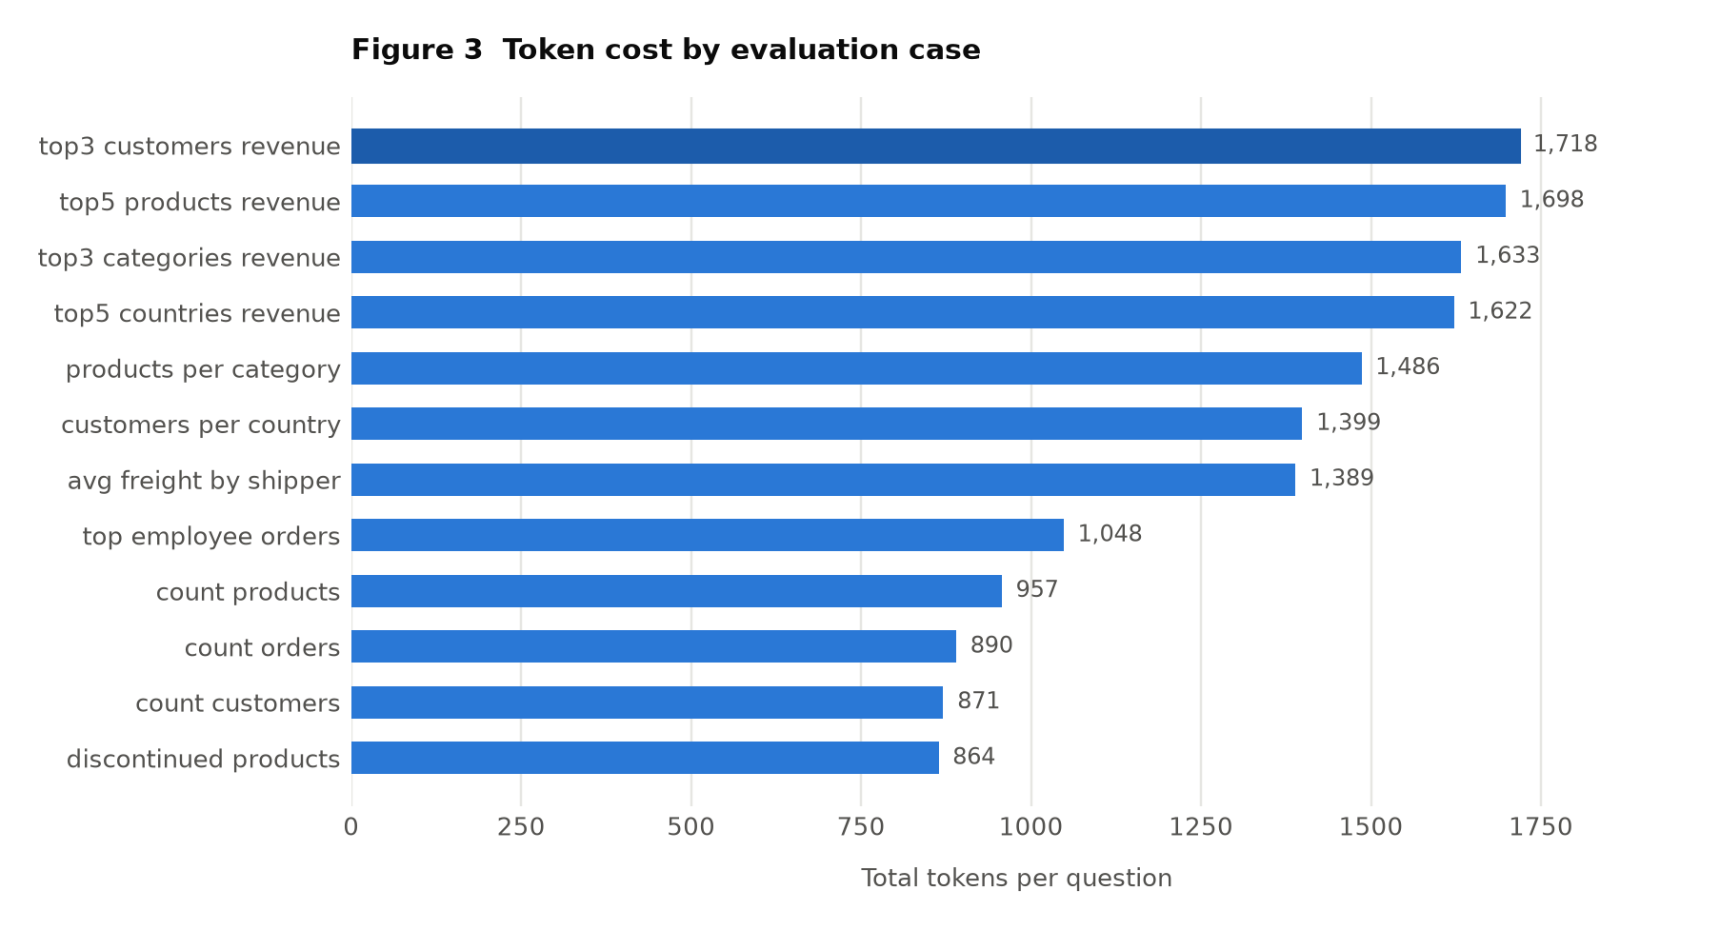
Figure 3 — Total tokens consumed per evaluation case, across both model calls.
Cost tracks the complexity of the answer rather than the complexity of the question. Simple counts return a single row and consume around 870 tokens; multi-row revenue rankings consume around 1,700, because the returned rows enter the synthesis prompt and a longer written finding is produced. The spread across the suite is narrow — roughly a factor of two between the cheapest and most expensive case — which makes per-question cost predictable for capacity planning.

7.4 Interpreting the grounding metric
Numeric grounding at 94% does not indicate that 6% of stated figures are fabricated. Inspection of the unverified figures shows them to be legitimately derived quantities that fall outside the enumerated families — typically a subset sum and its share of the whole, such as the combined total of the top three rows expressed as a percentage of all rows.
The enumeration was deliberately not extended further. Each additional derived family widens the set of accepted candidates, and past a point the metric would accept any figure at all and cease to discriminate. The check was validated against a deliberately fabricated summary, which it scores at zero, confirming that it still detects invention.

7.5 Safety verification
Read-only enforcement was verified at the connection layer rather than inferred from prompt content. The database is opened in SQLite read-only URI mode; any statement attempting modification is refused by the driver. The keyword validation stage provides defence in depth, and the evaluation suite confirms that no case produced a query rejected by it.

8. Impact

8.1 Removing the analyst bottleneck
The direct effect is that a business question no longer requires a SQL-literate intermediary. A question posed in plain English returns a charted, written answer in approximately two seconds. The practical significance is not the time saved on any single question — an analyst might answer one in minutes — but the change in which questions get asked. When the marginal cost of asking falls to seconds, the exploratory follow-up becomes viable, and analysis shifts from a scheduled activity to a continuous one.

8.2 Auditability as a condition of trust
Presenting the generated SQL alongside every answer is a deliberate design position. A system that returns only a conclusion asks to be trusted; a system that returns the conclusion together with the query that produced it can be checked. Any user who can read SQL can verify what was computed, and any user who cannot can forward it to someone who can. This matters for a class of system whose failure mode is confident wrongness.

8.3 Measured quality rather than asserted quality
The evaluation harness is arguably the project's most transferable outcome. It establishes that the agent's quality is a measurable property with a number attached, not a subjective impression formed by trying a few questions. A change to a prompt, a retrieval parameter or a model can be assessed against twelve reference-graded cases and five metrics before it is accepted.
This has a specific consequence for maintenance. Language model behaviour is sensitive to prompt changes in ways that are difficult to predict, and an improvement to one aspect of output can silently degrade another. A regression suite that grades against independent ground truth converts that risk from a hazard into a detectable event.

8.4 Operational characteristics
At approximately 1,300 tokens per question, cost is low enough that the system is economically viable for routine exploratory use rather than reserved for high-value queries. Latency of around two seconds places it within the range where an interaction feels conversational. The generation cache removes model cost entirely for repeated questions while preserving data freshness, which matters in a setting where several users ask overlapping questions.

8.5 Architectural transferability
The separation of concerns means the approach is not specific to Northwind. Retrieval, generation, validation, execution and synthesis communicate through defined interfaces. Targeting a different schema requires re-pointing the database layer and revising the domain vocabulary used in retrieval; the pipeline, the safety model and the evaluation harness carry over unchanged. The evaluation method in particular — pairing questions with reference SQL and grading on values — applies to any natural-language-to-SQL system.

9. Limitations and Future Work

9.1 Limitations
- Evaluation breadth. Twelve cases constitute a regression suite, not a benchmark. Every case is answerable within one or two joins. A 100% accuracy result should be read as the absence of regressions on the covered ground, not as a claim about arbitrary analytical questions.
- No conversational memory. Each question is answered independently. A follow-up such as "and the year before?" carries no context from the previous turn and must be restated in full.
- Vocabulary coupling. Retrieval depends on a curated business vocabulary. A question using terminology absent from that mapping, and sharing no tokens with any table or column name, may retrieve the wrong tables.
- Single dialect. The system targets SQLite and the Northwind schema. Dialect-specific constructs would require revision for another database.
- Semantic claims. The grounding metric verifies that figures are traceable; it does not verify that the surrounding prose reasons correctly about them. Comparison integrity closes one specific case of this gap, but the general problem — assessing whether an interpretation is sound — is not addressed by numeric checks.

9.2 Future work
- Conversational context. Carry prior questions and results into the prompt so that follow-up questions can be posed naturally, with the accompanying retrieval and cost implications assessed against the suite.
- Broader evaluation. Extend the suite toward multi-condition filters, date-range aggregation, window functions and deliberately ambiguous questions, so that measured accuracy reflects a wider range of real use.
- Schema-agnostic retrieval. Derive the domain vocabulary from foreign-key relationships and column statistics rather than curating it by hand, so that the approach transfers to a new schema without manual mapping.
- Semantic grading. Introduce a model-based judge for the qualitative claims that numeric checks cannot assess, calibrated against human judgement on a held-out sample.
- Query memory. Record answered questions and their verified SQL as retrieval examples, so that recurring question patterns improve generation accuracy over time.

10. Team and Contributions
Team 12 organised the work into five workstreams, each owning a component of the pipeline together with its tests.
Member | Workstream | Contribution
Baliji Manikanta | Data & Database Engineering | northwind.db provisioning, db_utils.py, schema extraction, read-only query layer, database fixtures
Nikesh Kumar Nirala | Retrieval / RAG Engineering | rag_index.py, hybrid TF-IDF and business-vocabulary retrieval, schema context assembly
Sravani Gollapudi | SQL Generation & Safety | sql_agent.py, prompt design, validation guard, repair loop, generation cache
Dhruv Bansal | Analytics & Visualisation | dashboard_generator.py, summary_generator.py, chart-form selection, executive summary synthesis
Shreyas Nitin Shimpi | Integration, UI & QA | app.py, main.py, conversational interface, evaluation harness, test suite

Integration was continuous rather than deferred to a final phase: the orchestration module and the evaluation harness were established early, so that each component could be exercised against the full pipeline and measured against the suite as it was developed.

Appendix A — Configuration Reference
Operational parameters are external to code, in config/config.yaml, so that behaviour can be tuned without modification of the pipeline.
Parameter | Value | Purpose
groq.model | openai/gpt-oss-20b | Model used for generation and synthesis
groq.temperature | 0 | Deterministic output; reproducible queries
groq.max_completion_tokens | 1024 | Upper bound on the generation response
groq.summary_max_tokens | 2000 | Upper bound on the synthesis response
groq.summary_reasoning_effort | low | Synthesis performs arithmetic, not deliberation
groq.api_max_retries | 5 | Transport-level retry on rate limiting
rag.top_k | 5 | Tables supplied as schema context
agent.max_rows | 1000 | Cap on rows returned from execution
agent.max_repairs | 1 | Corrected attempts permitted per question
agent.cache_size | 128 | Questions retained in the generation cache
dashboard.max_chart_rows | 20 | Rows rendered in a chart
dashboard.color_mode | categorical | Per-bar hue assignment for ranked charts

Appendix B — Worked Example
The following traces a single question through all six stages.

Question
Which 5 countries generate the most revenue?

Retrieved schema context
Retrieval returns the Orders and Order Details tables. Neither shares a token with the word "revenue"; both are selected through the domain vocabulary, which associates revenue with the order-line table and its price, quantity and discount columns.

Generated SQL
SELECT o.ShipCountry,
SUM(od.UnitPrice * od.Quantity * (1 - od.Discount))
AS Revenue
FROM Orders o
JOIN "Order Details" od ON o.OrderID = od.OrderID
GROUP BY o.ShipCountry
ORDER BY Revenue DESC
LIMIT 5;
The query quotes the order-line table, applies the discount, and draws the price from the order line rather than the product record — the three schema-specific behaviours the prompt establishes.

Validation and execution
The statement begins with SELECT and contains no modifying keyword, so validation passes. Execution over the read-only connection returns five rows.

Result
Ship country | Revenue (USD)
USA | 63,856,337.63
Germany | 59,094,757.22
France | 49,121,409.99
Brazil | 46,250,121.55
UK | 36,257,652.12

Synthesis
The result carries a category and a measure across five rows, so a horizontal bar chart is produced, ordered by value with direct value labels. The written summary reports the ranking, the figures behind it, and a closing observation — the concentration of revenue across the leading markets — with each percentage computed against the stated total.

