Mini Project on NoSQl

>employee collection
>insert 20 records
>perform
1 salary analysis
2 DEPARTMENT HEADCOUNT
3 top 5 highest paid employees
4 create index on salary
5 run aggregation pipeline

db.Employee.insertMany([{name:"Rahul",department:"it",salary:800000},
{name:"varun",department:"test",salary:700000},
{name:"raghu",department:"teaching",salary:85000},
{name:"vamshi",department:"test",salary:800000},
{name:"amar",department:"teaching",salary:900000},
{name:"akbar",department:"hr",salary:500000},
{name:"vinod",department:"hr",salary:800000},
{name:"niranjan",department:"it",salary:600000},
{name:"manoj",department:"hr",salary:400000},
{name:"harih",department:"management",salary:500000},
{name:"arun",department:"management",salary:800000},
{name:"vignesh",department:"management",salary:1000000},
{name:"rahul raj",department:"it",salary:700000},
{name:"vinay",department:"management",salary:900000},
{name:"pranay",department:"test",salary:850000},])
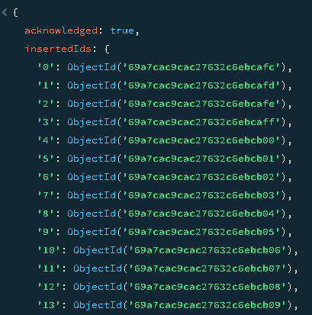

>Created a collection Employee in above

1 salary analysis

>Average salary in each department

db.Employee.aggregate([
{ $group: { _id:"$department", avgSalary: { $avg: "$salary" } } }
]);

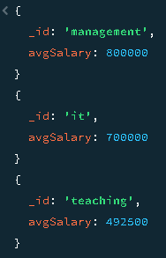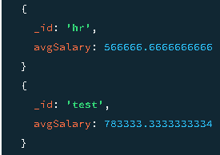

>Min and max salary in each department

db.Employee.aggregate([
{ $group: { _id: "$department", minSalary: { $min: "$salary" }, maxSalary: { $max: "$salary" } } }
]);
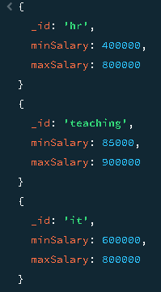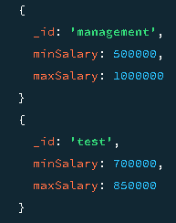

2 DEPARTMENT HEADCOUNT

>Finding department wise total numbers

db.Employee.aggregate([
{ $group: { _id: "$department", headcount: { $sum: 1 } } }
]);

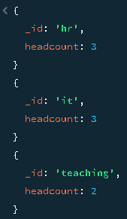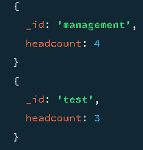

3 Top 5 highest paid employees

>Finding 5 employees who has highest salary irrespective of department

db.Employee.find().sort({ salary: -1 }).limit(5);

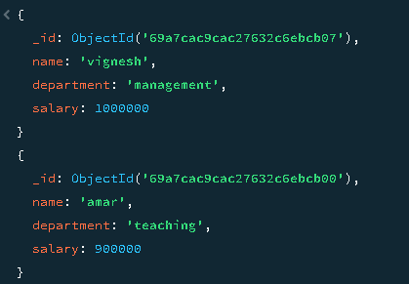
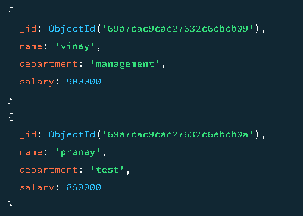
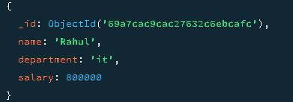

4 create index on salary

db.Employee.createIndex({ salary: -1 });
salary_-1
db.employees.getIndexes()
