Hands-On Lab 9:
Build ETL Pipeline Scenario Load customer data from:

CSV → Staging Table → DWH Table

Steps:

1. Load CSV
2. Clean data
3. Load to warehouse

Step 1: Loading Csv file using flatten file
CustomerID,Gender,Age,Annual_Income,Spending_Score
1,Male,19,15,39
2,Male,21,15,81
3,Female,20,16,6
4,Female,23,16,77

Step 2: Cleaning data and matching data type:

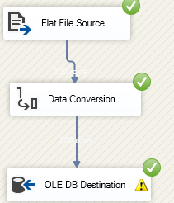
Step 3: Loading CSV → Staging Table → DWH Table
